S3-B

Anne Boxeth

Qi Sun

Zachary Taylor

Zixuan Yang

**Needs** **6**

General Needs 6

Assay Dev Manager 6

Production Manager 6

Assay Technician 6

Production Technician 6

**Features** **7**

**Other Requirements** **8**

**Business Process Model** **9**

**Use Case Diagram** **17**

**Use Cases Flow** **19**

Use Case: Login 19

Use Case: SearchProtocol 19

Use Case: SearchProduction 20

Use Case: DownloadProtocol 20

Use Case: SearchForAssay 21

Use Case: GetProtocolNotification 22

Use Case: CreateAssay 22

Use Case: ViewAssayStatus 22

Use Case: GenerateReport 23

Use Case: SubmitProtocolForApproval 23

Use Case: RecieveFDAResponse 24

Use Case: SubmitAssayStatus 24

Use Case: UploadProtocol 25

Use Case: ViewSampleStatus 25

Use Case: ViewTestResults 26

Use Case: UpdateSampleStatus 26

Use Case: ShareResultsOfSample 27

Use Case: ScheduleTechnicianTask 27

Use Case: CertifyTechnician 28

Use Case: AddSampleType 28

Use Case: ImportSampleID 29

Use Case: UploadResultsOfSample 29

Use Case: ViewStatusOfSample 30

Use Case: EnterError 31

Use Case: ViewTechnicianTasks 31

Use Case: AnalyzeSamples 32

Use Case: CreateOrder 32

**Low Fidelity Prototypes** **33**

Use Cases for Prototypes 33

Assay Development – Revise a protocol for an assay 34

Prototype 35

Interface Evaluation (Design 1) 37

Interface Evaluation (Design 2) 37

Assay Development – View assays by status 38

Prototype 39

Interface Evaluation 41

Alternate Design 42

Interface Evaluation 43

Assay Development - Add new assay idea email 44

Prototype 45

Interface Evaluation 51

Alternate Design 52

Interface Evaluation 57

Production – Enter Sample for Testing 58

Prototype 59

Interface Evaluation 62

Alternate Design 63

Interface Evaluation 66

Production – Enter Test Results 67

Prototype 68

Interface Evaluation 71

Alternate Design 72

Interface Evaluation 75

Production - View Technicians Workload Assignments 76

Prototype 77

Interface Evaluation (Design 1) 78

Interface Evaluation (Design 2) 78

**Usability Test Plan** **80**

Goals 80

Instructions for Users to Complete Task 80

Quantitative Measurements 81

Quantitative Analysis 81

Qualitative Measurements 82

Qualitative Analysis 82

**List of Non-Functional Questions** **84**

Usability 84

Availability 84

Modifiability 84

**High Fidelity Prototypes** **85**

Assay Development – Revise a protocol for an assay 85

Assay Development – View assays by status 87

Assay Development – Add a new assay idea 88

**Emails Exchanged Section for Prioritization** **89**

**Shall Statements** **89**

**Prioritization of Features and NFRs** **90**

Critical 90

General Critical 90

Assay Critical 90

Production Critical 91

Important 91

Useful 92

**Release Plan** **93**

**Pre-test Questionnaire** **95**

**Post-test Questionnaire** **96**

**Script** **98**

Introduction to Test 98

Possible Questions and Answers 98

Assay Development – Revise a protocol for an assay 98

Assay Development – View assays by status 100

Assay Development – Add a new assay idea 101

**Informed Consent Form** **103**

Empty informed consent form 103

Signed informed consent form 103

**Information About Users** **104**

**Ovo Report ScreenShots** **106**

**Post Test Questionnaire Analysis** **113**

**Quantitative Analysis** **113**

Assay Development - Revise a Protocol for an Assay 113

Prototype 113

Alternative 114

Assay Development - View Assays by Status 116

Prototype 116

Alternative 117

Assay Development - Add a New Assay Idea 119

Prototype 119

Alternative 120

**Qualitative Analysis** **122**

Categories 122

Analysis 122

Assay Development - Revise a protocol for an assay 122

Assay Development - View the assay by status 123

Assay Development - View the assay by status 124

**Summary and Conclusions** **126**

Revise a Protocol for an Assay 126

View Assays by Status 126

Add a New Assay Idea 126

**Recommendations for Change to Software** **127**

Recommendations 128

Looping in Task 2 128

Lack of Feedback 128

Lack of Constraint 128

Try to add before choose 128

# 

# 

# Needs

## General Needs

1. Need to be easy to use. [(transcript)](https://docs.google.com/document/d/1KzBfRg3pWlpYw4uTUH9maY_FCphE5WK0OpTnpD46gWw/edit#bookmark=id.netr8042yfws)

1. Need to be able to log in. [(transcript)](https://docs.google.com/document/d/1KzBfRg3pWlpYw4uTUH9maY_FCphE5WK0OpTnpD46gWw/edit#bookmark=id.fh80027jwho0)

1. Need to be able to view status of sample [(transcript)](https://docs.google.com/document/d/1KzBfRg3pWlpYw4uTUH9maY_FCphE5WK0OpTnpD46gWw/edit#bookmark=id.ae7igkebjzp1)

## Assay Dev Manager

1. Need to be able to eliminate the weekly meeting between managers and assay technicians by an application. [(transcript)](https://docs.google.com/document/d/1KzBfRg3pWlpYw4uTUH9maY_FCphE5WK0OpTnpD46gWw/edit#bookmark=id.d5l4fgrj55ii)
2. Need to eliminate redundant work. [(transcript)](https://docs.google.com/document/d/1KzBfRg3pWlpYw4uTUH9maY_FCphE5WK0OpTnpD46gWw/edit#bookmark=id.15tjv8sbl3wv)
3. Need to be able to transfer data securely. [(transcript)](https://docs.google.com/document/d/1KzBfRg3pWlpYw4uTUH9maY_FCphE5WK0OpTnpD46gWw/edit#bookmark=id.8bw4g4rchg56)
4. Need to be able to generate reports on project status. [(transcript](https://docs.google.com/document/d/1KzBfRg3pWlpYw4uTUH9maY_FCphE5WK0OpTnpD46gWw/edit#bookmark=id.vhbtu7ne2juz)[)](https://docs.google.com/document/d/1KzBfRg3pWlpYw4uTUH9maY_FCphE5WK0OpTnpD46gWw/edit#bookmark=id.vhbtu7ne2juz)

1. Need to be able to search for projects (implied)

1. Need to be able to generate FDA reports. [(transcript)](https://docs.google.com/document/d/1CBlPEiMYXz4eMUUcetFW4CAX8iUy32rkcTDAcYnK-pY/edit#bookmark=id.cnm7ujxxca9a)

## Production Manager

1. Need to be able to perform multi-sample analysis. [(correspondence](https://docs.google.com/document/d/1KzBfRg3pWlpYw4uTUH9maY_FCphE5WK0OpTnpD46gWw/edit#bookmark=id.1jb0n6vrk5d7))

1. Need to assign tasks to production technician (implied)

1. Need to add new samples (implied)

1. Need to search for an Order, Test, and Sample [(correspondence)](https://docs.google.com/document/d/1RFouwc4F7avrs-cWwcc-pPxqrb1N06HjIHjZBCBZut4/edit#bookmark=id.fqghohyf3jv8)

## Assay Technician

1. Need to be able to download, edit and upload the information about protocols easily. [(transcript)](https://docs.google.com/document/d/1KzBfRg3pWlpYw4uTUH9maY_FCphE5WK0OpTnpD46gWw/edit#bookmark=id.gqh7ksjioeu9)
2. Need to be able to update Assay manager on tasks completed in Development stage and timeline of when Development will be done [(transcript)](https://docs.google.com/document/d/1KzBfRg3pWlpYw4uTUH9maY_FCphE5WK0OpTnpD46gWw/edit#bookmark=id.c15mrn72xqla)
3. Need a way to search for protocols. [(transcript)](https://docs.google.com/document/d/1KzBfRg3pWlpYw4uTUH9maY_FCphE5WK0OpTnpD46gWw/edit#bookmark=id.xgdtihkfp5jf)

## Production Technician

1. Need to be able to track samples. [(transcript)](https://docs.google.com/document/d/1KzBfRg3pWlpYw4uTUH9maY_FCphE5WK0OpTnpD46gWw/edit#bookmark=id.mlne17wslxlq)
2. Need to have access to different versions of protocols if they been updated. [(transcript)](https://docs.google.com/document/d/1KzBfRg3pWlpYw4uTUH9maY_FCphE5WK0OpTnpD46gWw/edit#bookmark=id.tw6apkpa55ko)

1. Need to be able to keep track of sample error. [(transcript)](https://docs.google.com/document/d/1KzBfRg3pWlpYw4uTUH9maY_FCphE5WK0OpTnpD46gWw/edit#bookmark=id.sns819ri9y4j)
2. Need to be able to see past samples’ testing result. [(transcript)](https://docs.google.com/document/d/1KzBfRg3pWlpYw4uTUH9maY_FCphE5WK0OpTnpD46gWw/edit#bookmark=id.rhxy2s72vynz)

# 

# Features

1. Allow users to log into the system using username and password. (2)

1. Allow users from different departments and managerial levels log in with different abilities and permissions. (2)

1. Have an interface that can transfer data via secured internal network. (6) (1)
   1. Assay technicians can share and view protocols. (6)
   2. Product technicians can share and view sample testing results.
   3. Assay Manager can view and update the protocols’ status. (4)
   4. Production Manager can view and share the assay testing results.

1. Have an interface with a repository of protocols. (5) (1)
   1. Assay technicians can download, edit, and upload protocols. (13)
      1. Uploading protocols as one protocol will automatically keep the protocol as the same and update the version of the protocol, taking care of version control
   2. All technicians can download protocols from the system. (17)
   3. Search protocols by name or by type of experiment. (15)

1. Have an interface with a list of projects that can expand with more information about each project. (4) (1)
   1. Assay technicians can input information about project here. (14)
   2. Assay manager can view information about the project.
   3. Assay manager can approve the protocol.

1. Have an interface with a repository of samples. (19) (1)
   1. Production technicians can upload test results to sample document.
   2. Production technicians can download sample results in excel document.
   3. Each test has a status which is marked as normal (green) or abnormal (red) based on comparison of results to protocol.

1. Have an interface to track sample status. (16)
   1. These are the states:
      1. Ordered
      2. Collected
      3. Arrived
      4. Scheduled
      5. In Test
      6. Tested
      7. Reported
      8. Disposed
   2. Phlebotomist, production technician can view and update status of a particular sample.
   3. When an order is created, the status of the order is automatically ordered.
   4. Terre Haute Lab staff and doctor can create orders.
2. Have an interface for patients and doctors. [(3)](https://docs.google.com/document/d/1XqX027hSBrBORkCf2jik67-08-rgED4Qxllp7lZA3h4/edit#bookmark=kix.rouqr8o5d4sb)
   1. Patients and doctors can view the status and result of their sample.

1. Notify production technicians using a protocol that it has been updated. (17)

1. Import sample IDs to excel document. (5)
   1. Sample ID from software is placed into the excel templates.

1. Able to generate stakeholder report detailing what stage the assay is in and reasons for delays. (7)
   1. Assays go through the following stages: Development, testing, verification, approved, complete, rejected
   2. Reasons for delay comes from technician input on development progress

1. Errors or other comments can be recorded in a comment thread. (18)

1. Samples from different time points can be pulled together and analyzed. (9)
2. Production manager can schedule tasks for production technician. (10)
3. Production manager can add new sample types. (11)

1. Can search for a particular Order, Test, or Sample by PatientID, date executed, protocol version when executed, etc (12)

1. Can search for a particular Project. Which is an assay. (8)

1. FDA reports can be generated.(9)

# Other Requirements

1. Ability to able to run on existing platforms.
2. Compliant with governing regulations.
   1. HIPPA
      1. Maintains anonymity of samples by referring to them only by number.
   2. CFR Part 11
      1. All electronic records are kept indefinitely in storage.
      2. Electronic signature, software documentation, software records will follow conventions specified in FDA predicate rules.
3. Newly developed tool for internal use, avoid license cost for other software.
4. Have documentations including requirements document, design document, and user manual. (1)

# Business Process Model

Link to all BPMN is:<https://drive.google.com/open?id=0B7tUL5of4-LALVRuMWFXT3V2d3M>

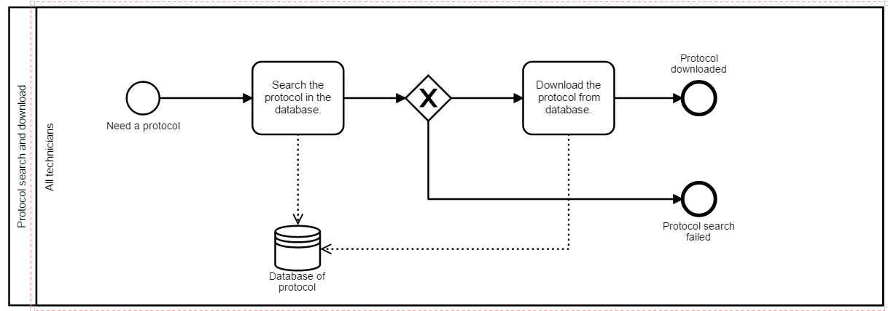

Figure 1. Search and Download protocol for all technicians

The link for BPMN file is:<https://drive.google.com/open?id=0B7tUL5of4-LAUE96b1c3bVRtSUk>

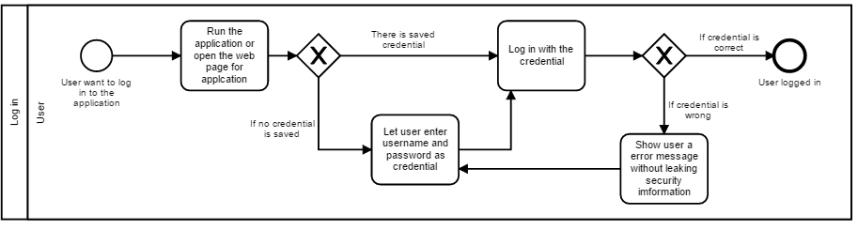

Figure 2. BPM for logging in

The link for BPMN file is:<https://drive.google.com/open?id=0B7tUL5of4-LAVUQ3U0hwR3VPdHc>

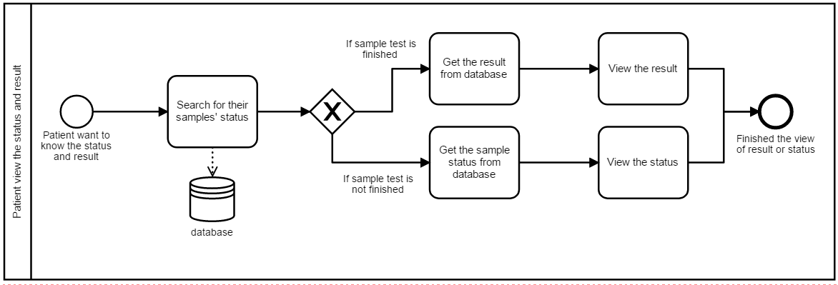

Figure 3. BPM for patient view the status and result of a sample

Link for BPMN file is: <https://drive.google.com/open?id=0B7tUL5of4-LAQmpYSUNYWWdKUE0>

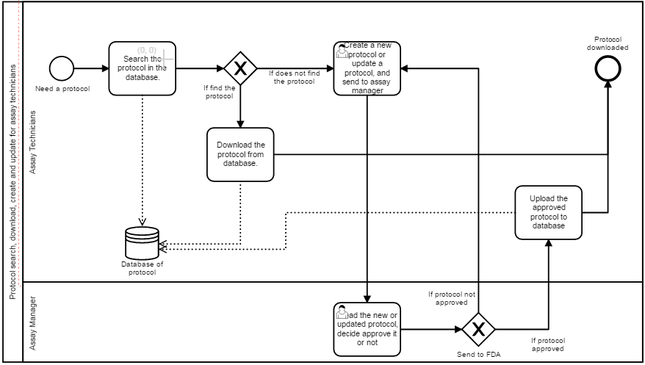

Figure 4. BPM for updating and creating new protocol

Link for BPMN file is:<https://drive.google.com/open?id=0B7tUL5of4-LAN0VYcE1LcUo0aVE>

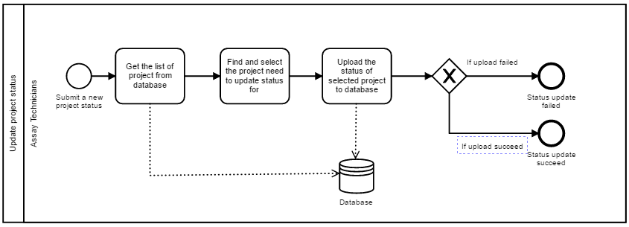

Figure 5. BPM for updating project status

Link for BPMN file is: <https://drive.google.com/open?id=0B7tUL5of4-LAWUZnbndMQk9OYnM>

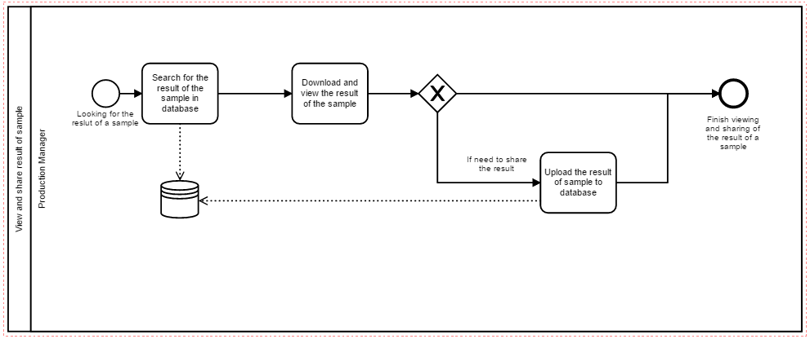

Figure 6. BPM for view and share the result of sample

The link for BPMN file is:<https://drive.google.com/open?id=0B7tUL5of4-LANHBDcUlpS01rMzA>

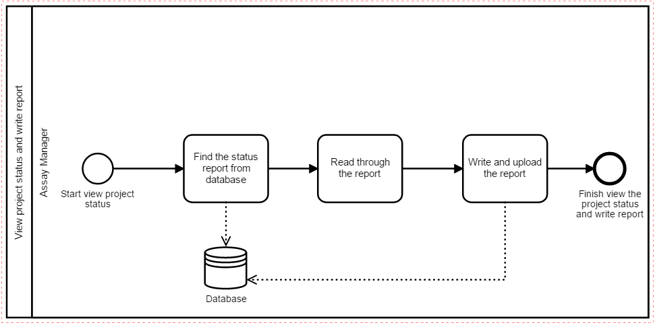

Figure 7. BPM for view project status and generate report

The link for BPMN file is:<https://drive.google.com/open?id=0B7tUL5of4-LATlhHWGNoSElMdUk>

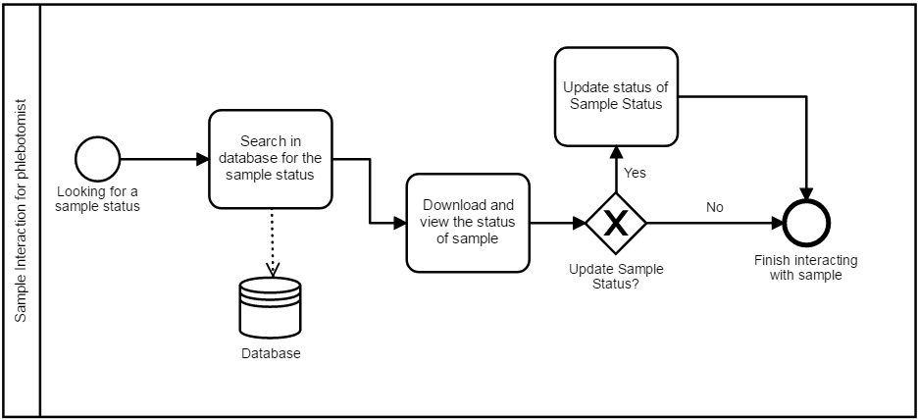

Figure 8. BPM for viewing sample status for phlebotomist

The link for BPMN file is:<https://drive.google.com/open?id=0B7tUL5of4-LAajl0RnZKSkxSbjg>

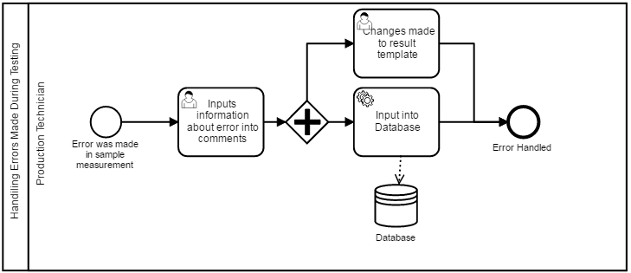Figure 9. BPM for handling errors made during sample testing

The link for BPMN file is: <https://drive.google.com/open?id=0Bze7JKGlef-oTEpGQlNHMllkd0E>

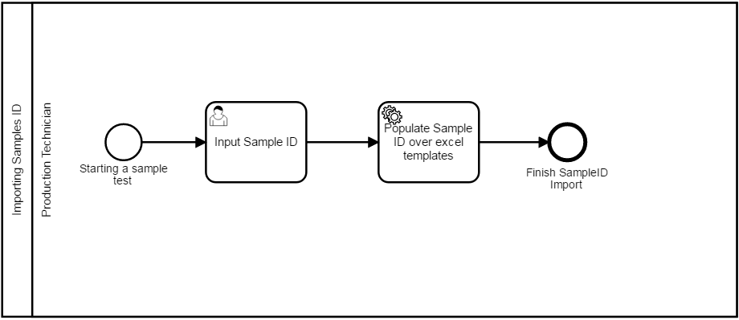Figure 10. BPM for importing sample IDs

The link for BPMN file is: <https://drive.google.com/open?id=0Bze7JKGlef-oRHRmTkFjVkN3dmc>

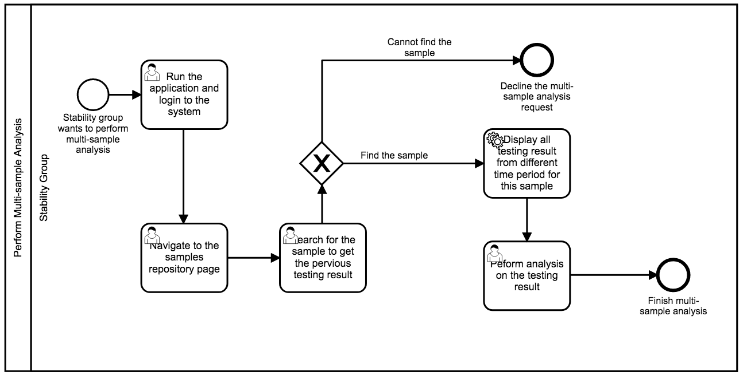

Figure 11. BPM for performing multi-sample analysis for stability group

The link for BPMN file is:<https://drive.google.com/file/d/0BzTJPgHKBnlpem1yX3JHekxlTW8>

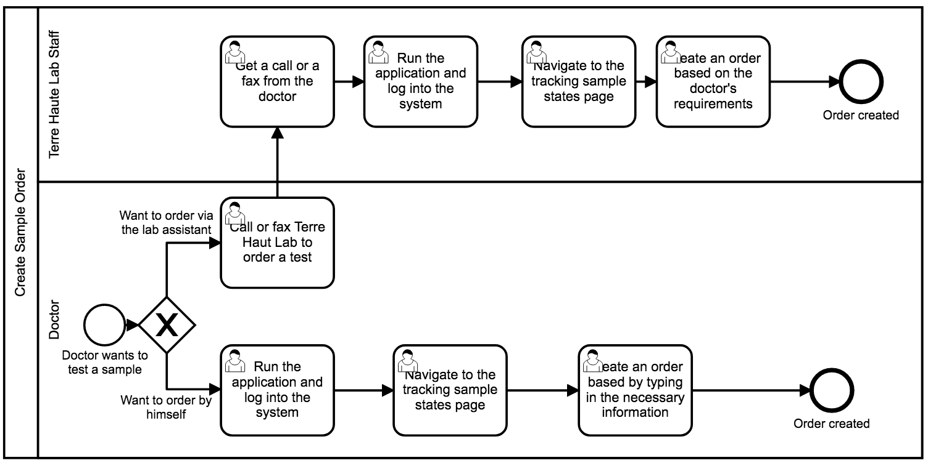

Figure 12. BPM for creating an sample testing order

Link to BPMN file is:<https://drive.google.com/file/d/0BzTJPgHKBnlpTHJhODhNMTRMa1U>

# 

Figure 13. BPM for uploading the result of a sample test by production technicians

Link to BPMN file is:<https://drive.google.com/open?id=0B7tUL5of4-LASnlfaU9nWGgyZHc>

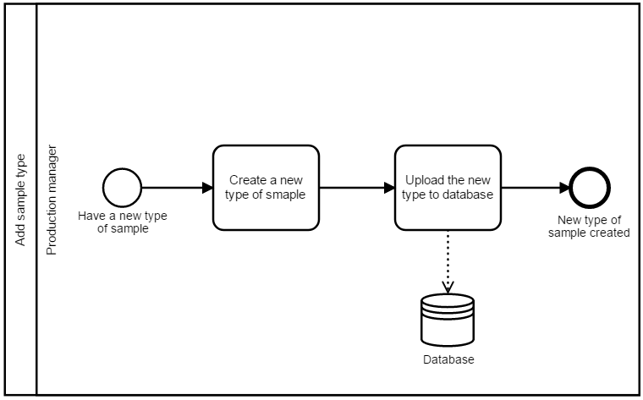

Figure 14. Create a new type of sample

Link to BPMN file is:<https://drive.google.com/open?id=0B7tUL5of4-LAYjRFQk1JRmNiSzA>

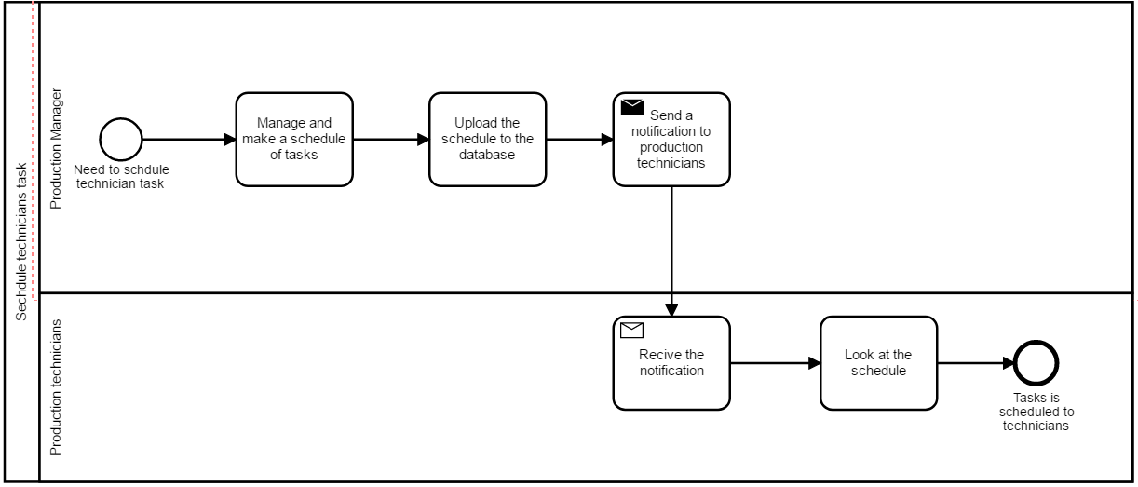

Figure 15. Schedule production technicians tasks

Link to BPMN file is:<https://drive.google.com/open?id=0B7tUL5of4-LAa0dNa25DZ1ZaZ1k>

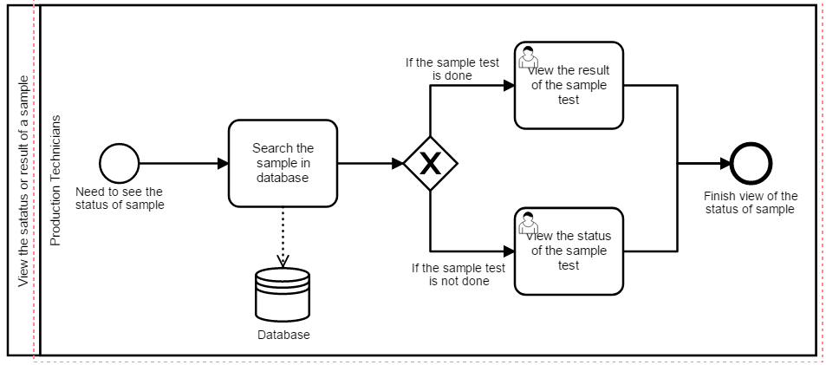

Figure 16 BPM for viewing the status and result of a sample by production technicians

The link to BPMN file is:<https://drive.google.com/open?id=0B7tUL5of4-LAa0dNa25DZ1ZaZ1k>

# 

# 

# Use Case Diagram

|  |  |  |
| --- | --- | --- |
| Actor | Case | Feature |
| All users | Login | [1](https://docs.google.com/document/d/1KzBfRg3pWlpYw4uTUH9maY_FCphE5WK0OpTnpD46gWw/edit#bookmark=id.rtzoagu2h1lo) [2](https://docs.google.com/document/d/1KzBfRg3pWlpYw4uTUH9maY_FCphE5WK0OpTnpD46gWw/edit#bookmark=id.i45mhyfl4f65) |
| Production Manager, Production Technician, Assay Manager, Assay Technician | SearchProtocols | [4](https://docs.google.com/document/d/1KzBfRg3pWlpYw4uTUH9maY_FCphE5WK0OpTnpD46gWw/edit#bookmark=id.fqc4dp6ued8w) |
| Production Manager, Production Technician, Doctor, Phlebotomist, Patient | SearchProduction | 16 |
| All Technicians | DownloadProtocol | [4](https://docs.google.com/document/d/1KzBfRg3pWlpYw4uTUH9maY_FCphE5WK0OpTnpD46gWw/edit#bookmark=id.fqc4dp6ued8w) |
| All Technicians | GetProtocolNotification | [9](https://docs.google.com/document/d/1KzBfRg3pWlpYw4uTUH9maY_FCphE5WK0OpTnpD46gWw/edit#bookmark=id.8sapje5sc7x0) |
| Assay Manager, Assay Technician | SearchAssay | 17 |
| Assay Manager | ViewAssayStatus | [5](https://docs.google.com/document/d/1KzBfRg3pWlpYw4uTUH9maY_FCphE5WK0OpTnpD46gWw/edit#bookmark=id.fqc4dp6ued8w) |
| Assay Manager | GenerateReport | [11](https://docs.google.com/document/d/1KzBfRg3pWlpYw4uTUH9maY_FCphE5WK0OpTnpD46gWw/edit#bookmark=id.jnz7o3hs7bz0) |
| Assay Manager | SubmitProtocolForApproval | [5](https://docs.google.com/document/d/1KzBfRg3pWlpYw4uTUH9maY_FCphE5WK0OpTnpD46gWw/edit#bookmark=id.fqc4dp6ued8w) |
| Assay Manager | RecieveFDAResponse | [5](https://docs.google.com/document/d/1KzBfRg3pWlpYw4uTUH9maY_FCphE5WK0OpTnpD46gWw/edit#bookmark=id.fqc4dp6ued8w) |
| Assay Manager | CreateAssay | [5](https://docs.google.com/document/d/1KzBfRg3pWlpYw4uTUH9maY_FCphE5WK0OpTnpD46gWw/edit#bookmark=id.fqc4dp6ued8w) |
| Assay Technician | SubmitAssayStatus | [5](https://docs.google.com/document/d/1KzBfRg3pWlpYw4uTUH9maY_FCphE5WK0OpTnpD46gWw/edit#bookmark=id.fqc4dp6ued8w) |
| Assay Technician | UploadProtocol | [4](https://docs.google.com/document/d/1KzBfRg3pWlpYw4uTUH9maY_FCphE5WK0OpTnpD46gWw/edit#bookmark=id.fqc4dp6ued8w) |
| Patient, Doctor, Production Manager, Production Technician, Phlebotomist | ViewSampleStatus | [8](https://docs.google.com/document/d/1KzBfRg3pWlpYw4uTUH9maY_FCphE5WK0OpTnpD46gWw/edit#bookmark=id.xhugwqoxydeg) , [7](https://docs.google.com/document/d/1KzBfRg3pWlpYw4uTUH9maY_FCphE5WK0OpTnpD46gWw/edit#bookmark=id.9xo7nkur2tv9) |
| Patient, Doctor, Production Manager, Production Technician, Phlebotomist | ViewTestResults | [8](https://docs.google.com/document/d/1KzBfRg3pWlpYw4uTUH9maY_FCphE5WK0OpTnpD46gWw/edit#bookmark=id.xhugwqoxydeg) , [3](https://docs.google.com/document/d/1KzBfRg3pWlpYw4uTUH9maY_FCphE5WK0OpTnpD46gWw/edit#bookmark=id.qii0zsu51a39) |
| Production Manager, Production Technician, Phlebotomist | UpdateSampleStatus | [7](https://docs.google.com/document/d/1KzBfRg3pWlpYw4uTUH9maY_FCphE5WK0OpTnpD46gWw/edit#bookmark=id.9xo7nkur2tv9) |
| Production Manager | ShareResultsOfSample | [3](https://docs.google.com/document/d/1KzBfRg3pWlpYw4uTUH9maY_FCphE5WK0OpTnpD46gWw/edit#bookmark=id.qii0zsu51a39) |
| Production Manager | ScheduleTechnicianTask | [14](https://docs.google.com/document/d/1KzBfRg3pWlpYw4uTUH9maY_FCphE5WK0OpTnpD46gWw/edit#bookmark=id.to2xsy3gvpng) |
| Production Manager | CertifyTechnician | [14](https://docs.google.com/document/d/1KzBfRg3pWlpYw4uTUH9maY_FCphE5WK0OpTnpD46gWw/edit#bookmark=id.to2xsy3gvpng) |
| Production Manager | AddSampleType | [15](https://docs.google.com/document/d/1KzBfRg3pWlpYw4uTUH9maY_FCphE5WK0OpTnpD46gWw/edit#bookmark=id.19dam29qis11) |
| Production Technician | ImportSampleID | [10](https://docs.google.com/document/d/1KzBfRg3pWlpYw4uTUH9maY_FCphE5WK0OpTnpD46gWw/edit#bookmark=id.xjvd4w61l86) |
| Production Technician | UploadResultsOfSample | [6](https://docs.google.com/document/d/1KzBfRg3pWlpYw4uTUH9maY_FCphE5WK0OpTnpD46gWw/edit#bookmark=id.5b566cpmjopq) |
| Production Technician | EnterError | [12](https://docs.google.com/document/d/1KzBfRg3pWlpYw4uTUH9maY_FCphE5WK0OpTnpD46gWw/edit#bookmark=id.dbh2ychss64m) |
| Production Technician | ViewTechnicianTask | [14](https://docs.google.com/document/d/1KzBfRg3pWlpYw4uTUH9maY_FCphE5WK0OpTnpD46gWw/edit#bookmark=id.to2xsy3gvpng) |
| Stability Group | AnalyzeSamples | [13](https://docs.google.com/document/d/1KzBfRg3pWlpYw4uTUH9maY_FCphE5WK0OpTnpD46gWw/edit#bookmark=id.i2x5hzwu3yx4) |
| Terre Haute lab staff, doctor | CreateOrder | [7](https://docs.google.com/document/d/1KzBfRg3pWlpYw4uTUH9maY_FCphE5WK0OpTnpD46gWw/edit#bookmark=id.ai1edqg7hj42) |

# 

# [Use Cases Flow](https://docs.google.com/document/d/1KzBfRg3pWlpYw4uTUH9maY_FCphE5WK0OpTnpD46gWw/edit#bookmark=id.ai1edqg7hj42)

|  |
| --- |
| [Use Case: Login](https://docs.google.com/document/d/1KzBfRg3pWlpYw4uTUH9maY_FCphE5WK0OpTnpD46gWw/edit#bookmark=id.ai1edqg7hj42) [Actor: All users](https://docs.google.com/document/d/1KzBfRg3pWlpYw4uTUH9maY_FCphE5WK0OpTnpD46gWw/edit#bookmark=id.ai1edqg7hj42)  [Description: Log into the system](https://docs.google.com/document/d/1KzBfRg3pWlpYw4uTUH9maY_FCphE5WK0OpTnpD46gWw/edit#bookmark=id.ai1edqg7hj42)  [Basic flow:](https://docs.google.com/document/d/1KzBfRg3pWlpYw4uTUH9maY_FCphE5WK0OpTnpD46gWw/edit#bookmark=id.ai1edqg7hj42)   1. [System prompts for username and password](https://docs.google.com/document/d/1KzBfRg3pWlpYw4uTUH9maY_FCphE5WK0OpTnpD46gWw/edit#bookmark=id.ai1edqg7hj42) 2. [User submits login request](https://docs.google.com/document/d/1KzBfRg3pWlpYw4uTUH9maY_FCphE5WK0OpTnpD46gWw/edit#bookmark=id.ai1edqg7hj42) 3. [Login credentials valid (Alternative flow 1)](https://docs.google.com/document/d/1KzBfRg3pWlpYw4uTUH9maY_FCphE5WK0OpTnpD46gWw/edit#bookmark=id.ai1edqg7hj42) 4. [User logged into system](https://docs.google.com/document/d/1KzBfRg3pWlpYw4uTUH9maY_FCphE5WK0OpTnpD46gWw/edit#bookmark=id.ai1edqg7hj42)   [Alternative flow:](https://docs.google.com/document/d/1KzBfRg3pWlpYw4uTUH9maY_FCphE5WK0OpTnpD46gWw/edit#bookmark=id.ai1edqg7hj42)   1. [Login credentials invalid](https://docs.google.com/document/d/1KzBfRg3pWlpYw4uTUH9maY_FCphE5WK0OpTnpD46gWw/edit#bookmark=id.ai1edqg7hj42)    1. [User notified credentials were invalid](https://docs.google.com/document/d/1KzBfRg3pWlpYw4uTUH9maY_FCphE5WK0OpTnpD46gWw/edit#bookmark=id.ai1edqg7hj42)    2. [User directed back to login page](https://docs.google.com/document/d/1KzBfRg3pWlpYw4uTUH9maY_FCphE5WK0OpTnpD46gWw/edit#bookmark=id.ai1edqg7hj42)   [Pre Conditions: User has login credentials](https://docs.google.com/document/d/1KzBfRg3pWlpYw4uTUH9maY_FCphE5WK0OpTnpD46gWw/edit#bookmark=id.ai1edqg7hj42)  [Post Conditions: N/A](https://docs.google.com/document/d/1KzBfRg3pWlpYw4uTUH9maY_FCphE5WK0OpTnpD46gWw/edit#bookmark=id.ai1edqg7hj42) |
| [Use Case: SearchProtocol](https://docs.google.com/document/d/1KzBfRg3pWlpYw4uTUH9maY_FCphE5WK0OpTnpD46gWw/edit#bookmark=id.ai1edqg7hj42) [Actor: Production Manager, Production Technician, Assay Manager, Assay Technician](https://docs.google.com/document/d/1KzBfRg3pWlpYw4uTUH9maY_FCphE5WK0OpTnpD46gWw/edit#bookmark=id.ai1edqg7hj42)  [Description: Search database of protocols for a certain protocol](https://docs.google.com/document/d/1KzBfRg3pWlpYw4uTUH9maY_FCphE5WK0OpTnpD46gWw/edit#bookmark=id.ai1edqg7hj42)  [Basic flow:](https://docs.google.com/document/d/1KzBfRg3pWlpYw4uTUH9maY_FCphE5WK0OpTnpD46gWw/edit#bookmark=id.ai1edqg7hj42)   1. [User navigates to protocol repository interface](https://docs.google.com/document/d/1KzBfRg3pWlpYw4uTUH9maY_FCphE5WK0OpTnpD46gWw/edit#bookmark=id.ai1edqg7hj42) 2. [User inputs keyword to search protocol list by (Alternative flow 1) (Alternative flow 4)](https://docs.google.com/document/d/1KzBfRg3pWlpYw4uTUH9maY_FCphE5WK0OpTnpD46gWw/edit#bookmark=id.ai1edqg7hj42) 3. [User presses search button](https://docs.google.com/document/d/1KzBfRg3pWlpYw4uTUH9maY_FCphE5WK0OpTnpD46gWw/edit#bookmark=id.ai1edqg7hj42) 4. [System sends request to the database asking for matching protocols](https://docs.google.com/document/d/1KzBfRg3pWlpYw4uTUH9maY_FCphE5WK0OpTnpD46gWw/edit#bookmark=id.ai1edqg7hj42) 5. [Database sends back results of search (Alternative flow 2)](https://docs.google.com/document/d/1KzBfRg3pWlpYw4uTUH9maY_FCphE5WK0OpTnpD46gWw/edit#bookmark=id.ai1edqg7hj42) 6. [System displays results of search to the user (Alternative flow 3)](https://docs.google.com/document/d/1KzBfRg3pWlpYw4uTUH9maY_FCphE5WK0OpTnpD46gWw/edit#bookmark=id.ai1edqg7hj42)   [Alternative flow:](https://docs.google.com/document/d/1KzBfRg3pWlpYw4uTUH9maY_FCphE5WK0OpTnpD46gWw/edit#bookmark=id.ai1edqg7hj42)   1. [User inputs filter parameters](https://docs.google.com/document/d/1KzBfRg3pWlpYw4uTUH9maY_FCphE5WK0OpTnpD46gWw/edit#bookmark=id.ai1edqg7hj42)     1. [User enters a date](https://docs.google.com/document/d/1KzBfRg3pWlpYw4uTUH9maY_FCphE5WK0OpTnpD46gWw/edit#bookmark=id.ai1edqg7hj42)    2. [User presses search button](https://docs.google.com/document/d/1KzBfRg3pWlpYw4uTUH9maY_FCphE5WK0OpTnpD46gWw/edit#bookmark=id.ai1edqg7hj42)    3. [System displays protocol versions activated during that date](https://docs.google.com/document/d/1KzBfRg3pWlpYw4uTUH9maY_FCphE5WK0OpTnpD46gWw/edit#bookmark=id.ai1edqg7hj42)    4. [Enter Basic flow at step 5](https://docs.google.com/document/d/1KzBfRg3pWlpYw4uTUH9maY_FCphE5WK0OpTnpD46gWw/edit#bookmark=id.ai1edqg7hj42) 2. [System cannot receive results from database](https://docs.google.com/document/d/1KzBfRg3pWlpYw4uTUH9maY_FCphE5WK0OpTnpD46gWw/edit#bookmark=id.ai1edqg7hj42)    1. [System notifies user that there was an error submitting search request](https://docs.google.com/document/d/1KzBfRg3pWlpYw4uTUH9maY_FCphE5WK0OpTnpD46gWw/edit#bookmark=id.ai1edqg7hj42) 3. [System displays no results](https://docs.google.com/document/d/1KzBfRg3pWlpYw4uTUH9maY_FCphE5WK0OpTnpD46gWw/edit#bookmark=id.ai1edqg7hj42)    1. [System notifies user that there were no results found for this search](https://docs.google.com/document/d/1KzBfRg3pWlpYw4uTUH9maY_FCphE5WK0OpTnpD46gWw/edit#bookmark=id.ai1edqg7hj42) 4. [User inputs filter parameters](https://docs.google.com/document/d/1KzBfRg3pWlpYw4uTUH9maY_FCphE5WK0OpTnpD46gWw/edit#bookmark=id.ai1edqg7hj42)    1. [User selects assay status from drop down menu](https://docs.google.com/document/d/1KzBfRg3pWlpYw4uTUH9maY_FCphE5WK0OpTnpD46gWw/edit#bookmark=id.ai1edqg7hj42)    2. [Enter Basic flow at step 3](https://docs.google.com/document/d/1KzBfRg3pWlpYw4uTUH9maY_FCphE5WK0OpTnpD46gWw/edit#bookmark=id.ai1edqg7hj42)   [Pre Conditions: User is logged into system](https://docs.google.com/document/d/1KzBfRg3pWlpYw4uTUH9maY_FCphE5WK0OpTnpD46gWw/edit#bookmark=id.ai1edqg7hj42)  [Post Conditions: N/A](https://docs.google.com/document/d/1KzBfRg3pWlpYw4uTUH9maY_FCphE5WK0OpTnpD46gWw/edit#bookmark=id.ai1edqg7hj42) |
| [Use Case: SearchProduction](https://docs.google.com/document/d/1KzBfRg3pWlpYw4uTUH9maY_FCphE5WK0OpTnpD46gWw/edit#bookmark=id.ai1edqg7hj42) [Actor: Production Manager, Production Technician, Doctor, Phlebotomist, Patient](https://docs.google.com/document/d/1KzBfRg3pWlpYw4uTUH9maY_FCphE5WK0OpTnpD46gWw/edit#bookmark=id.ai1edqg7hj42)  [Description: Search for sample, order, or test in production database](https://docs.google.com/document/d/1KzBfRg3pWlpYw4uTUH9maY_FCphE5WK0OpTnpD46gWw/edit#bookmark=id.ai1edqg7hj42)  [Basic Flow:](https://docs.google.com/document/d/1KzBfRg3pWlpYw4uTUH9maY_FCphE5WK0OpTnpD46gWw/edit#bookmark=id.ai1edqg7hj42)   1. [User navigates to the sample repository interface](https://docs.google.com/document/d/1KzBfRg3pWlpYw4uTUH9maY_FCphE5WK0OpTnpD46gWw/edit#bookmark=id.ai1edqg7hj42) 2. [User searches for a sample (Alternative flow 1, 2, 3) (Alternative flow 5)](https://docs.google.com/document/d/1KzBfRg3pWlpYw4uTUH9maY_FCphE5WK0OpTnpD46gWw/edit#bookmark=id.ai1edqg7hj42) 3. [User types Sample ID in search box (Alternative flow 4)](https://docs.google.com/document/d/1KzBfRg3pWlpYw4uTUH9maY_FCphE5WK0OpTnpD46gWw/edit#bookmark=id.ai1edqg7hj42) 4. [User submits search](https://docs.google.com/document/d/1KzBfRg3pWlpYw4uTUH9maY_FCphE5WK0OpTnpD46gWw/edit#bookmark=id.ai1edqg7hj42) 5. [System displays samples with matching Sample ID (Alternative flow 6)](https://docs.google.com/document/d/1KzBfRg3pWlpYw4uTUH9maY_FCphE5WK0OpTnpD46gWw/edit#bookmark=id.ai1edqg7hj42)   [Alternative Flow:](https://docs.google.com/document/d/1KzBfRg3pWlpYw4uTUH9maY_FCphE5WK0OpTnpD46gWw/edit#bookmark=id.ai1edqg7hj42)   1. [User searches for a order](https://docs.google.com/document/d/1KzBfRg3pWlpYw4uTUH9maY_FCphE5WK0OpTnpD46gWw/edit#bookmark=id.ai1edqg7hj42)     1. [User toggles radio button to search for order](https://docs.google.com/document/d/1KzBfRg3pWlpYw4uTUH9maY_FCphE5WK0OpTnpD46gWw/edit#bookmark=id.ai1edqg7hj42)    2. [User types Order ID into search box](https://docs.google.com/document/d/1KzBfRg3pWlpYw4uTUH9maY_FCphE5WK0OpTnpD46gWw/edit#bookmark=id.ai1edqg7hj42)    3. [System displays samples associated with the Order ID (Alternative flow 6)](https://docs.google.com/document/d/1KzBfRg3pWlpYw4uTUH9maY_FCphE5WK0OpTnpD46gWw/edit#bookmark=id.ai1edqg7hj42) 2. [User searches for a test](https://docs.google.com/document/d/1KzBfRg3pWlpYw4uTUH9maY_FCphE5WK0OpTnpD46gWw/edit#bookmark=id.ai1edqg7hj42)    1. [User toggles radio button to search for test](https://docs.google.com/document/d/1KzBfRg3pWlpYw4uTUH9maY_FCphE5WK0OpTnpD46gWw/edit#bookmark=id.ai1edqg7hj42)    2. [System displays a dropdown for test type](https://docs.google.com/document/d/1KzBfRg3pWlpYw4uTUH9maY_FCphE5WK0OpTnpD46gWw/edit#bookmark=id.ai1edqg7hj42)    3. [User selects test type](https://docs.google.com/document/d/1KzBfRg3pWlpYw4uTUH9maY_FCphE5WK0OpTnpD46gWw/edit#bookmark=id.ai1edqg7hj42)    4. [System displays samples that include any test of selected test type (Alternative flow 6)](https://docs.google.com/document/d/1KzBfRg3pWlpYw4uTUH9maY_FCphE5WK0OpTnpD46gWw/edit#bookmark=id.ai1edqg7hj42) 3. [User searches for patient](https://docs.google.com/document/d/1KzBfRg3pWlpYw4uTUH9maY_FCphE5WK0OpTnpD46gWw/edit#bookmark=id.ai1edqg7hj42)    1. [User toggles radio button to search for patient](https://docs.google.com/document/d/1KzBfRg3pWlpYw4uTUH9maY_FCphE5WK0OpTnpD46gWw/edit#bookmark=id.ai1edqg7hj42)    2. [User types Patient ID](https://docs.google.com/document/d/1KzBfRg3pWlpYw4uTUH9maY_FCphE5WK0OpTnpD46gWw/edit#bookmark=id.ai1edqg7hj42)    3. [System displays samples with matching patient ID (Alternative flow 6)](https://docs.google.com/document/d/1KzBfRg3pWlpYw4uTUH9maY_FCphE5WK0OpTnpD46gWw/edit#bookmark=id.ai1edqg7hj42) 4. [User is a doctor (Alternative flow 5)](https://docs.google.com/document/d/1KzBfRg3pWlpYw4uTUH9maY_FCphE5WK0OpTnpD46gWw/edit#bookmark=id.ai1edqg7hj42)    1. [User searches by patient name](https://docs.google.com/document/d/1KzBfRg3pWlpYw4uTUH9maY_FCphE5WK0OpTnpD46gWw/edit#bookmark=id.ai1edqg7hj42)    2. [Enter basic flow at step 4](https://docs.google.com/document/d/1KzBfRg3pWlpYw4uTUH9maY_FCphE5WK0OpTnpD46gWw/edit#bookmark=id.ai1edqg7hj42) 5. [User is a patient](https://docs.google.com/document/d/1KzBfRg3pWlpYw4uTUH9maY_FCphE5WK0OpTnpD46gWw/edit#bookmark=id.ai1edqg7hj42)     1. [System displays samples that are associated with patient with most recent on top (Alternative flow 1, 2)](https://docs.google.com/document/d/1KzBfRg3pWlpYw4uTUH9maY_FCphE5WK0OpTnpD46gWw/edit#bookmark=id.ai1edqg7hj42) 6. [There are no matching results](https://docs.google.com/document/d/1KzBfRg3pWlpYw4uTUH9maY_FCphE5WK0OpTnpD46gWw/edit#bookmark=id.ai1edqg7hj42)    1. [System displays message to indicate no results match the search (instead of display blank list)](https://docs.google.com/document/d/1KzBfRg3pWlpYw4uTUH9maY_FCphE5WK0OpTnpD46gWw/edit#bookmark=id.ai1edqg7hj42)   [Pre Conditions: User is logged into system](https://docs.google.com/document/d/1KzBfRg3pWlpYw4uTUH9maY_FCphE5WK0OpTnpD46gWw/edit#bookmark=id.ai1edqg7hj42)  [Post Conditions: N/A](https://docs.google.com/document/d/1KzBfRg3pWlpYw4uTUH9maY_FCphE5WK0OpTnpD46gWw/edit#bookmark=id.ai1edqg7hj42) |
| [Use Case: DownloadProtocol](https://docs.google.com/document/d/1KzBfRg3pWlpYw4uTUH9maY_FCphE5WK0OpTnpD46gWw/edit#bookmark=id.ai1edqg7hj42) [Actor: All technicians](https://docs.google.com/document/d/1KzBfRg3pWlpYw4uTUH9maY_FCphE5WK0OpTnpD46gWw/edit#bookmark=id.ai1edqg7hj42)  [Description: Download a specific protocol from the application](https://docs.google.com/document/d/1KzBfRg3pWlpYw4uTUH9maY_FCphE5WK0OpTnpD46gWw/edit#bookmark=id.ai1edqg7hj42)  [Basic flow:](https://docs.google.com/document/d/1KzBfRg3pWlpYw4uTUH9maY_FCphE5WK0OpTnpD46gWw/edit#bookmark=id.ai1edqg7hj42)   1. [Technician performs SearchProtocol](https://docs.google.com/document/d/1KzBfRg3pWlpYw4uTUH9maY_FCphE5WK0OpTnpD46gWw/edit#bookmark=id.ai1edqg7hj42) 2. [System directs the user to the protocol information page of the selected protocol](https://docs.google.com/document/d/1KzBfRg3pWlpYw4uTUH9maY_FCphE5WK0OpTnpD46gWw/edit#bookmark=id.ai1edqg7hj42) 3. [Technician clicks the download button](https://docs.google.com/document/d/1KzBfRg3pWlpYw4uTUH9maY_FCphE5WK0OpTnpD46gWw/edit#bookmark=id.ai1edqg7hj42) 4. [System pops out a window for the user to pick the version of the protocol to download](https://docs.google.com/document/d/1KzBfRg3pWlpYw4uTUH9maY_FCphE5WK0OpTnpD46gWw/edit#bookmark=id.ai1edqg7hj42) 5. [Technician selects the desired version](https://docs.google.com/document/d/1KzBfRg3pWlpYw4uTUH9maY_FCphE5WK0OpTnpD46gWw/edit#bookmark=id.ai1edqg7hj42) 6. [Technician clicks confirm button](https://docs.google.com/document/d/1KzBfRg3pWlpYw4uTUH9maY_FCphE5WK0OpTnpD46gWw/edit#bookmark=id.ai1edqg7hj42) 7. [System sends request to the database](https://docs.google.com/document/d/1KzBfRg3pWlpYw4uTUH9maY_FCphE5WK0OpTnpD46gWw/edit#bookmark=id.ai1edqg7hj42) 8. [Database sends back data of the protocol selected (Alternate flow 1)](https://docs.google.com/document/d/1KzBfRg3pWlpYw4uTUH9maY_FCphE5WK0OpTnpD46gWw/edit#bookmark=id.ai1edqg7hj42) 9. [System prompts a window to let the user pick the downloading destination](https://docs.google.com/document/d/1KzBfRg3pWlpYw4uTUH9maY_FCphE5WK0OpTnpD46gWw/edit#bookmark=id.ai1edqg7hj42) 10. [Technician selects downloading destination (Alternate flow 2)](https://docs.google.com/document/d/1KzBfRg3pWlpYw4uTUH9maY_FCphE5WK0OpTnpD46gWw/edit#bookmark=id.ai1edqg7hj42) 11. [Technician presses confirm](https://docs.google.com/document/d/1KzBfRg3pWlpYw4uTUH9maY_FCphE5WK0OpTnpD46gWw/edit#bookmark=id.ai1edqg7hj42) 12. [System downloads the response from the database as a word document to the downloading destination (Alternate flow 3)](https://docs.google.com/document/d/1KzBfRg3pWlpYw4uTUH9maY_FCphE5WK0OpTnpD46gWw/edit#bookmark=id.ai1edqg7hj42)   [Alternative flow:](https://docs.google.com/document/d/1KzBfRg3pWlpYw4uTUH9maY_FCphE5WK0OpTnpD46gWw/edit#bookmark=id.ai1edqg7hj42)   1. [Data of the protocol is not available](https://docs.google.com/document/d/1KzBfRg3pWlpYw4uTUH9maY_FCphE5WK0OpTnpD46gWw/edit#bookmark=id.ai1edqg7hj42)    1. [System prompts error message that the downloading of the protocol is unavailable](https://docs.google.com/document/d/1KzBfRg3pWlpYw4uTUH9maY_FCphE5WK0OpTnpD46gWw/edit#bookmark=id.ai1edqg7hj42) 2. [Downloading destination is unavailable](https://docs.google.com/document/d/1KzBfRg3pWlpYw4uTUH9maY_FCphE5WK0OpTnpD46gWw/edit#bookmark=id.ai1edqg7hj42)    1. [System prompts error message that the destination is unavailable](https://docs.google.com/document/d/1KzBfRg3pWlpYw4uTUH9maY_FCphE5WK0OpTnpD46gWw/edit#bookmark=id.ai1edqg7hj42)    2. [System reprompts a window to let the user pick the downloading destination](https://docs.google.com/document/d/1KzBfRg3pWlpYw4uTUH9maY_FCphE5WK0OpTnpD46gWw/edit#bookmark=id.ai1edqg7hj42) 3. [The confirmation is declined](https://docs.google.com/document/d/1KzBfRg3pWlpYw4uTUH9maY_FCphE5WK0OpTnpD46gWw/edit#bookmark=id.ai1edqg7hj42)    1. [System redirect user to the protocol information page of the selected protocol](https://docs.google.com/document/d/1KzBfRg3pWlpYw4uTUH9maY_FCphE5WK0OpTnpD46gWw/edit#bookmark=id.ai1edqg7hj42)   [Pre Conditions: User is logged into system, navigated to the protocols repository interface and performed searching on the protocols](https://docs.google.com/document/d/1KzBfRg3pWlpYw4uTUH9maY_FCphE5WK0OpTnpD46gWw/edit#bookmark=id.ai1edqg7hj42)  [Post Conditions: Word document of the protocol is downloaded to the destination folder](https://docs.google.com/document/d/1KzBfRg3pWlpYw4uTUH9maY_FCphE5WK0OpTnpD46gWw/edit#bookmark=id.ai1edqg7hj42) |
| [Use Case: SearchForAssay](https://docs.google.com/document/d/1KzBfRg3pWlpYw4uTUH9maY_FCphE5WK0OpTnpD46gWw/edit#bookmark=id.ai1edqg7hj42) [Actor: Assay Manager, Assay Technician](https://docs.google.com/document/d/1KzBfRg3pWlpYw4uTUH9maY_FCphE5WK0OpTnpD46gWw/edit#bookmark=id.ai1edqg7hj42)  [Description: Search for a particular assay or assays that satisfies the input criteria.](https://docs.google.com/document/d/1KzBfRg3pWlpYw4uTUH9maY_FCphE5WK0OpTnpD46gWw/edit#bookmark=id.ai1edqg7hj42)  [Basic flow:](https://docs.google.com/document/d/1KzBfRg3pWlpYw4uTUH9maY_FCphE5WK0OpTnpD46gWw/edit#bookmark=id.ai1edqg7hj42)   1. [User inputs keyword to search protocol list by (Alternative flow 1) (Alternative flow 2)](https://docs.google.com/document/d/1KzBfRg3pWlpYw4uTUH9maY_FCphE5WK0OpTnpD46gWw/edit#bookmark=id.ai1edqg7hj42) 2. [System sends request to the database asking for matching protocols](https://docs.google.com/document/d/1KzBfRg3pWlpYw4uTUH9maY_FCphE5WK0OpTnpD46gWw/edit#bookmark=id.ai1edqg7hj42) 3. [Database sends back results of search (Alternative flow 3)](https://docs.google.com/document/d/1KzBfRg3pWlpYw4uTUH9maY_FCphE5WK0OpTnpD46gWw/edit#bookmark=id.ai1edqg7hj42) 4. [System displays results of search to the user (Alternative flow 4)](https://docs.google.com/document/d/1KzBfRg3pWlpYw4uTUH9maY_FCphE5WK0OpTnpD46gWw/edit#bookmark=id.ai1edqg7hj42)   [Alternative flow:](https://docs.google.com/document/d/1KzBfRg3pWlpYw4uTUH9maY_FCphE5WK0OpTnpD46gWw/edit#bookmark=id.ai1edqg7hj42)   1. [User searches by protocol version](https://docs.google.com/document/d/1KzBfRg3pWlpYw4uTUH9maY_FCphE5WK0OpTnpD46gWw/edit#bookmark=id.ai1edqg7hj42)    1. [Enter basic flow at 2](https://docs.google.com/document/d/1KzBfRg3pWlpYw4uTUH9maY_FCphE5WK0OpTnpD46gWw/edit#bookmark=id.ai1edqg7hj42) 2. [User searches by start or end date](https://docs.google.com/document/d/1KzBfRg3pWlpYw4uTUH9maY_FCphE5WK0OpTnpD46gWw/edit#bookmark=id.ai1edqg7hj42)    1. [Enter basic flow at 2](https://docs.google.com/document/d/1KzBfRg3pWlpYw4uTUH9maY_FCphE5WK0OpTnpD46gWw/edit#bookmark=id.ai1edqg7hj42) 3. [System cannot receive results from database](https://docs.google.com/document/d/1KzBfRg3pWlpYw4uTUH9maY_FCphE5WK0OpTnpD46gWw/edit#bookmark=id.ai1edqg7hj42)    1. [System notifies user that there was an error submitting search request](https://docs.google.com/document/d/1KzBfRg3pWlpYw4uTUH9maY_FCphE5WK0OpTnpD46gWw/edit#bookmark=id.ai1edqg7hj42) 4. [System displays no results](https://docs.google.com/document/d/1KzBfRg3pWlpYw4uTUH9maY_FCphE5WK0OpTnpD46gWw/edit#bookmark=id.ai1edqg7hj42)    1. [System notifies user that there were no results found for this search](https://docs.google.com/document/d/1KzBfRg3pWlpYw4uTUH9maY_FCphE5WK0OpTnpD46gWw/edit#bookmark=id.ai1edqg7hj42)   [Pre Conditions: User is logged in, user is on the assay repository interface.](https://docs.google.com/document/d/1KzBfRg3pWlpYw4uTUH9maY_FCphE5WK0OpTnpD46gWw/edit#bookmark=id.ai1edqg7hj42)  [Post Conditions: N/A](https://docs.google.com/document/d/1KzBfRg3pWlpYw4uTUH9maY_FCphE5WK0OpTnpD46gWw/edit#bookmark=id.ai1edqg7hj42) |
| [Use Case: GetProtocolNotification](https://docs.google.com/document/d/1KzBfRg3pWlpYw4uTUH9maY_FCphE5WK0OpTnpD46gWw/edit#bookmark=id.ai1edqg7hj42) [Actor: All technicians](https://docs.google.com/document/d/1KzBfRg3pWlpYw4uTUH9maY_FCphE5WK0OpTnpD46gWw/edit#bookmark=id.ai1edqg7hj42)  [Description: Get notification and view the new changes if any protocol is updated](https://docs.google.com/document/d/1KzBfRg3pWlpYw4uTUH9maY_FCphE5WK0OpTnpD46gWw/edit#bookmark=id.ai1edqg7hj42)  [Basic flow:](https://docs.google.com/document/d/1KzBfRg3pWlpYw4uTUH9maY_FCphE5WK0OpTnpD46gWw/edit#bookmark=id.ai1edqg7hj42)   1. [System makes the notification icon on the top right side of the screen glowing if any protocol is updated](https://docs.google.com/document/d/1KzBfRg3pWlpYw4uTUH9maY_FCphE5WK0OpTnpD46gWw/edit#bookmark=id.ai1edqg7hj42) 2. [System prompts a message to the user that there are new changes made to the protocols and if user want to check the new changes, he can click the notification icon](https://docs.google.com/document/d/1KzBfRg3pWlpYw4uTUH9maY_FCphE5WK0OpTnpD46gWw/edit#bookmark=id.ai1edqg7hj42) 3. [User clicks the notification icon (Alternate flow 1)](https://docs.google.com/document/d/1KzBfRg3pWlpYw4uTUH9maY_FCphE5WK0OpTnpD46gWw/edit#bookmark=id.ai1edqg7hj42) 4. [Systems displays the new changes made to the protocols](https://docs.google.com/document/d/1KzBfRg3pWlpYw4uTUH9maY_FCphE5WK0OpTnpD46gWw/edit#bookmark=id.ai1edqg7hj42)   [Alternative flow:](https://docs.google.com/document/d/1KzBfRg3pWlpYw4uTUH9maY_FCphE5WK0OpTnpD46gWw/edit#bookmark=id.ai1edqg7hj42)   1. [Updated details are not available](https://docs.google.com/document/d/1KzBfRg3pWlpYw4uTUH9maY_FCphE5WK0OpTnpD46gWw/edit#bookmark=id.ai1edqg7hj42)    1. [System redirects the user to the previous page](https://docs.google.com/document/d/1KzBfRg3pWlpYw4uTUH9maY_FCphE5WK0OpTnpD46gWw/edit#bookmark=id.ai1edqg7hj42)   [Pre Conditions: User is logged into system](https://docs.google.com/document/d/1KzBfRg3pWlpYw4uTUH9maY_FCphE5WK0OpTnpD46gWw/edit#bookmark=id.ai1edqg7hj42)  [Post Conditions: System remarks the notification icon to not glowing](https://docs.google.com/document/d/1KzBfRg3pWlpYw4uTUH9maY_FCphE5WK0OpTnpD46gWw/edit#bookmark=id.ai1edqg7hj42) |
| [Use Case: CreateAssay](https://docs.google.com/document/d/1KzBfRg3pWlpYw4uTUH9maY_FCphE5WK0OpTnpD46gWw/edit#bookmark=id.ai1edqg7hj42) [Actor: Assay Manager](https://docs.google.com/document/d/1KzBfRg3pWlpYw4uTUH9maY_FCphE5WK0OpTnpD46gWw/edit#bookmark=id.ai1edqg7hj42)  [Description: Create an assay to propose new test idea](https://docs.google.com/document/d/1KzBfRg3pWlpYw4uTUH9maY_FCphE5WK0OpTnpD46gWw/edit#bookmark=id.ai1edqg7hj42)  [Basic flow:](https://docs.google.com/document/d/1KzBfRg3pWlpYw4uTUH9maY_FCphE5WK0OpTnpD46gWw/edit#bookmark=id.ai1edqg7hj42)   1. [User navigates to assay repository interface](https://docs.google.com/document/d/1KzBfRg3pWlpYw4uTUH9maY_FCphE5WK0OpTnpD46gWw/edit#bookmark=id.ai1edqg7hj42) 2. [User selects create button](https://docs.google.com/document/d/1KzBfRg3pWlpYw4uTUH9maY_FCphE5WK0OpTnpD46gWw/edit#bookmark=id.ai1edqg7hj42) 3. [System prompts for new test name and description in text boxes and allows user to add accompanying document with a drop down and submit button to append documents to a list (Alternative flow 1)](https://docs.google.com/document/d/1KzBfRg3pWlpYw4uTUH9maY_FCphE5WK0OpTnpD46gWw/edit#bookmark=id.ai1edqg7hj42) 4. [User submits](https://docs.google.com/document/d/1KzBfRg3pWlpYw4uTUH9maY_FCphE5WK0OpTnpD46gWw/edit#bookmark=id.ai1edqg7hj42) 5. [System alerts higher management of assay idea submitted with an email](https://docs.google.com/document/d/1KzBfRg3pWlpYw4uTUH9maY_FCphE5WK0OpTnpD46gWw/edit#bookmark=id.ai1edqg7hj42)   [Alternative flow:](https://docs.google.com/document/d/1KzBfRg3pWlpYw4uTUH9maY_FCphE5WK0OpTnpD46gWw/edit#bookmark=id.ai1edqg7hj42)   1. [User wants to delete document from list](https://docs.google.com/document/d/1KzBfRg3pWlpYw4uTUH9maY_FCphE5WK0OpTnpD46gWw/edit#bookmark=id.ai1edqg7hj42)    1. [User presses delete button next to document in list](https://docs.google.com/document/d/1KzBfRg3pWlpYw4uTUH9maY_FCphE5WK0OpTnpD46gWw/edit#bookmark=id.ai1edqg7hj42)    2. [System removes document from list](https://docs.google.com/document/d/1KzBfRg3pWlpYw4uTUH9maY_FCphE5WK0OpTnpD46gWw/edit#bookmark=id.ai1edqg7hj42)    3. [Return to basic flow step 3](https://docs.google.com/document/d/1KzBfRg3pWlpYw4uTUH9maY_FCphE5WK0OpTnpD46gWw/edit#bookmark=id.ai1edqg7hj42)   [Pre conditions: User is logged into the system](https://docs.google.com/document/d/1KzBfRg3pWlpYw4uTUH9maY_FCphE5WK0OpTnpD46gWw/edit#bookmark=id.ai1edqg7hj42)  [Post conditions: Assay idea is added to the system](https://docs.google.com/document/d/1KzBfRg3pWlpYw4uTUH9maY_FCphE5WK0OpTnpD46gWw/edit#bookmark=id.ai1edqg7hj42) |
| [Use Case: ViewAssayStatus](https://docs.google.com/document/d/1KzBfRg3pWlpYw4uTUH9maY_FCphE5WK0OpTnpD46gWw/edit#bookmark=id.ai1edqg7hj42) [Actor: Assay manager](https://docs.google.com/document/d/1KzBfRg3pWlpYw4uTUH9maY_FCphE5WK0OpTnpD46gWw/edit#bookmark=id.ai1edqg7hj42)  [Description: View the assay status (development, testing, verification, approved, complete or rejected) for a specific assay](https://docs.google.com/document/d/1KzBfRg3pWlpYw4uTUH9maY_FCphE5WK0OpTnpD46gWw/edit#bookmark=id.ai1edqg7hj42)  [Basic flow:](https://docs.google.com/document/d/1KzBfRg3pWlpYw4uTUH9maY_FCphE5WK0OpTnpD46gWw/edit#bookmark=id.ai1edqg7hj42)   1. [Manager navigates to the assay repository interface](https://docs.google.com/document/d/1KzBfRg3pWlpYw4uTUH9maY_FCphE5WK0OpTnpD46gWw/edit#bookmark=id.ai1edqg7hj42) 2. [User performs SearchForAssay use case](https://docs.google.com/document/d/1KzBfRg3pWlpYw4uTUH9maY_FCphE5WK0OpTnpD46gWw/edit#bookmark=id.ai1edqg7hj42) 3. [Manager selects the assay desired.](https://docs.google.com/document/d/1KzBfRg3pWlpYw4uTUH9maY_FCphE5WK0OpTnpD46gWw/edit#bookmark=id.ai1edqg7hj42) 4. [Database sends back the status data of the assay (Alternate flow 1)](https://docs.google.com/document/d/1KzBfRg3pWlpYw4uTUH9maY_FCphE5WK0OpTnpD46gWw/edit#bookmark=id.ai1edqg7hj42) 5. [System directs the user to the assay information page of the selected assay](https://docs.google.com/document/d/1KzBfRg3pWlpYw4uTUH9maY_FCphE5WK0OpTnpD46gWw/edit#bookmark=id.ai1edqg7hj42) 6. [System displays assay status to the user on the information page](https://docs.google.com/document/d/1KzBfRg3pWlpYw4uTUH9maY_FCphE5WK0OpTnpD46gWw/edit#bookmark=id.ai1edqg7hj42)   [Alternative flow:](https://docs.google.com/document/d/1KzBfRg3pWlpYw4uTUH9maY_FCphE5WK0OpTnpD46gWw/edit#bookmark=id.ai1edqg7hj42)   1. [Status data of the assay is not available](https://docs.google.com/document/d/1KzBfRg3pWlpYw4uTUH9maY_FCphE5WK0OpTnpD46gWw/edit#bookmark=id.ai1edqg7hj42)    1. [System displays the error message that the request is declined](https://docs.google.com/document/d/1KzBfRg3pWlpYw4uTUH9maY_FCphE5WK0OpTnpD46gWw/edit#bookmark=id.ai1edqg7hj42)    2. [System redirects the user to the interface that displaying list of assays](https://docs.google.com/document/d/1KzBfRg3pWlpYw4uTUH9maY_FCphE5WK0OpTnpD46gWw/edit#bookmark=id.ai1edqg7hj42)   [Pre Conditions: User is logged into system](https://docs.google.com/document/d/1KzBfRg3pWlpYw4uTUH9maY_FCphE5WK0OpTnpD46gWw/edit#bookmark=id.ai1edqg7hj42)  [Post Conditions: N/A](https://docs.google.com/document/d/1KzBfRg3pWlpYw4uTUH9maY_FCphE5WK0OpTnpD46gWw/edit#bookmark=id.ai1edqg7hj42) |
| [Use Case: GenerateReport](https://docs.google.com/document/d/1KzBfRg3pWlpYw4uTUH9maY_FCphE5WK0OpTnpD46gWw/edit#bookmark=id.ai1edqg7hj42) [Actor: Assay manager](https://docs.google.com/document/d/1KzBfRg3pWlpYw4uTUH9maY_FCphE5WK0OpTnpD46gWw/edit#bookmark=id.ai1edqg7hj42)  [Description: Generate stakeholder report detailing what stage the assay is in and reasons for delays](https://docs.google.com/document/d/1KzBfRg3pWlpYw4uTUH9maY_FCphE5WK0OpTnpD46gWw/edit#bookmark=id.ai1edqg7hj42)  [Basic flow:](https://docs.google.com/document/d/1KzBfRg3pWlpYw4uTUH9maY_FCphE5WK0OpTnpD46gWw/edit#bookmark=id.ai1edqg7hj42)   1. [Manager navigates to the assay repository interface](https://docs.google.com/document/d/1KzBfRg3pWlpYw4uTUH9maY_FCphE5WK0OpTnpD46gWw/edit#bookmark=id.ai1edqg7hj42) 2. [Manager performs SearchForAssay use case](https://docs.google.com/document/d/1KzBfRg3pWlpYw4uTUH9maY_FCphE5WK0OpTnpD46gWw/edit#bookmark=id.ai1edqg7hj42) 3. [Manager selects a assay](https://docs.google.com/document/d/1KzBfRg3pWlpYw4uTUH9maY_FCphE5WK0OpTnpD46gWw/edit#bookmark=id.ai1edqg7hj42) 4. [System directs the user to the assay information page of the selected assay (Alternate flow 1)](https://docs.google.com/document/d/1KzBfRg3pWlpYw4uTUH9maY_FCphE5WK0OpTnpD46gWw/edit#bookmark=id.ai1edqg7hj42) 5. [Manager presses the Generate Report button](https://docs.google.com/document/d/1KzBfRg3pWlpYw4uTUH9maY_FCphE5WK0OpTnpD46gWw/edit#bookmark=id.ai1edqg7hj42) 6. [System sends request to the database](https://docs.google.com/document/d/1KzBfRg3pWlpYw4uTUH9maY_FCphE5WK0OpTnpD46gWw/edit#bookmark=id.ai1edqg7hj42) 7. [Database sends back the status of the selected assay and the reasons for delay that inputted by the technicians of the selected assay (Alternate flow 2)](https://docs.google.com/document/d/1KzBfRg3pWlpYw4uTUH9maY_FCphE5WK0OpTnpD46gWw/edit#bookmark=id.ai1edqg7hj42) 8. [System displays the data using the build-in template](https://docs.google.com/document/d/1KzBfRg3pWlpYw4uTUH9maY_FCphE5WK0OpTnpD46gWw/edit#bookmark=id.ai1edqg7hj42)   [Alternative flow:](https://docs.google.com/document/d/1KzBfRg3pWlpYw4uTUH9maY_FCphE5WK0OpTnpD46gWw/edit#bookmark=id.ai1edqg7hj42)   1. [Assay is unavailable](https://docs.google.com/document/d/1KzBfRg3pWlpYw4uTUH9maY_FCphE5WK0OpTnpD46gWw/edit#bookmark=id.ai1edqg7hj42)    1. [System prompts the error message that the assay information is unavailable](https://docs.google.com/document/d/1KzBfRg3pWlpYw4uTUH9maY_FCphE5WK0OpTnpD46gWw/edit#bookmark=id.ai1edqg7hj42) 2. [Data of the selected assay is not available](https://docs.google.com/document/d/1KzBfRg3pWlpYw4uTUH9maY_FCphE5WK0OpTnpD46gWw/edit#bookmark=id.ai1edqg7hj42)    1. [System prompts the error message that the report in unavailable](https://docs.google.com/document/d/1KzBfRg3pWlpYw4uTUH9maY_FCphE5WK0OpTnpD46gWw/edit#bookmark=id.ai1edqg7hj42)   [Pre Conditions: User is logged into system](https://docs.google.com/document/d/1KzBfRg3pWlpYw4uTUH9maY_FCphE5WK0OpTnpD46gWw/edit#bookmark=id.ai1edqg7hj42)  [Post Conditions: A report for stakeholders has been made available for sharing.](https://docs.google.com/document/d/1KzBfRg3pWlpYw4uTUH9maY_FCphE5WK0OpTnpD46gWw/edit#bookmark=id.ai1edqg7hj42) |
| [Use Case: SubmitProtocolForApproval](https://docs.google.com/document/d/1KzBfRg3pWlpYw4uTUH9maY_FCphE5WK0OpTnpD46gWw/edit#bookmark=id.ai1edqg7hj42) [Actor: Assay manager](https://docs.google.com/document/d/1KzBfRg3pWlpYw4uTUH9maY_FCphE5WK0OpTnpD46gWw/edit#bookmark=id.ai1edqg7hj42)  [Description: Approve a specific assay to move on to next stage](https://docs.google.com/document/d/1KzBfRg3pWlpYw4uTUH9maY_FCphE5WK0OpTnpD46gWw/edit#bookmark=id.ai1edqg7hj42)  [Basic flow:](https://docs.google.com/document/d/1KzBfRg3pWlpYw4uTUH9maY_FCphE5WK0OpTnpD46gWw/edit#bookmark=id.ai1edqg7hj42)   1. [Manager navigates to the assay repository interface](https://docs.google.com/document/d/1KzBfRg3pWlpYw4uTUH9maY_FCphE5WK0OpTnpD46gWw/edit#bookmark=id.ai1edqg7hj42) 2. [Manager performs SearchForAssay use case](https://docs.google.com/document/d/1KzBfRg3pWlpYw4uTUH9maY_FCphE5WK0OpTnpD46gWw/edit#bookmark=id.ai1edqg7hj42) 3. [Manager selects a assay](https://docs.google.com/document/d/1KzBfRg3pWlpYw4uTUH9maY_FCphE5WK0OpTnpD46gWw/edit#bookmark=id.ai1edqg7hj42) 4. [System directs the user to the assay information page of the selected assay (Alternate flow 1)](https://docs.google.com/document/d/1KzBfRg3pWlpYw4uTUH9maY_FCphE5WK0OpTnpD46gWw/edit#bookmark=id.ai1edqg7hj42) 5. [Manager clicks submit to FDA button](https://docs.google.com/document/d/1KzBfRg3pWlpYw4uTUH9maY_FCphE5WK0OpTnpD46gWw/edit#bookmark=id.ai1edqg7hj42) 6. [System submits the selected assay to FDA for approval](https://docs.google.com/document/d/1KzBfRg3pWlpYw4uTUH9maY_FCphE5WK0OpTnpD46gWw/edit#bookmark=id.ai1edqg7hj42)   [Alternative flow:](https://docs.google.com/document/d/1KzBfRg3pWlpYw4uTUH9maY_FCphE5WK0OpTnpD46gWw/edit#bookmark=id.ai1edqg7hj42)   1. [Assay is unavailable](https://docs.google.com/document/d/1KzBfRg3pWlpYw4uTUH9maY_FCphE5WK0OpTnpD46gWw/edit#bookmark=id.ai1edqg7hj42)    1. [System prompts the error message that the assay information is unavailable](https://docs.google.com/document/d/1KzBfRg3pWlpYw4uTUH9maY_FCphE5WK0OpTnpD46gWw/edit#bookmark=id.ai1edqg7hj42)   [Pre Conditions: User is logged into system](https://docs.google.com/document/d/1KzBfRg3pWlpYw4uTUH9maY_FCphE5WK0OpTnpD46gWw/edit#bookmark=id.ai1edqg7hj42)  [Post Conditions: Assay is marked as approved in database](https://docs.google.com/document/d/1KzBfRg3pWlpYw4uTUH9maY_FCphE5WK0OpTnpD46gWw/edit#bookmark=id.ai1edqg7hj42) |
| [Use Case: RecieveFDAResponse](https://docs.google.com/document/d/1KzBfRg3pWlpYw4uTUH9maY_FCphE5WK0OpTnpD46gWw/edit#bookmark=id.ai1edqg7hj42) [Actor: Assay manager](https://docs.google.com/document/d/1KzBfRg3pWlpYw4uTUH9maY_FCphE5WK0OpTnpD46gWw/edit#bookmark=id.ai1edqg7hj42)  [Description: Approve a specific assay to move on to next stage](https://docs.google.com/document/d/1KzBfRg3pWlpYw4uTUH9maY_FCphE5WK0OpTnpD46gWw/edit#bookmark=id.ai1edqg7hj42)  [Basic flow:](https://docs.google.com/document/d/1KzBfRg3pWlpYw4uTUH9maY_FCphE5WK0OpTnpD46gWw/edit#bookmark=id.ai1edqg7hj42)   1. [Manager receives response from FDA](https://docs.google.com/document/d/1KzBfRg3pWlpYw4uTUH9maY_FCphE5WK0OpTnpD46gWw/edit#bookmark=id.ai1edqg7hj42) 2. [FDA has approved protocol (Alternative flow 1)](https://docs.google.com/document/d/1KzBfRg3pWlpYw4uTUH9maY_FCphE5WK0OpTnpD46gWw/edit#bookmark=id.ai1edqg7hj42) 3. [Manager updates the protocol’s status as approved](https://docs.google.com/document/d/1KzBfRg3pWlpYw4uTUH9maY_FCphE5WK0OpTnpD46gWw/edit#bookmark=id.ai1edqg7hj42) 4. [System marks previous protocol version as inactive (Alternative flow 2)](https://docs.google.com/document/d/1KzBfRg3pWlpYw4uTUH9maY_FCphE5WK0OpTnpD46gWw/edit#bookmark=id.ai1edqg7hj42) 5. [System marks the new protocol as active](https://docs.google.com/document/d/1KzBfRg3pWlpYw4uTUH9maY_FCphE5WK0OpTnpD46gWw/edit#bookmark=id.ai1edqg7hj42) 6. [System notifies technicians that there is a new protocol version by sending them a message.](https://docs.google.com/document/d/1KzBfRg3pWlpYw4uTUH9maY_FCphE5WK0OpTnpD46gWw/edit#bookmark=id.ai1edqg7hj42)   [Alternative flow:](https://docs.google.com/document/d/1KzBfRg3pWlpYw4uTUH9maY_FCphE5WK0OpTnpD46gWw/edit#bookmark=id.ai1edqg7hj42)   1. [FDA has not approved protocol](https://docs.google.com/document/d/1KzBfRg3pWlpYw4uTUH9maY_FCphE5WK0OpTnpD46gWw/edit#bookmark=id.ai1edqg7hj42)    1. [Manager updates protocol status to Rejected](https://docs.google.com/document/d/1KzBfRg3pWlpYw4uTUH9maY_FCphE5WK0OpTnpD46gWw/edit#bookmark=id.ai1edqg7hj42)    2. [System notifies technicians that a protocol was rejected by sending them a message.](https://docs.google.com/document/d/1KzBfRg3pWlpYw4uTUH9maY_FCphE5WK0OpTnpD46gWw/edit#bookmark=id.ai1edqg7hj42) 2. [There is no previous protocol version](https://docs.google.com/document/d/1KzBfRg3pWlpYw4uTUH9maY_FCphE5WK0OpTnpD46gWw/edit#bookmark=id.ai1edqg7hj42)    1. [System does not mark anything as inactive](https://docs.google.com/document/d/1KzBfRg3pWlpYw4uTUH9maY_FCphE5WK0OpTnpD46gWw/edit#bookmark=id.ai1edqg7hj42)   [Pre Conditions: User is logged into system, FDA has sent response to assay approval](https://docs.google.com/document/d/1KzBfRg3pWlpYw4uTUH9maY_FCphE5WK0OpTnpD46gWw/edit#bookmark=id.ai1edqg7hj42)  [Post Conditions: N/A](https://docs.google.com/document/d/1KzBfRg3pWlpYw4uTUH9maY_FCphE5WK0OpTnpD46gWw/edit#bookmark=id.ai1edqg7hj42) |
| [Use Case: SubmitAssayStatus](https://docs.google.com/document/d/1KzBfRg3pWlpYw4uTUH9maY_FCphE5WK0OpTnpD46gWw/edit#bookmark=id.ai1edqg7hj42) [Actor: Assay Technician](https://docs.google.com/document/d/1KzBfRg3pWlpYw4uTUH9maY_FCphE5WK0OpTnpD46gWw/edit#bookmark=id.ai1edqg7hj42)  [Description: Add update on development of protocol for assay on assay page. Status is one of the following: development, testing, verification, approved, complete or rejected](https://docs.google.com/document/d/1KzBfRg3pWlpYw4uTUH9maY_FCphE5WK0OpTnpD46gWw/edit#bookmark=id.ai1edqg7hj42)  [Basic flow:](https://docs.google.com/document/d/1KzBfRg3pWlpYw4uTUH9maY_FCphE5WK0OpTnpD46gWw/edit#bookmark=id.ai1edqg7hj42)   1. [User navigates to assay repository interface](https://docs.google.com/document/d/1KzBfRg3pWlpYw4uTUH9maY_FCphE5WK0OpTnpD46gWw/edit#bookmark=id.ai1edqg7hj42) 2. [User performs SearchForAssay use case](https://docs.google.com/document/d/1KzBfRg3pWlpYw4uTUH9maY_FCphE5WK0OpTnpD46gWw/edit#bookmark=id.ai1edqg7hj42) 3. [User selects a assay](https://docs.google.com/document/d/1KzBfRg3pWlpYw4uTUH9maY_FCphE5WK0OpTnpD46gWw/edit#bookmark=id.ai1edqg7hj42) 4. [System directs user to assay information page](https://docs.google.com/document/d/1KzBfRg3pWlpYw4uTUH9maY_FCphE5WK0OpTnpD46gWw/edit#bookmark=id.ai1edqg7hj42) 5. [User clicks edit button](https://docs.google.com/document/d/1KzBfRg3pWlpYw4uTUH9maY_FCphE5WK0OpTnpD46gWw/edit#bookmark=id.ai1edqg7hj42) 6. [User updates assay progress/status](https://docs.google.com/document/d/1KzBfRg3pWlpYw4uTUH9maY_FCphE5WK0OpTnpD46gWw/edit#bookmark=id.ai1edqg7hj42) 7. [User saves assay changes (Alternative flow 1)](https://docs.google.com/document/d/1KzBfRg3pWlpYw4uTUH9maY_FCphE5WK0OpTnpD46gWw/edit#bookmark=id.ai1edqg7hj42)   [Alternative flow:](https://docs.google.com/document/d/1KzBfRg3pWlpYw4uTUH9maY_FCphE5WK0OpTnpD46gWw/edit#bookmark=id.ai1edqg7hj42)   1. [User closes assay](https://docs.google.com/document/d/1KzBfRg3pWlpYw4uTUH9maY_FCphE5WK0OpTnpD46gWw/edit#bookmark=id.ai1edqg7hj42)     1. [System prompts user to save changes](https://docs.google.com/document/d/1KzBfRg3pWlpYw4uTUH9maY_FCphE5WK0OpTnpD46gWw/edit#bookmark=id.ai1edqg7hj42)    2. [User save changes (Alternative flow 2)](https://docs.google.com/document/d/1KzBfRg3pWlpYw4uTUH9maY_FCphE5WK0OpTnpD46gWw/edit#bookmark=id.ai1edqg7hj42)    3. [System closes the assay](https://docs.google.com/document/d/1KzBfRg3pWlpYw4uTUH9maY_FCphE5WK0OpTnpD46gWw/edit#bookmark=id.ai1edqg7hj42) 2. [User chooses to discard changes](https://docs.google.com/document/d/1KzBfRg3pWlpYw4uTUH9maY_FCphE5WK0OpTnpD46gWw/edit#bookmark=id.ai1edqg7hj42)    1. [System closes the assay](https://docs.google.com/document/d/1KzBfRg3pWlpYw4uTUH9maY_FCphE5WK0OpTnpD46gWw/edit#bookmark=id.ai1edqg7hj42)   [Pre Conditions: Technician is logged into system](https://docs.google.com/document/d/1KzBfRg3pWlpYw4uTUH9maY_FCphE5WK0OpTnpD46gWw/edit#bookmark=id.ai1edqg7hj42)  [Post Conditions: System changes the assay status and assay page information reflects saved updates](https://docs.google.com/document/d/1KzBfRg3pWlpYw4uTUH9maY_FCphE5WK0OpTnpD46gWw/edit#bookmark=id.ai1edqg7hj42) |
| [Use Case: UploadProtocol](https://docs.google.com/document/d/1KzBfRg3pWlpYw4uTUH9maY_FCphE5WK0OpTnpD46gWw/edit#bookmark=id.ai1edqg7hj42) [Actor: Assay Technician](https://docs.google.com/document/d/1KzBfRg3pWlpYw4uTUH9maY_FCphE5WK0OpTnpD46gWw/edit#bookmark=id.ai1edqg7hj42)  [Description: Upload newly developed protocol document to repository of protocols](https://docs.google.com/document/d/1KzBfRg3pWlpYw4uTUH9maY_FCphE5WK0OpTnpD46gWw/edit#bookmark=id.ai1edqg7hj42)  [Basic flow:](https://docs.google.com/document/d/1KzBfRg3pWlpYw4uTUH9maY_FCphE5WK0OpTnpD46gWw/edit#bookmark=id.ai1edqg7hj42)   1. [Technician navigates to protocol repository interface](https://docs.google.com/document/d/1KzBfRg3pWlpYw4uTUH9maY_FCphE5WK0OpTnpD46gWw/edit#bookmark=id.ai1edqg7hj42) 2. [Technician performs SearchProtocol use case](https://docs.google.com/document/d/1KzBfRg3pWlpYw4uTUH9maY_FCphE5WK0OpTnpD46gWw/edit#bookmark=id.ai1edqg7hj42) 3. [Technician selects a protocol](https://docs.google.com/document/d/1KzBfRg3pWlpYw4uTUH9maY_FCphE5WK0OpTnpD46gWw/edit#bookmark=id.ai1edqg7hj42) 4. [Technician clicks upload button](https://docs.google.com/document/d/1KzBfRg3pWlpYw4uTUH9maY_FCphE5WK0OpTnpD46gWw/edit#bookmark=id.ai1edqg7hj42) 5. [System displays an entry of the protocol’s name and a file browser](https://docs.google.com/document/d/1KzBfRg3pWlpYw4uTUH9maY_FCphE5WK0OpTnpD46gWw/edit#bookmark=id.ai1edqg7hj42) 6. [Technician enters name of protocol](https://docs.google.com/document/d/1KzBfRg3pWlpYw4uTUH9maY_FCphE5WK0OpTnpD46gWw/edit#bookmark=id.ai1edqg7hj42) 7. [Technician chooses new protocol document from the file browser](https://docs.google.com/document/d/1KzBfRg3pWlpYw4uTUH9maY_FCphE5WK0OpTnpD46gWw/edit#bookmark=id.ai1edqg7hj42) 8. [Technician submits document (Alternative flow 1)](https://docs.google.com/document/d/1KzBfRg3pWlpYw4uTUH9maY_FCphE5WK0OpTnpD46gWw/edit#bookmark=id.ai1edqg7hj42) 9. [System adds protocol to list of protocols (Alternative flow 2)](https://docs.google.com/document/d/1KzBfRg3pWlpYw4uTUH9maY_FCphE5WK0OpTnpD46gWw/edit#bookmark=id.ai1edqg7hj42)   [Alternative flow:](https://docs.google.com/document/d/1KzBfRg3pWlpYw4uTUH9maY_FCphE5WK0OpTnpD46gWw/edit#bookmark=id.ai1edqg7hj42)   1. [User chooses different document](https://docs.google.com/document/d/1KzBfRg3pWlpYw4uTUH9maY_FCphE5WK0OpTnpD46gWw/edit#bookmark=id.ai1edqg7hj42)    1. [User chooses different protocol document](https://docs.google.com/document/d/1KzBfRg3pWlpYw4uTUH9maY_FCphE5WK0OpTnpD46gWw/edit#bookmark=id.ai1edqg7hj42)    2. [Enter basic flow at step 4](https://docs.google.com/document/d/1KzBfRg3pWlpYw4uTUH9maY_FCphE5WK0OpTnpD46gWw/edit#bookmark=id.ai1edqg7hj42) 2. [User uploads new version of document](https://docs.google.com/document/d/1KzBfRg3pWlpYw4uTUH9maY_FCphE5WK0OpTnpD46gWw/edit#bookmark=id.ai1edqg7hj42)    1. [User chooses a new version of protocol](https://docs.google.com/document/d/1KzBfRg3pWlpYw4uTUH9maY_FCphE5WK0OpTnpD46gWw/edit#bookmark=id.ai1edqg7hj42)    2. [User submits document](https://docs.google.com/document/d/1KzBfRg3pWlpYw4uTUH9maY_FCphE5WK0OpTnpD46gWw/edit#bookmark=id.ai1edqg7hj42)    3. [System marks uploaded new document under the specified name with next version number appended to document name](https://docs.google.com/document/d/1KzBfRg3pWlpYw4uTUH9maY_FCphE5WK0OpTnpD46gWw/edit#bookmark=id.ai1edqg7hj42)   [Pre Conditions: Technician is logged into system](https://docs.google.com/document/d/1KzBfRg3pWlpYw4uTUH9maY_FCphE5WK0OpTnpD46gWw/edit#bookmark=id.ai1edqg7hj42)  [Post Conditions: Protocol changes is reflected in the repository](https://docs.google.com/document/d/1KzBfRg3pWlpYw4uTUH9maY_FCphE5WK0OpTnpD46gWw/edit#bookmark=id.ai1edqg7hj42) |
| [Use Case: ViewSampleStatus](https://docs.google.com/document/d/1KzBfRg3pWlpYw4uTUH9maY_FCphE5WK0OpTnpD46gWw/edit#bookmark=id.ai1edqg7hj42) [Actor: Patient, Doctor, Production manager, production technician, Phlebotomist](https://docs.google.com/document/d/1KzBfRg3pWlpYw4uTUH9maY_FCphE5WK0OpTnpD46gWw/edit#bookmark=id.ai1edqg7hj42)  [Description: View the testing status of the sample (Ordered, Collected, Arrived, Scheduled, In Test, Tested, Reported, Disposed)](https://docs.google.com/document/d/1KzBfRg3pWlpYw4uTUH9maY_FCphE5WK0OpTnpD46gWw/edit#bookmark=id.ai1edqg7hj42)  [Basic flow:](https://docs.google.com/document/d/1KzBfRg3pWlpYw4uTUH9maY_FCphE5WK0OpTnpD46gWw/edit#bookmark=id.ai1edqg7hj42)   1. [User performs SearchProduction](https://docs.google.com/document/d/1KzBfRg3pWlpYw4uTUH9maY_FCphE5WK0OpTnpD46gWw/edit#bookmark=id.ai1edqg7hj42) 2. [User selects a sample (Alternative flow 1)](https://docs.google.com/document/d/1KzBfRg3pWlpYw4uTUH9maY_FCphE5WK0OpTnpD46gWw/edit#bookmark=id.ai1edqg7hj42) 3. [Systems directs user to sample information page](https://docs.google.com/document/d/1KzBfRg3pWlpYw4uTUH9maY_FCphE5WK0OpTnpD46gWw/edit#bookmark=id.ai1edqg7hj42) 4. [System displays the sample’s status and all tests ordered to run on current sample with the name of the technicians who assigned to do the corresponding test (Alternative flow 2)](https://docs.google.com/document/d/1KzBfRg3pWlpYw4uTUH9maY_FCphE5WK0OpTnpD46gWw/edit#bookmark=id.ai1edqg7hj42)   [Alternative flow:](https://docs.google.com/document/d/1KzBfRg3pWlpYw4uTUH9maY_FCphE5WK0OpTnpD46gWw/edit#bookmark=id.ai1edqg7hj42)   1. [User does a new search](https://docs.google.com/document/d/1KzBfRg3pWlpYw4uTUH9maY_FCphE5WK0OpTnpD46gWw/edit#bookmark=id.ai1edqg7hj42)     1. [User clears search text box](https://docs.google.com/document/d/1KzBfRg3pWlpYw4uTUH9maY_FCphE5WK0OpTnpD46gWw/edit#bookmark=id.ai1edqg7hj42)    2. [User performs SearchProdcution](https://docs.google.com/document/d/1KzBfRg3pWlpYw4uTUH9maY_FCphE5WK0OpTnpD46gWw/edit#bookmark=id.ai1edqg7hj42) 2. [Sample has completed all testing](https://docs.google.com/document/d/1KzBfRg3pWlpYw4uTUH9maY_FCphE5WK0OpTnpD46gWw/edit#bookmark=id.ai1edqg7hj42)    1. [System displays list of tests ordered for the selected sample](https://docs.google.com/document/d/1KzBfRg3pWlpYw4uTUH9maY_FCphE5WK0OpTnpD46gWw/edit#bookmark=id.ai1edqg7hj42)    2. [User selects a testing of the sample](https://docs.google.com/document/d/1KzBfRg3pWlpYw4uTUH9maY_FCphE5WK0OpTnpD46gWw/edit#bookmark=id.ai1edqg7hj42)    3. [System displays a list of tests ordered on the sample](https://docs.google.com/document/d/1KzBfRg3pWlpYw4uTUH9maY_FCphE5WK0OpTnpD46gWw/edit#bookmark=id.ai1edqg7hj42)    4. [User selects test](https://docs.google.com/document/d/1KzBfRg3pWlpYw4uTUH9maY_FCphE5WK0OpTnpD46gWw/edit#bookmark=id.ai1edqg7hj42)    5. [System displays testing results for the selected test on said sample](https://docs.google.com/document/d/1KzBfRg3pWlpYw4uTUH9maY_FCphE5WK0OpTnpD46gWw/edit#bookmark=id.ai1edqg7hj42)   [Pre Conditions: User is logged into system](https://docs.google.com/document/d/1KzBfRg3pWlpYw4uTUH9maY_FCphE5WK0OpTnpD46gWw/edit#bookmark=id.ai1edqg7hj42)  [Post Conditions: N/A](https://docs.google.com/document/d/1KzBfRg3pWlpYw4uTUH9maY_FCphE5WK0OpTnpD46gWw/edit#bookmark=id.ai1edqg7hj42) |
| [Use Case: ViewTestResults](https://docs.google.com/document/d/1KzBfRg3pWlpYw4uTUH9maY_FCphE5WK0OpTnpD46gWw/edit#bookmark=id.ai1edqg7hj42) [Actor: Patient, Doctor, Production manager, production technician, Phlebotomist](https://docs.google.com/document/d/1KzBfRg3pWlpYw4uTUH9maY_FCphE5WK0OpTnpD46gWw/edit#bookmark=id.ai1edqg7hj42)  [Description: View results of a test on a sample](https://docs.google.com/document/d/1KzBfRg3pWlpYw4uTUH9maY_FCphE5WK0OpTnpD46gWw/edit#bookmark=id.ai1edqg7hj42)  [Basic flow:](https://docs.google.com/document/d/1KzBfRg3pWlpYw4uTUH9maY_FCphE5WK0OpTnpD46gWw/edit#bookmark=id.ai1edqg7hj42)   1. [User performs SearchProduction](https://docs.google.com/document/d/1KzBfRg3pWlpYw4uTUH9maY_FCphE5WK0OpTnpD46gWw/edit#bookmark=id.ai1edqg7hj42) 2. [User selects a sample (Alternative flow 1)](https://docs.google.com/document/d/1KzBfRg3pWlpYw4uTUH9maY_FCphE5WK0OpTnpD46gWw/edit#bookmark=id.ai1edqg7hj42) 3. [System directs user to sample information page](https://docs.google.com/document/d/1KzBfRg3pWlpYw4uTUH9maY_FCphE5WK0OpTnpD46gWw/edit#bookmark=id.ai1edqg7hj42) 4. [System displays list of tests ordered for the selected sample (Alternative flow 2)](https://docs.google.com/document/d/1KzBfRg3pWlpYw4uTUH9maY_FCphE5WK0OpTnpD46gWw/edit#bookmark=id.ai1edqg7hj42) 5. [User selects a test](https://docs.google.com/document/d/1KzBfRg3pWlpYw4uTUH9maY_FCphE5WK0OpTnpD46gWw/edit#bookmark=id.ai1edqg7hj42) 6. [System displays sample test performed on, order ID test associated with, and test results. If results are outside the normal range then display red flag next to results which displays the normal range in a pop up window if the mouse hovers over the flag](https://docs.google.com/document/d/1KzBfRg3pWlpYw4uTUH9maY_FCphE5WK0OpTnpD46gWw/edit#bookmark=id.ai1edqg7hj42)   [Alternative flow:](https://docs.google.com/document/d/1KzBfRg3pWlpYw4uTUH9maY_FCphE5WK0OpTnpD46gWw/edit#bookmark=id.ai1edqg7hj42)   1. [User does a new search](https://docs.google.com/document/d/1KzBfRg3pWlpYw4uTUH9maY_FCphE5WK0OpTnpD46gWw/edit#bookmark=id.ai1edqg7hj42)     1. [User clears search text box](https://docs.google.com/document/d/1KzBfRg3pWlpYw4uTUH9maY_FCphE5WK0OpTnpD46gWw/edit#bookmark=id.ai1edqg7hj42)    2. [User performs SearchProdcution](https://docs.google.com/document/d/1KzBfRg3pWlpYw4uTUH9maY_FCphE5WK0OpTnpD46gWw/edit#bookmark=id.ai1edqg7hj42) 2. [Sample has not completed the testing](https://docs.google.com/document/d/1KzBfRg3pWlpYw4uTUH9maY_FCphE5WK0OpTnpD46gWw/edit#bookmark=id.ai1edqg7hj42)    1. [System displays sample status](https://docs.google.com/document/d/1KzBfRg3pWlpYw4uTUH9maY_FCphE5WK0OpTnpD46gWw/edit#bookmark=id.ai1edqg7hj42)   [Pre Conditions: User is logged into system](https://docs.google.com/document/d/1KzBfRg3pWlpYw4uTUH9maY_FCphE5WK0OpTnpD46gWw/edit#bookmark=id.ai1edqg7hj42)  [Post Conditions: N/A](https://docs.google.com/document/d/1KzBfRg3pWlpYw4uTUH9maY_FCphE5WK0OpTnpD46gWw/edit#bookmark=id.ai1edqg7hj42) |
| [Use Case: UpdateSampleStatus](https://docs.google.com/document/d/1KzBfRg3pWlpYw4uTUH9maY_FCphE5WK0OpTnpD46gWw/edit#bookmark=id.ai1edqg7hj42) [Actor: Production Manager, Production Technician, Phlebotomist](https://docs.google.com/document/d/1KzBfRg3pWlpYw4uTUH9maY_FCphE5WK0OpTnpD46gWw/edit#bookmark=id.ai1edqg7hj42)  [Description: Updating the status of a sample from any of the states to any other state.](https://docs.google.com/document/d/1KzBfRg3pWlpYw4uTUH9maY_FCphE5WK0OpTnpD46gWw/edit#bookmark=id.ai1edqg7hj42)  [Basic flow:](https://docs.google.com/document/d/1KzBfRg3pWlpYw4uTUH9maY_FCphE5WK0OpTnpD46gWw/edit#bookmark=id.ai1edqg7hj42)   1. [User performs ViewSampleStatus to find the particular sample the User wishes to update.](https://docs.google.com/document/d/1KzBfRg3pWlpYw4uTUH9maY_FCphE5WK0OpTnpD46gWw/edit#bookmark=id.ai1edqg7hj42) 2. [User clicks the edit button which brings up a window with the Sample information summary, which contains SampleID, Technician, Date ordered, and Sample Status](https://docs.google.com/document/d/1KzBfRg3pWlpYw4uTUH9maY_FCphE5WK0OpTnpD46gWw/edit#bookmark=id.ai1edqg7hj42) 3. [User edits the Sample Status field via a drop down menu containing all of the Sample Status options (Ordered, Collected, Arrived, Scheduled, In Test, Tested, Reported, Disposed)](https://docs.google.com/document/d/1KzBfRg3pWlpYw4uTUH9maY_FCphE5WK0OpTnpD46gWw/edit#bookmark=id.ai1edqg7hj42) 4. [User presses save changes (Alternative flow 1)](https://docs.google.com/document/d/1KzBfRg3pWlpYw4uTUH9maY_FCphE5WK0OpTnpD46gWw/edit#bookmark=id.ai1edqg7hj42) 5. [System confirms changes have been saved via a popup window stating “Changes Saved”](https://docs.google.com/document/d/1KzBfRg3pWlpYw4uTUH9maY_FCphE5WK0OpTnpD46gWw/edit#bookmark=id.ai1edqg7hj42)   [Alternative flow:](https://docs.google.com/document/d/1KzBfRg3pWlpYw4uTUH9maY_FCphE5WK0OpTnpD46gWw/edit#bookmark=id.ai1edqg7hj42)   1. [Actor discards changes](https://docs.google.com/document/d/1KzBfRg3pWlpYw4uTUH9maY_FCphE5WK0OpTnpD46gWw/edit#bookmark=id.ai1edqg7hj42)    1. [Discard changes and exit sample information view.l](https://docs.google.com/document/d/1KzBfRg3pWlpYw4uTUH9maY_FCphE5WK0OpTnpD46gWw/edit#bookmark=id.ai1edqg7hj42)    2. [Return to sample repository](https://docs.google.com/document/d/1KzBfRg3pWlpYw4uTUH9maY_FCphE5WK0OpTnpD46gWw/edit#bookmark=id.ai1edqg7hj42)   [Pre Conditions: Actor is logged in, sample exists in database.](https://docs.google.com/document/d/1KzBfRg3pWlpYw4uTUH9maY_FCphE5WK0OpTnpD46gWw/edit#bookmark=id.ai1edqg7hj42)  [Post Conditions: Sample status is updated in database.](https://docs.google.com/document/d/1KzBfRg3pWlpYw4uTUH9maY_FCphE5WK0OpTnpD46gWw/edit#bookmark=id.ai1edqg7hj42) |
| [Use Case: ShareResultsOfSample](https://docs.google.com/document/d/1KzBfRg3pWlpYw4uTUH9maY_FCphE5WK0OpTnpD46gWw/edit#bookmark=id.ai1edqg7hj42) [Actor: Production manager](https://docs.google.com/document/d/1KzBfRg3pWlpYw4uTUH9maY_FCphE5WK0OpTnpD46gWw/edit#bookmark=id.ai1edqg7hj42)  [Description: Share result of testing on a sample to other people](https://docs.google.com/document/d/1KzBfRg3pWlpYw4uTUH9maY_FCphE5WK0OpTnpD46gWw/edit#bookmark=id.ai1edqg7hj42)  [Basic flow:](https://docs.google.com/document/d/1KzBfRg3pWlpYw4uTUH9maY_FCphE5WK0OpTnpD46gWw/edit#bookmark=id.ai1edqg7hj42)   1. [User presses the Share the Result button](https://docs.google.com/document/d/1KzBfRg3pWlpYw4uTUH9maY_FCphE5WK0OpTnpD46gWw/edit#bookmark=id.ai1edqg7hj42) 2. [System prompts a window with a list of available users to share the result of testing on the sample and a search bar that user can use to search people to share the result](https://docs.google.com/document/d/1KzBfRg3pWlpYw4uTUH9maY_FCphE5WK0OpTnpD46gWw/edit#bookmark=id.ai1edqg7hj42) 3. [User selects people to share the result to](https://docs.google.com/document/d/1KzBfRg3pWlpYw4uTUH9maY_FCphE5WK0OpTnpD46gWw/edit#bookmark=id.ai1edqg7hj42) 4. [User confirms the people to share the result (Alternate flow 1)](https://docs.google.com/document/d/1KzBfRg3pWlpYw4uTUH9maY_FCphE5WK0OpTnpD46gWw/edit#bookmark=id.ai1edqg7hj42) 5. [System sends the result of testing on the sample to selected people (Alternate flow 2)](https://docs.google.com/document/d/1KzBfRg3pWlpYw4uTUH9maY_FCphE5WK0OpTnpD46gWw/edit#bookmark=id.ai1edqg7hj42) 6. [System displays succeed message](https://docs.google.com/document/d/1KzBfRg3pWlpYw4uTUH9maY_FCphE5WK0OpTnpD46gWw/edit#bookmark=id.ai1edqg7hj42)   [Alternative flow:](https://docs.google.com/document/d/1KzBfRg3pWlpYw4uTUH9maY_FCphE5WK0OpTnpD46gWw/edit#bookmark=id.ai1edqg7hj42)   1. [No share-to people selected](https://docs.google.com/document/d/1KzBfRg3pWlpYw4uTUH9maY_FCphE5WK0OpTnpD46gWw/edit#bookmark=id.ai1edqg7hj42)    1. [System disables the confirm button](https://docs.google.com/document/d/1KzBfRg3pWlpYw4uTUH9maY_FCphE5WK0OpTnpD46gWw/edit#bookmark=id.ai1edqg7hj42)    2. [System displays error message that user much selects at least one person to share the result](https://docs.google.com/document/d/1KzBfRg3pWlpYw4uTUH9maY_FCphE5WK0OpTnpD46gWw/edit#bookmark=id.ai1edqg7hj42) 2. [Result sharing failed](https://docs.google.com/document/d/1KzBfRg3pWlpYw4uTUH9maY_FCphE5WK0OpTnpD46gWw/edit#bookmark=id.ai1edqg7hj42) 3. [System displays error message that result sharing failed](https://docs.google.com/document/d/1KzBfRg3pWlpYw4uTUH9maY_FCphE5WK0OpTnpD46gWw/edit#bookmark=id.ai1edqg7hj42) 4. [System redirects user to the information page of the sample](https://docs.google.com/document/d/1KzBfRg3pWlpYw4uTUH9maY_FCphE5WK0OpTnpD46gWw/edit#bookmark=id.ai1edqg7hj42)   [Pre Conditions: User is logged into system and is in the sample information page of a specific sample](https://docs.google.com/document/d/1KzBfRg3pWlpYw4uTUH9maY_FCphE5WK0OpTnpD46gWw/edit#bookmark=id.ai1edqg7hj42)  [Post Conditions: N/A](https://docs.google.com/document/d/1KzBfRg3pWlpYw4uTUH9maY_FCphE5WK0OpTnpD46gWw/edit#bookmark=id.ai1edqg7hj42) |
| [Use Case: ScheduleTechnicianTask](https://docs.google.com/document/d/1KzBfRg3pWlpYw4uTUH9maY_FCphE5WK0OpTnpD46gWw/edit#bookmark=id.ai1edqg7hj42) [Actor: Production manager](https://docs.google.com/document/d/1KzBfRg3pWlpYw4uTUH9maY_FCphE5WK0OpTnpD46gWw/edit#bookmark=id.ai1edqg7hj42)  [Description: Schedule tasks to production technicians](https://docs.google.com/document/d/1KzBfRg3pWlpYw4uTUH9maY_FCphE5WK0OpTnpD46gWw/edit#bookmark=id.ai1edqg7hj42)  [Basic flow:](https://docs.google.com/document/d/1KzBfRg3pWlpYw4uTUH9maY_FCphE5WK0OpTnpD46gWw/edit#bookmark=id.ai1edqg7hj42)   1. [User navigates to task repository page](https://docs.google.com/document/d/1KzBfRg3pWlpYw4uTUH9maY_FCphE5WK0OpTnpD46gWw/edit#bookmark=id.ai1edqg7hj42) 2. [User clicks schedule new task button](https://docs.google.com/document/d/1KzBfRg3pWlpYw4uTUH9maY_FCphE5WK0OpTnpD46gWw/edit#bookmark=id.ai1edqg7hj42) 3. [System pops out a window for user to pick test and technician](https://docs.google.com/document/d/1KzBfRg3pWlpYw4uTUH9maY_FCphE5WK0OpTnpD46gWw/edit#bookmark=id.ai1edqg7hj42) 4. [User choose a test from the available test dropdown list](https://docs.google.com/document/d/1KzBfRg3pWlpYw4uTUH9maY_FCphE5WK0OpTnpD46gWw/edit#bookmark=id.ai1edqg7hj42) 5. [System displays a dropdown with technicians that are qualified to do this specific type of test](https://docs.google.com/document/d/1KzBfRg3pWlpYw4uTUH9maY_FCphE5WK0OpTnpD46gWw/edit#bookmark=id.ai1edqg7hj42) 6. [User chooses a technician from the dropdown](https://docs.google.com/document/d/1KzBfRg3pWlpYw4uTUH9maY_FCphE5WK0OpTnpD46gWw/edit#bookmark=id.ai1edqg7hj42) 7. [User submits the schedule](https://docs.google.com/document/d/1KzBfRg3pWlpYw4uTUH9maY_FCphE5WK0OpTnpD46gWw/edit#bookmark=id.ai1edqg7hj42)   [Alternative flow:](https://docs.google.com/document/d/1KzBfRg3pWlpYw4uTUH9maY_FCphE5WK0OpTnpD46gWw/edit#bookmark=id.ai1edqg7hj42)   1. [System display no technician](https://docs.google.com/document/d/1KzBfRg3pWlpYw4uTUH9maY_FCphE5WK0OpTnpD46gWw/edit#bookmark=id.ai1edqg7hj42) 2. [Display a message saying there is no such technician](https://docs.google.com/document/d/1KzBfRg3pWlpYw4uTUH9maY_FCphE5WK0OpTnpD46gWw/edit#bookmark=id.ai1edqg7hj42)   [Pre Conditions: Production manager is logged into system](https://docs.google.com/document/d/1KzBfRg3pWlpYw4uTUH9maY_FCphE5WK0OpTnpD46gWw/edit#bookmark=id.ai1edqg7hj42)  [Post Conditions: Technicians will get a notification about that they are assigned to tasks](https://docs.google.com/document/d/1KzBfRg3pWlpYw4uTUH9maY_FCphE5WK0OpTnpD46gWw/edit#bookmark=id.ai1edqg7hj42) |
| [Use Case: CertifyTechnician](https://docs.google.com/document/d/1KzBfRg3pWlpYw4uTUH9maY_FCphE5WK0OpTnpD46gWw/edit#bookmark=id.ai1edqg7hj42) [Actor: Production manager](https://docs.google.com/document/d/1KzBfRg3pWlpYw4uTUH9maY_FCphE5WK0OpTnpD46gWw/edit#bookmark=id.ai1edqg7hj42)  [Description: Mark a technician as certified for a protocol](https://docs.google.com/document/d/1KzBfRg3pWlpYw4uTUH9maY_FCphE5WK0OpTnpD46gWw/edit#bookmark=id.ai1edqg7hj42)  [Basic flow:](https://docs.google.com/document/d/1KzBfRg3pWlpYw4uTUH9maY_FCphE5WK0OpTnpD46gWw/edit#bookmark=id.ai1edqg7hj42)   1. [User navigates to protocol repository page](https://docs.google.com/document/d/1KzBfRg3pWlpYw4uTUH9maY_FCphE5WK0OpTnpD46gWw/edit#bookmark=id.ai1edqg7hj42) 2. [User performs SearchProtocol use case](https://docs.google.com/document/d/1KzBfRg3pWlpYw4uTUH9maY_FCphE5WK0OpTnpD46gWw/edit#bookmark=id.ai1edqg7hj42) 3. [User selects the desired protocol](https://docs.google.com/document/d/1KzBfRg3pWlpYw4uTUH9maY_FCphE5WK0OpTnpD46gWw/edit#bookmark=id.ai1edqg7hj42) 4. [System directs user to the protocol information page](https://docs.google.com/document/d/1KzBfRg3pWlpYw4uTUH9maY_FCphE5WK0OpTnpD46gWw/edit#bookmark=id.ai1edqg7hj42) 5. [User clicks Certify Technician button](https://docs.google.com/document/d/1KzBfRg3pWlpYw4uTUH9maY_FCphE5WK0OpTnpD46gWw/edit#bookmark=id.ai1edqg7hj42) 6. [System pops out a window with a queryable dropdown of all production technicians and a confirm button](https://docs.google.com/document/d/1KzBfRg3pWlpYw4uTUH9maY_FCphE5WK0OpTnpD46gWw/edit#bookmark=id.ai1edqg7hj42) 7. [User selects a technician by selecting directly from the drop down or typing the technician name into the drop down to find him (Alternative flow 1)](https://docs.google.com/document/d/1KzBfRg3pWlpYw4uTUH9maY_FCphE5WK0OpTnpD46gWw/edit#bookmark=id.ai1edqg7hj42) 8. [User clicks confirm button](https://docs.google.com/document/d/1KzBfRg3pWlpYw4uTUH9maY_FCphE5WK0OpTnpD46gWw/edit#bookmark=id.ai1edqg7hj42) 9. [System sends request to the database to mark the technician as certified for the protocol](https://docs.google.com/document/d/1KzBfRg3pWlpYw4uTUH9maY_FCphE5WK0OpTnpD46gWw/edit#bookmark=id.ai1edqg7hj42) 10. [Database add the technician to the certified technicians of the protocol (Alternative flow 2)](https://docs.google.com/document/d/1KzBfRg3pWlpYw4uTUH9maY_FCphE5WK0OpTnpD46gWw/edit#bookmark=id.ai1edqg7hj42) 11. [System displays success message](https://docs.google.com/document/d/1KzBfRg3pWlpYw4uTUH9maY_FCphE5WK0OpTnpD46gWw/edit#bookmark=id.ai1edqg7hj42)   [Alternative flow:](https://docs.google.com/document/d/1KzBfRg3pWlpYw4uTUH9maY_FCphE5WK0OpTnpD46gWw/edit#bookmark=id.ai1edqg7hj42)   1. [No technician that matches the name user types in](https://docs.google.com/document/d/1KzBfRg3pWlpYw4uTUH9maY_FCphE5WK0OpTnpD46gWw/edit#bookmark=id.ai1edqg7hj42)    1. [System displays error message saying there is no such technician](https://docs.google.com/document/d/1KzBfRg3pWlpYw4uTUH9maY_FCphE5WK0OpTnpD46gWw/edit#bookmark=id.ai1edqg7hj42) 2. [Cannot certify the technician for the protocol](https://docs.google.com/document/d/1KzBfRg3pWlpYw4uTUH9maY_FCphE5WK0OpTnpD46gWw/edit#bookmark=id.ai1edqg7hj42)    1. [System displays error message that cannot certify the selected technician](https://docs.google.com/document/d/1KzBfRg3pWlpYw4uTUH9maY_FCphE5WK0OpTnpD46gWw/edit#bookmark=id.ai1edqg7hj42)   [Pre Conditions: Production manager is logged into system](https://docs.google.com/document/d/1KzBfRg3pWlpYw4uTUH9maY_FCphE5WK0OpTnpD46gWw/edit#bookmark=id.ai1edqg7hj42)  [Post Conditions: System notifies the technician that he is certified for the protocol](https://docs.google.com/document/d/1KzBfRg3pWlpYw4uTUH9maY_FCphE5WK0OpTnpD46gWw/edit#bookmark=id.ai1edqg7hj42) |
| [Use Case: AddSampleType](https://docs.google.com/document/d/1KzBfRg3pWlpYw4uTUH9maY_FCphE5WK0OpTnpD46gWw/edit#bookmark=id.ai1edqg7hj42) [Actor: Production manager](https://docs.google.com/document/d/1KzBfRg3pWlpYw4uTUH9maY_FCphE5WK0OpTnpD46gWw/edit#bookmark=id.ai1edqg7hj42)  [Description: Create new sample type and add it to database](https://docs.google.com/document/d/1KzBfRg3pWlpYw4uTUH9maY_FCphE5WK0OpTnpD46gWw/edit#bookmark=id.ai1edqg7hj42)  [Basic flow:](https://docs.google.com/document/d/1KzBfRg3pWlpYw4uTUH9maY_FCphE5WK0OpTnpD46gWw/edit#bookmark=id.ai1edqg7hj42)   1. [User navigates to sample repository interface](https://docs.google.com/document/d/1KzBfRg3pWlpYw4uTUH9maY_FCphE5WK0OpTnpD46gWw/edit#bookmark=id.ai1edqg7hj42) 2. [User chooses to add a new sample type](https://docs.google.com/document/d/1KzBfRg3pWlpYw4uTUH9maY_FCphE5WK0OpTnpD46gWw/edit#bookmark=id.ai1edqg7hj42) 3. [System will display a page with two empty text fields, which let user to fill in sample type name and description. (Alternate flow 4)](https://docs.google.com/document/d/1KzBfRg3pWlpYw4uTUH9maY_FCphE5WK0OpTnpD46gWw/edit#bookmark=id.ai1edqg7hj42) 4. [User fills in the two text fields with new sample type name and description (Alternate flow 1)](https://docs.google.com/document/d/1KzBfRg3pWlpYw4uTUH9maY_FCphE5WK0OpTnpD46gWw/edit#bookmark=id.ai1edqg7hj42) 5. [User submits the new sample type (Alternate flow 2)](https://docs.google.com/document/d/1KzBfRg3pWlpYw4uTUH9maY_FCphE5WK0OpTnpD46gWw/edit#bookmark=id.ai1edqg7hj42) 6. [System will display a confirm message showing the name and description of the new sample type.](https://docs.google.com/document/d/1KzBfRg3pWlpYw4uTUH9maY_FCphE5WK0OpTnpD46gWw/edit#bookmark=id.ai1edqg7hj42) 7. [User review the name and description and click “submit” button to confirm to add this new sample type. (Alternate flow 3)](https://docs.google.com/document/d/1KzBfRg3pWlpYw4uTUH9maY_FCphE5WK0OpTnpD46gWw/edit#bookmark=id.ai1edqg7hj42) 8. [System will display a message saying new sample type added](https://docs.google.com/document/d/1KzBfRg3pWlpYw4uTUH9maY_FCphE5WK0OpTnpD46gWw/edit#bookmark=id.ai1edqg7hj42)   [Alternative flow:](https://docs.google.com/document/d/1KzBfRg3pWlpYw4uTUH9maY_FCphE5WK0OpTnpD46gWw/edit#bookmark=id.ai1edqg7hj42)   1. [New sample type has same information as existed sample type](https://docs.google.com/document/d/1KzBfRg3pWlpYw4uTUH9maY_FCphE5WK0OpTnpD46gWw/edit#bookmark=id.ai1edqg7hj42) 2. [System will display a message saying sample type already existed](https://docs.google.com/document/d/1KzBfRg3pWlpYw4uTUH9maY_FCphE5WK0OpTnpD46gWw/edit#bookmark=id.ai1edqg7hj42) 3. [Submit the new sample type failed](https://docs.google.com/document/d/1KzBfRg3pWlpYw4uTUH9maY_FCphE5WK0OpTnpD46gWw/edit#bookmark=id.ai1edqg7hj42) 4. [System will display a message saying new sample type failed](https://docs.google.com/document/d/1KzBfRg3pWlpYw4uTUH9maY_FCphE5WK0OpTnpD46gWw/edit#bookmark=id.ai1edqg7hj42) 5. [User cancel the addition of new sample type when they review the confirm message](https://docs.google.com/document/d/1KzBfRg3pWlpYw4uTUH9maY_FCphE5WK0OpTnpD46gWw/edit#bookmark=id.ai1edqg7hj42) 6. [System direct user back to basic flow 4, and the text fields are filled in automatically by the name and description user just entered.](https://docs.google.com/document/d/1KzBfRg3pWlpYw4uTUH9maY_FCphE5WK0OpTnpD46gWw/edit#bookmark=id.ai1edqg7hj42) 7. [User cancel the addition of new sample type when they input name and description of the new sample type](https://docs.google.com/document/d/1KzBfRg3pWlpYw4uTUH9maY_FCphE5WK0OpTnpD46gWw/edit#bookmark=id.ai1edqg7hj42) 8. [System direct user back to the sample repository](https://docs.google.com/document/d/1KzBfRg3pWlpYw4uTUH9maY_FCphE5WK0OpTnpD46gWw/edit#bookmark=id.ai1edqg7hj42)   [Pre Conditions: Production manager is logged into the system](https://docs.google.com/document/d/1KzBfRg3pWlpYw4uTUH9maY_FCphE5WK0OpTnpD46gWw/edit#bookmark=id.ai1edqg7hj42)  [Post Conditions: N/A](https://docs.google.com/document/d/1KzBfRg3pWlpYw4uTUH9maY_FCphE5WK0OpTnpD46gWw/edit#bookmark=id.ai1edqg7hj42) |
| [Use Case: ImportSampleID](https://docs.google.com/document/d/1KzBfRg3pWlpYw4uTUH9maY_FCphE5WK0OpTnpD46gWw/edit#bookmark=id.ai1edqg7hj42) [Actor: Production Technician](https://docs.google.com/document/d/1KzBfRg3pWlpYw4uTUH9maY_FCphE5WK0OpTnpD46gWw/edit#bookmark=id.ai1edqg7hj42)  [Description: The ability to import a sample’s sampleID into the software to fill out some excel templates.](https://docs.google.com/document/d/1KzBfRg3pWlpYw4uTUH9maY_FCphE5WK0OpTnpD46gWw/edit#bookmark=id.ai1edqg7hj42)  [Basic flow:](https://docs.google.com/document/d/1KzBfRg3pWlpYw4uTUH9maY_FCphE5WK0OpTnpD46gWw/edit#bookmark=id.ai1edqg7hj42)   1. [User selected import SampleID to excel button (Alternative flow 1)](https://docs.google.com/document/d/1KzBfRg3pWlpYw4uTUH9maY_FCphE5WK0OpTnpD46gWw/edit#bookmark=id.ai1edqg7hj42) 2. [System populates excel templates with SampleID](https://docs.google.com/document/d/1KzBfRg3pWlpYw4uTUH9maY_FCphE5WK0OpTnpD46gWw/edit#bookmark=id.ai1edqg7hj42)   [Alternative flow:](https://docs.google.com/document/d/1KzBfRg3pWlpYw4uTUH9maY_FCphE5WK0OpTnpD46gWw/edit#bookmark=id.ai1edqg7hj42)   1. [SampleID fails to import](https://docs.google.com/document/d/1KzBfRg3pWlpYw4uTUH9maY_FCphE5WK0OpTnpD46gWw/edit#bookmark=id.ai1edqg7hj42) 2. [Software prompts to user that an error has occurred and then suggests retry](https://docs.google.com/document/d/1KzBfRg3pWlpYw4uTUH9maY_FCphE5WK0OpTnpD46gWw/edit#bookmark=id.ai1edqg7hj42)   [Pre Conditions: Technician is logged in, sample possesses an ID, user is on the sample information page of the sample he wants to import](https://docs.google.com/document/d/1KzBfRg3pWlpYw4uTUH9maY_FCphE5WK0OpTnpD46gWw/edit#bookmark=id.ai1edqg7hj42)  [Post Conditions: SampleID is populated over the excel documents.](https://docs.google.com/document/d/1KzBfRg3pWlpYw4uTUH9maY_FCphE5WK0OpTnpD46gWw/edit#bookmark=id.ai1edqg7hj42) |
| [Use Case: UploadResultsOfSample](https://docs.google.com/document/d/1KzBfRg3pWlpYw4uTUH9maY_FCphE5WK0OpTnpD46gWw/edit#bookmark=id.ai1edqg7hj42) [Actor: Production Technician](https://docs.google.com/document/d/1KzBfRg3pWlpYw4uTUH9maY_FCphE5WK0OpTnpD46gWw/edit#bookmark=id.ai1edqg7hj42)  [Description: After a sample has been tested the results are saved in an excel spreadsheet. This spreadsheet is then uploaded into the database by these steps. This user case details the ability to upload such results into the database that stores samples and their data.](https://docs.google.com/document/d/1KzBfRg3pWlpYw4uTUH9maY_FCphE5WK0OpTnpD46gWw/edit#bookmark=id.ai1edqg7hj42)  [Basic flow:](https://docs.google.com/document/d/1KzBfRg3pWlpYw4uTUH9maY_FCphE5WK0OpTnpD46gWw/edit#bookmark=id.ai1edqg7hj42)   1. [Technician selects a sample](https://docs.google.com/document/d/1KzBfRg3pWlpYw4uTUH9maY_FCphE5WK0OpTnpD46gWw/edit#bookmark=id.ai1edqg7hj42) 2. [System directs technician to sample information page](https://docs.google.com/document/d/1KzBfRg3pWlpYw4uTUH9maY_FCphE5WK0OpTnpD46gWw/edit#bookmark=id.ai1edqg7hj42) 3. [Technician clicks edit button](https://docs.google.com/document/d/1KzBfRg3pWlpYw4uTUH9maY_FCphE5WK0OpTnpD46gWw/edit#bookmark=id.ai1edqg7hj42) 4. [System pops out a window with a list of uploaded results (information including result file name, uploaded date and test type), sample status, and a upload new result button](https://docs.google.com/document/d/1KzBfRg3pWlpYw4uTUH9maY_FCphE5WK0OpTnpD46gWw/edit#bookmark=id.ai1edqg7hj42) 5. [Technician clicks the upload new result button](https://docs.google.com/document/d/1KzBfRg3pWlpYw4uTUH9maY_FCphE5WK0OpTnpD46gWw/edit#bookmark=id.ai1edqg7hj42) 6. [System prompts a new window to let technician selects the file from the file browser and enters testing name](https://docs.google.com/document/d/1KzBfRg3pWlpYw4uTUH9maY_FCphE5WK0OpTnpD46gWw/edit#bookmark=id.ai1edqg7hj42) 7. [Technician selects the file and enters testing name (Alternative flow 1)](https://docs.google.com/document/d/1KzBfRg3pWlpYw4uTUH9maY_FCphE5WK0OpTnpD46gWw/edit#bookmark=id.ai1edqg7hj42) 8. [The file is uploaded and a progress bar is shown (Alternative flow 2)](https://docs.google.com/document/d/1KzBfRg3pWlpYw4uTUH9maY_FCphE5WK0OpTnpD46gWw/edit#bookmark=id.ai1edqg7hj42) 9. [Technician is notified that upload was successful](https://docs.google.com/document/d/1KzBfRg3pWlpYw4uTUH9maY_FCphE5WK0OpTnpD46gWw/edit#bookmark=id.ai1edqg7hj42)   [Alternative flow:](https://docs.google.com/document/d/1KzBfRg3pWlpYw4uTUH9maY_FCphE5WK0OpTnpD46gWw/edit#bookmark=id.ai1edqg7hj42)   1. [Sample is not in the system](https://docs.google.com/document/d/1KzBfRg3pWlpYw4uTUH9maY_FCphE5WK0OpTnpD46gWw/edit#bookmark=id.ai1edqg7hj42)    1. [System displays a message saying the sample has not entered to the system yet](https://docs.google.com/document/d/1KzBfRg3pWlpYw4uTUH9maY_FCphE5WK0OpTnpD46gWw/edit#bookmark=id.ai1edqg7hj42) 2. [File not found](https://docs.google.com/document/d/1KzBfRg3pWlpYw4uTUH9maY_FCphE5WK0OpTnpD46gWw/edit#bookmark=id.ai1edqg7hj42)    1. [Technician must discover the file location](https://docs.google.com/document/d/1KzBfRg3pWlpYw4uTUH9maY_FCphE5WK0OpTnpD46gWw/edit#bookmark=id.ai1edqg7hj42) 3. [File upload failed](https://docs.google.com/document/d/1KzBfRg3pWlpYw4uTUH9maY_FCphE5WK0OpTnpD46gWw/edit#bookmark=id.ai1edqg7hj42)    1. [A specific error message is shown to technician with reference to manual](https://docs.google.com/document/d/1KzBfRg3pWlpYw4uTUH9maY_FCphE5WK0OpTnpD46gWw/edit#bookmark=id.ai1edqg7hj42)    2. [Technician is prompted to retry](https://docs.google.com/document/d/1KzBfRg3pWlpYw4uTUH9maY_FCphE5WK0OpTnpD46gWw/edit#bookmark=id.ai1edqg7hj42)   [Pre Conditions: Technician is logged in, sample results are in an excel spreadsheet, technician performed search on the samples and the list of samples that match the searching requirements are displayed](https://docs.google.com/document/d/1KzBfRg3pWlpYw4uTUH9maY_FCphE5WK0OpTnpD46gWw/edit#bookmark=id.ai1edqg7hj42)  [Post Conditions: Sample results are added to database](https://docs.google.com/document/d/1KzBfRg3pWlpYw4uTUH9maY_FCphE5WK0OpTnpD46gWw/edit#bookmark=id.ai1edqg7hj42) |
| [Use Case: ViewStatusOfSample](https://docs.google.com/document/d/1KzBfRg3pWlpYw4uTUH9maY_FCphE5WK0OpTnpD46gWw/edit#bookmark=id.ai1edqg7hj42) [Actor: Production Technician](https://docs.google.com/document/d/1KzBfRg3pWlpYw4uTUH9maY_FCphE5WK0OpTnpD46gWw/edit#bookmark=id.ai1edqg7hj42)  [Description: View the status of a specific sample](https://docs.google.com/document/d/1KzBfRg3pWlpYw4uTUH9maY_FCphE5WK0OpTnpD46gWw/edit#bookmark=id.ai1edqg7hj42)  [Basic flow:](https://docs.google.com/document/d/1KzBfRg3pWlpYw4uTUH9maY_FCphE5WK0OpTnpD46gWw/edit#bookmark=id.ai1edqg7hj42)   1. [User performs SearchProduction use case](https://docs.google.com/document/d/1KzBfRg3pWlpYw4uTUH9maY_FCphE5WK0OpTnpD46gWw/edit#bookmark=id.ai1edqg7hj42) 2. [User selects a sample by clicking one row of the resulting list from SearchProduction use case (Alternative flow 1)](https://docs.google.com/document/d/1KzBfRg3pWlpYw4uTUH9maY_FCphE5WK0OpTnpD46gWw/edit#bookmark=id.ai1edqg7hj42) 3. [System directs user to sample information page](https://docs.google.com/document/d/1KzBfRg3pWlpYw4uTUH9maY_FCphE5WK0OpTnpD46gWw/edit#bookmark=id.ai1edqg7hj42) 4. [System displays the details of a sample: SampleID, patient name, sample status, comments on sample, and tests ordered for this sample](https://docs.google.com/document/d/1KzBfRg3pWlpYw4uTUH9maY_FCphE5WK0OpTnpD46gWw/edit#bookmark=id.ai1edqg7hj42)   [Alternative flow:](https://docs.google.com/document/d/1KzBfRg3pWlpYw4uTUH9maY_FCphE5WK0OpTnpD46gWw/edit#bookmark=id.ai1edqg7hj42)   1. [Sample is not found in repository](https://docs.google.com/document/d/1KzBfRg3pWlpYw4uTUH9maY_FCphE5WK0OpTnpD46gWw/edit#bookmark=id.ai1edqg7hj42)    1. [User is prompted to contact their database administrator](https://docs.google.com/document/d/1KzBfRg3pWlpYw4uTUH9maY_FCphE5WK0OpTnpD46gWw/edit#bookmark=id.ai1edqg7hj42)   [Pre Conditions: Technician is logged in, sample is already in system](https://docs.google.com/document/d/1KzBfRg3pWlpYw4uTUH9maY_FCphE5WK0OpTnpD46gWw/edit#bookmark=id.ai1edqg7hj42)  [Post Conditions: N/A](https://docs.google.com/document/d/1KzBfRg3pWlpYw4uTUH9maY_FCphE5WK0OpTnpD46gWw/edit#bookmark=id.ai1edqg7hj42) |
| [Use Case: EnterError](https://docs.google.com/document/d/1KzBfRg3pWlpYw4uTUH9maY_FCphE5WK0OpTnpD46gWw/edit#bookmark=id.ai1edqg7hj42) [Actor: Production Technician](https://docs.google.com/document/d/1KzBfRg3pWlpYw4uTUH9maY_FCphE5WK0OpTnpD46gWw/edit#bookmark=id.ai1edqg7hj42)  [Description: Errors that are made when running the sample are entered into the software as a comment, and when results are uploaded the sample results are checked against known boundaries.](https://docs.google.com/document/d/1KzBfRg3pWlpYw4uTUH9maY_FCphE5WK0OpTnpD46gWw/edit#bookmark=id.ai1edqg7hj42)  [Basic flow:](https://docs.google.com/document/d/1KzBfRg3pWlpYw4uTUH9maY_FCphE5WK0OpTnpD46gWw/edit#bookmark=id.ai1edqg7hj42)   1. [Technician performs SearchProduction use case](https://docs.google.com/document/d/1KzBfRg3pWlpYw4uTUH9maY_FCphE5WK0OpTnpD46gWw/edit#bookmark=id.ai1edqg7hj42) 2. [Technician selects a sample (Alternative flow 1)](https://docs.google.com/document/d/1KzBfRg3pWlpYw4uTUH9maY_FCphE5WK0OpTnpD46gWw/edit#bookmark=id.ai1edqg7hj42) 3. [Technician performs UploadResultsOfSample use case.](https://docs.google.com/document/d/1KzBfRg3pWlpYw4uTUH9maY_FCphE5WK0OpTnpD46gWw/edit#bookmark=id.ai1edqg7hj42) 4. [Software checks results against the known boundaries for the sample type and marks the results as outside normal boundaries.](https://docs.google.com/document/d/1KzBfRg3pWlpYw4uTUH9maY_FCphE5WK0OpTnpD46gWw/edit#bookmark=id.ai1edqg7hj42) 5. [Technician inputs error description into the comments box](https://docs.google.com/document/d/1KzBfRg3pWlpYw4uTUH9maY_FCphE5WK0OpTnpD46gWw/edit#bookmark=id.ai1edqg7hj42) 6. [Software displays new updated sample information (Alternative flow 2)](https://docs.google.com/document/d/1KzBfRg3pWlpYw4uTUH9maY_FCphE5WK0OpTnpD46gWw/edit#bookmark=id.ai1edqg7hj42)   [Alternative flow:](https://docs.google.com/document/d/1KzBfRg3pWlpYw4uTUH9maY_FCphE5WK0OpTnpD46gWw/edit#bookmark=id.ai1edqg7hj42)   1. [Technician cannot find their sample](https://docs.google.com/document/d/1KzBfRg3pWlpYw4uTUH9maY_FCphE5WK0OpTnpD46gWw/edit#bookmark=id.ai1edqg7hj42)    1. [Technician follows CreateSampleOrder use case](https://docs.google.com/document/d/1KzBfRg3pWlpYw4uTUH9maY_FCphE5WK0OpTnpD46gWw/edit#bookmark=id.ai1edqg7hj42) 2. [Software displays no new information](https://docs.google.com/document/d/1KzBfRg3pWlpYw4uTUH9maY_FCphE5WK0OpTnpD46gWw/edit#bookmark=id.ai1edqg7hj42)    1. [Technician must attempt to input the comment again](https://docs.google.com/document/d/1KzBfRg3pWlpYw4uTUH9maY_FCphE5WK0OpTnpD46gWw/edit#bookmark=id.ai1edqg7hj42)   [Pre Conditions: Technician is logged in, an error has been made, reference ranges are already input based on sample type](https://docs.google.com/document/d/1KzBfRg3pWlpYw4uTUH9maY_FCphE5WK0OpTnpD46gWw/edit#bookmark=id.ai1edqg7hj42)  [Post Conditions: Error description now exists for sample in database and sample is flagged in red outline as being outside the normal boundaries.](https://docs.google.com/document/d/1KzBfRg3pWlpYw4uTUH9maY_FCphE5WK0OpTnpD46gWw/edit#bookmark=id.ai1edqg7hj42) |
| [Use Case: ViewTechnicianTasks](https://docs.google.com/document/d/1KzBfRg3pWlpYw4uTUH9maY_FCphE5WK0OpTnpD46gWw/edit#bookmark=id.ai1edqg7hj42) [Actor: Production Technician, production manager](https://docs.google.com/document/d/1KzBfRg3pWlpYw4uTUH9maY_FCphE5WK0OpTnpD46gWw/edit#bookmark=id.ai1edqg7hj42)  [Description: View tasks assigned to a technician. A technician can only view tasks assigned to himself](https://docs.google.com/document/d/1KzBfRg3pWlpYw4uTUH9maY_FCphE5WK0OpTnpD46gWw/edit#bookmark=id.ai1edqg7hj42)  [Basic flow:](https://docs.google.com/document/d/1KzBfRg3pWlpYw4uTUH9maY_FCphE5WK0OpTnpD46gWw/edit#bookmark=id.ai1edqg7hj42)   1. [Technician navigates to the tasks interface](https://docs.google.com/document/d/1KzBfRg3pWlpYw4uTUH9maY_FCphE5WK0OpTnpD46gWw/edit#bookmark=id.ai1edqg7hj42) 2. [System displays tasks assigned to technician in a table (Alternative flow 1) (Alternative flow 2)](https://docs.google.com/document/d/1KzBfRg3pWlpYw4uTUH9maY_FCphE5WK0OpTnpD46gWw/edit#bookmark=id.ai1edqg7hj42)   [Alternative flow:](https://docs.google.com/document/d/1KzBfRg3pWlpYw4uTUH9maY_FCphE5WK0OpTnpD46gWw/edit#bookmark=id.ai1edqg7hj42)   1. [Technician has no tasks](https://docs.google.com/document/d/1KzBfRg3pWlpYw4uTUH9maY_FCphE5WK0OpTnpD46gWw/edit#bookmark=id.ai1edqg7hj42)    1. [System displays “no tasks” in table.](https://docs.google.com/document/d/1KzBfRg3pWlpYw4uTUH9maY_FCphE5WK0OpTnpD46gWw/edit#bookmark=id.ai1edqg7hj42) 2. [User is a production manager](https://docs.google.com/document/d/1KzBfRg3pWlpYw4uTUH9maY_FCphE5WK0OpTnpD46gWw/edit#bookmark=id.ai1edqg7hj42)    1. [System displays a queryable dropdown of all available production technicians’ names](https://docs.google.com/document/d/1KzBfRg3pWlpYw4uTUH9maY_FCphE5WK0OpTnpD46gWw/edit#bookmark=id.ai1edqg7hj42)    2. [User selects a technician directly from dropdown or types the technician’s name into the dropdown to find a technician](https://docs.google.com/document/d/1KzBfRg3pWlpYw4uTUH9maY_FCphE5WK0OpTnpD46gWw/edit#bookmark=id.ai1edqg7hj42)    3. [System displays the tasks assigned to the technician in a table](https://docs.google.com/document/d/1KzBfRg3pWlpYw4uTUH9maY_FCphE5WK0OpTnpD46gWw/edit#bookmark=id.ai1edqg7hj42)   [Pre Conditions: Technician is logged in](https://docs.google.com/document/d/1KzBfRg3pWlpYw4uTUH9maY_FCphE5WK0OpTnpD46gWw/edit#bookmark=id.ai1edqg7hj42)  [Post Conditions: N/A](https://docs.google.com/document/d/1KzBfRg3pWlpYw4uTUH9maY_FCphE5WK0OpTnpD46gWw/edit#bookmark=id.ai1edqg7hj42) |
| [Use Case: AnalyzeSamples](https://docs.google.com/document/d/1KzBfRg3pWlpYw4uTUH9maY_FCphE5WK0OpTnpD46gWw/edit#bookmark=id.ai1edqg7hj42) [Actor: Stability Group](https://docs.google.com/document/d/1KzBfRg3pWlpYw4uTUH9maY_FCphE5WK0OpTnpD46gWw/edit#bookmark=id.ai1edqg7hj42)  [Description: Sample from multiple stages in time have their results exported to the stability group](https://docs.google.com/document/d/1KzBfRg3pWlpYw4uTUH9maY_FCphE5WK0OpTnpD46gWw/edit#bookmark=id.ai1edqg7hj42)  [Basic flow:](https://docs.google.com/document/d/1KzBfRg3pWlpYw4uTUH9maY_FCphE5WK0OpTnpD46gWw/edit#bookmark=id.ai1edqg7hj42)   1. [User performs SearchProduction use case](https://docs.google.com/document/d/1KzBfRg3pWlpYw4uTUH9maY_FCphE5WK0OpTnpD46gWw/edit#bookmark=id.ai1edqg7hj42) 2. [User selects a sample](https://docs.google.com/document/d/1KzBfRg3pWlpYw4uTUH9maY_FCphE5WK0OpTnpD46gWw/edit#bookmark=id.ai1edqg7hj42) 3. [System exports multiple results of the sample (Alternative flow 1)](https://docs.google.com/document/d/1KzBfRg3pWlpYw4uTUH9maY_FCphE5WK0OpTnpD46gWw/edit#bookmark=id.ai1edqg7hj42)   [Alternative flow:](https://docs.google.com/document/d/1KzBfRg3pWlpYw4uTUH9maY_FCphE5WK0OpTnpD46gWw/edit#bookmark=id.ai1edqg7hj42)   1. [Export failed](https://docs.google.com/document/d/1KzBfRg3pWlpYw4uTUH9maY_FCphE5WK0OpTnpD46gWw/edit#bookmark=id.ai1edqg7hj42)    1. [User prompted to attempt to export again](https://docs.google.com/document/d/1KzBfRg3pWlpYw4uTUH9maY_FCphE5WK0OpTnpD46gWw/edit#bookmark=id.ai1edqg7hj42)    2. [Enter basic flow at 3](https://docs.google.com/document/d/1KzBfRg3pWlpYw4uTUH9maY_FCphE5WK0OpTnpD46gWw/edit#bookmark=id.ai1edqg7hj42)   [Pre Conditions: Stability group is logged in, samples exist](https://docs.google.com/document/d/1KzBfRg3pWlpYw4uTUH9maY_FCphE5WK0OpTnpD46gWw/edit#bookmark=id.ai1edqg7hj42)  [Post Conditions: Sample results are exported](https://docs.google.com/document/d/1KzBfRg3pWlpYw4uTUH9maY_FCphE5WK0OpTnpD46gWw/edit#bookmark=id.ai1edqg7hj42) |
| [Use Case: CreateOrder](https://docs.google.com/document/d/1KzBfRg3pWlpYw4uTUH9maY_FCphE5WK0OpTnpD46gWw/edit#bookmark=id.ai1edqg7hj42) [Actor: Terre Haute Lab Staff, Doctor](https://docs.google.com/document/d/1KzBfRg3pWlpYw4uTUH9maY_FCphE5WK0OpTnpD46gWw/edit#bookmark=id.ai1edqg7hj42)  [Description: Create an order to perform tests for a patient](https://docs.google.com/document/d/1KzBfRg3pWlpYw4uTUH9maY_FCphE5WK0OpTnpD46gWw/edit#bookmark=id.ai1edqg7hj42)  [Basic flow:](https://docs.google.com/document/d/1KzBfRg3pWlpYw4uTUH9maY_FCphE5WK0OpTnpD46gWw/edit#bookmark=id.ai1edqg7hj42)   1. [User navigates to the sample repository interface](https://docs.google.com/document/d/1KzBfRg3pWlpYw4uTUH9maY_FCphE5WK0OpTnpD46gWw/edit#bookmark=id.ai1edqg7hj42) 2. [User clicks Create a New Order button](https://docs.google.com/document/d/1KzBfRg3pWlpYw4uTUH9maY_FCphE5WK0OpTnpD46gWw/edit#bookmark=id.ai1edqg7hj42) 3. [System prompts a window for user to enter order name, enter one or multiple tests (User selects a type of test from a dropdown of available test types each time, then clicks the add button next to the drop down. System displays the added test to a list of tests above the drop down. User repeats this step to add multiple tests), enter patient name by selecting patient from a dropdown of available patients, enter instruction for patient, and enter instruction for phlebotomist](https://docs.google.com/document/d/1KzBfRg3pWlpYw4uTUH9maY_FCphE5WK0OpTnpD46gWw/edit#bookmark=id.ai1edqg7hj42) 4. [User enters the required information listed in the window](https://docs.google.com/document/d/1KzBfRg3pWlpYw4uTUH9maY_FCphE5WK0OpTnpD46gWw/edit#bookmark=id.ai1edqg7hj42) 5. [User clicks confirm](https://docs.google.com/document/d/1KzBfRg3pWlpYw4uTUH9maY_FCphE5WK0OpTnpD46gWw/edit#bookmark=id.ai1edqg7hj42) 6. [System sends request and data to the database](https://docs.google.com/document/d/1KzBfRg3pWlpYw4uTUH9maY_FCphE5WK0OpTnpD46gWw/edit#bookmark=id.ai1edqg7hj42) 7. [Database receives the request and creates a new record for the order with “ Ordered” status (Alternate flow 1)](https://docs.google.com/document/d/1KzBfRg3pWlpYw4uTUH9maY_FCphE5WK0OpTnpD46gWw/edit#bookmark=id.ai1edqg7hj42) 8. [System displays succeed message](https://docs.google.com/document/d/1KzBfRg3pWlpYw4uTUH9maY_FCphE5WK0OpTnpD46gWw/edit#bookmark=id.ai1edqg7hj42) 9. [System sends instructions to the patient and the phlebotomist](https://docs.google.com/document/d/1KzBfRg3pWlpYw4uTUH9maY_FCphE5WK0OpTnpD46gWw/edit#bookmark=id.ai1edqg7hj42)   [Alternative flow:](https://docs.google.com/document/d/1KzBfRg3pWlpYw4uTUH9maY_FCphE5WK0OpTnpD46gWw/edit#bookmark=id.ai1edqg7hj42)   1. [Database cannot create a new order](https://docs.google.com/document/d/1KzBfRg3pWlpYw4uTUH9maY_FCphE5WK0OpTnpD46gWw/edit#bookmark=id.ai1edqg7hj42) 2. [System displays error message](https://docs.google.com/document/d/1KzBfRg3pWlpYw4uTUH9maY_FCphE5WK0OpTnpD46gWw/edit#bookmark=id.ai1edqg7hj42) 3. [System redirects user to repository interface](https://docs.google.com/document/d/1KzBfRg3pWlpYw4uTUH9maY_FCphE5WK0OpTnpD46gWw/edit#bookmark=id.ai1edqg7hj42)   [Pre Conditions: User is logged into the system](https://docs.google.com/document/d/1KzBfRg3pWlpYw4uTUH9maY_FCphE5WK0OpTnpD46gWw/edit#bookmark=id.ai1edqg7hj42)  [Post Conditions: System displays new created sample information page](https://docs.google.com/document/d/1KzBfRg3pWlpYw4uTUH9maY_FCphE5WK0OpTnpD46gWw/edit#bookmark=id.ai1edqg7hj42) |

# 

# [Low Fidelity Prototypes](https://docs.google.com/document/d/1KzBfRg3pWlpYw4uTUH9maY_FCphE5WK0OpTnpD46gWw/edit#bookmark=id.ai1edqg7hj42)

## [Use Cases for Prototypes](https://docs.google.com/document/d/1KzBfRg3pWlpYw4uTUH9maY_FCphE5WK0OpTnpD46gWw/edit#bookmark=id.ai1edqg7hj42)

|  |  |
| --- | --- |
| [Prototypes](https://docs.google.com/document/d/1KzBfRg3pWlpYw4uTUH9maY_FCphE5WK0OpTnpD46gWw/edit#bookmark=id.ai1edqg7hj42) | [Use Case](https://docs.google.com/document/d/1KzBfRg3pWlpYw4uTUH9maY_FCphE5WK0OpTnpD46gWw/edit#bookmark=id.ai1edqg7hj42) |
| [Assay Development – Revise a protocol for an assay](https://docs.google.com/document/d/1KzBfRg3pWlpYw4uTUH9maY_FCphE5WK0OpTnpD46gWw/edit#bookmark=id.ai1edqg7hj42) | [DownloadProtocol](https://docs.google.com/document/d/1KzBfRg3pWlpYw4uTUH9maY_FCphE5WK0OpTnpD46gWw/edit#bookmark=id.ai1edqg7hj42) [(link)](https://docs.google.com/document/d/1KzBfRg3pWlpYw4uTUH9maY_FCphE5WK0OpTnpD46gWw/edit#bookmark=id.ai1edqg7hj42)  [UploadProtocol](https://docs.google.com/document/d/1KzBfRg3pWlpYw4uTUH9maY_FCphE5WK0OpTnpD46gWw/edit#bookmark=id.ai1edqg7hj42) [(link)](https://docs.google.com/document/d/1KzBfRg3pWlpYw4uTUH9maY_FCphE5WK0OpTnpD46gWw/edit#bookmark=id.ai1edqg7hj42) |
| [Assay Development – View assays by status](https://docs.google.com/document/d/1KzBfRg3pWlpYw4uTUH9maY_FCphE5WK0OpTnpD46gWw/edit#bookmark=id.ai1edqg7hj42) | [ViewAssayStatus](https://docs.google.com/document/d/1KzBfRg3pWlpYw4uTUH9maY_FCphE5WK0OpTnpD46gWw/edit#bookmark=id.ai1edqg7hj42) [(link)](https://docs.google.com/document/d/1KzBfRg3pWlpYw4uTUH9maY_FCphE5WK0OpTnpD46gWw/edit#bookmark=id.ai1edqg7hj42) |
| [Assay Development – Add a new assay idea](https://docs.google.com/document/d/1KzBfRg3pWlpYw4uTUH9maY_FCphE5WK0OpTnpD46gWw/edit#bookmark=id.ai1edqg7hj42) | [CreateAssay](https://docs.google.com/document/d/1KzBfRg3pWlpYw4uTUH9maY_FCphE5WK0OpTnpD46gWw/edit#bookmark=id.ai1edqg7hj42) [(link)](https://docs.google.com/document/d/1KzBfRg3pWlpYw4uTUH9maY_FCphE5WK0OpTnpD46gWw/edit#bookmark=id.ai1edqg7hj42) |
| [Production – Enter Sample for Testing](https://docs.google.com/document/d/1KzBfRg3pWlpYw4uTUH9maY_FCphE5WK0OpTnpD46gWw/edit#bookmark=id.ai1edqg7hj42) | [UpdateSampleStatus](https://docs.google.com/document/d/1KzBfRg3pWlpYw4uTUH9maY_FCphE5WK0OpTnpD46gWw/edit#bookmark=id.ai1edqg7hj42) [(link)](https://docs.google.com/document/d/1KzBfRg3pWlpYw4uTUH9maY_FCphE5WK0OpTnpD46gWw/edit#bookmark=id.ai1edqg7hj42) |
| [Production – Enter Test Results](https://docs.google.com/document/d/1KzBfRg3pWlpYw4uTUH9maY_FCphE5WK0OpTnpD46gWw/edit#bookmark=id.ai1edqg7hj42) | [UploadResultofSample](https://docs.google.com/document/d/1KzBfRg3pWlpYw4uTUH9maY_FCphE5WK0OpTnpD46gWw/edit#bookmark=id.ai1edqg7hj42) [(link)](https://docs.google.com/document/d/1KzBfRg3pWlpYw4uTUH9maY_FCphE5WK0OpTnpD46gWw/edit#bookmark=id.ai1edqg7hj42)  [EnterError](https://docs.google.com/document/d/1KzBfRg3pWlpYw4uTUH9maY_FCphE5WK0OpTnpD46gWw/edit#bookmark=id.ai1edqg7hj42) [(link)](https://docs.google.com/document/d/1KzBfRg3pWlpYw4uTUH9maY_FCphE5WK0OpTnpD46gWw/edit#bookmark=id.ai1edqg7hj42) |
| [Production – View Technician Workload Assignments](https://docs.google.com/document/d/1KzBfRg3pWlpYw4uTUH9maY_FCphE5WK0OpTnpD46gWw/edit#bookmark=id.ai1edqg7hj42) | [ViewTechnicianTasks](https://docs.google.com/document/d/1KzBfRg3pWlpYw4uTUH9maY_FCphE5WK0OpTnpD46gWw/edit#bookmark=id.ai1edqg7hj42) [(link)](https://docs.google.com/document/d/1KzBfRg3pWlpYw4uTUH9maY_FCphE5WK0OpTnpD46gWw/edit#bookmark=id.ai1edqg7hj42) |

## 

## 

## [Assay Development – Revise a protocol for an assay](https://docs.google.com/document/d/1KzBfRg3pWlpYw4uTUH9maY_FCphE5WK0OpTnpD46gWw/edit#bookmark=id.ai1edqg7hj42)

|  |  |
| --- | --- |
| [Prototypes](https://docs.google.com/document/d/1KzBfRg3pWlpYw4uTUH9maY_FCphE5WK0OpTnpD46gWw/edit#bookmark=id.ai1edqg7hj42) | [Use Case](https://docs.google.com/document/d/1KzBfRg3pWlpYw4uTUH9maY_FCphE5WK0OpTnpD46gWw/edit#bookmark=id.ai1edqg7hj42) |
| [Assay Development – Revise a protocol for an assay](https://docs.google.com/document/d/1KzBfRg3pWlpYw4uTUH9maY_FCphE5WK0OpTnpD46gWw/edit#bookmark=id.ai1edqg7hj42) | [DownloadProtocol](https://docs.google.com/document/d/1KzBfRg3pWlpYw4uTUH9maY_FCphE5WK0OpTnpD46gWw/edit#bookmark=id.ai1edqg7hj42) [(link)](https://docs.google.com/document/d/1KzBfRg3pWlpYw4uTUH9maY_FCphE5WK0OpTnpD46gWw/edit#bookmark=id.ai1edqg7hj42)  [UploadProtocol](https://docs.google.com/document/d/1KzBfRg3pWlpYw4uTUH9maY_FCphE5WK0OpTnpD46gWw/edit#bookmark=id.ai1edqg7hj42) [(link)](https://docs.google.com/document/d/1KzBfRg3pWlpYw4uTUH9maY_FCphE5WK0OpTnpD46gWw/edit#bookmark=id.ai1edqg7hj42) |

### [Prototype](https://docs.google.com/document/d/1KzBfRg3pWlpYw4uTUH9maY_FCphE5WK0OpTnpD46gWw/edit#bookmark=id.ai1edqg7hj42)

[Continued on next page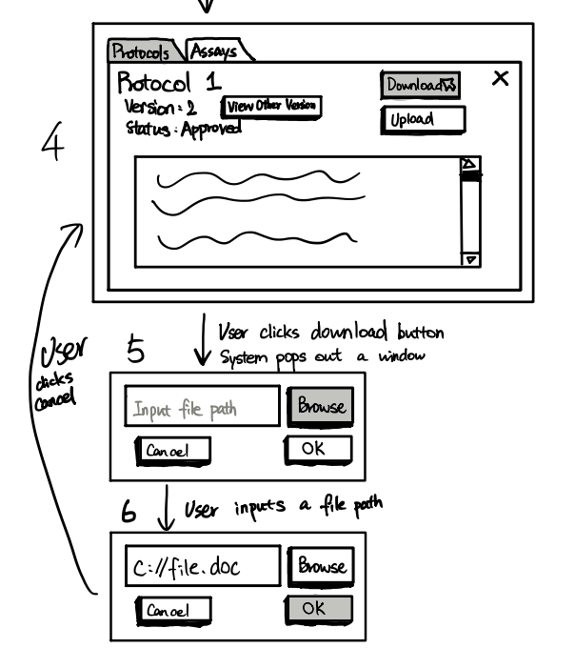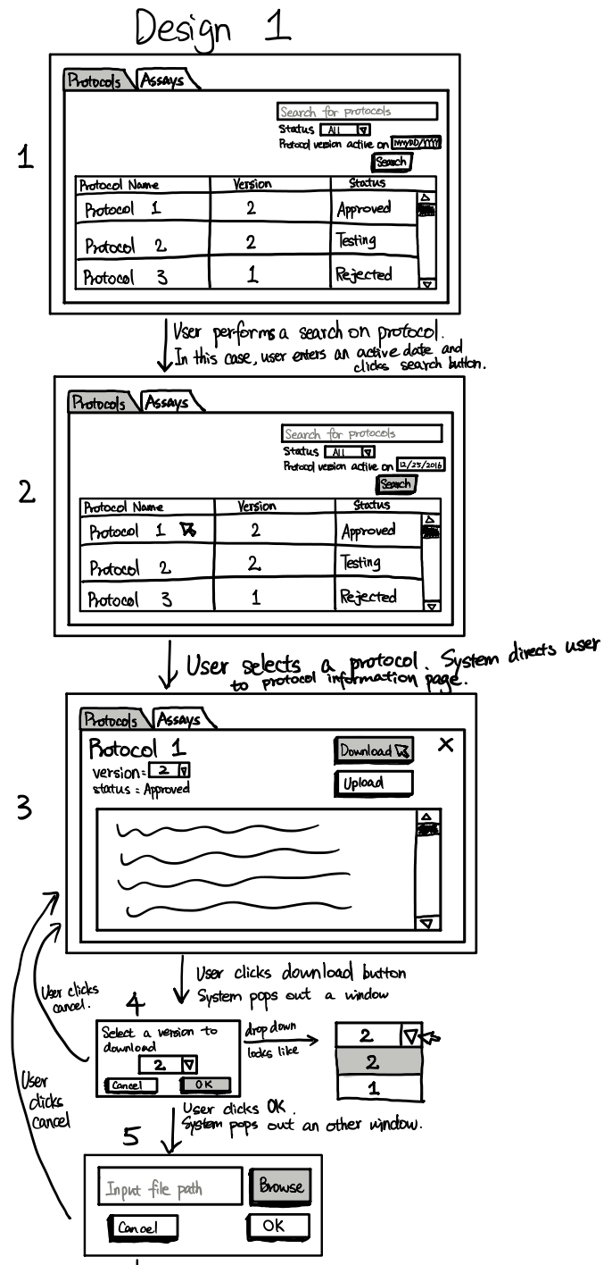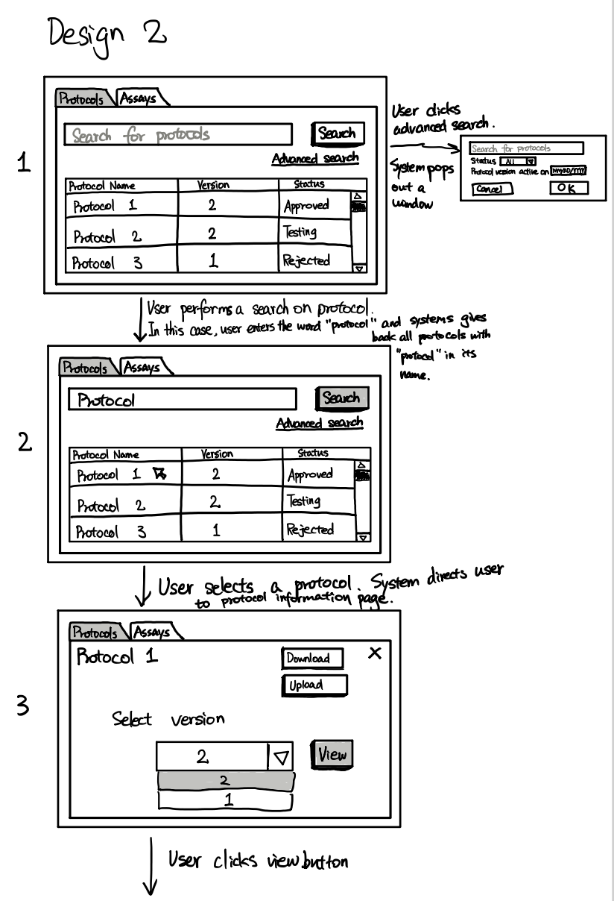](https://docs.google.com/document/d/1KzBfRg3pWlpYw4uTUH9maY_FCphE5WK0OpTnpD46gWw/edit#bookmark=id.ai1edqg7hj42)

[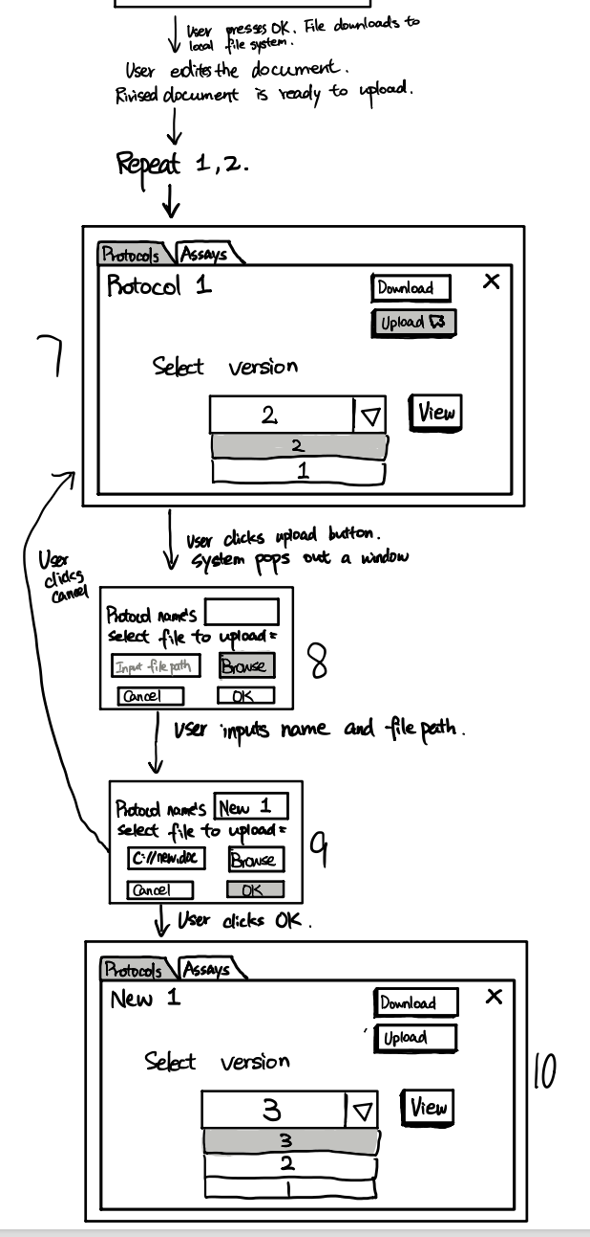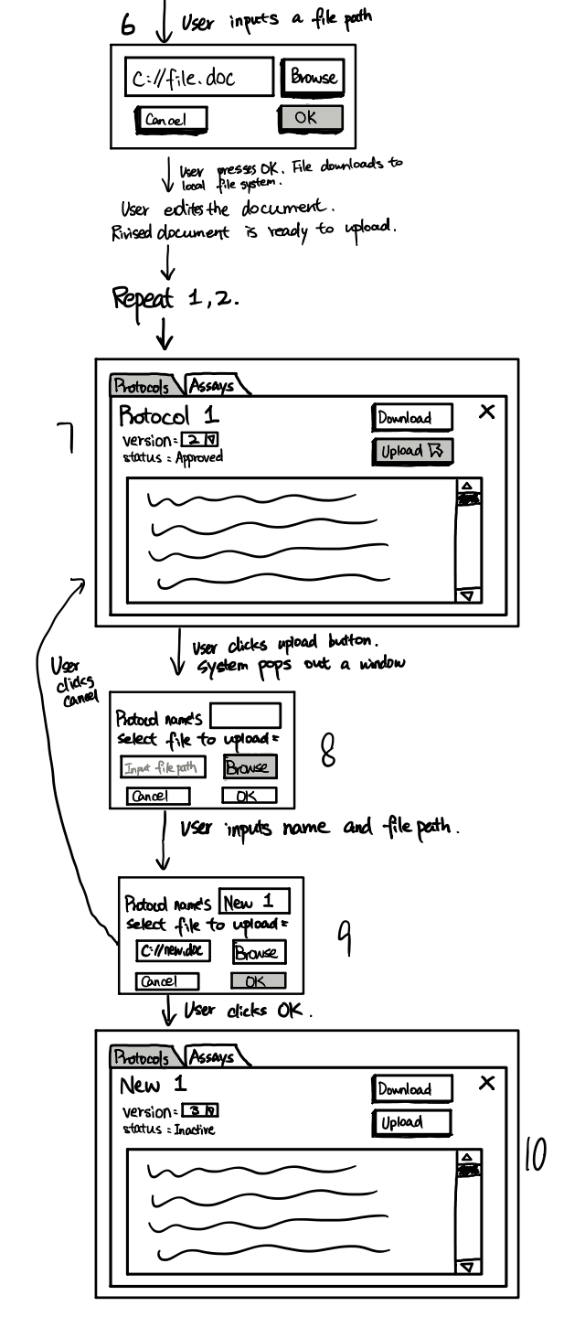](https://docs.google.com/document/d/1KzBfRg3pWlpYw4uTUH9maY_FCphE5WK0OpTnpD46gWw/edit#bookmark=id.ai1edqg7hj42)

### [Interface Evaluation (Design 1)](https://docs.google.com/document/d/1KzBfRg3pWlpYw4uTUH9maY_FCphE5WK0OpTnpD46gWw/edit#bookmark=id.ai1edqg7hj42)

|  |  |  |
| --- | --- | --- |
|  | [Design Principle](https://docs.google.com/document/d/1KzBfRg3pWlpYw4uTUH9maY_FCphE5WK0OpTnpD46gWw/edit#bookmark=id.ai1edqg7hj42) | [Rationale](https://docs.google.com/document/d/1KzBfRg3pWlpYw4uTUH9maY_FCphE5WK0OpTnpD46gWw/edit#bookmark=id.ai1edqg7hj42) |
| [1](https://docs.google.com/document/d/1KzBfRg3pWlpYw4uTUH9maY_FCphE5WK0OpTnpD46gWw/edit#bookmark=id.ai1edqg7hj42) | [Consistency](https://docs.google.com/document/d/1KzBfRg3pWlpYw4uTUH9maY_FCphE5WK0OpTnpD46gWw/edit#bookmark=id.ai1edqg7hj42) | [It was designed with consistency in mind, with all cancel buttons being on the left side and all interaction buttons being on the right side of the screen. (Meaning upload, edit, etc).](https://docs.google.com/document/d/1KzBfRg3pWlpYw4uTUH9maY_FCphE5WK0OpTnpD46gWw/edit#bookmark=id.ai1edqg7hj42) |
| [2](https://docs.google.com/document/d/1KzBfRg3pWlpYw4uTUH9maY_FCphE5WK0OpTnpD46gWw/edit#bookmark=id.ai1edqg7hj42) | [Affordance](https://docs.google.com/document/d/1KzBfRg3pWlpYw4uTUH9maY_FCphE5WK0OpTnpD46gWw/edit#bookmark=id.ai1edqg7hj42) | [The design is intuitively easy to use with the plethora of buttons available. When you want to edit something you need to select the thing you wish to edit and then press edit.](https://docs.google.com/document/d/1KzBfRg3pWlpYw4uTUH9maY_FCphE5WK0OpTnpD46gWw/edit#bookmark=id.ai1edqg7hj42) |

|  |  |  |
| --- | --- | --- |
|  | [Cognitive Paradigm](https://docs.google.com/document/d/1KzBfRg3pWlpYw4uTUH9maY_FCphE5WK0OpTnpD46gWw/edit#bookmark=id.ai1edqg7hj42) | [Rationale](https://docs.google.com/document/d/1KzBfRg3pWlpYw4uTUH9maY_FCphE5WK0OpTnpD46gWw/edit#bookmark=id.ai1edqg7hj42) |
| [1](https://docs.google.com/document/d/1KzBfRg3pWlpYw4uTUH9maY_FCphE5WK0OpTnpD46gWw/edit#bookmark=id.ai1edqg7hj42) | [Perception](https://docs.google.com/document/d/1KzBfRg3pWlpYw4uTUH9maY_FCphE5WK0OpTnpD46gWw/edit#bookmark=id.ai1edqg7hj42) | [The design is easy to perceive with lots of well sized text and buttons making everything easy to understand to the user.](https://docs.google.com/document/d/1KzBfRg3pWlpYw4uTUH9maY_FCphE5WK0OpTnpD46gWw/edit#bookmark=id.ai1edqg7hj42) |
| [2](https://docs.google.com/document/d/1KzBfRg3pWlpYw4uTUH9maY_FCphE5WK0OpTnpD46gWw/edit#bookmark=id.ai1edqg7hj42) | [Decision Making](https://docs.google.com/document/d/1KzBfRg3pWlpYw4uTUH9maY_FCphE5WK0OpTnpD46gWw/edit#bookmark=id.ai1edqg7hj42) | [The design utilizes the cognitive design of decision making by having only just the information strictly necessary to complete the tasks required available to the user.](https://docs.google.com/document/d/1KzBfRg3pWlpYw4uTUH9maY_FCphE5WK0OpTnpD46gWw/edit#bookmark=id.ai1edqg7hj42) |

### [Interface Evaluation (Design 2)](https://docs.google.com/document/d/1KzBfRg3pWlpYw4uTUH9maY_FCphE5WK0OpTnpD46gWw/edit#bookmark=id.ai1edqg7hj42)

|  |  |  |
| --- | --- | --- |
|  | [Design Principle](https://docs.google.com/document/d/1KzBfRg3pWlpYw4uTUH9maY_FCphE5WK0OpTnpD46gWw/edit#bookmark=id.ai1edqg7hj42) | [Rationale](https://docs.google.com/document/d/1KzBfRg3pWlpYw4uTUH9maY_FCphE5WK0OpTnpD46gWw/edit#bookmark=id.ai1edqg7hj42) |
| [1](https://docs.google.com/document/d/1KzBfRg3pWlpYw4uTUH9maY_FCphE5WK0OpTnpD46gWw/edit#bookmark=id.ai1edqg7hj42) | [Consistency](https://docs.google.com/document/d/1KzBfRg3pWlpYw4uTUH9maY_FCphE5WK0OpTnpD46gWw/edit#bookmark=id.ai1edqg7hj42) | [It was designed with consistency in mind, with all cancel buttons being on the left side and all interaction buttons being on the right side of the screen. (Meaning upload, edit, etc).](https://docs.google.com/document/d/1KzBfRg3pWlpYw4uTUH9maY_FCphE5WK0OpTnpD46gWw/edit#bookmark=id.ai1edqg7hj42) |
| [2](https://docs.google.com/document/d/1KzBfRg3pWlpYw4uTUH9maY_FCphE5WK0OpTnpD46gWw/edit#bookmark=id.ai1edqg7hj42) | [Affordance](https://docs.google.com/document/d/1KzBfRg3pWlpYw4uTUH9maY_FCphE5WK0OpTnpD46gWw/edit#bookmark=id.ai1edqg7hj42) | [The design is intuitively easy to use with the plethora of buttons available. When you want to edit something you need to select the thing you wish to edit and then press edit.](https://docs.google.com/document/d/1KzBfRg3pWlpYw4uTUH9maY_FCphE5WK0OpTnpD46gWw/edit#bookmark=id.ai1edqg7hj42) |

|  |  |  |
| --- | --- | --- |
|  | [Cognitive Paradigm](https://docs.google.com/document/d/1KzBfRg3pWlpYw4uTUH9maY_FCphE5WK0OpTnpD46gWw/edit#bookmark=id.ai1edqg7hj42) | [Rationale](https://docs.google.com/document/d/1KzBfRg3pWlpYw4uTUH9maY_FCphE5WK0OpTnpD46gWw/edit#bookmark=id.ai1edqg7hj42) |
| [1](https://docs.google.com/document/d/1KzBfRg3pWlpYw4uTUH9maY_FCphE5WK0OpTnpD46gWw/edit#bookmark=id.ai1edqg7hj42) | [Perception](https://docs.google.com/document/d/1KzBfRg3pWlpYw4uTUH9maY_FCphE5WK0OpTnpD46gWw/edit#bookmark=id.ai1edqg7hj42) | [The design is easy to perceive with lots of well sized text and buttons making everything easy to understand to the user.](https://docs.google.com/document/d/1KzBfRg3pWlpYw4uTUH9maY_FCphE5WK0OpTnpD46gWw/edit#bookmark=id.ai1edqg7hj42) |
| [2](https://docs.google.com/document/d/1KzBfRg3pWlpYw4uTUH9maY_FCphE5WK0OpTnpD46gWw/edit#bookmark=id.ai1edqg7hj42) | [Attention](https://docs.google.com/document/d/1KzBfRg3pWlpYw4uTUH9maY_FCphE5WK0OpTnpD46gWw/edit#bookmark=id.ai1edqg7hj42) | [Makes more use of attention than design 1 by reducing the clutter of information on the protocol page to only things that a user would need to complete this task.](https://docs.google.com/document/d/1KzBfRg3pWlpYw4uTUH9maY_FCphE5WK0OpTnpD46gWw/edit#bookmark=id.ai1edqg7hj42) |

## [Assay Development – View assays by status](https://docs.google.com/document/d/1KzBfRg3pWlpYw4uTUH9maY_FCphE5WK0OpTnpD46gWw/edit#bookmark=id.ai1edqg7hj42)

|  |  |
| --- | --- |
| [Prototypes](https://docs.google.com/document/d/1KzBfRg3pWlpYw4uTUH9maY_FCphE5WK0OpTnpD46gWw/edit#bookmark=id.ai1edqg7hj42) | [Use Case](https://docs.google.com/document/d/1KzBfRg3pWlpYw4uTUH9maY_FCphE5WK0OpTnpD46gWw/edit#bookmark=id.ai1edqg7hj42) |
| [Assay Development – View assays by status](https://docs.google.com/document/d/1KzBfRg3pWlpYw4uTUH9maY_FCphE5WK0OpTnpD46gWw/edit#bookmark=id.ai1edqg7hj42) | [ViewAssayStatus](https://docs.google.com/document/d/1KzBfRg3pWlpYw4uTUH9maY_FCphE5WK0OpTnpD46gWw/edit#bookmark=id.ai1edqg7hj42) [(link)](https://docs.google.com/document/d/1KzBfRg3pWlpYw4uTUH9maY_FCphE5WK0OpTnpD46gWw/edit#bookmark=id.ai1edqg7hj42) |

### [Prototype](https://docs.google.com/document/d/1KzBfRg3pWlpYw4uTUH9maY_FCphE5WK0OpTnpD46gWw/edit#bookmark=id.ai1edqg7hj42)

[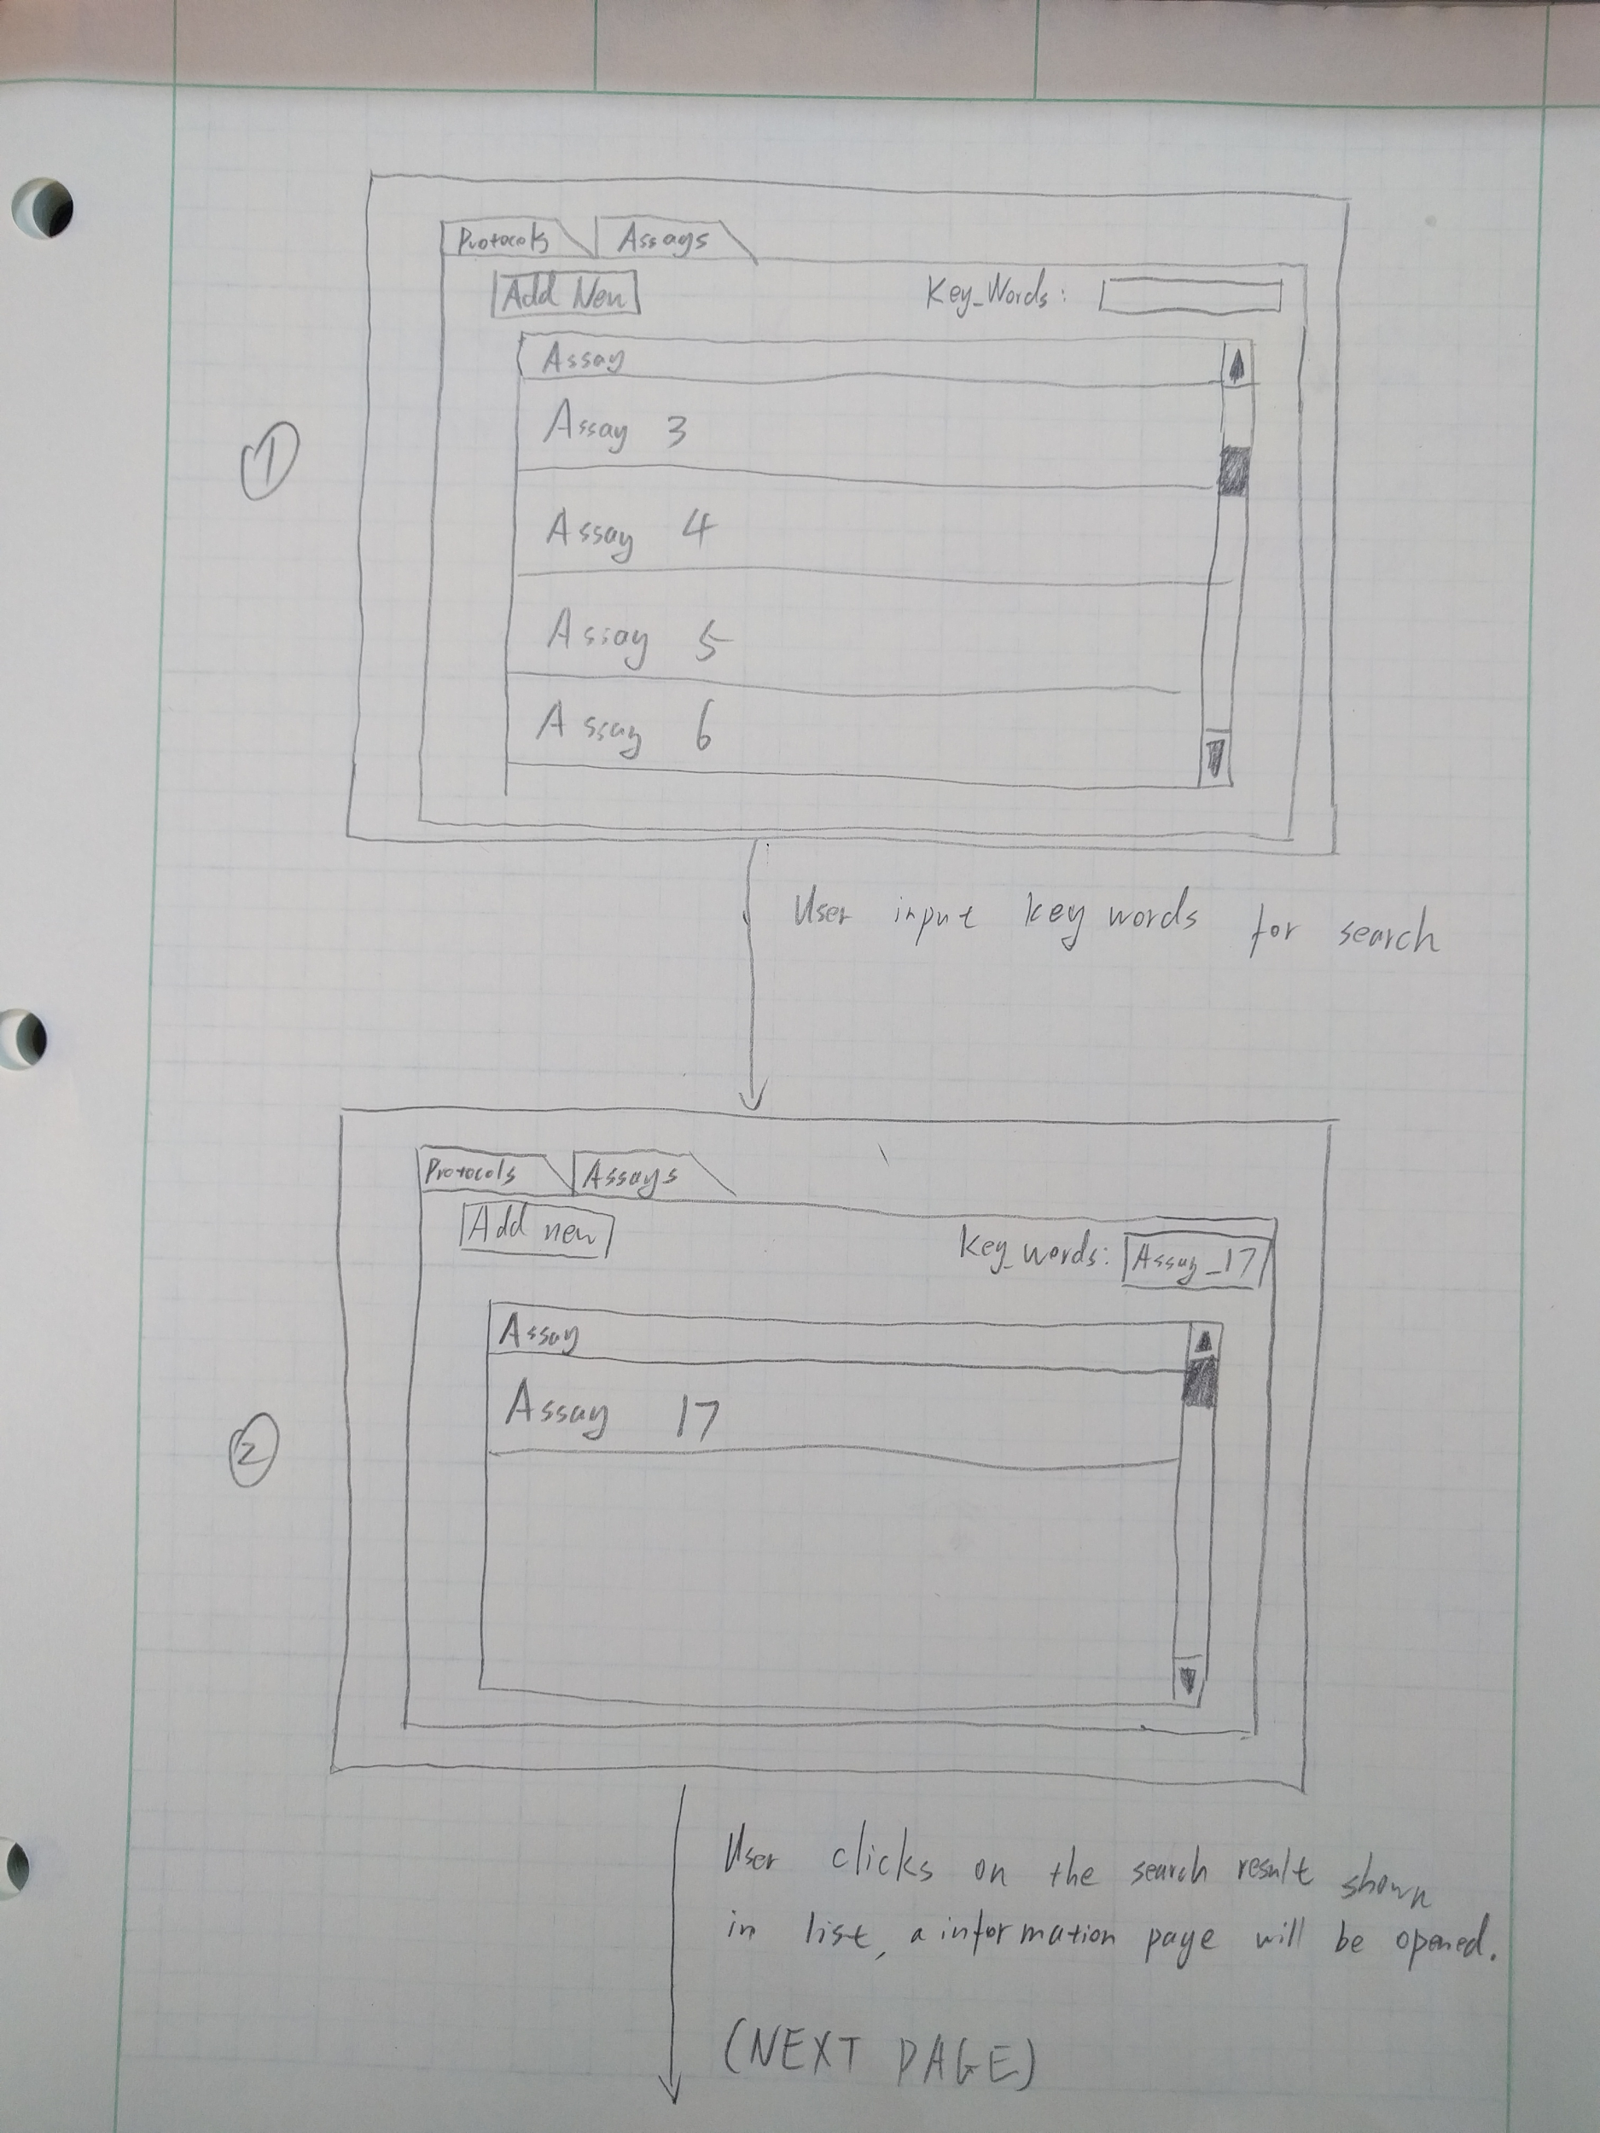](https://docs.google.com/document/d/1KzBfRg3pWlpYw4uTUH9maY_FCphE5WK0OpTnpD46gWw/edit#bookmark=id.ai1edqg7hj42)

[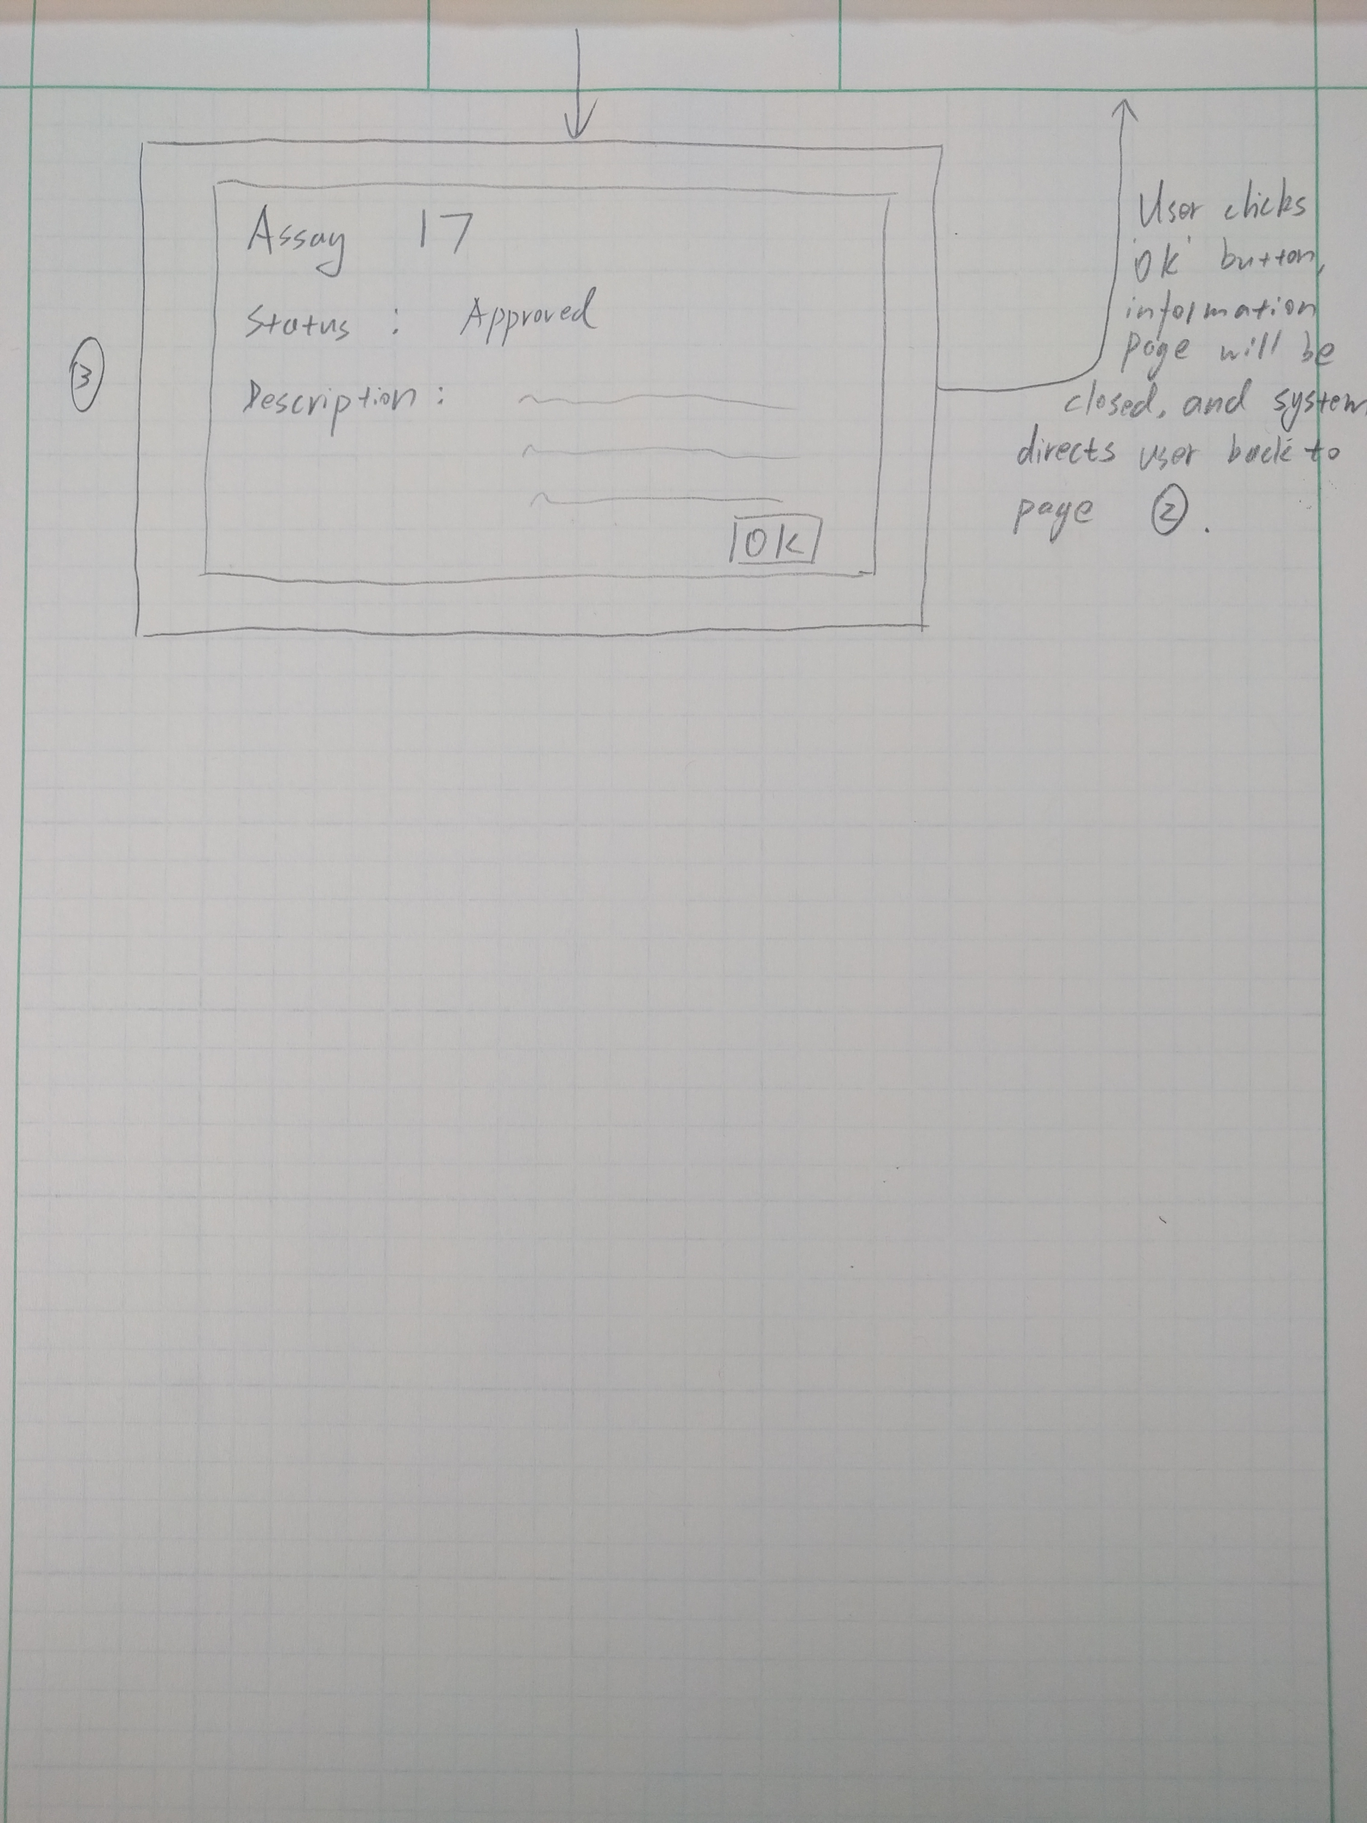](https://docs.google.com/document/d/1KzBfRg3pWlpYw4uTUH9maY_FCphE5WK0OpTnpD46gWw/edit#bookmark=id.ai1edqg7hj42)

### [Interface Evaluation](https://docs.google.com/document/d/1KzBfRg3pWlpYw4uTUH9maY_FCphE5WK0OpTnpD46gWw/edit#bookmark=id.ai1edqg7hj42)

|  |  |  |
| --- | --- | --- |
|  | [Design Principle](https://docs.google.com/document/d/1KzBfRg3pWlpYw4uTUH9maY_FCphE5WK0OpTnpD46gWw/edit#bookmark=id.ai1edqg7hj42) | [Rationale](https://docs.google.com/document/d/1KzBfRg3pWlpYw4uTUH9maY_FCphE5WK0OpTnpD46gWw/edit#bookmark=id.ai1edqg7hj42) |
| [1](https://docs.google.com/document/d/1KzBfRg3pWlpYw4uTUH9maY_FCphE5WK0OpTnpD46gWw/edit#bookmark=id.ai1edqg7hj42) | [Consistency](https://docs.google.com/document/d/1KzBfRg3pWlpYw4uTUH9maY_FCphE5WK0OpTnpD46gWw/edit#bookmark=id.ai1edqg7hj42) | [All tabs of our interface are consistent across interface. For instance the protocols tab is laid out the same as the Assays tab so users know how to use the tab.](https://docs.google.com/document/d/1KzBfRg3pWlpYw4uTUH9maY_FCphE5WK0OpTnpD46gWw/edit#bookmark=id.ai1edqg7hj42) |
| [2](https://docs.google.com/document/d/1KzBfRg3pWlpYw4uTUH9maY_FCphE5WK0OpTnpD46gWw/edit#bookmark=id.ai1edqg7hj42) | [Affordance](https://docs.google.com/document/d/1KzBfRg3pWlpYw4uTUH9maY_FCphE5WK0OpTnpD46gWw/edit#bookmark=id.ai1edqg7hj42) | [The Assays tab looks like a search page from any common database with a search bar and a list of data. This design supports affordance in that users will know that they can either scroll through the data to find the assay they specifically want via the appearance of a scroll bar or that they can search and what options they can search with by looking near the search bar which is located in the same location most search bars are in web browsers which our users interact with most commonly.](https://docs.google.com/document/d/1KzBfRg3pWlpYw4uTUH9maY_FCphE5WK0OpTnpD46gWw/edit#bookmark=id.ai1edqg7hj42) |

|  |  |  |
| --- | --- | --- |
|  | [Cognitive Paradigm](https://docs.google.com/document/d/1KzBfRg3pWlpYw4uTUH9maY_FCphE5WK0OpTnpD46gWw/edit#bookmark=id.ai1edqg7hj42) | [Rationale](https://docs.google.com/document/d/1KzBfRg3pWlpYw4uTUH9maY_FCphE5WK0OpTnpD46gWw/edit#bookmark=id.ai1edqg7hj42) |
| [1](https://docs.google.com/document/d/1KzBfRg3pWlpYw4uTUH9maY_FCphE5WK0OpTnpD46gWw/edit#bookmark=id.ai1edqg7hj42) | [Attention](https://docs.google.com/document/d/1KzBfRg3pWlpYw4uTUH9maY_FCphE5WK0OpTnpD46gWw/edit#bookmark=id.ai1edqg7hj42) | [We draw attention to the search bar to make it easy to find anything by making it slightly larger than any entry in the table, being the only thing in its row and having it be one of the first elements of the UI that the user gets to see.](https://docs.google.com/document/d/1KzBfRg3pWlpYw4uTUH9maY_FCphE5WK0OpTnpD46gWw/edit#bookmark=id.ai1edqg7hj42) |
| [2](https://docs.google.com/document/d/1KzBfRg3pWlpYw4uTUH9maY_FCphE5WK0OpTnpD46gWw/edit#bookmark=id.ai1edqg7hj42) | [Perception](https://docs.google.com/document/d/1KzBfRg3pWlpYw4uTUH9maY_FCphE5WK0OpTnpD46gWw/edit#bookmark=id.ai1edqg7hj42) | [All of our text is laid out in a plain font with all the important information in a column as is typical with tabular data. This allows the user to easily perceive what is in the table and what it means via the usage of labels and fonts.](https://docs.google.com/document/d/1KzBfRg3pWlpYw4uTUH9maY_FCphE5WK0OpTnpD46gWw/edit#bookmark=id.ai1edqg7hj42) |

## 

## 

### [Alternate Design](https://docs.google.com/document/d/1KzBfRg3pWlpYw4uTUH9maY_FCphE5WK0OpTnpD46gWw/edit#bookmark=id.ai1edqg7hj42)

[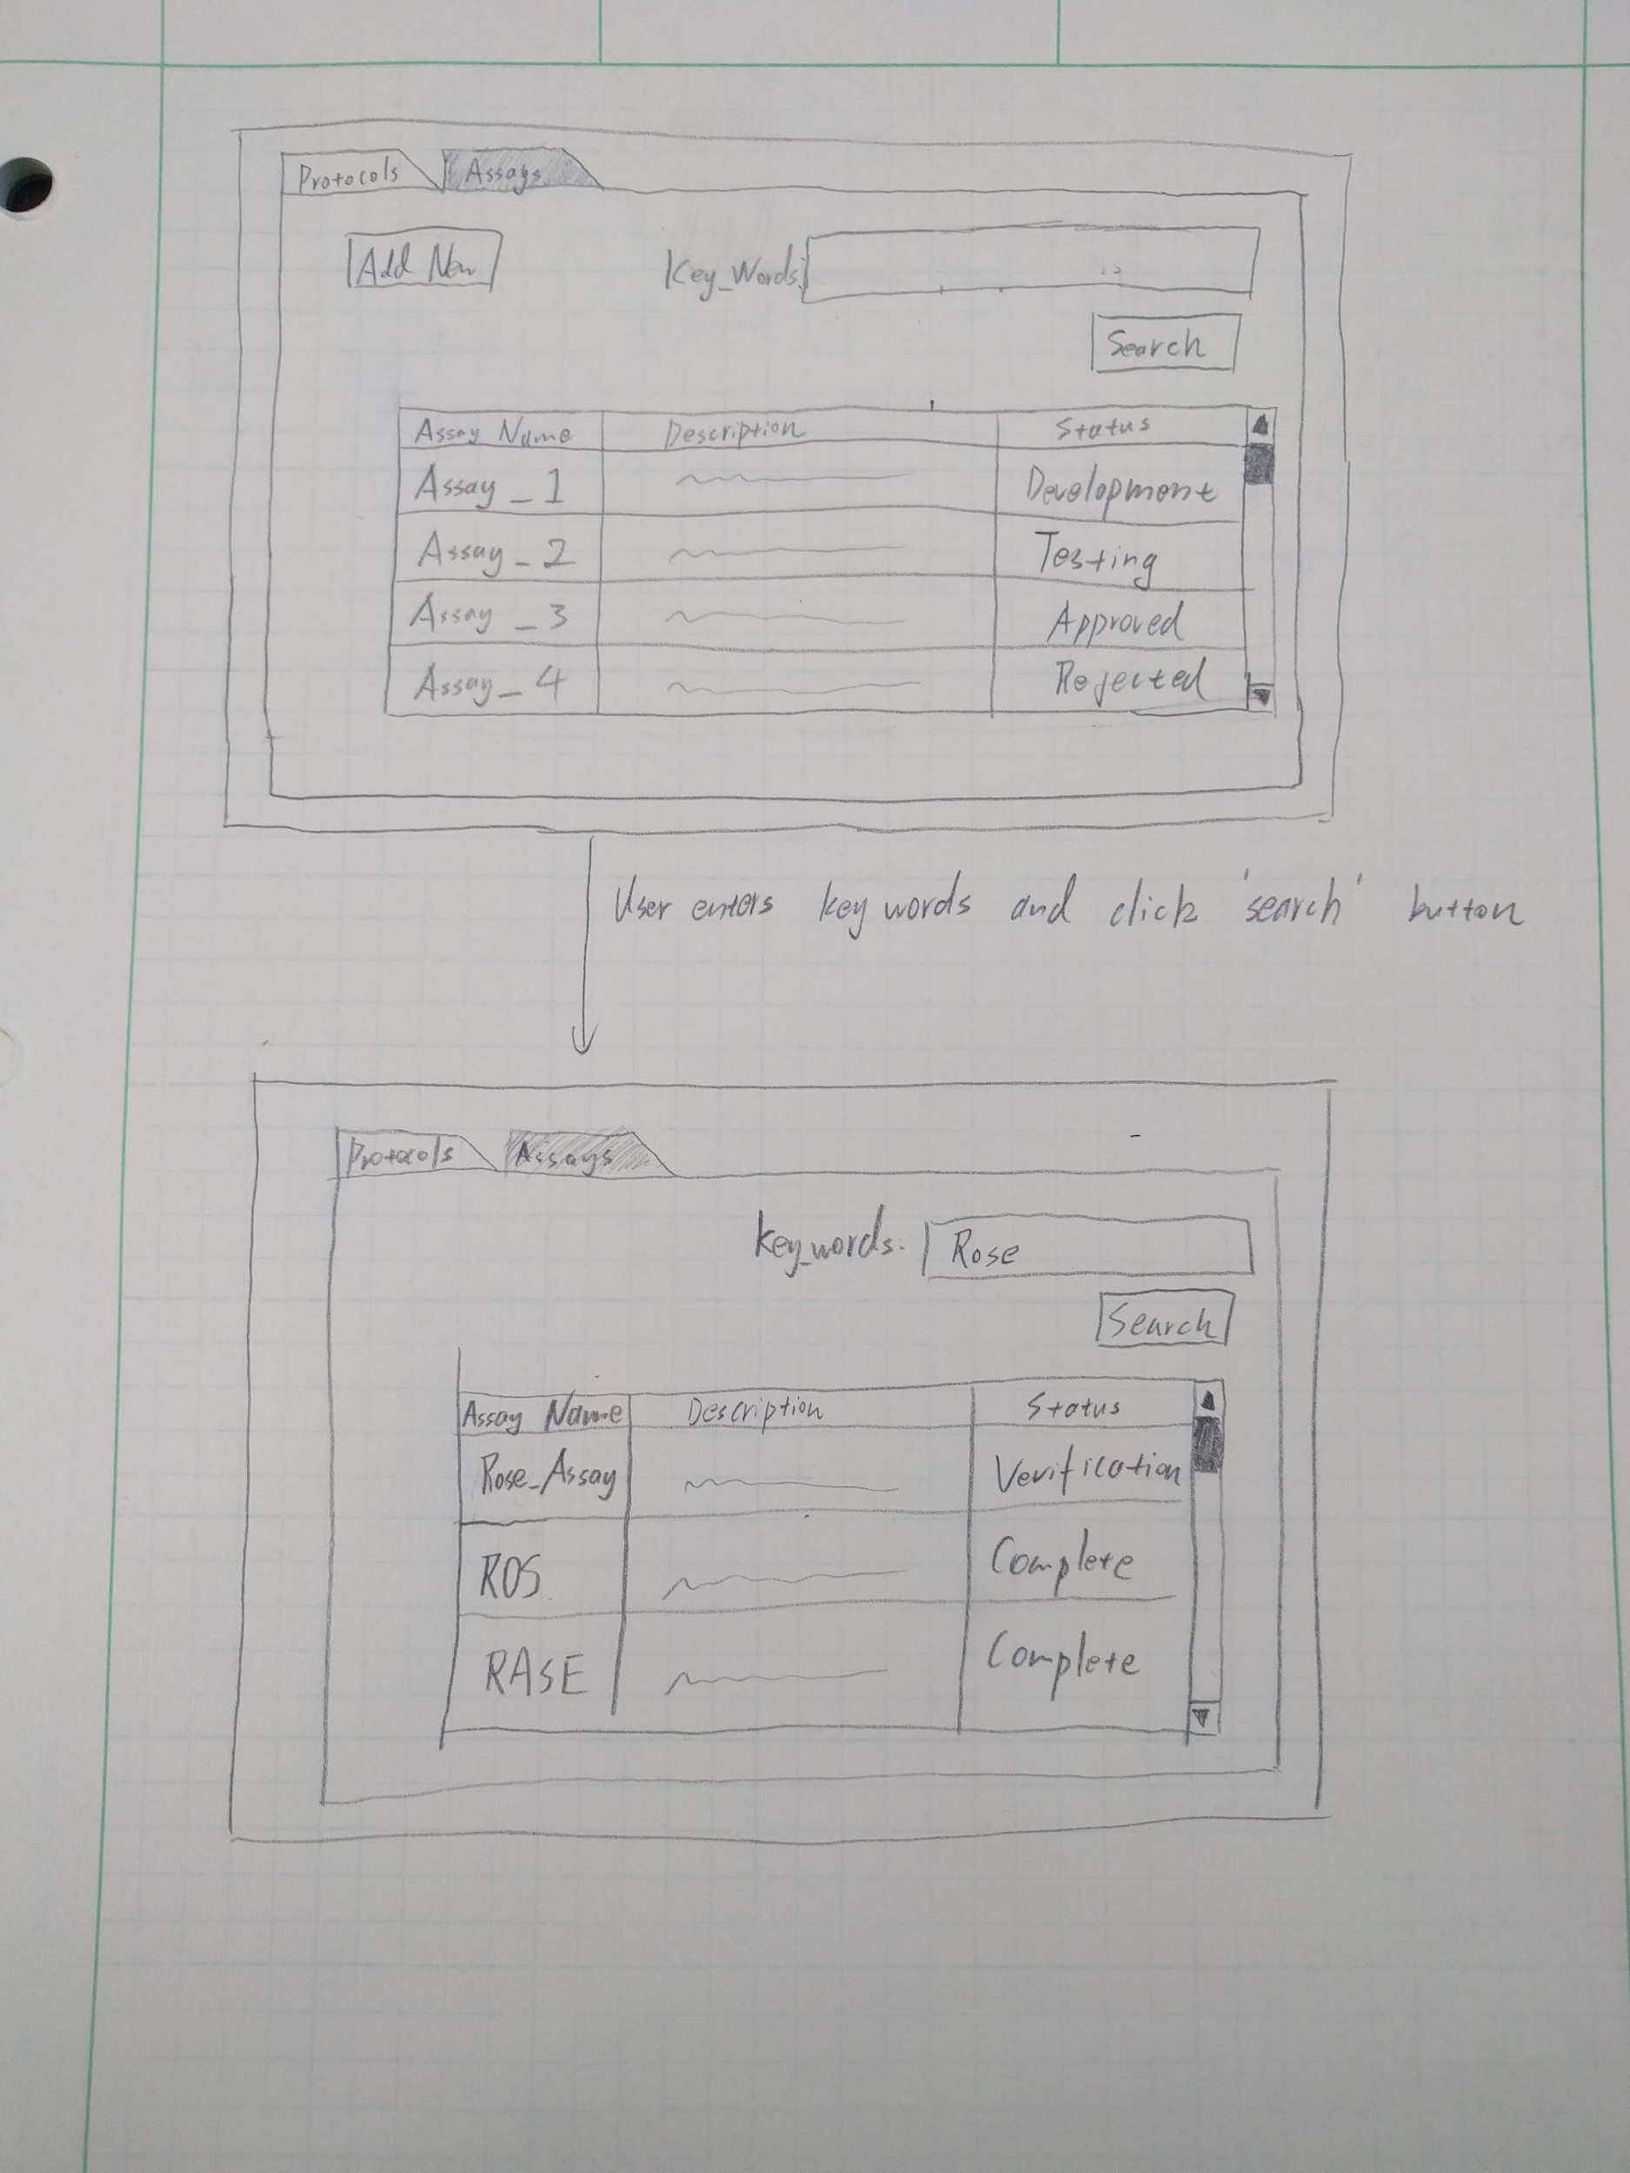](https://docs.google.com/document/d/1KzBfRg3pWlpYw4uTUH9maY_FCphE5WK0OpTnpD46gWw/edit#bookmark=id.ai1edqg7hj42)

### [Interface Evaluation](https://docs.google.com/document/d/1KzBfRg3pWlpYw4uTUH9maY_FCphE5WK0OpTnpD46gWw/edit#bookmark=id.ai1edqg7hj42)

|  |  |  |
| --- | --- | --- |
|  | [Design Principle](https://docs.google.com/document/d/1KzBfRg3pWlpYw4uTUH9maY_FCphE5WK0OpTnpD46gWw/edit#bookmark=id.ai1edqg7hj42) | [Rationale](https://docs.google.com/document/d/1KzBfRg3pWlpYw4uTUH9maY_FCphE5WK0OpTnpD46gWw/edit#bookmark=id.ai1edqg7hj42) |
| [1](https://docs.google.com/document/d/1KzBfRg3pWlpYw4uTUH9maY_FCphE5WK0OpTnpD46gWw/edit#bookmark=id.ai1edqg7hj42) | [Visibility](https://docs.google.com/document/d/1KzBfRg3pWlpYw4uTUH9maY_FCphE5WK0OpTnpD46gWw/edit#bookmark=id.ai1edqg7hj42) | [The information is laid out in a way that makes it easy to see all of the options one can perform on the system.](https://docs.google.com/document/d/1KzBfRg3pWlpYw4uTUH9maY_FCphE5WK0OpTnpD46gWw/edit#bookmark=id.ai1edqg7hj42) |
| [2](https://docs.google.com/document/d/1KzBfRg3pWlpYw4uTUH9maY_FCphE5WK0OpTnpD46gWw/edit#bookmark=id.ai1edqg7hj42) | [Affordance](https://docs.google.com/document/d/1KzBfRg3pWlpYw4uTUH9maY_FCphE5WK0OpTnpD46gWw/edit#bookmark=id.ai1edqg7hj42) | [The Assays tab looks like any search engine tab and allows users therefore to apply what they know there, to here. This expands into the advanced search tab which is very intuitive.](https://docs.google.com/document/d/1KzBfRg3pWlpYw4uTUH9maY_FCphE5WK0OpTnpD46gWw/edit#bookmark=id.ai1edqg7hj42) |

|  |  |  |
| --- | --- | --- |
|  | [Cognitive Paradigm](https://docs.google.com/document/d/1KzBfRg3pWlpYw4uTUH9maY_FCphE5WK0OpTnpD46gWw/edit#bookmark=id.ai1edqg7hj42) | [Rationale](https://docs.google.com/document/d/1KzBfRg3pWlpYw4uTUH9maY_FCphE5WK0OpTnpD46gWw/edit#bookmark=id.ai1edqg7hj42) |
| [1](https://docs.google.com/document/d/1KzBfRg3pWlpYw4uTUH9maY_FCphE5WK0OpTnpD46gWw/edit#bookmark=id.ai1edqg7hj42) | [Attention](https://docs.google.com/document/d/1KzBfRg3pWlpYw4uTUH9maY_FCphE5WK0OpTnpD46gWw/edit#bookmark=id.ai1edqg7hj42) | [We put the list, which is where people want to get information from at the center of the page. It will make it easier for people to look for status information.](https://docs.google.com/document/d/1KzBfRg3pWlpYw4uTUH9maY_FCphE5WK0OpTnpD46gWw/edit#bookmark=id.ai1edqg7hj42) |
| [2](https://docs.google.com/document/d/1KzBfRg3pWlpYw4uTUH9maY_FCphE5WK0OpTnpD46gWw/edit#bookmark=id.ai1edqg7hj42) | [Perception](https://docs.google.com/document/d/1KzBfRg3pWlpYw4uTUH9maY_FCphE5WK0OpTnpD46gWw/edit#bookmark=id.ai1edqg7hj42) | [All the information is laid out in a nice font at an easily read size with very little clutter allowing the user to easily perceive what is going on in the interface.](https://docs.google.com/document/d/1KzBfRg3pWlpYw4uTUH9maY_FCphE5WK0OpTnpD46gWw/edit#bookmark=id.ai1edqg7hj42) |

## [Assay Development - Add new assay idea](https://docs.google.com/document/d/1KzBfRg3pWlpYw4uTUH9maY_FCphE5WK0OpTnpD46gWw/edit#bookmark=id.ai1edqg7hj42) [[email](https://docs.google.com/document/d/1KzBfRg3pWlpYw4uTUH9maY_FCphE5WK0OpTnpD46gWw/edit#bookmark=id.ai1edqg7hj42)](https://docs.google.com/document/d/1XqX027hSBrBORkCf2jik67-08-rgED4Qxllp7lZA3h4/edit#bookmark=id.lf47df459r3)

|  |  |
| --- | --- |
| [Prototypes](https://docs.google.com/document/d/1KzBfRg3pWlpYw4uTUH9maY_FCphE5WK0OpTnpD46gWw/edit#bookmark=id.ai1edqg7hj42) | [Use Case](https://docs.google.com/document/d/1KzBfRg3pWlpYw4uTUH9maY_FCphE5WK0OpTnpD46gWw/edit#bookmark=id.ai1edqg7hj42) |
| [Assay Development – Add a new assay idea](https://docs.google.com/document/d/1KzBfRg3pWlpYw4uTUH9maY_FCphE5WK0OpTnpD46gWw/edit#bookmark=id.ai1edqg7hj42) | [CreateAssay](https://docs.google.com/document/d/1KzBfRg3pWlpYw4uTUH9maY_FCphE5WK0OpTnpD46gWw/edit#bookmark=id.ai1edqg7hj42) [(link)](https://docs.google.com/document/d/1KzBfRg3pWlpYw4uTUH9maY_FCphE5WK0OpTnpD46gWw/edit#bookmark=id.ai1edqg7hj42) |

### [Prototype](https://docs.google.com/document/d/1KzBfRg3pWlpYw4uTUH9maY_FCphE5WK0OpTnpD46gWw/edit#bookmark=id.ai1edqg7hj42)

[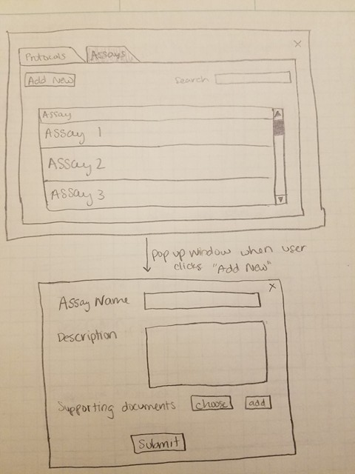](https://docs.google.com/document/d/1KzBfRg3pWlpYw4uTUH9maY_FCphE5WK0OpTnpD46gWw/edit#bookmark=id.ai1edqg7hj42)

[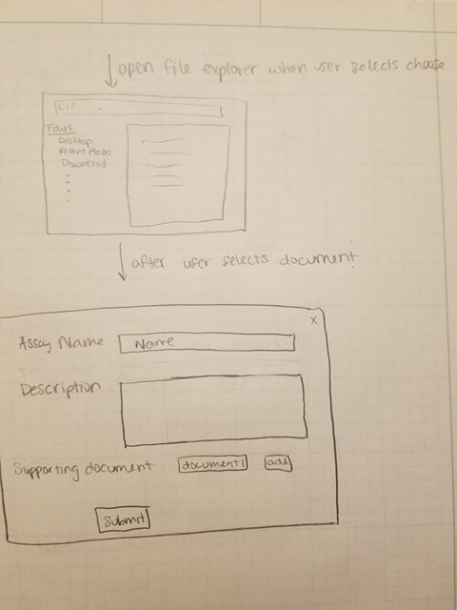](https://docs.google.com/document/d/1KzBfRg3pWlpYw4uTUH9maY_FCphE5WK0OpTnpD46gWw/edit#bookmark=id.ai1edqg7hj42)

[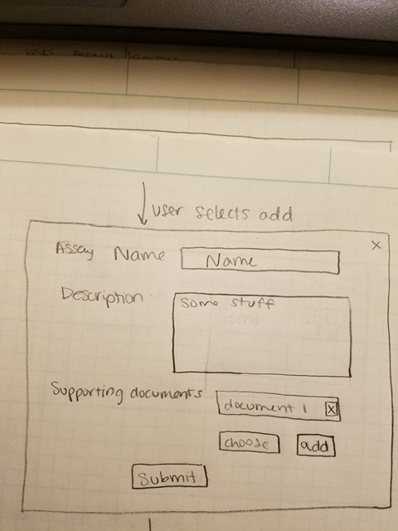](https://docs.google.com/document/d/1KzBfRg3pWlpYw4uTUH9maY_FCphE5WK0OpTnpD46gWw/edit#bookmark=id.ai1edqg7hj42)

[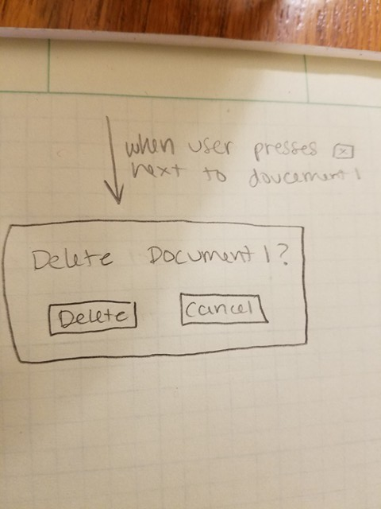](https://docs.google.com/document/d/1KzBfRg3pWlpYw4uTUH9maY_FCphE5WK0OpTnpD46gWw/edit#bookmark=id.ai1edqg7hj42)

[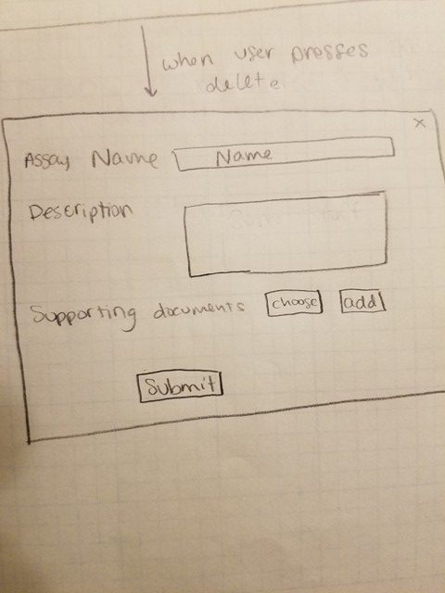](https://docs.google.com/document/d/1KzBfRg3pWlpYw4uTUH9maY_FCphE5WK0OpTnpD46gWw/edit#bookmark=id.ai1edqg7hj42)

[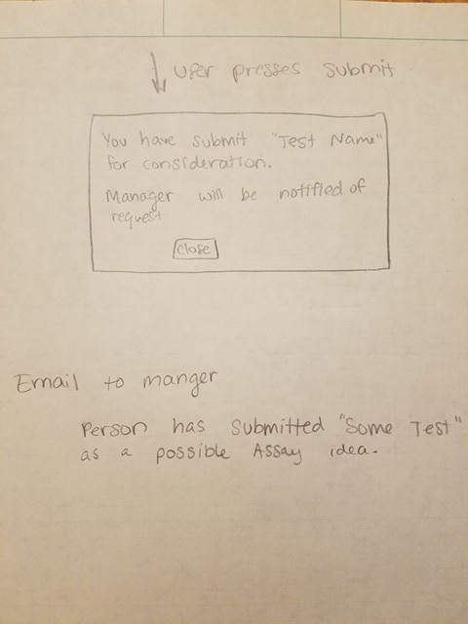](https://docs.google.com/document/d/1KzBfRg3pWlpYw4uTUH9maY_FCphE5WK0OpTnpD46gWw/edit#bookmark=id.ai1edqg7hj42)

### [Interface Evaluation](https://docs.google.com/document/d/1KzBfRg3pWlpYw4uTUH9maY_FCphE5WK0OpTnpD46gWw/edit#bookmark=id.ai1edqg7hj42)

|  |  |  |
| --- | --- | --- |
|  | [Design Principle](https://docs.google.com/document/d/1KzBfRg3pWlpYw4uTUH9maY_FCphE5WK0OpTnpD46gWw/edit#bookmark=id.ai1edqg7hj42) | [Rationale](https://docs.google.com/document/d/1KzBfRg3pWlpYw4uTUH9maY_FCphE5WK0OpTnpD46gWw/edit#bookmark=id.ai1edqg7hj42) |
| [1](https://docs.google.com/document/d/1KzBfRg3pWlpYw4uTUH9maY_FCphE5WK0OpTnpD46gWw/edit#bookmark=id.ai1edqg7hj42) | [Consistency](https://docs.google.com/document/d/1KzBfRg3pWlpYw4uTUH9maY_FCphE5WK0OpTnpD46gWw/edit#bookmark=id.ai1edqg7hj42) | [The system is setup to follow a typical flow when adding data. The more general information is added at the top while moving down to more detailed information. The button to submit is at the bottom, where it is places on other common websites surveys. When the person reaches this place, they should also be done entering information thus would be ready to submit as well.](https://docs.google.com/document/d/1KzBfRg3pWlpYw4uTUH9maY_FCphE5WK0OpTnpD46gWw/edit#bookmark=id.ai1edqg7hj42) |
| [2](https://docs.google.com/document/d/1KzBfRg3pWlpYw4uTUH9maY_FCphE5WK0OpTnpD46gWw/edit#bookmark=id.ai1edqg7hj42) | [Feedback](https://docs.google.com/document/d/1KzBfRg3pWlpYw4uTUH9maY_FCphE5WK0OpTnpD46gWw/edit#bookmark=id.ai1edqg7hj42) | [The system gives feedback with button presses so that the user stays informed with what is going on in the system. The system also provides overviews and emails so that everyone knows what's going on and the information is accurate when entered.](https://docs.google.com/document/d/1KzBfRg3pWlpYw4uTUH9maY_FCphE5WK0OpTnpD46gWw/edit#bookmark=id.ai1edqg7hj42) |

|  |  |  |
| --- | --- | --- |
|  | [Cognitive Paradigm](https://docs.google.com/document/d/1KzBfRg3pWlpYw4uTUH9maY_FCphE5WK0OpTnpD46gWw/edit#bookmark=id.ai1edqg7hj42) | [Rationale](https://docs.google.com/document/d/1KzBfRg3pWlpYw4uTUH9maY_FCphE5WK0OpTnpD46gWw/edit#bookmark=id.ai1edqg7hj42) |
| [1](https://docs.google.com/document/d/1KzBfRg3pWlpYw4uTUH9maY_FCphE5WK0OpTnpD46gWw/edit#bookmark=id.ai1edqg7hj42) | [Attention](https://docs.google.com/document/d/1KzBfRg3pWlpYw4uTUH9maY_FCphE5WK0OpTnpD46gWw/edit#bookmark=id.ai1edqg7hj42) | [The user attention is drawn to places to enter data with labels directing them to the text boxes in a way that is natural to read. It also keeps screen uncluttered with only putting the relevant information on a screen.](https://docs.google.com/document/d/1KzBfRg3pWlpYw4uTUH9maY_FCphE5WK0OpTnpD46gWw/edit#bookmark=id.ai1edqg7hj42) |
| [2](https://docs.google.com/document/d/1KzBfRg3pWlpYw4uTUH9maY_FCphE5WK0OpTnpD46gWw/edit#bookmark=id.ai1edqg7hj42) | [Decision Making](https://docs.google.com/document/d/1KzBfRg3pWlpYw4uTUH9maY_FCphE5WK0OpTnpD46gWw/edit#bookmark=id.ai1edqg7hj42) | [The user will have to decide on the information being submitted. A review at the end of the submission will allow them to ensure that all the information they want present is indeed included in the submission. This will help them in the decision to submit the assay idea or continue editing.](https://docs.google.com/document/d/1KzBfRg3pWlpYw4uTUH9maY_FCphE5WK0OpTnpD46gWw/edit#bookmark=id.ai1edqg7hj42) |

### [Alternate Design](https://docs.google.com/document/d/1KzBfRg3pWlpYw4uTUH9maY_FCphE5WK0OpTnpD46gWw/edit#bookmark=id.ai1edqg7hj42)

[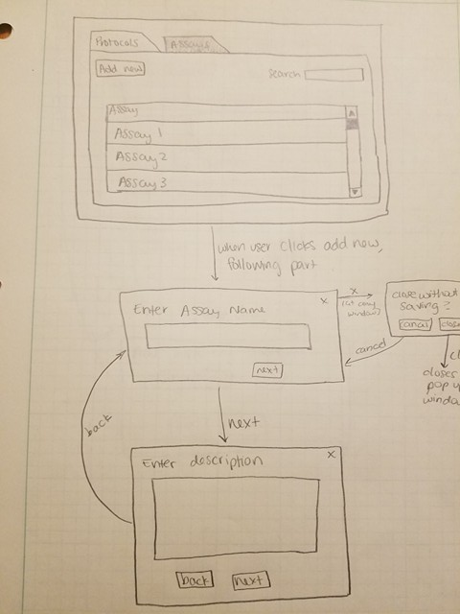](https://docs.google.com/document/d/1KzBfRg3pWlpYw4uTUH9maY_FCphE5WK0OpTnpD46gWw/edit#bookmark=id.ai1edqg7hj42)

[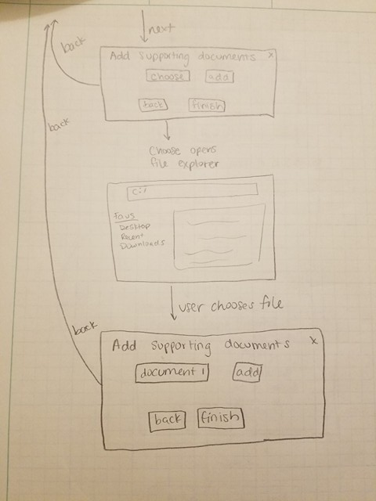](https://docs.google.com/document/d/1KzBfRg3pWlpYw4uTUH9maY_FCphE5WK0OpTnpD46gWw/edit#bookmark=id.ai1edqg7hj42)

[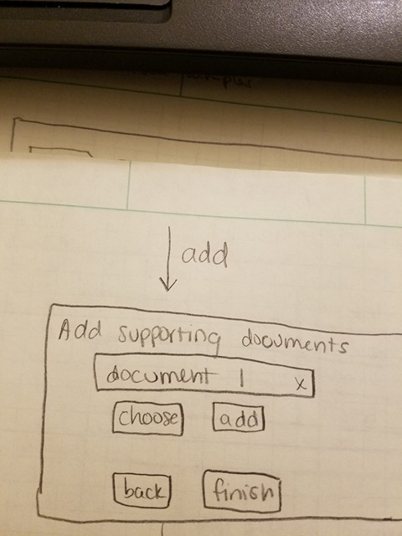](https://docs.google.com/document/d/1KzBfRg3pWlpYw4uTUH9maY_FCphE5WK0OpTnpD46gWw/edit#bookmark=id.ai1edqg7hj42)

[](https://docs.google.com/document/d/1KzBfRg3pWlpYw4uTUH9maY_FCphE5WK0OpTnpD46gWw/edit#bookmark=id.ai1edqg7hj42)

[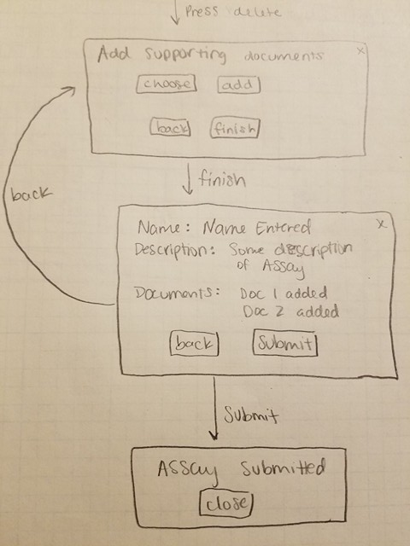](https://docs.google.com/document/d/1KzBfRg3pWlpYw4uTUH9maY_FCphE5WK0OpTnpD46gWw/edit#bookmark=id.ai1edqg7hj42)

### [Interface Evaluation](https://docs.google.com/document/d/1KzBfRg3pWlpYw4uTUH9maY_FCphE5WK0OpTnpD46gWw/edit#bookmark=id.ai1edqg7hj42)

|  |  |  |
| --- | --- | --- |
|  | [Design Principle](https://docs.google.com/document/d/1KzBfRg3pWlpYw4uTUH9maY_FCphE5WK0OpTnpD46gWw/edit#bookmark=id.ai1edqg7hj42) | [Rationale](https://docs.google.com/document/d/1KzBfRg3pWlpYw4uTUH9maY_FCphE5WK0OpTnpD46gWw/edit#bookmark=id.ai1edqg7hj42) |
| [1](https://docs.google.com/document/d/1KzBfRg3pWlpYw4uTUH9maY_FCphE5WK0OpTnpD46gWw/edit#bookmark=id.ai1edqg7hj42) | [Affordance](https://docs.google.com/document/d/1KzBfRg3pWlpYw4uTUH9maY_FCphE5WK0OpTnpD46gWw/edit#bookmark=id.ai1edqg7hj42) | [The layout is setup to guide the user through the steps. It starts with a label at the top so when the user starts they start with the prompt of information for the page. The text boxes next invite the user to add information with the bottom of the page containing navigation buttons. The buttons invite user interaction to proceed to the next step once they are done with the current step.](https://docs.google.com/document/d/1KzBfRg3pWlpYw4uTUH9maY_FCphE5WK0OpTnpD46gWw/edit#bookmark=id.ai1edqg7hj42) |
| [2](https://docs.google.com/document/d/1KzBfRg3pWlpYw4uTUH9maY_FCphE5WK0OpTnpD46gWw/edit#bookmark=id.ai1edqg7hj42) | [Feedback](https://docs.google.com/document/d/1KzBfRg3pWlpYw4uTUH9maY_FCphE5WK0OpTnpD46gWw/edit#bookmark=id.ai1edqg7hj42) | [When the user is adding documents, the user can see the different changes of the system as they choose, add, and remove documents. The choose button changes to the document’s name when a document is chosen so the user knows what document was selected. The add button will cause the system to show the document in a list. The remove button causes the system to remove the document from the list. This makes the user aware of what documents are currently in the list and allows them to see the changes that resulted from their actions.](https://docs.google.com/document/d/1KzBfRg3pWlpYw4uTUH9maY_FCphE5WK0OpTnpD46gWw/edit#bookmark=id.ai1edqg7hj42) |

|  |  |  |
| --- | --- | --- |
|  | [Cognitive Paradigm](https://docs.google.com/document/d/1KzBfRg3pWlpYw4uTUH9maY_FCphE5WK0OpTnpD46gWw/edit#bookmark=id.ai1edqg7hj42) | [Rationale](https://docs.google.com/document/d/1KzBfRg3pWlpYw4uTUH9maY_FCphE5WK0OpTnpD46gWw/edit#bookmark=id.ai1edqg7hj42) |
| [1](https://docs.google.com/document/d/1KzBfRg3pWlpYw4uTUH9maY_FCphE5WK0OpTnpD46gWw/edit#bookmark=id.ai1edqg7hj42) | [Attention](https://docs.google.com/document/d/1KzBfRg3pWlpYw4uTUH9maY_FCphE5WK0OpTnpD46gWw/edit#bookmark=id.ai1edqg7hj42) | [The user focuses on one step at a time as only one thing is displayed on the screen at a time. The user will be able to enter the information needed for that step with ease as there is one piece of information and one place to enter that information.](https://docs.google.com/document/d/1KzBfRg3pWlpYw4uTUH9maY_FCphE5WK0OpTnpD46gWw/edit#bookmark=id.ai1edqg7hj42) |
| [2](https://docs.google.com/document/d/1KzBfRg3pWlpYw4uTUH9maY_FCphE5WK0OpTnpD46gWw/edit#bookmark=id.ai1edqg7hj42) | [Decision Making](https://docs.google.com/document/d/1KzBfRg3pWlpYw4uTUH9maY_FCphE5WK0OpTnpD46gWw/edit#bookmark=id.ai1edqg7hj42) | [The system prompts the user when the user tries to exit and when the user tries to submit. When the user exits, the user is prompted to close without saving changes. This allows the user to decide whether or not that was the intended action. A similar situation happens with the submit. When the user is finished and click submit, the system shows an overview of the information added. This allows the user to easily review to decide whether or not the submission is complete.](https://docs.google.com/document/d/1KzBfRg3pWlpYw4uTUH9maY_FCphE5WK0OpTnpD46gWw/edit#bookmark=id.ai1edqg7hj42) |

## [Production – Enter Sample for Testing](https://docs.google.com/document/d/1KzBfRg3pWlpYw4uTUH9maY_FCphE5WK0OpTnpD46gWw/edit#bookmark=id.ai1edqg7hj42)

|  |  |
| --- | --- |
| [Prototypes](https://docs.google.com/document/d/1KzBfRg3pWlpYw4uTUH9maY_FCphE5WK0OpTnpD46gWw/edit#bookmark=id.ai1edqg7hj42) | [Use Case](https://docs.google.com/document/d/1KzBfRg3pWlpYw4uTUH9maY_FCphE5WK0OpTnpD46gWw/edit#bookmark=id.ai1edqg7hj42) |
| [Production – Enter Sample for Testing](https://docs.google.com/document/d/1KzBfRg3pWlpYw4uTUH9maY_FCphE5WK0OpTnpD46gWw/edit#bookmark=id.ai1edqg7hj42) | [UpdateSampleStatus](https://docs.google.com/document/d/1KzBfRg3pWlpYw4uTUH9maY_FCphE5WK0OpTnpD46gWw/edit#bookmark=id.ai1edqg7hj42) [(link)](https://docs.google.com/document/d/1KzBfRg3pWlpYw4uTUH9maY_FCphE5WK0OpTnpD46gWw/edit#bookmark=id.ai1edqg7hj42) |

### [Prototype](https://docs.google.com/document/d/1KzBfRg3pWlpYw4uTUH9maY_FCphE5WK0OpTnpD46gWw/edit#bookmark=id.ai1edqg7hj42)

[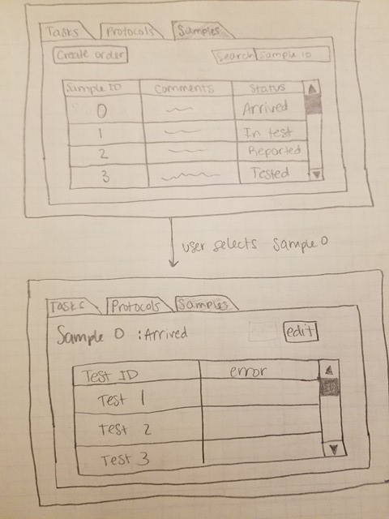](https://docs.google.com/document/d/1KzBfRg3pWlpYw4uTUH9maY_FCphE5WK0OpTnpD46gWw/edit#bookmark=id.ai1edqg7hj42)

[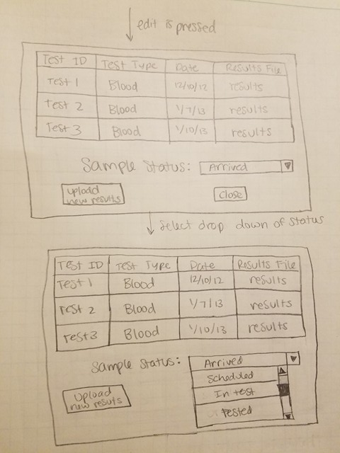](https://docs.google.com/document/d/1KzBfRg3pWlpYw4uTUH9maY_FCphE5WK0OpTnpD46gWw/edit#bookmark=id.ai1edqg7hj42)

[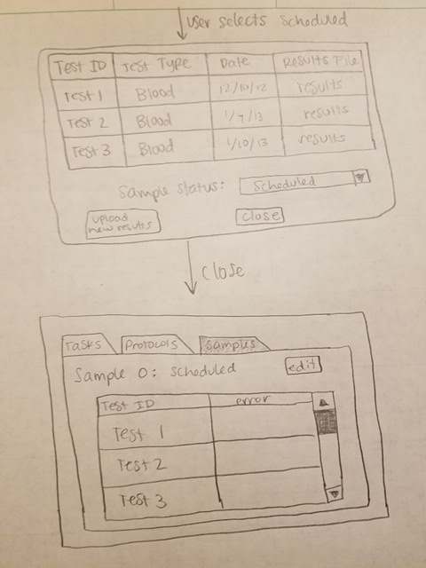](https://docs.google.com/document/d/1KzBfRg3pWlpYw4uTUH9maY_FCphE5WK0OpTnpD46gWw/edit#bookmark=id.ai1edqg7hj42)

### [Interface Evaluation](https://docs.google.com/document/d/1KzBfRg3pWlpYw4uTUH9maY_FCphE5WK0OpTnpD46gWw/edit#bookmark=id.ai1edqg7hj42)

|  |  |  |
| --- | --- | --- |
|  | [Design Principle](https://docs.google.com/document/d/1KzBfRg3pWlpYw4uTUH9maY_FCphE5WK0OpTnpD46gWw/edit#bookmark=id.ai1edqg7hj42) | [Rationale](https://docs.google.com/document/d/1KzBfRg3pWlpYw4uTUH9maY_FCphE5WK0OpTnpD46gWw/edit#bookmark=id.ai1edqg7hj42) |
| [1](https://docs.google.com/document/d/1KzBfRg3pWlpYw4uTUH9maY_FCphE5WK0OpTnpD46gWw/edit#bookmark=id.ai1edqg7hj42) | [Visibility](https://docs.google.com/document/d/1KzBfRg3pWlpYw4uTUH9maY_FCphE5WK0OpTnpD46gWw/edit#bookmark=id.ai1edqg7hj42) | [The information needed about the sample and the tests ordered on the sample are available to the viewer. Most importantly the status is explicitly stated and the sample ID is easily identifiable so that the user can select the correct sample.](https://docs.google.com/document/d/1KzBfRg3pWlpYw4uTUH9maY_FCphE5WK0OpTnpD46gWw/edit#bookmark=id.ai1edqg7hj42) |
| [2](https://docs.google.com/document/d/1KzBfRg3pWlpYw4uTUH9maY_FCphE5WK0OpTnpD46gWw/edit#bookmark=id.ai1edqg7hj42) | [Constraints](https://docs.google.com/document/d/1KzBfRg3pWlpYw4uTUH9maY_FCphE5WK0OpTnpD46gWw/edit#bookmark=id.ai1edqg7hj42) | [The user sets the sample status by choosing from a drop down. This constrains the user to only selecting a value that is actually a possible status the sample could have, preventing the user from making up any status for the sample.](https://docs.google.com/document/d/1KzBfRg3pWlpYw4uTUH9maY_FCphE5WK0OpTnpD46gWw/edit#bookmark=id.ai1edqg7hj42) |

|  |  |  |
| --- | --- | --- |
|  | [Cognitive Paradigm](https://docs.google.com/document/d/1KzBfRg3pWlpYw4uTUH9maY_FCphE5WK0OpTnpD46gWw/edit#bookmark=id.ai1edqg7hj42) | [Rationale](https://docs.google.com/document/d/1KzBfRg3pWlpYw4uTUH9maY_FCphE5WK0OpTnpD46gWw/edit#bookmark=id.ai1edqg7hj42) |
| [1](https://docs.google.com/document/d/1KzBfRg3pWlpYw4uTUH9maY_FCphE5WK0OpTnpD46gWw/edit#bookmark=id.ai1edqg7hj42) | [Attention](https://docs.google.com/document/d/1KzBfRg3pWlpYw4uTUH9maY_FCphE5WK0OpTnpD46gWw/edit#bookmark=id.ai1edqg7hj42) | [The important information is on the left and top, which are the places that person starts reading. This will cause the reader to see the information they are looking for first since it is located in these spots.](https://docs.google.com/document/d/1KzBfRg3pWlpYw4uTUH9maY_FCphE5WK0OpTnpD46gWw/edit#bookmark=id.ai1edqg7hj42) |
| [2](https://docs.google.com/document/d/1KzBfRg3pWlpYw4uTUH9maY_FCphE5WK0OpTnpD46gWw/edit#bookmark=id.ai1edqg7hj42) | [Decision Making](https://docs.google.com/document/d/1KzBfRg3pWlpYw4uTUH9maY_FCphE5WK0OpTnpD46gWw/edit#bookmark=id.ai1edqg7hj42) | [With a drop down, the user knows what options they had for setting the status. The options are also ordered in the order that a sample will generally move through the statuses in. This will allow the user to be guided to the natural choice.](https://docs.google.com/document/d/1KzBfRg3pWlpYw4uTUH9maY_FCphE5WK0OpTnpD46gWw/edit#bookmark=id.ai1edqg7hj42) |

### 

### 

### [Alternate Design](https://docs.google.com/document/d/1KzBfRg3pWlpYw4uTUH9maY_FCphE5WK0OpTnpD46gWw/edit#bookmark=id.ai1edqg7hj42)

[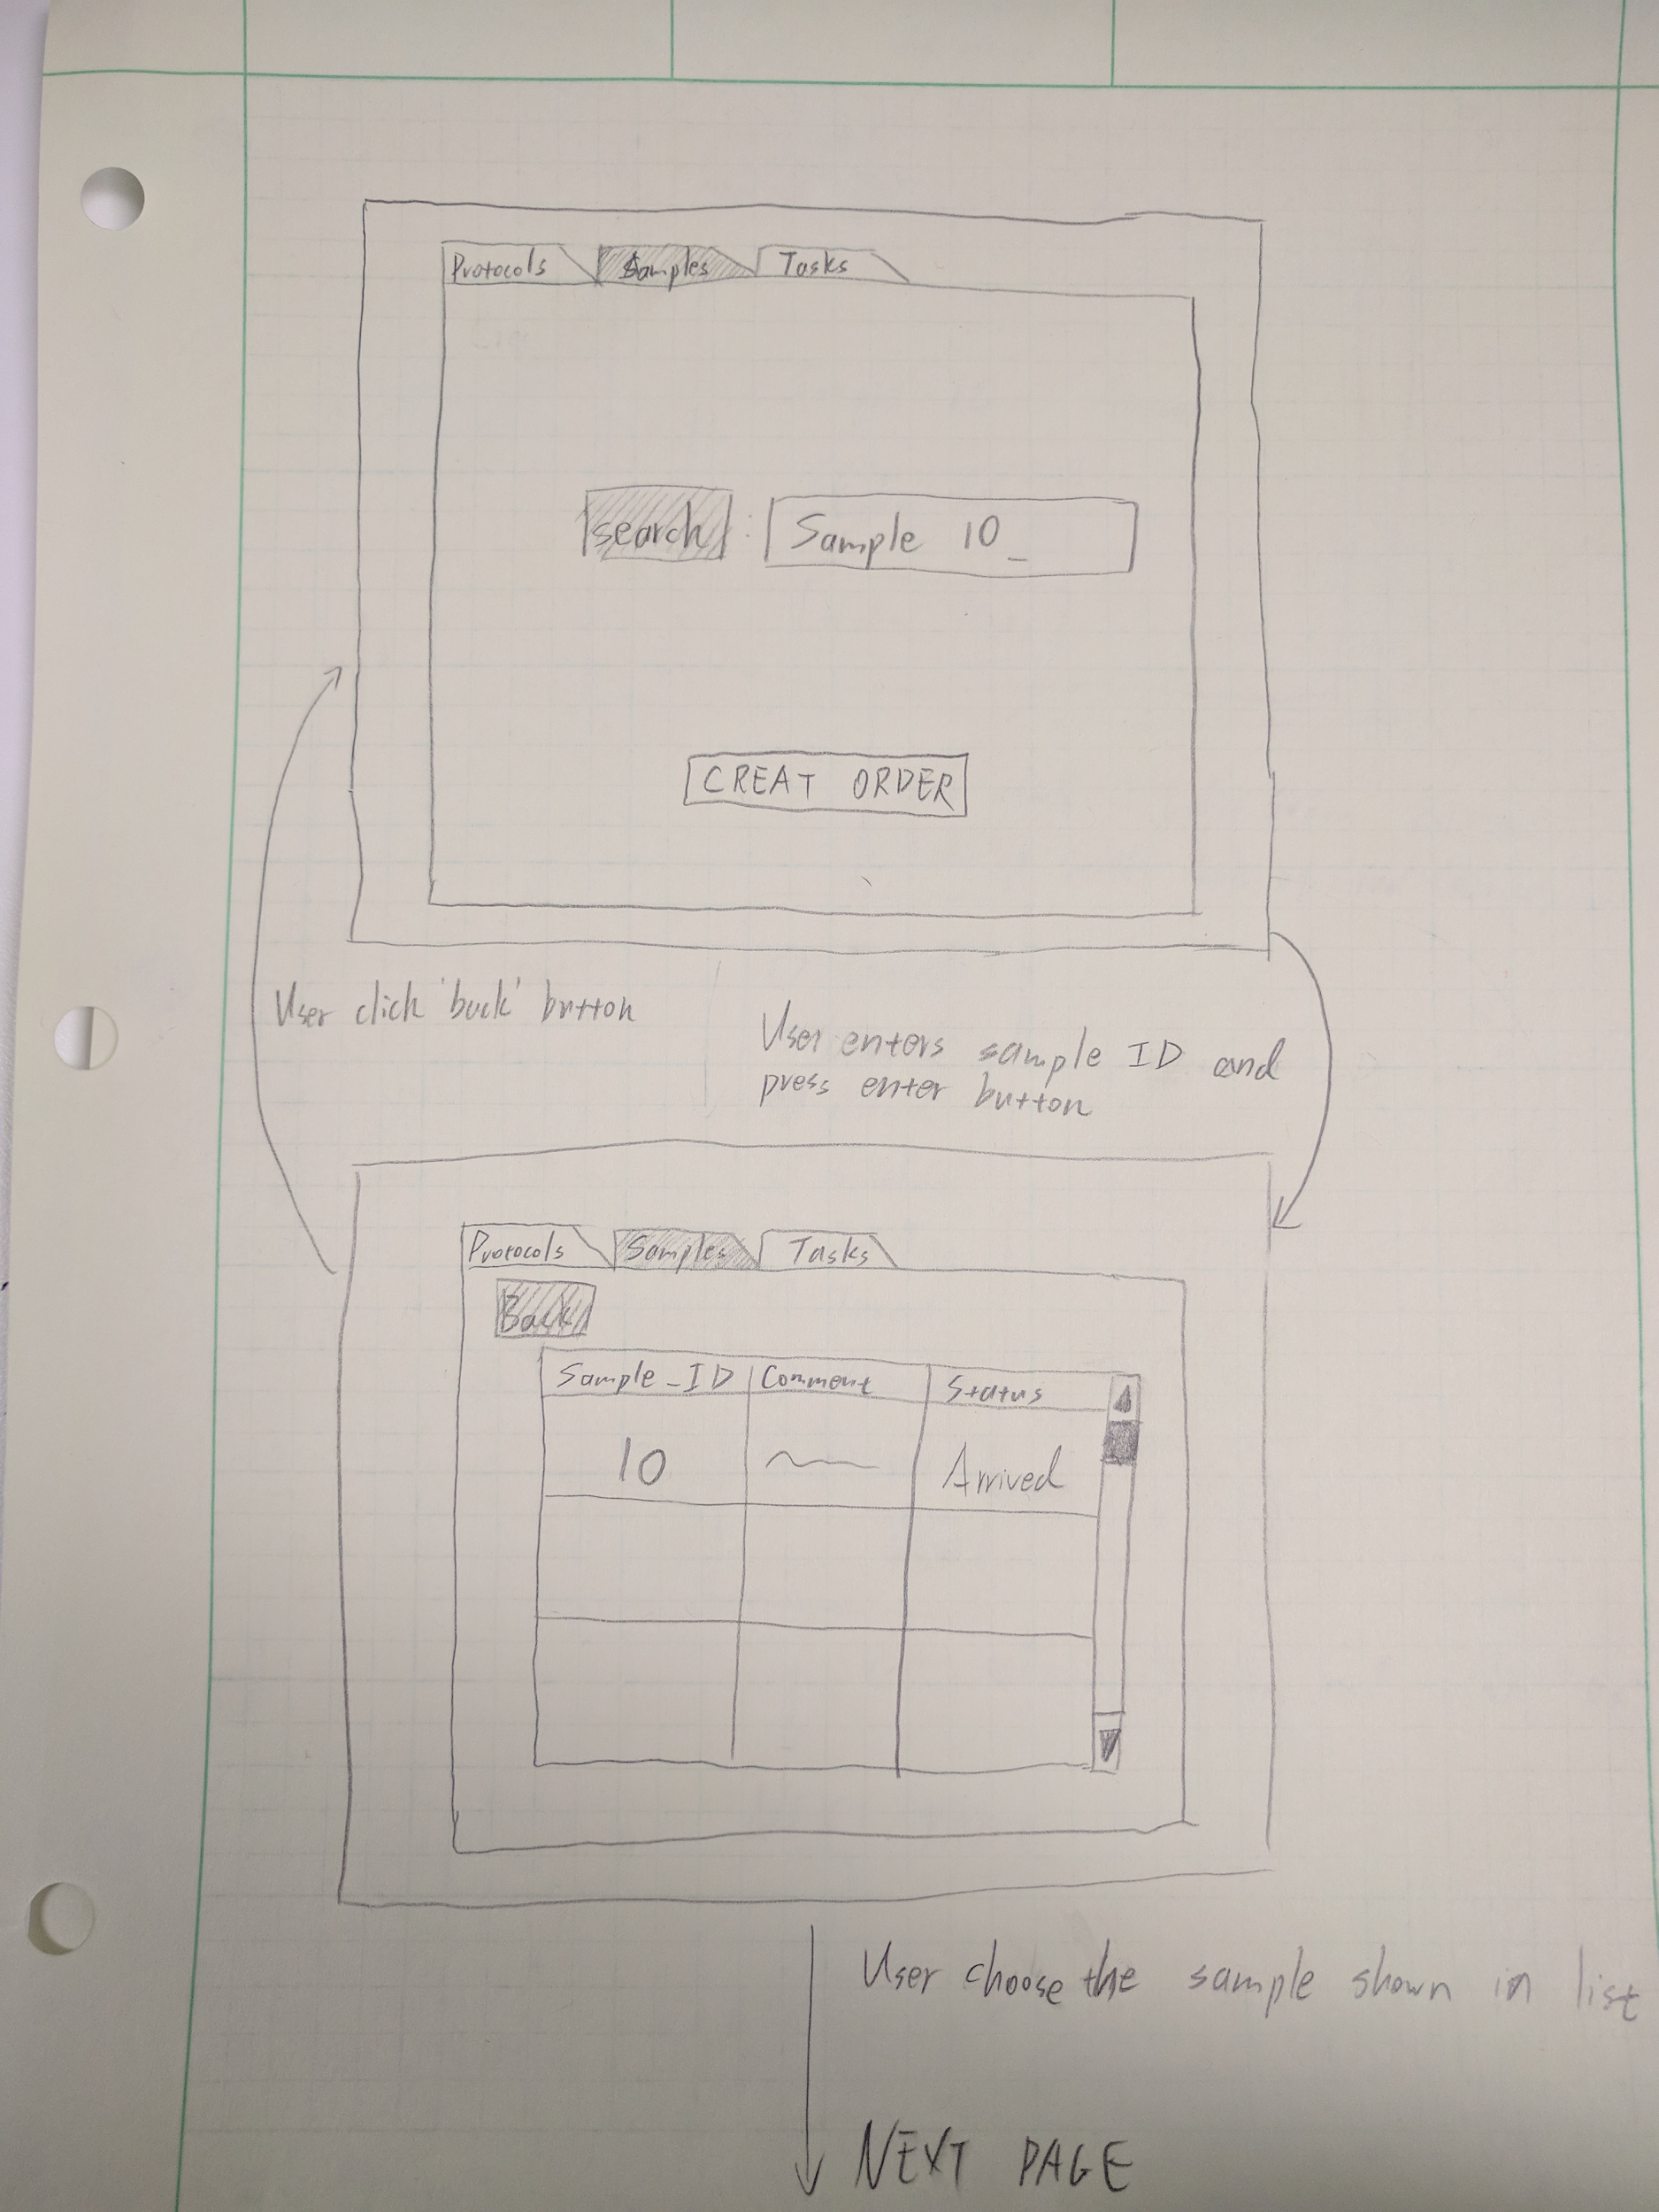](https://docs.google.com/document/d/1KzBfRg3pWlpYw4uTUH9maY_FCphE5WK0OpTnpD46gWw/edit#bookmark=id.ai1edqg7hj42)

[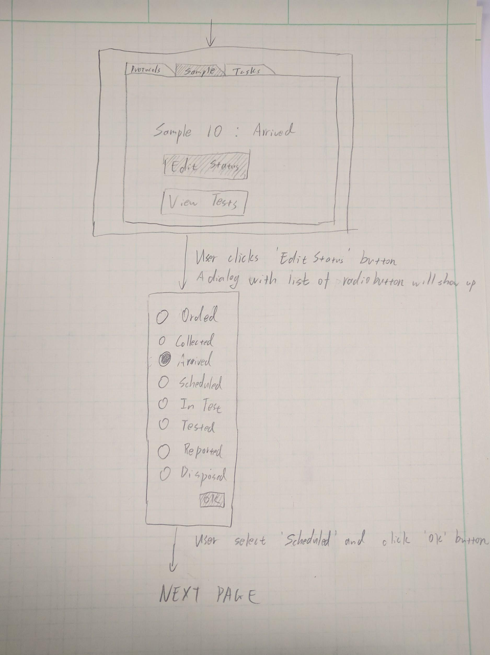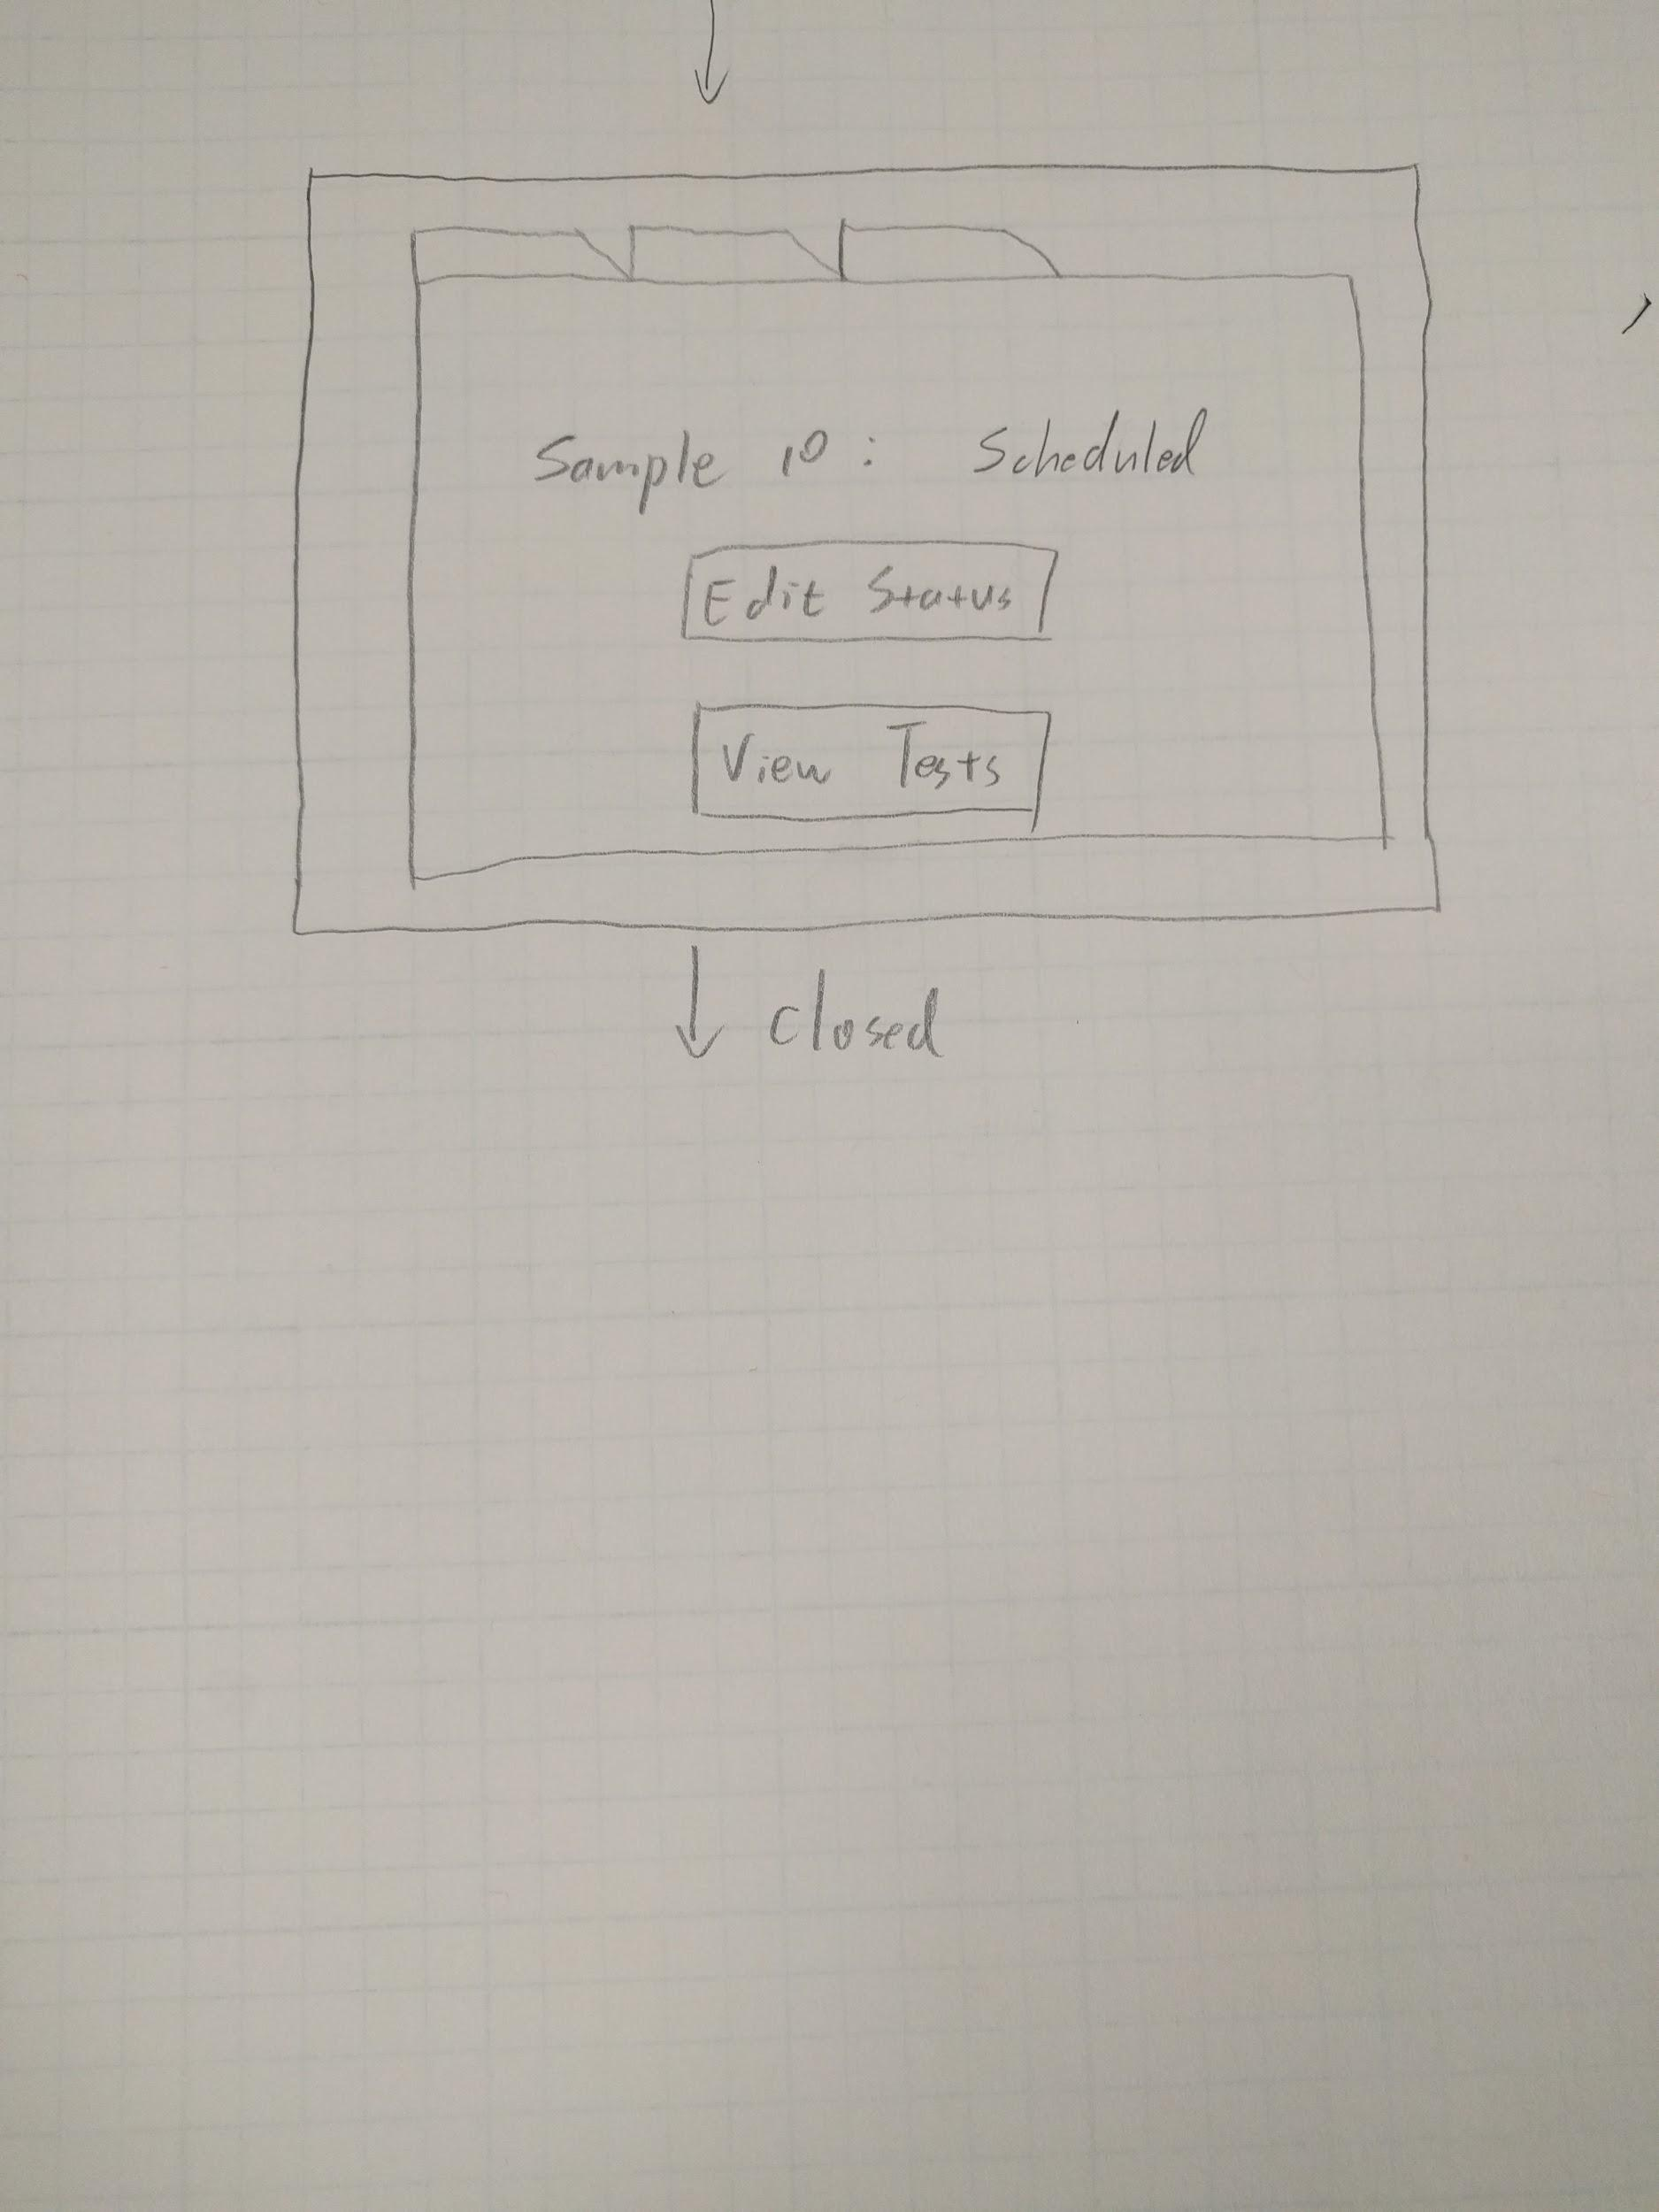](https://docs.google.com/document/d/1KzBfRg3pWlpYw4uTUH9maY_FCphE5WK0OpTnpD46gWw/edit#bookmark=id.ai1edqg7hj42)

### [Interface Evaluation](https://docs.google.com/document/d/1KzBfRg3pWlpYw4uTUH9maY_FCphE5WK0OpTnpD46gWw/edit#bookmark=id.ai1edqg7hj42)

|  |  |  |
| --- | --- | --- |
|  | [Design Principle](https://docs.google.com/document/d/1KzBfRg3pWlpYw4uTUH9maY_FCphE5WK0OpTnpD46gWw/edit#bookmark=id.ai1edqg7hj42) | [Rationale](https://docs.google.com/document/d/1KzBfRg3pWlpYw4uTUH9maY_FCphE5WK0OpTnpD46gWw/edit#bookmark=id.ai1edqg7hj42) |
| [1](https://docs.google.com/document/d/1KzBfRg3pWlpYw4uTUH9maY_FCphE5WK0OpTnpD46gWw/edit#bookmark=id.ai1edqg7hj42) | [Visibility](https://docs.google.com/document/d/1KzBfRg3pWlpYw4uTUH9maY_FCphE5WK0OpTnpD46gWw/edit#bookmark=id.ai1edqg7hj42) | [The tags of protocols, samples and tasks clearly show which section the user is currently on. All the buttons and radio buttons have texts to show what they mean. There is no information put in the corner of the window.](https://docs.google.com/document/d/1KzBfRg3pWlpYw4uTUH9maY_FCphE5WK0OpTnpD46gWw/edit#bookmark=id.ai1edqg7hj42) |
| [2](https://docs.google.com/document/d/1KzBfRg3pWlpYw4uTUH9maY_FCphE5WK0OpTnpD46gWw/edit#bookmark=id.ai1edqg7hj42) | [Feedback](https://docs.google.com/document/d/1KzBfRg3pWlpYw4uTUH9maY_FCphE5WK0OpTnpD46gWw/edit#bookmark=id.ai1edqg7hj42) | [When the status is changed, the system will directs users back to the page that let users view the change is already made. The radio buttons are a immediate feedback to users that what status they current select.](https://docs.google.com/document/d/1KzBfRg3pWlpYw4uTUH9maY_FCphE5WK0OpTnpD46gWw/edit#bookmark=id.ai1edqg7hj42) |

|  |  |  |
| --- | --- | --- |
|  | [Cognitive Paradigm](https://docs.google.com/document/d/1KzBfRg3pWlpYw4uTUH9maY_FCphE5WK0OpTnpD46gWw/edit#bookmark=id.ai1edqg7hj42) | [Rationale](https://docs.google.com/document/d/1KzBfRg3pWlpYw4uTUH9maY_FCphE5WK0OpTnpD46gWw/edit#bookmark=id.ai1edqg7hj42) |
| [1](https://docs.google.com/document/d/1KzBfRg3pWlpYw4uTUH9maY_FCphE5WK0OpTnpD46gWw/edit#bookmark=id.ai1edqg7hj42) | [Attention](https://docs.google.com/document/d/1KzBfRg3pWlpYw4uTUH9maY_FCphE5WK0OpTnpD46gWw/edit#bookmark=id.ai1edqg7hj42) | [The search bar is at the center of the page to attract users’ attention. The text that shows sample’s current status is also at the center of the page. The buttons for editing status and create order are really big, and near the text shows current status, which let user put attention on these two functions](https://docs.google.com/document/d/1KzBfRg3pWlpYw4uTUH9maY_FCphE5WK0OpTnpD46gWw/edit#bookmark=id.ai1edqg7hj42) |
| [2](https://docs.google.com/document/d/1KzBfRg3pWlpYw4uTUH9maY_FCphE5WK0OpTnpD46gWw/edit#bookmark=id.ai1edqg7hj42) | [Decision Making](https://docs.google.com/document/d/1KzBfRg3pWlpYw4uTUH9maY_FCphE5WK0OpTnpD46gWw/edit#bookmark=id.ai1edqg7hj42) | [The list of radio buttons give user a clear view of what decision they have, and what decision they current are making. The ‘OK’ text on the button at the list of radio buttons shows users they will make the decision after they click the button.](https://docs.google.com/document/d/1KzBfRg3pWlpYw4uTUH9maY_FCphE5WK0OpTnpD46gWw/edit#bookmark=id.ai1edqg7hj42) |

## 

## 

## [Production – Enter Test Results](https://docs.google.com/document/d/1KzBfRg3pWlpYw4uTUH9maY_FCphE5WK0OpTnpD46gWw/edit#bookmark=id.ai1edqg7hj42)

|  |  |
| --- | --- |
| [Prototypes](https://docs.google.com/document/d/1KzBfRg3pWlpYw4uTUH9maY_FCphE5WK0OpTnpD46gWw/edit#bookmark=id.ai1edqg7hj42) | [Use Case](https://docs.google.com/document/d/1KzBfRg3pWlpYw4uTUH9maY_FCphE5WK0OpTnpD46gWw/edit#bookmark=id.ai1edqg7hj42) |
| [Production – Enter Test Results](https://docs.google.com/document/d/1KzBfRg3pWlpYw4uTUH9maY_FCphE5WK0OpTnpD46gWw/edit#bookmark=id.ai1edqg7hj42) | [UploadResultofSample](https://docs.google.com/document/d/1KzBfRg3pWlpYw4uTUH9maY_FCphE5WK0OpTnpD46gWw/edit#bookmark=id.ai1edqg7hj42) [(link)](https://docs.google.com/document/d/1KzBfRg3pWlpYw4uTUH9maY_FCphE5WK0OpTnpD46gWw/edit#bookmark=id.ai1edqg7hj42)  [EnterError](https://docs.google.com/document/d/1KzBfRg3pWlpYw4uTUH9maY_FCphE5WK0OpTnpD46gWw/edit#bookmark=id.ai1edqg7hj42) [(link)](https://docs.google.com/document/d/1KzBfRg3pWlpYw4uTUH9maY_FCphE5WK0OpTnpD46gWw/edit#bookmark=id.ai1edqg7hj42) |

### [Prototype](https://docs.google.com/document/d/1KzBfRg3pWlpYw4uTUH9maY_FCphE5WK0OpTnpD46gWw/edit#bookmark=id.ai1edqg7hj42)

[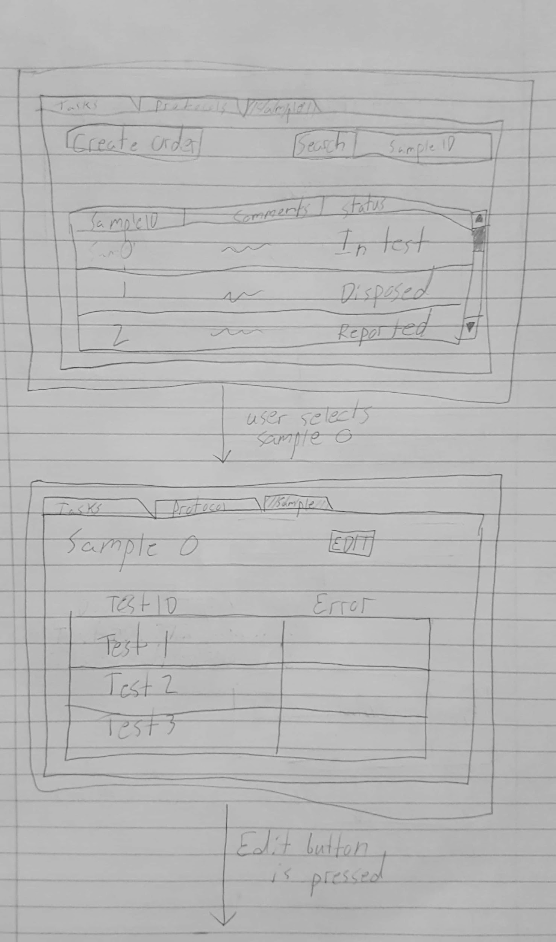](https://docs.google.com/document/d/1KzBfRg3pWlpYw4uTUH9maY_FCphE5WK0OpTnpD46gWw/edit#bookmark=id.ai1edqg7hj42)

### 

### 

### [Interface Evaluation](https://docs.google.com/document/d/1KzBfRg3pWlpYw4uTUH9maY_FCphE5WK0OpTnpD46gWw/edit#bookmark=id.ai1edqg7hj42)

|  |  |  |
| --- | --- | --- |
|  | [Design Principle](https://docs.google.com/document/d/1KzBfRg3pWlpYw4uTUH9maY_FCphE5WK0OpTnpD46gWw/edit#bookmark=id.ai1edqg7hj42) | [Rationale](https://docs.google.com/document/d/1KzBfRg3pWlpYw4uTUH9maY_FCphE5WK0OpTnpD46gWw/edit#bookmark=id.ai1edqg7hj42) |
| [1](https://docs.google.com/document/d/1KzBfRg3pWlpYw4uTUH9maY_FCphE5WK0OpTnpD46gWw/edit#bookmark=id.ai1edqg7hj42) | [Visibility](https://docs.google.com/document/d/1KzBfRg3pWlpYw4uTUH9maY_FCphE5WK0OpTnpD46gWw/edit#bookmark=id.ai1edqg7hj42) | [The design keeps uses visibility as a design principle by keeping all the functions that a user can perform at that moment plain to see in front of them in the form of buttons.](https://docs.google.com/document/d/1KzBfRg3pWlpYw4uTUH9maY_FCphE5WK0OpTnpD46gWw/edit#bookmark=id.ai1edqg7hj42) |
| [2](https://docs.google.com/document/d/1KzBfRg3pWlpYw4uTUH9maY_FCphE5WK0OpTnpD46gWw/edit#bookmark=id.ai1edqg7hj42) | [Affordance](https://docs.google.com/document/d/1KzBfRg3pWlpYw4uTUH9maY_FCphE5WK0OpTnpD46gWw/edit#bookmark=id.ai1edqg7hj42) | [The design dually uses affordance because the button design is easy to understand and therefore intuitive for the user to use.](https://docs.google.com/document/d/1KzBfRg3pWlpYw4uTUH9maY_FCphE5WK0OpTnpD46gWw/edit#bookmark=id.ai1edqg7hj42) |

|  |  |  |
| --- | --- | --- |
|  | [Cognitive Paradigm](https://docs.google.com/document/d/1KzBfRg3pWlpYw4uTUH9maY_FCphE5WK0OpTnpD46gWw/edit#bookmark=id.ai1edqg7hj42) | [Rationale](https://docs.google.com/document/d/1KzBfRg3pWlpYw4uTUH9maY_FCphE5WK0OpTnpD46gWw/edit#bookmark=id.ai1edqg7hj42) |
| [1](https://docs.google.com/document/d/1KzBfRg3pWlpYw4uTUH9maY_FCphE5WK0OpTnpD46gWw/edit#bookmark=id.ai1edqg7hj42) | [Memory](https://docs.google.com/document/d/1KzBfRg3pWlpYw4uTUH9maY_FCphE5WK0OpTnpD46gWw/edit#bookmark=id.ai1edqg7hj42) | [The design utilizes memory in that it requires the user to recall the file extension but it assists the user by allowing them to simply browse to where they would have saved the object instead of requiring them to know the entire path they can simply know the way they would get there.](https://docs.google.com/document/d/1KzBfRg3pWlpYw4uTUH9maY_FCphE5WK0OpTnpD46gWw/edit#bookmark=id.ai1edqg7hj42) |
| [2](https://docs.google.com/document/d/1KzBfRg3pWlpYw4uTUH9maY_FCphE5WK0OpTnpD46gWw/edit#bookmark=id.ai1edqg7hj42) | [Perception](https://docs.google.com/document/d/1KzBfRg3pWlpYw4uTUH9maY_FCphE5WK0OpTnpD46gWw/edit#bookmark=id.ai1edqg7hj42) | [The design uses perception by being easy to read and have nicely sized text so the user does not strain themselves trying to understand the material presented to them.](https://docs.google.com/document/d/1KzBfRg3pWlpYw4uTUH9maY_FCphE5WK0OpTnpD46gWw/edit#bookmark=id.ai1edqg7hj42) |

### [Alternate Design](https://docs.google.com/document/d/1KzBfRg3pWlpYw4uTUH9maY_FCphE5WK0OpTnpD46gWw/edit#bookmark=id.ai1edqg7hj42)

[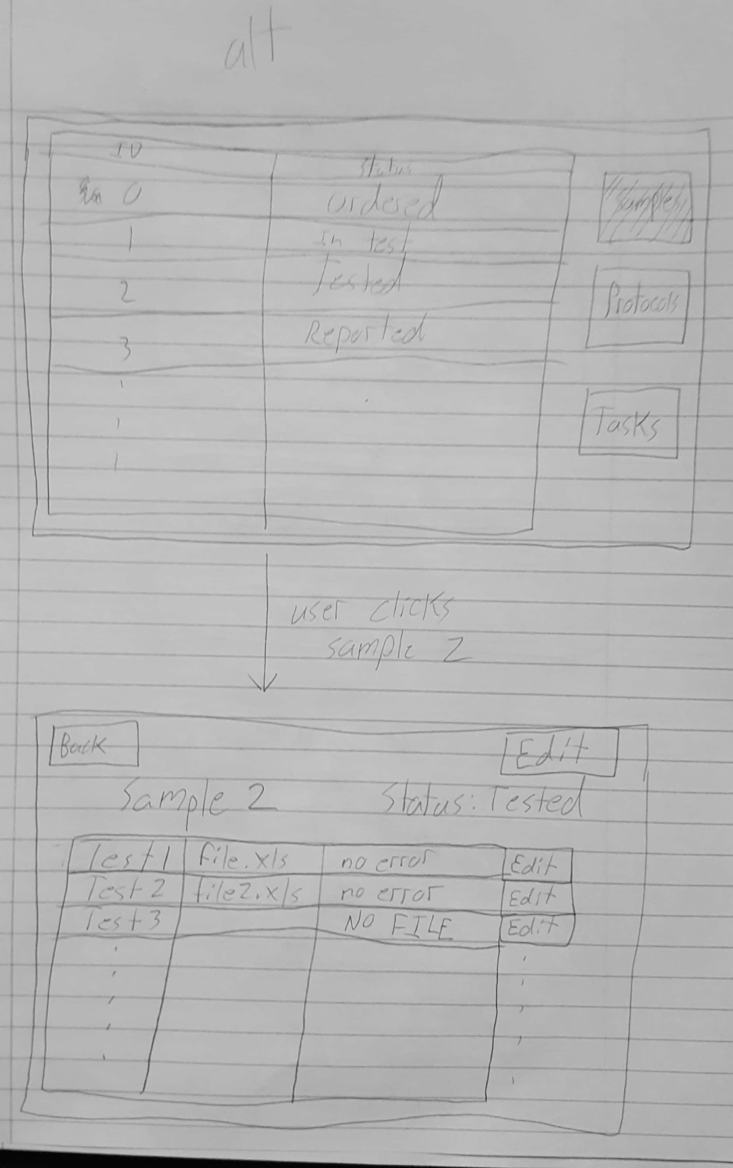](https://docs.google.com/document/d/1KzBfRg3pWlpYw4uTUH9maY_FCphE5WK0OpTnpD46gWw/edit#bookmark=id.ai1edqg7hj42)

[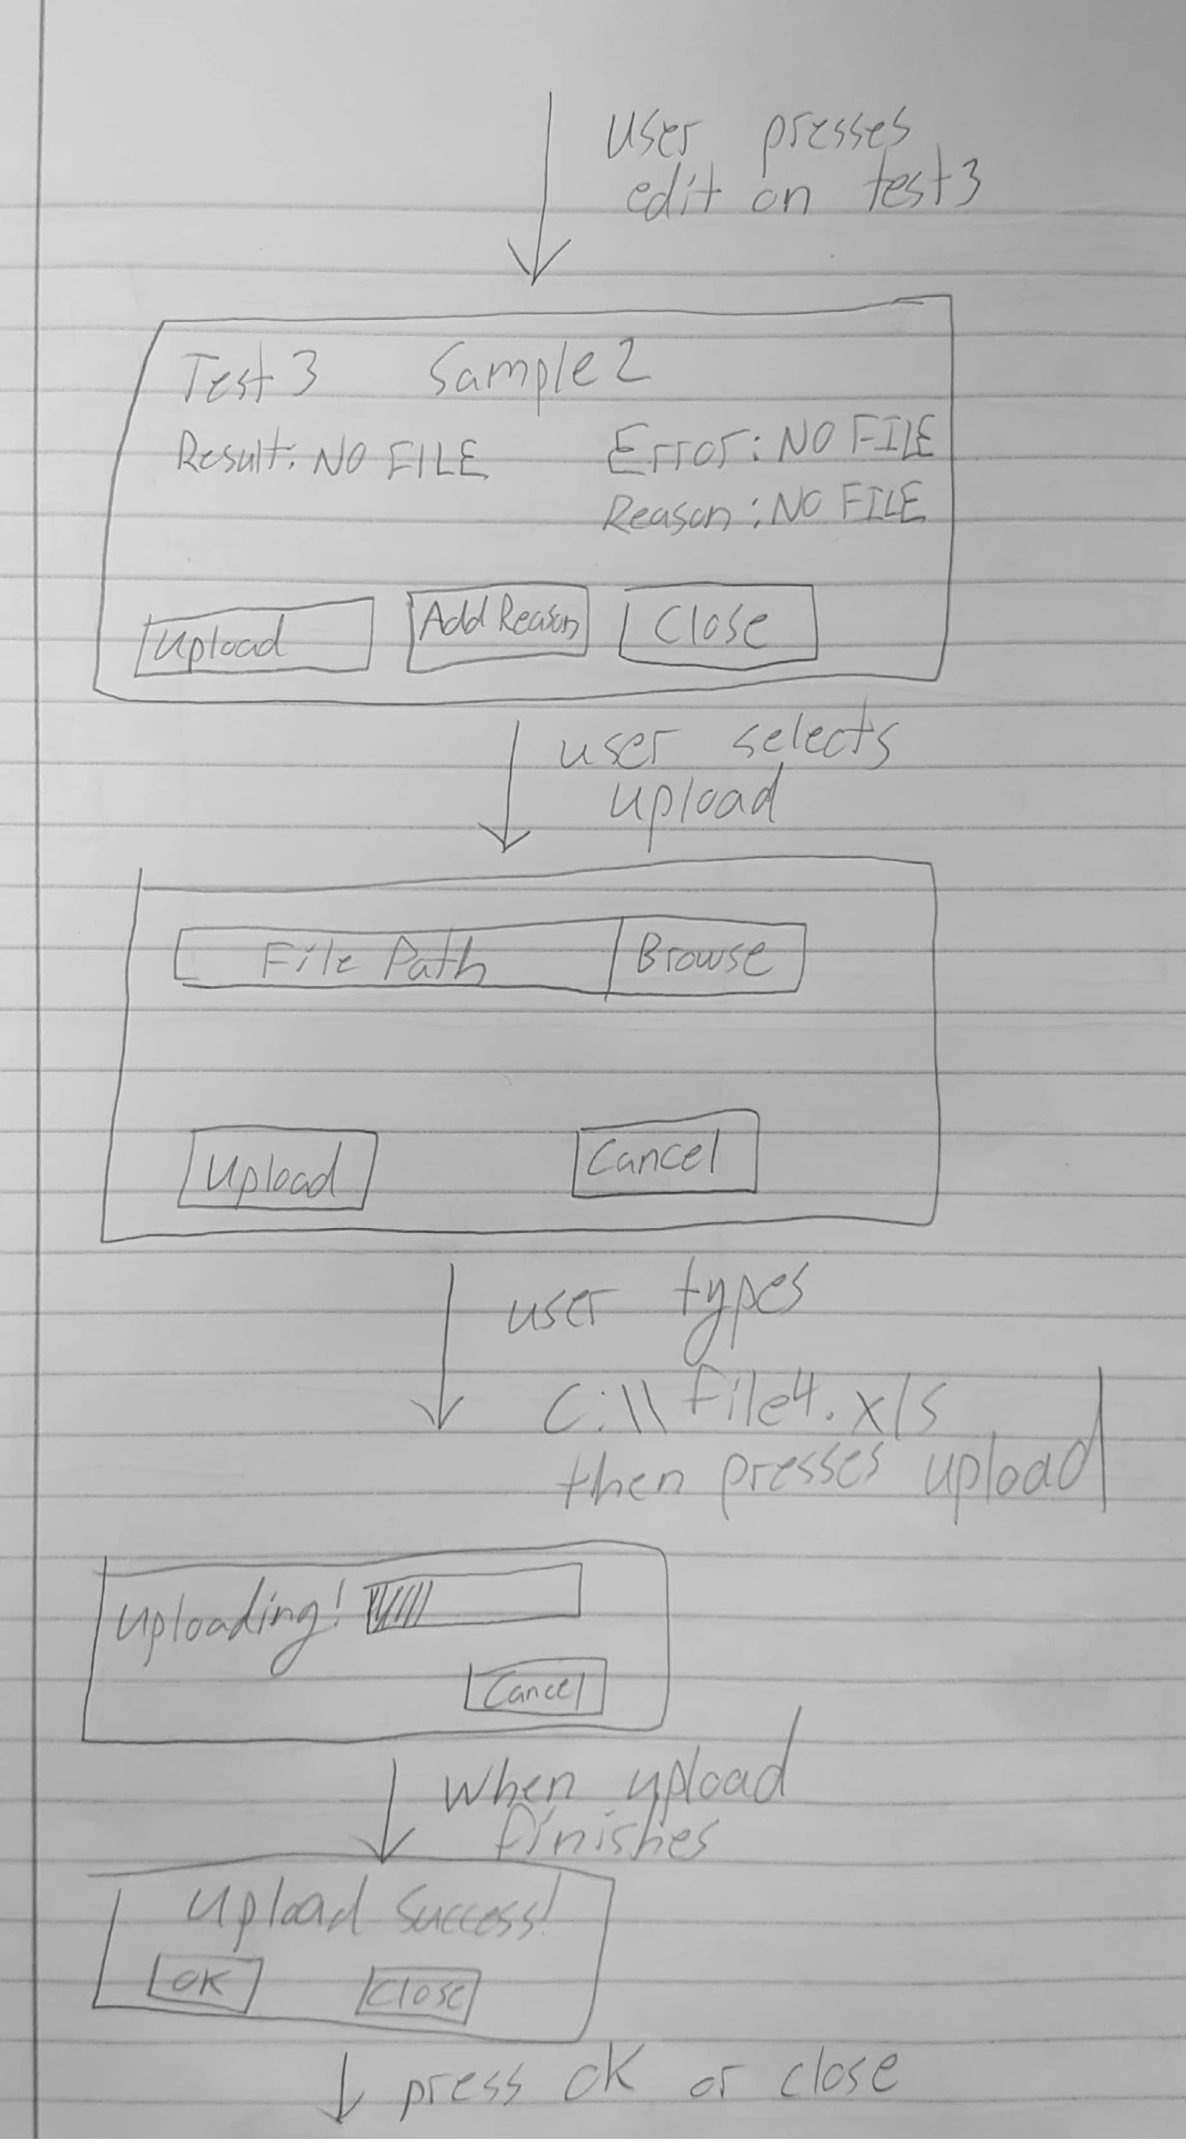](https://docs.google.com/document/d/1KzBfRg3pWlpYw4uTUH9maY_FCphE5WK0OpTnpD46gWw/edit#bookmark=id.ai1edqg7hj42)

[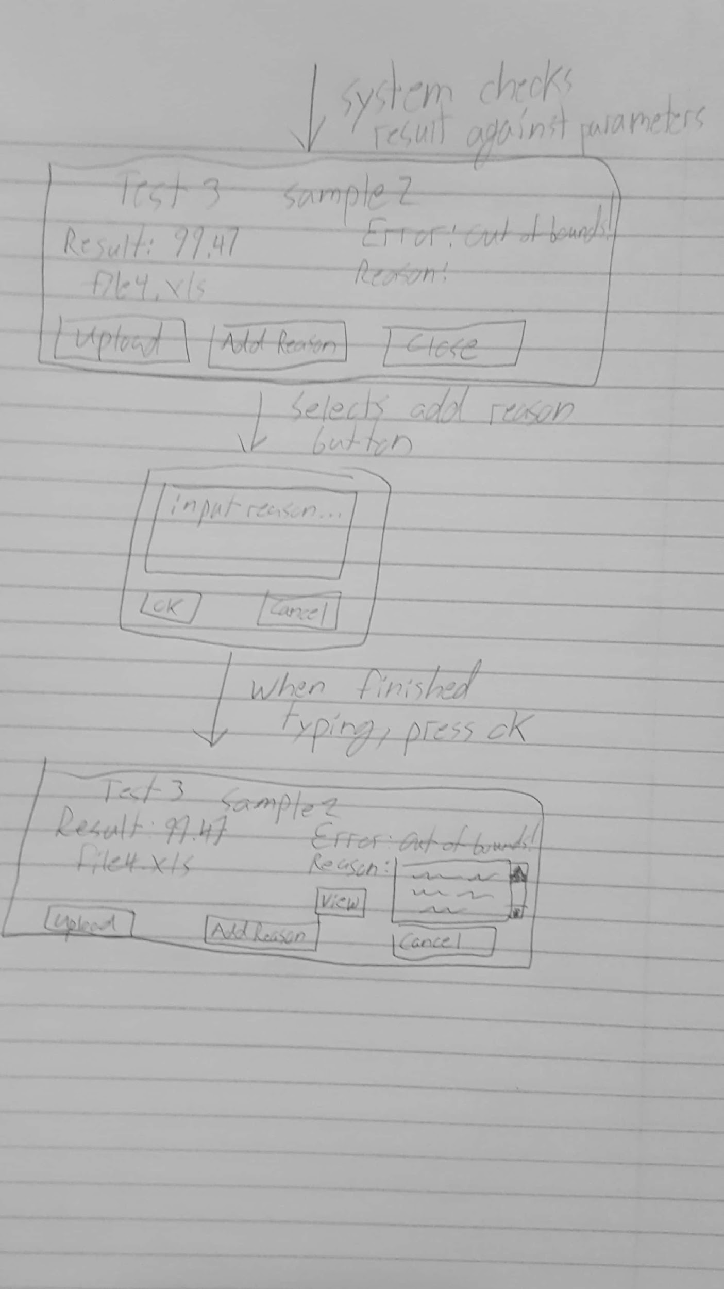](https://docs.google.com/document/d/1KzBfRg3pWlpYw4uTUH9maY_FCphE5WK0OpTnpD46gWw/edit#bookmark=id.ai1edqg7hj42)

### [Interface Evaluation](https://docs.google.com/document/d/1KzBfRg3pWlpYw4uTUH9maY_FCphE5WK0OpTnpD46gWw/edit#bookmark=id.ai1edqg7hj42)

|  |  |  |
| --- | --- | --- |
|  | [Design Principle](https://docs.google.com/document/d/1KzBfRg3pWlpYw4uTUH9maY_FCphE5WK0OpTnpD46gWw/edit#bookmark=id.ai1edqg7hj42) | [Rationale](https://docs.google.com/document/d/1KzBfRg3pWlpYw4uTUH9maY_FCphE5WK0OpTnpD46gWw/edit#bookmark=id.ai1edqg7hj42) |
| [1](https://docs.google.com/document/d/1KzBfRg3pWlpYw4uTUH9maY_FCphE5WK0OpTnpD46gWw/edit#bookmark=id.ai1edqg7hj42) | [Consistency](https://docs.google.com/document/d/1KzBfRg3pWlpYw4uTUH9maY_FCphE5WK0OpTnpD46gWw/edit#bookmark=id.ai1edqg7hj42) | [The design is consistent with operating system standards by having the action buttons on the left and the inaction buttons (cancel and close) on the right, it keeps this across all interfaces.](https://docs.google.com/document/d/1KzBfRg3pWlpYw4uTUH9maY_FCphE5WK0OpTnpD46gWw/edit#bookmark=id.ai1edqg7hj42) |
| [2](https://docs.google.com/document/d/1KzBfRg3pWlpYw4uTUH9maY_FCphE5WK0OpTnpD46gWw/edit#bookmark=id.ai1edqg7hj42) | [Affordance](https://docs.google.com/document/d/1KzBfRg3pWlpYw4uTUH9maY_FCphE5WK0OpTnpD46gWw/edit#bookmark=id.ai1edqg7hj42) | [The design in intuitive for this task by making it as easy to step through the task as possible and having clearly named buttons so that users always know what they’re about to do.](https://docs.google.com/document/d/1KzBfRg3pWlpYw4uTUH9maY_FCphE5WK0OpTnpD46gWw/edit#bookmark=id.ai1edqg7hj42) |

|  |  |  |
| --- | --- | --- |
|  | [Cognitive Paradigm](https://docs.google.com/document/d/1KzBfRg3pWlpYw4uTUH9maY_FCphE5WK0OpTnpD46gWw/edit#bookmark=id.ai1edqg7hj42) | [Rationale](https://docs.google.com/document/d/1KzBfRg3pWlpYw4uTUH9maY_FCphE5WK0OpTnpD46gWw/edit#bookmark=id.ai1edqg7hj42) |
| [1](https://docs.google.com/document/d/1KzBfRg3pWlpYw4uTUH9maY_FCphE5WK0OpTnpD46gWw/edit#bookmark=id.ai1edqg7hj42) | [Memory](https://docs.google.com/document/d/1KzBfRg3pWlpYw4uTUH9maY_FCphE5WK0OpTnpD46gWw/edit#bookmark=id.ai1edqg7hj42) | [The design utilizes memory in that it requires the user to recall the file extension but it assists the user by allowing them to simply browse to where they would have saved the object instead of requiring them to know the entire path they can simply know the way they would get there.](https://docs.google.com/document/d/1KzBfRg3pWlpYw4uTUH9maY_FCphE5WK0OpTnpD46gWw/edit#bookmark=id.ai1edqg7hj42) |
| [2](https://docs.google.com/document/d/1KzBfRg3pWlpYw4uTUH9maY_FCphE5WK0OpTnpD46gWw/edit#bookmark=id.ai1edqg7hj42) | [Perception](https://docs.google.com/document/d/1KzBfRg3pWlpYw4uTUH9maY_FCphE5WK0OpTnpD46gWw/edit#bookmark=id.ai1edqg7hj42) | [The design uses perception by being easy to read and have nicely sized text so the user does not strain themselves trying to understand the material presented to them.](https://docs.google.com/document/d/1KzBfRg3pWlpYw4uTUH9maY_FCphE5WK0OpTnpD46gWw/edit#bookmark=id.ai1edqg7hj42) |

## [Production - View Technicians Workload Assignments](https://docs.google.com/document/d/1KzBfRg3pWlpYw4uTUH9maY_FCphE5WK0OpTnpD46gWw/edit#bookmark=id.ai1edqg7hj42)

|  |  |
| --- | --- |
| [Prototypes](https://docs.google.com/document/d/1KzBfRg3pWlpYw4uTUH9maY_FCphE5WK0OpTnpD46gWw/edit#bookmark=id.ai1edqg7hj42) | [Use Case](https://docs.google.com/document/d/1KzBfRg3pWlpYw4uTUH9maY_FCphE5WK0OpTnpD46gWw/edit#bookmark=id.ai1edqg7hj42) |
| [Production – View Technician Workload Assignments](https://docs.google.com/document/d/1KzBfRg3pWlpYw4uTUH9maY_FCphE5WK0OpTnpD46gWw/edit#bookmark=id.ai1edqg7hj42) | [ViewTechnicianTasks](https://docs.google.com/document/d/1KzBfRg3pWlpYw4uTUH9maY_FCphE5WK0OpTnpD46gWw/edit#bookmark=id.ai1edqg7hj42) [(link)](https://docs.google.com/document/d/1KzBfRg3pWlpYw4uTUH9maY_FCphE5WK0OpTnpD46gWw/edit#bookmark=id.ai1edqg7hj42) |

### [Prototype](https://docs.google.com/document/d/1KzBfRg3pWlpYw4uTUH9maY_FCphE5WK0OpTnpD46gWw/edit#bookmark=id.ai1edqg7hj42)

[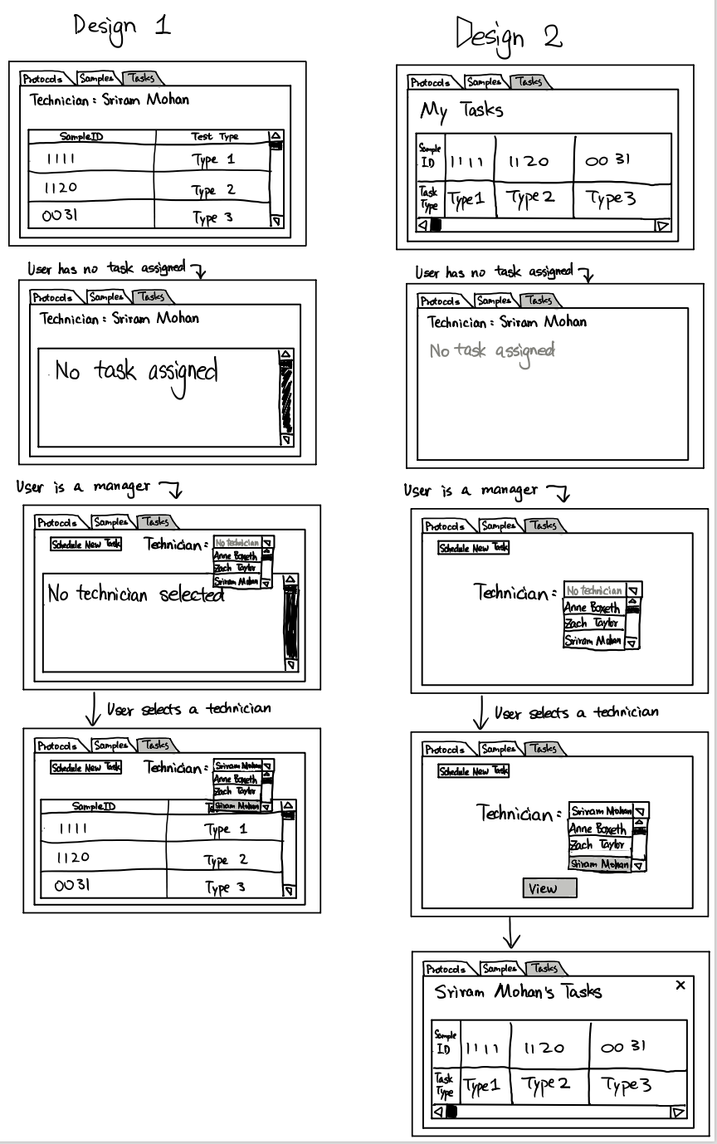](https://docs.google.com/document/d/1KzBfRg3pWlpYw4uTUH9maY_FCphE5WK0OpTnpD46gWw/edit#bookmark=id.ai1edqg7hj42)

### [Interface Evaluation (Design 1)](https://docs.google.com/document/d/1KzBfRg3pWlpYw4uTUH9maY_FCphE5WK0OpTnpD46gWw/edit#bookmark=id.ai1edqg7hj42)

|  |  |  |
| --- | --- | --- |
|  | [Design Principle](https://docs.google.com/document/d/1KzBfRg3pWlpYw4uTUH9maY_FCphE5WK0OpTnpD46gWw/edit#bookmark=id.ai1edqg7hj42) | [Rationale](https://docs.google.com/document/d/1KzBfRg3pWlpYw4uTUH9maY_FCphE5WK0OpTnpD46gWw/edit#bookmark=id.ai1edqg7hj42) |
| [1](https://docs.google.com/document/d/1KzBfRg3pWlpYw4uTUH9maY_FCphE5WK0OpTnpD46gWw/edit#bookmark=id.ai1edqg7hj42) | [Feedback](https://docs.google.com/document/d/1KzBfRg3pWlpYw4uTUH9maY_FCphE5WK0OpTnpD46gWw/edit#bookmark=id.ai1edqg7hj42) | [The design gives feedback by telling the user what it has not done yet, by having not selected a technician the user is told that they have not yet done the one thing required, when they have selected a technician immediately their information is brought up.](https://docs.google.com/document/d/1KzBfRg3pWlpYw4uTUH9maY_FCphE5WK0OpTnpD46gWw/edit#bookmark=id.ai1edqg7hj42) |
| [2](https://docs.google.com/document/d/1KzBfRg3pWlpYw4uTUH9maY_FCphE5WK0OpTnpD46gWw/edit#bookmark=id.ai1edqg7hj42) | [Affordance](https://docs.google.com/document/d/1KzBfRg3pWlpYw4uTUH9maY_FCphE5WK0OpTnpD46gWw/edit#bookmark=id.ai1edqg7hj42) | [The design is intuitive to use because it supports interaction both by clicking on what is desired and by navigating with buttons.](https://docs.google.com/document/d/1KzBfRg3pWlpYw4uTUH9maY_FCphE5WK0OpTnpD46gWw/edit#bookmark=id.ai1edqg7hj42) |

|  |  |  |
| --- | --- | --- |
|  | [Cognitive Paradigm](https://docs.google.com/document/d/1KzBfRg3pWlpYw4uTUH9maY_FCphE5WK0OpTnpD46gWw/edit#bookmark=id.ai1edqg7hj42) | [Rationale](https://docs.google.com/document/d/1KzBfRg3pWlpYw4uTUH9maY_FCphE5WK0OpTnpD46gWw/edit#bookmark=id.ai1edqg7hj42) |
| [1](https://docs.google.com/document/d/1KzBfRg3pWlpYw4uTUH9maY_FCphE5WK0OpTnpD46gWw/edit#bookmark=id.ai1edqg7hj42) | [Attention( Decision making)](https://docs.google.com/document/d/1KzBfRg3pWlpYw4uTUH9maY_FCphE5WK0OpTnpD46gWw/edit#bookmark=id.ai1edqg7hj42) | [The design favors decision making by having all of the things that can be done right in front of the user so that they never have to consider what can and cannot be done they can simply do.](https://docs.google.com/document/d/1KzBfRg3pWlpYw4uTUH9maY_FCphE5WK0OpTnpD46gWw/edit#bookmark=id.ai1edqg7hj42) |
| [2](https://docs.google.com/document/d/1KzBfRg3pWlpYw4uTUH9maY_FCphE5WK0OpTnpD46gWw/edit#bookmark=id.ai1edqg7hj42) | [Memory](https://docs.google.com/document/d/1KzBfRg3pWlpYw4uTUH9maY_FCphE5WK0OpTnpD46gWw/edit#bookmark=id.ai1edqg7hj42) | [This design uses memory in that it requires the user to recall the technician they want to assign tasks to but it also helps them by running a live search to narrow down the possible technicians to help the user with finding the one they want even if they only know the first few letters of the technician.](https://docs.google.com/document/d/1KzBfRg3pWlpYw4uTUH9maY_FCphE5WK0OpTnpD46gWw/edit#bookmark=id.ai1edqg7hj42) |

### [Interface Evaluation (Design 2)](https://docs.google.com/document/d/1KzBfRg3pWlpYw4uTUH9maY_FCphE5WK0OpTnpD46gWw/edit#bookmark=id.ai1edqg7hj42)

|  |  |  |
| --- | --- | --- |
|  | [Design Principle](https://docs.google.com/document/d/1KzBfRg3pWlpYw4uTUH9maY_FCphE5WK0OpTnpD46gWw/edit#bookmark=id.ai1edqg7hj42) | [Rationale](https://docs.google.com/document/d/1KzBfRg3pWlpYw4uTUH9maY_FCphE5WK0OpTnpD46gWw/edit#bookmark=id.ai1edqg7hj42) |
| [1](https://docs.google.com/document/d/1KzBfRg3pWlpYw4uTUH9maY_FCphE5WK0OpTnpD46gWw/edit#bookmark=id.ai1edqg7hj42) | [Consistency](https://docs.google.com/document/d/1KzBfRg3pWlpYw4uTUH9maY_FCphE5WK0OpTnpD46gWw/edit#bookmark=id.ai1edqg7hj42) | [The design is consistent across interfaces by laying everything out the same so the user never gets lost.](https://docs.google.com/document/d/1KzBfRg3pWlpYw4uTUH9maY_FCphE5WK0OpTnpD46gWw/edit#bookmark=id.ai1edqg7hj42) |
| [2](https://docs.google.com/document/d/1KzBfRg3pWlpYw4uTUH9maY_FCphE5WK0OpTnpD46gWw/edit#bookmark=id.ai1edqg7hj42) | [Visibility](https://docs.google.com/document/d/1KzBfRg3pWlpYw4uTUH9maY_FCphE5WK0OpTnpD46gWw/edit#bookmark=id.ai1edqg7hj42) | [The design uses visibility by having everything in the design be easy to see and therefore what can be changed, it eliminates guesswork.](https://docs.google.com/document/d/1KzBfRg3pWlpYw4uTUH9maY_FCphE5WK0OpTnpD46gWw/edit#bookmark=id.ai1edqg7hj42) |

|  |  |  |
| --- | --- | --- |
|  | [Cognitive Paradigm](https://docs.google.com/document/d/1KzBfRg3pWlpYw4uTUH9maY_FCphE5WK0OpTnpD46gWw/edit#bookmark=id.ai1edqg7hj42) | [Rationale](https://docs.google.com/document/d/1KzBfRg3pWlpYw4uTUH9maY_FCphE5WK0OpTnpD46gWw/edit#bookmark=id.ai1edqg7hj42) |
| [1](https://docs.google.com/document/d/1KzBfRg3pWlpYw4uTUH9maY_FCphE5WK0OpTnpD46gWw/edit#bookmark=id.ai1edqg7hj42) | [Decision Making](https://docs.google.com/document/d/1KzBfRg3pWlpYw4uTUH9maY_FCphE5WK0OpTnpD46gWw/edit#bookmark=id.ai1edqg7hj42) | [The design favors decision making by having all of the things that can be done right in front of the user so that they never have to consider what can and cannot be done they can simply do.](https://docs.google.com/document/d/1KzBfRg3pWlpYw4uTUH9maY_FCphE5WK0OpTnpD46gWw/edit#bookmark=id.ai1edqg7hj42) |
| [2](https://docs.google.com/document/d/1KzBfRg3pWlpYw4uTUH9maY_FCphE5WK0OpTnpD46gWw/edit#bookmark=id.ai1edqg7hj42) | [Memory](https://docs.google.com/document/d/1KzBfRg3pWlpYw4uTUH9maY_FCphE5WK0OpTnpD46gWw/edit#bookmark=id.ai1edqg7hj42) | [This design uses memory in that it requires the user to recall the technician they want to assign tasks to but it also helps them by running a live search to narrow down the possible technicians to help the user with finding the one they want even if they only know the first few letters of the technician.](https://docs.google.com/document/d/1KzBfRg3pWlpYw4uTUH9maY_FCphE5WK0OpTnpD46gWw/edit#bookmark=id.ai1edqg7hj42) |

# [Usability Test Plan](https://docs.google.com/document/d/1KzBfRg3pWlpYw4uTUH9maY_FCphE5WK0OpTnpD46gWw/edit#bookmark=id.ai1edqg7hj42)

## [Goals](https://docs.google.com/document/d/1KzBfRg3pWlpYw4uTUH9maY_FCphE5WK0OpTnpD46gWw/edit#bookmark=id.ai1edqg7hj42)

[The basic goals for the usability test include verifying relevant information is shown, the interfaces have intuitive design, the design follows visibility conventions, and the application is easy to use. We want to know if relevant information is presented for each task the users will have to do. We think we have shown all important data on the pages, but the users may be puzzled by lack of a piece of information we have overlooked. We have created a design that we believe to be easy to use and enables the user to perform tasks quickly and efficiently. The users may have different background using pieces of software different than what we are used to thus they may encounter difficulties we didn’t predict in design. The usability test will reveal shortcomings that our design may have in areas of information displayed and effectiveness of our application.](https://docs.google.com/document/d/1KzBfRg3pWlpYw4uTUH9maY_FCphE5WK0OpTnpD46gWw/edit#bookmark=id.ai1edqg7hj42)

## [Instructions for Users to Complete Task](https://docs.google.com/document/d/1KzBfRg3pWlpYw4uTUH9maY_FCphE5WK0OpTnpD46gWw/edit#bookmark=id.ai1edqg7hj42)

|  |  |
| --- | --- |
| [Task](https://docs.google.com/document/d/1KzBfRg3pWlpYw4uTUH9maY_FCphE5WK0OpTnpD46gWw/edit#bookmark=id.ai1edqg7hj42) | [Instructions](https://docs.google.com/document/d/1KzBfRg3pWlpYw4uTUH9maY_FCphE5WK0OpTnpD46gWw/edit#bookmark=id.ai1edqg7hj42) |
| [Assay Development – Revise a protocol for an assay](https://docs.google.com/document/d/1KzBfRg3pWlpYw4uTUH9maY_FCphE5WK0OpTnpD46gWw/edit#bookmark=id.ai1edqg7hj42) | [We provide the user with a protocol name and a protocol version for the user to complete the following steps:](https://docs.google.com/document/d/1KzBfRg3pWlpYw4uTUH9maY_FCphE5WK0OpTnpD46gWw/edit#bookmark=id.ai1edqg7hj42)   * [User searches for protocol based on the information he is given](https://docs.google.com/document/d/1KzBfRg3pWlpYw4uTUH9maY_FCphE5WK0OpTnpD46gWw/edit#bookmark=id.ai1edqg7hj42) * [User downloads the right version of the protocol](https://docs.google.com/document/d/1KzBfRg3pWlpYw4uTUH9maY_FCphE5WK0OpTnpD46gWw/edit#bookmark=id.ai1edqg7hj42) * [User edits the protocol in Microsoft Word](https://docs.google.com/document/d/1KzBfRg3pWlpYw4uTUH9maY_FCphE5WK0OpTnpD46gWw/edit#bookmark=id.ai1edqg7hj42) * [User uploads a new file to the protocol](https://docs.google.com/document/d/1KzBfRg3pWlpYw4uTUH9maY_FCphE5WK0OpTnpD46gWw/edit#bookmark=id.ai1edqg7hj42) |
| [Assay Development – View assays by status](https://docs.google.com/document/d/1KzBfRg3pWlpYw4uTUH9maY_FCphE5WK0OpTnpD46gWw/edit#bookmark=id.ai1edqg7hj42) | [We provide the user with an assay name for the user to complete the following steps:](https://docs.google.com/document/d/1KzBfRg3pWlpYw4uTUH9maY_FCphE5WK0OpTnpD46gWw/edit#bookmark=id.ai1edqg7hj42)   * [User locates and selects assay](https://docs.google.com/document/d/1KzBfRg3pWlpYw4uTUH9maY_FCphE5WK0OpTnpD46gWw/edit#bookmark=id.ai1edqg7hj42) * [User reports assay status](https://docs.google.com/document/d/1KzBfRg3pWlpYw4uTUH9maY_FCphE5WK0OpTnpD46gWw/edit#bookmark=id.ai1edqg7hj42) |
| [Assay Development – Add a new assay idea](https://docs.google.com/document/d/1KzBfRg3pWlpYw4uTUH9maY_FCphE5WK0OpTnpD46gWw/edit#bookmark=id.ai1edqg7hj42) | [We provide the user with a new assay name, description, and two documents for the user to complete the following steps:](https://docs.google.com/document/d/1KzBfRg3pWlpYw4uTUH9maY_FCphE5WK0OpTnpD46gWw/edit#bookmark=id.ai1edqg7hj42)   * [User navigates to “Assays” tab in an assay manager’s view](https://docs.google.com/document/d/1KzBfRg3pWlpYw4uTUH9maY_FCphE5WK0OpTnpD46gWw/edit#bookmark=id.ai1edqg7hj42) * [User create new assay idea](https://docs.google.com/document/d/1KzBfRg3pWlpYw4uTUH9maY_FCphE5WK0OpTnpD46gWw/edit#bookmark=id.ai1edqg7hj42) * [User enters new assay name and description and adds the two documents](https://docs.google.com/document/d/1KzBfRg3pWlpYw4uTUH9maY_FCphE5WK0OpTnpD46gWw/edit#bookmark=id.ai1edqg7hj42) * [User submits new assay idea](https://docs.google.com/document/d/1KzBfRg3pWlpYw4uTUH9maY_FCphE5WK0OpTnpD46gWw/edit#bookmark=id.ai1edqg7hj42) |
| [Production – Enter Sample for Testing](https://docs.google.com/document/d/1KzBfRg3pWlpYw4uTUH9maY_FCphE5WK0OpTnpD46gWw/edit#bookmark=id.ai1edqg7hj42) | [We provide the user with an sample ID for the user to complete the following steps:](https://docs.google.com/document/d/1KzBfRg3pWlpYw4uTUH9maY_FCphE5WK0OpTnpD46gWw/edit#bookmark=id.ai1edqg7hj42)   * [Navigate to given sample information page](https://docs.google.com/document/d/1KzBfRg3pWlpYw4uTUH9maY_FCphE5WK0OpTnpD46gWw/edit#bookmark=id.ai1edqg7hj42) * [Edit status of sample to be “Scheduled”](https://docs.google.com/document/d/1KzBfRg3pWlpYw4uTUH9maY_FCphE5WK0OpTnpD46gWw/edit#bookmark=id.ai1edqg7hj42) * [Close sample](https://docs.google.com/document/d/1KzBfRg3pWlpYw4uTUH9maY_FCphE5WK0OpTnpD46gWw/edit#bookmark=id.ai1edqg7hj42) |
| [Production -- Enter Test Results](https://docs.google.com/document/d/1KzBfRg3pWlpYw4uTUH9maY_FCphE5WK0OpTnpD46gWw/edit#bookmark=id.ai1edqg7hj42) | [We provide the user with a sample ID and test name for the user to complete the following steps:](https://docs.google.com/document/d/1KzBfRg3pWlpYw4uTUH9maY_FCphE5WK0OpTnpD46gWw/edit#bookmark=id.ai1edqg7hj42)   * [User searches for sample ID of the sample associated with the test ran](https://docs.google.com/document/d/1KzBfRg3pWlpYw4uTUH9maY_FCphE5WK0OpTnpD46gWw/edit#bookmark=id.ai1edqg7hj42) * [User edits the test that the results that the have corresponds to](https://docs.google.com/document/d/1KzBfRg3pWlpYw4uTUH9maY_FCphE5WK0OpTnpD46gWw/edit#bookmark=id.ai1edqg7hj42) * [User uploads a file to the test information page](https://docs.google.com/document/d/1KzBfRg3pWlpYw4uTUH9maY_FCphE5WK0OpTnpD46gWw/edit#bookmark=id.ai1edqg7hj42) |
| [Production – View Technician Workload Assignments](https://docs.google.com/document/d/1KzBfRg3pWlpYw4uTUH9maY_FCphE5WK0OpTnpD46gWw/edit#bookmark=id.ai1edqg7hj42) | [We provide the user with a technician name for the user to complete the following steps:](https://docs.google.com/document/d/1KzBfRg3pWlpYw4uTUH9maY_FCphE5WK0OpTnpD46gWw/edit#bookmark=id.ai1edqg7hj42)   * [User navigates to the tasks interface](https://docs.google.com/document/d/1KzBfRg3pWlpYw4uTUH9maY_FCphE5WK0OpTnpD46gWw/edit#bookmark=id.ai1edqg7hj42) * [User searches the technician whose name is given to him](https://docs.google.com/document/d/1KzBfRg3pWlpYw4uTUH9maY_FCphE5WK0OpTnpD46gWw/edit#bookmark=id.ai1edqg7hj42) * [User views the technician’s workload assignments](https://docs.google.com/document/d/1KzBfRg3pWlpYw4uTUH9maY_FCphE5WK0OpTnpD46gWw/edit#bookmark=id.ai1edqg7hj42) |

## [Quantitative Measurements](https://docs.google.com/document/d/1KzBfRg3pWlpYw4uTUH9maY_FCphE5WK0OpTnpD46gWw/edit#bookmark=id.ai1edqg7hj42)

[The metrics we want to measure are time consumed for each instruction, mouse clicks, and answers to closed questions on a questionnaire. We will measure time consumed per step for each use case. This will help us determine if the software is an overall easy to use, effective solution to the problem. We will measure time using the usability lab software and also a team member’s phone’s stopwatch. We also want to count number of mouse clicks. This will give us information about if the user can correctly identify what things to interact with, determining intuitiveness of design and ease of use. We will have a counter on the usability lab software to count the number clicks per task. We will have another team members counting clicks per step for each use case, starting when the timer is started for that step as backup. Lastly, plan to ask subjects to rate the following items on a scale from 1 (bad) to 5 (good): ease of use, readability of interface, clarity of interface, time taken to complete tasks, efficiency/effectiveness, and overall satisfaction. These will be a starting point to see trends of user experience with the application.](https://docs.google.com/document/d/1KzBfRg3pWlpYw4uTUH9maY_FCphE5WK0OpTnpD46gWw/edit#bookmark=id.ai1edqg7hj42)

## [Quantitative Analysis](https://docs.google.com/document/d/1KzBfRg3pWlpYw4uTUH9maY_FCphE5WK0OpTnpD46gWw/edit#bookmark=id.ai1edqg7hj42)

* [Time](https://docs.google.com/document/d/1KzBfRg3pWlpYw4uTUH9maY_FCphE5WK0OpTnpD46gWw/edit#bookmark=id.ai1edqg7hj42)

[We will calculate the average, median and mode of the time that each user uses to finish each task and the whole experiment. A bar graph will be drawn to show the average time of each task. We will also compare the time taken during the usability tests to the estimated time used calculated from the Fitt’s Law. A plot will be made from the comparison.](https://docs.google.com/document/d/1KzBfRg3pWlpYw4uTUH9maY_FCphE5WK0OpTnpD46gWw/edit#bookmark=id.ai1edqg7hj42)

* [Mouse Clicks](https://docs.google.com/document/d/1KzBfRg3pWlpYw4uTUH9maY_FCphE5WK0OpTnpD46gWw/edit#bookmark=id.ai1edqg7hj42)

[We will draw a bar graph of to show the average the mouse clicks for each task. We will also try to conclude which task consumes most mouse clicks and which consumes least.](https://docs.google.com/document/d/1KzBfRg3pWlpYw4uTUH9maY_FCphE5WK0OpTnpD46gWw/edit#bookmark=id.ai1edqg7hj42)

* [Closed Questionnaire](https://docs.google.com/document/d/1KzBfRg3pWlpYw4uTUH9maY_FCphE5WK0OpTnpD46gWw/edit#bookmark=id.ai1edqg7hj42)

[We will calculate the average score or find the mode of the answer for each question. We will compare these average or mode scores to see which part of the design is efficient and easy to use, and which part of the design is inefficient and obscure for user to use. We will try to conclude what is the most serious problem our design has.](https://docs.google.com/document/d/1KzBfRg3pWlpYw4uTUH9maY_FCphE5WK0OpTnpD46gWw/edit#bookmark=id.ai1edqg7hj42)

## [Qualitative Measurements](https://docs.google.com/document/d/1KzBfRg3pWlpYw4uTUH9maY_FCphE5WK0OpTnpD46gWw/edit#bookmark=id.ai1edqg7hj42)

* [User emotions](https://docs.google.com/document/d/1KzBfRg3pWlpYw4uTUH9maY_FCphE5WK0OpTnpD46gWw/edit#bookmark=id.ai1edqg7hj42)

[We plan on using the camera located in the lab to record any visible emotional states of the user during their testing. Additionally as we are using the “think aloud” model of examination we will record any time the user mentions an emotional word and map that emotional state to their current task.](https://docs.google.com/document/d/1KzBfRg3pWlpYw4uTUH9maY_FCphE5WK0OpTnpD46gWw/edit#bookmark=id.ai1edqg7hj42)

* [User thoughts](https://docs.google.com/document/d/1KzBfRg3pWlpYw4uTUH9maY_FCphE5WK0OpTnpD46gWw/edit#bookmark=id.ai1edqg7hj42)

[We will record the user in the lab and ask them to think aloud about what they are trying to accomplish as they move about the interface. We will mark down all events that we think are important such as emotional states, satisfaction comments on the design, and anything else we find was important from their speech.](https://docs.google.com/document/d/1KzBfRg3pWlpYw4uTUH9maY_FCphE5WK0OpTnpD46gWw/edit#bookmark=id.ai1edqg7hj42)

* [Open questions on questionnaire](https://docs.google.com/document/d/1KzBfRg3pWlpYw4uTUH9maY_FCphE5WK0OpTnpD46gWw/edit#bookmark=id.ai1edqg7hj42)

[We have a questionnaire that the user will fill out after completing the tasks assigned to them. There will be both closed and open questions present. The open ended questions will be tracked as qualitative data, some questions we intend to ask “What do you like about the design? What do you dislike about the design? Do you have any suggestions for the design? Any other comments on the tasks you performed today?”](https://docs.google.com/document/d/1KzBfRg3pWlpYw4uTUH9maY_FCphE5WK0OpTnpD46gWw/edit#bookmark=id.ai1edqg7hj42)

## [Qualitative Analysis](https://docs.google.com/document/d/1KzBfRg3pWlpYw4uTUH9maY_FCphE5WK0OpTnpD46gWw/edit#bookmark=id.ai1edqg7hj42)

[Our plan for qualitative analysis is the following steps:](https://docs.google.com/document/d/1KzBfRg3pWlpYw4uTUH9maY_FCphE5WK0OpTnpD46gWw/edit#bookmark=id.ai1edqg7hj42)

1. [Identify themes present in the comments made in the audio transcripts or in the open ended questions asked of the users.](https://docs.google.com/document/d/1KzBfRg3pWlpYw4uTUH9maY_FCphE5WK0OpTnpD46gWw/edit#bookmark=id.ai1edqg7hj42)
2. [Attempt to break down the responses to our questions and reactions to our lab into categories. Our basic idea of categories so far: Difficulty navigating the interface, Length of time for task is not as expected, Design was non-intuitive, Difficulty locating relevant information to my task.](https://docs.google.com/document/d/1KzBfRg3pWlpYw4uTUH9maY_FCphE5WK0OpTnpD46gWw/edit#bookmark=id.ai1edqg7hj42)
3. [We will then take our categories and attempt to graph them as a bar graph to get an idea of what category users had the most difficulty with.](https://docs.google.com/document/d/1KzBfRg3pWlpYw4uTUH9maY_FCphE5WK0OpTnpD46gWw/edit#bookmark=id.ai1edqg7hj42)
4. [Additionally we can take the categories and attempt to draw statements of preferences about our designs from our users. Ex) Users rate design A as more difficult to navigate than design B.](https://docs.google.com/document/d/1KzBfRg3pWlpYw4uTUH9maY_FCphE5WK0OpTnpD46gWw/edit#bookmark=id.ai1edqg7hj42)

# 

# 

# 

# [List of Non-Functional Questions](https://docs.google.com/document/d/1KzBfRg3pWlpYw4uTUH9maY_FCphE5WK0OpTnpD46gWw/edit#bookmark=id.ai1edqg7hj42)

## [Usability](https://docs.google.com/document/d/1KzBfRg3pWlpYw4uTUH9maY_FCphE5WK0OpTnpD46gWw/edit#bookmark=id.ai1edqg7hj42)

1. [What is the maximum failure rate allowable compared to your current system?](https://docs.google.com/document/d/1KzBfRg3pWlpYw4uTUH9maY_FCphE5WK0OpTnpD46gWw/edit#bookmark=id.ai1edqg7hj42)
2. [How long should a new user be expected to take to learn how to use the system?](https://docs.google.com/document/d/1KzBfRg3pWlpYw4uTUH9maY_FCphE5WK0OpTnpD46gWw/edit#bookmark=id.ai1edqg7hj42)
3. [How long should retraining time be compared to your current system?](https://docs.google.com/document/d/1KzBfRg3pWlpYw4uTUH9maY_FCphE5WK0OpTnpD46gWw/edit#bookmark=id.ai1edqg7hj42)
4. [How easy should the system be to complete a task compared to your current system?](https://docs.google.com/document/d/1KzBfRg3pWlpYw4uTUH9maY_FCphE5WK0OpTnpD46gWw/edit#bookmark=id.ai1edqg7hj42)
5. [How much more intuitive should the system be compared to your current system?](https://docs.google.com/document/d/1KzBfRg3pWlpYw4uTUH9maY_FCphE5WK0OpTnpD46gWw/edit#bookmark=id.ai1edqg7hj42)
6. [How long does it take to perform the current tasks that are within the scope of this new system?](https://docs.google.com/document/d/1KzBfRg3pWlpYw4uTUH9maY_FCphE5WK0OpTnpD46gWw/edit#bookmark=id.ai1edqg7hj42)
7. [How skilled are your technicians with these sorts of systems?](https://docs.google.com/document/d/1KzBfRg3pWlpYw4uTUH9maY_FCphE5WK0OpTnpD46gWw/edit#bookmark=id.ai1edqg7hj42)
8. [What is the computer background of your technicians?](https://docs.google.com/document/d/1KzBfRg3pWlpYw4uTUH9maY_FCphE5WK0OpTnpD46gWw/edit#bookmark=id.ai1edqg7hj42)

## [Availability](https://docs.google.com/document/d/1KzBfRg3pWlpYw4uTUH9maY_FCphE5WK0OpTnpD46gWw/edit#bookmark=id.ai1edqg7hj42)

1. [What is the maximum time allowed between a protocol or status being updated and someone else being able to see that it has been updated?](https://docs.google.com/document/d/1KzBfRg3pWlpYw4uTUH9maY_FCphE5WK0OpTnpD46gWw/edit#bookmark=id.ai1edqg7hj42)
2. [When maintenance needs to be done can the system go down?](https://docs.google.com/document/d/1KzBfRg3pWlpYw4uTUH9maY_FCphE5WK0OpTnpD46gWw/edit#bookmark=id.ai1edqg7hj42)
3. [What is the maximum amount of time the system can be unavailable?](https://docs.google.com/document/d/1KzBfRg3pWlpYw4uTUH9maY_FCphE5WK0OpTnpD46gWw/edit#bookmark=id.ai1edqg7hj42)
4. [What should the system due if an unplanned failure occurs?](https://docs.google.com/document/d/1KzBfRg3pWlpYw4uTUH9maY_FCphE5WK0OpTnpD46gWw/edit#bookmark=id.ai1edqg7hj42)
5. [How should the system handle requests that are obtained while the system is down?](https://docs.google.com/document/d/1KzBfRg3pWlpYw4uTUH9maY_FCphE5WK0OpTnpD46gWw/edit#bookmark=id.ai1edqg7hj42)
6. [What is the schedule of your employees?](https://docs.google.com/document/d/1KzBfRg3pWlpYw4uTUH9maY_FCphE5WK0OpTnpD46gWw/edit#bookmark=id.ai1edqg7hj42)
7. [When can the system go down for maintenance?](https://docs.google.com/document/d/1KzBfRg3pWlpYw4uTUH9maY_FCphE5WK0OpTnpD46gWw/edit#bookmark=id.ai1edqg7hj42)

## [Modifiability](https://docs.google.com/document/d/1KzBfRg3pWlpYw4uTUH9maY_FCphE5WK0OpTnpD46gWw/edit#bookmark=id.ai1edqg7hj42)

1. [How long do you expect it should take for the addition of new departments functionalities?](https://docs.google.com/document/d/1KzBfRg3pWlpYw4uTUH9maY_FCphE5WK0OpTnpD46gWw/edit#bookmark=id.ai1edqg7hj42)
2. [Will the system ever need to support multiple languages?](https://docs.google.com/document/d/1KzBfRg3pWlpYw4uTUH9maY_FCphE5WK0OpTnpD46gWw/edit#bookmark=id.ai1edqg7hj42)
3. [What kinds of features are you looking to add for future iterations of this software?](https://docs.google.com/document/d/1KzBfRg3pWlpYw4uTUH9maY_FCphE5WK0OpTnpD46gWw/edit#bookmark=id.ai1edqg7hj42)
4. [Are you looking to support any other platforms in the future?](https://docs.google.com/document/d/1KzBfRg3pWlpYw4uTUH9maY_FCphE5WK0OpTnpD46gWw/edit#bookmark=id.ai1edqg7hj42)

# 

# 

# [High Fidelity Prototypes](https://docs.google.com/document/d/1KzBfRg3pWlpYw4uTUH9maY_FCphE5WK0OpTnpD46gWw/edit#bookmark=id.ai1edqg7hj42)

## [Assay Development – Revise a protocol for an assay](https://docs.google.com/document/d/1KzBfRg3pWlpYw4uTUH9maY_FCphE5WK0OpTnpD46gWw/edit#bookmark=id.ai1edqg7hj42)

|  |  |
| --- | --- |
| [Use Case](https://docs.google.com/document/d/1KzBfRg3pWlpYw4uTUH9maY_FCphE5WK0OpTnpD46gWw/edit#bookmark=id.ai1edqg7hj42) | [[DownloadProtocol](https://docs.google.com/document/d/1KzBfRg3pWlpYw4uTUH9maY_FCphE5WK0OpTnpD46gWw/edit#bookmark=id.ai1edqg7hj42)](https://docs.google.com/document/d/1XqX027hSBrBORkCf2jik67-08-rgED4Qxllp7lZA3h4/edit#bookmark=id.4v41nqei2b1e)  [[UploadProtocol](https://docs.google.com/document/d/1KzBfRg3pWlpYw4uTUH9maY_FCphE5WK0OpTnpD46gWw/edit#bookmark=id.ai1edqg7hj42)](https://docs.google.com/document/d/1XqX027hSBrBORkCf2jik67-08-rgED4Qxllp7lZA3h4/edit#bookmark=id.igrjkpx6gpsl) |
| [Steps for completing task in prototype](https://docs.google.com/document/d/1KzBfRg3pWlpYw4uTUH9maY_FCphE5WK0OpTnpD46gWw/edit#bookmark=id.ai1edqg7hj42) | [(All information here is pre-entered for you, you just need to click)](https://docs.google.com/document/d/1KzBfRg3pWlpYw4uTUH9maY_FCphE5WK0OpTnpD46gWw/edit#bookmark=id.ai1edqg7hj42)  [Step 1: Click the date entry to enter date.](https://docs.google.com/document/d/1KzBfRg3pWlpYw4uTUH9maY_FCphE5WK0OpTnpD46gWw/edit#bookmark=id.ai1edqg7hj42)  [Step 2: Click Search button to start searching.](https://docs.google.com/document/d/1KzBfRg3pWlpYw4uTUH9maY_FCphE5WK0OpTnpD46gWw/edit#bookmark=id.ai1edqg7hj42)  [Step 3: Select Iron Content Test Protocol by clicking the name of the protocol.](https://docs.google.com/document/d/1KzBfRg3pWlpYw4uTUH9maY_FCphE5WK0OpTnpD46gWw/edit#bookmark=id.ai1edqg7hj42)  [Step 4: Click Download button.](https://docs.google.com/document/d/1KzBfRg3pWlpYw4uTUH9maY_FCphE5WK0OpTnpD46gWw/edit#bookmark=id.ai1edqg7hj42)  [Step 5: System shows the download is not available temporarily. Click OK button to get back to the information page.](https://docs.google.com/document/d/1KzBfRg3pWlpYw4uTUH9maY_FCphE5WK0OpTnpD46gWw/edit#bookmark=id.ai1edqg7hj42)  [Step 6: Click Download button again.](https://docs.google.com/document/d/1KzBfRg3pWlpYw4uTUH9maY_FCphE5WK0OpTnpD46gWw/edit#bookmark=id.ai1edqg7hj42)  [Step 7: Click version drop down to select version 3.](https://docs.google.com/document/d/1KzBfRg3pWlpYw4uTUH9maY_FCphE5WK0OpTnpD46gWw/edit#bookmark=id.ai1edqg7hj42)  [Step 8: Click OK button to go to next stage.](https://docs.google.com/document/d/1KzBfRg3pWlpYw4uTUH9maY_FCphE5WK0OpTnpD46gWw/edit#bookmark=id.ai1edqg7hj42)  [Step 11: Click Browse to choose file.](https://docs.google.com/document/d/1KzBfRg3pWlpYw4uTUH9maY_FCphE5WK0OpTnpD46gWw/edit#bookmark=id.ai1edqg7hj42)  [Step 12: Click OK to start downloading.](https://docs.google.com/document/d/1KzBfRg3pWlpYw4uTUH9maY_FCphE5WK0OpTnpD46gWw/edit#bookmark=id.ai1edqg7hj42)  [Step 13: Click downloading destination entry box to reenter valid destination.](https://docs.google.com/document/d/1KzBfRg3pWlpYw4uTUH9maY_FCphE5WK0OpTnpD46gWw/edit#bookmark=id.ai1edqg7hj42)  [Step 14: Click OK to start downloading.](https://docs.google.com/document/d/1KzBfRg3pWlpYw4uTUH9maY_FCphE5WK0OpTnpD46gWw/edit#bookmark=id.ai1edqg7hj42)  [Step 15: Click OK to get back to the information page.](https://docs.google.com/document/d/1KzBfRg3pWlpYw4uTUH9maY_FCphE5WK0OpTnpD46gWw/edit#bookmark=id.ai1edqg7hj42)  [Now pretend you already finished editing the protocol.](https://docs.google.com/document/d/1KzBfRg3pWlpYw4uTUH9maY_FCphE5WK0OpTnpD46gWw/edit#bookmark=id.ai1edqg7hj42)  [Step 16: Click Upload button.](https://docs.google.com/document/d/1KzBfRg3pWlpYw4uTUH9maY_FCphE5WK0OpTnpD46gWw/edit#bookmark=id.ai1edqg7hj42)  [Step 17: Click protocol name entry box to enter protocol name.](https://docs.google.com/document/d/1KzBfRg3pWlpYw4uTUH9maY_FCphE5WK0OpTnpD46gWw/edit#bookmark=id.ai1edqg7hj42)  [Step 18: Click input destination entry box to enter file path.](https://docs.google.com/document/d/1KzBfRg3pWlpYw4uTUH9maY_FCphE5WK0OpTnpD46gWw/edit#bookmark=id.ai1edqg7hj42)  [Step 19: You wanna change the input file. Click Browse button to select another file.](https://docs.google.com/document/d/1KzBfRg3pWlpYw4uTUH9maY_FCphE5WK0OpTnpD46gWw/edit#bookmark=id.ai1edqg7hj42)  [Step 20: Click OK to start uploading.](https://docs.google.com/document/d/1KzBfRg3pWlpYw4uTUH9maY_FCphE5WK0OpTnpD46gWw/edit#bookmark=id.ai1edqg7hj42) |
| [Prototype name](https://docs.google.com/document/d/1KzBfRg3pWlpYw4uTUH9maY_FCphE5WK0OpTnpD46gWw/edit#bookmark=id.ai1edqg7hj42) | [[Revise protocol (Official version)](https://docs.google.com/document/d/1KzBfRg3pWlpYw4uTUH9maY_FCphE5WK0OpTnpD46gWw/edit#bookmark=id.ai1edqg7hj42)](https://drive.google.com/file/d/0BzTJPgHKBnlpemJ0dEtxWGM4UWs) |
| [Steps for completing task in alternative prototype](https://docs.google.com/document/d/1KzBfRg3pWlpYw4uTUH9maY_FCphE5WK0OpTnpD46gWw/edit#bookmark=id.ai1edqg7hj42) | [(All information here is pre-entered for you, you just need to click)](https://docs.google.com/document/d/1KzBfRg3pWlpYw4uTUH9maY_FCphE5WK0OpTnpD46gWw/edit#bookmark=id.ai1edqg7hj42)  [Step 1: Click advanced search.](https://docs.google.com/document/d/1KzBfRg3pWlpYw4uTUH9maY_FCphE5WK0OpTnpD46gWw/edit#bookmark=id.ai1edqg7hj42)  [Step 2: Click the date entry to enter date.](https://docs.google.com/document/d/1KzBfRg3pWlpYw4uTUH9maY_FCphE5WK0OpTnpD46gWw/edit#bookmark=id.ai1edqg7hj42)  [Step 3: Click OK button to start searching.](https://docs.google.com/document/d/1KzBfRg3pWlpYw4uTUH9maY_FCphE5WK0OpTnpD46gWw/edit#bookmark=id.ai1edqg7hj42)  [Step 4: Select Iron Content Test Protocol by clicking the name of the protocol.](https://docs.google.com/document/d/1KzBfRg3pWlpYw4uTUH9maY_FCphE5WK0OpTnpD46gWw/edit#bookmark=id.ai1edqg7hj42)  [Step 5: Click version drop down to select version 3.](https://docs.google.com/document/d/1KzBfRg3pWlpYw4uTUH9maY_FCphE5WK0OpTnpD46gWw/edit#bookmark=id.ai1edqg7hj42)  [Step 6: Click View button.](https://docs.google.com/document/d/1KzBfRg3pWlpYw4uTUH9maY_FCphE5WK0OpTnpD46gWw/edit#bookmark=id.ai1edqg7hj42)  [Step 7: Click Download button.](https://docs.google.com/document/d/1KzBfRg3pWlpYw4uTUH9maY_FCphE5WK0OpTnpD46gWw/edit#bookmark=id.ai1edqg7hj42)  [Step 8: System shows the download is not available temporarily. Click OK button to get back to the information page.](https://docs.google.com/document/d/1KzBfRg3pWlpYw4uTUH9maY_FCphE5WK0OpTnpD46gWw/edit#bookmark=id.ai1edqg7hj42)  [Step 9: Click Download button again.](https://docs.google.com/document/d/1KzBfRg3pWlpYw4uTUH9maY_FCphE5WK0OpTnpD46gWw/edit#bookmark=id.ai1edqg7hj42)  [Step 10: Click Browse to choose file.](https://docs.google.com/document/d/1KzBfRg3pWlpYw4uTUH9maY_FCphE5WK0OpTnpD46gWw/edit#bookmark=id.ai1edqg7hj42)  [Step 11: Click OK to start downloading.](https://docs.google.com/document/d/1KzBfRg3pWlpYw4uTUH9maY_FCphE5WK0OpTnpD46gWw/edit#bookmark=id.ai1edqg7hj42)  [Step 12: Click downloading destination entry box to reenter valid destination.](https://docs.google.com/document/d/1KzBfRg3pWlpYw4uTUH9maY_FCphE5WK0OpTnpD46gWw/edit#bookmark=id.ai1edqg7hj42)  [Step 13: Click OK to start downloading.](https://docs.google.com/document/d/1KzBfRg3pWlpYw4uTUH9maY_FCphE5WK0OpTnpD46gWw/edit#bookmark=id.ai1edqg7hj42)  [Step 14: Click OK to get back to the information page.](https://docs.google.com/document/d/1KzBfRg3pWlpYw4uTUH9maY_FCphE5WK0OpTnpD46gWw/edit#bookmark=id.ai1edqg7hj42)  [Now pretend you already finished editing the protocol.](https://docs.google.com/document/d/1KzBfRg3pWlpYw4uTUH9maY_FCphE5WK0OpTnpD46gWw/edit#bookmark=id.ai1edqg7hj42)  [Step 15: Click Upload button.](https://docs.google.com/document/d/1KzBfRg3pWlpYw4uTUH9maY_FCphE5WK0OpTnpD46gWw/edit#bookmark=id.ai1edqg7hj42)  [Step 16: Click protocol name entry box to enter protocol name.](https://docs.google.com/document/d/1KzBfRg3pWlpYw4uTUH9maY_FCphE5WK0OpTnpD46gWw/edit#bookmark=id.ai1edqg7hj42)  [Step 17: Click input destination entry box to enter file path.](https://docs.google.com/document/d/1KzBfRg3pWlpYw4uTUH9maY_FCphE5WK0OpTnpD46gWw/edit#bookmark=id.ai1edqg7hj42)  [Step 18: You wanna change the input file. Click Browse button to select another file.](https://docs.google.com/document/d/1KzBfRg3pWlpYw4uTUH9maY_FCphE5WK0OpTnpD46gWw/edit#bookmark=id.ai1edqg7hj42)  [Step 19: Click OK to start uploading.](https://docs.google.com/document/d/1KzBfRg3pWlpYw4uTUH9maY_FCphE5WK0OpTnpD46gWw/edit#bookmark=id.ai1edqg7hj42) |
| [Alternative prototype name](https://docs.google.com/document/d/1KzBfRg3pWlpYw4uTUH9maY_FCphE5WK0OpTnpD46gWw/edit#bookmark=id.ai1edqg7hj42) | [[Revise protocol (Alternate design)](https://docs.google.com/document/d/1KzBfRg3pWlpYw4uTUH9maY_FCphE5WK0OpTnpD46gWw/edit#bookmark=id.ai1edqg7hj42)](https://drive.google.com/file/d/0BzTJPgHKBnlpemJ0dEtxWGM4UWs) |



## 

## 

## [Assay Development – View assays by status](https://docs.google.com/document/d/1KzBfRg3pWlpYw4uTUH9maY_FCphE5WK0OpTnpD46gWw/edit#bookmark=id.ai1edqg7hj42)

|  |  |
| --- | --- |
| [Use Case](https://docs.google.com/document/d/1KzBfRg3pWlpYw4uTUH9maY_FCphE5WK0OpTnpD46gWw/edit#bookmark=id.ai1edqg7hj42) | [[ViewAssayStatus](https://docs.google.com/document/d/1KzBfRg3pWlpYw4uTUH9maY_FCphE5WK0OpTnpD46gWw/edit#bookmark=id.ai1edqg7hj42)](https://docs.google.com/document/d/1XqX027hSBrBORkCf2jik67-08-rgED4Qxllp7lZA3h4/edit#bookmark=id.e83favbv2kie) |
| [Steps for completing task in prototype](https://docs.google.com/document/d/1KzBfRg3pWlpYw4uTUH9maY_FCphE5WK0OpTnpD46gWw/edit#bookmark=id.ai1edqg7hj42) | 1. [System will initially show a list of all assays](https://docs.google.com/document/d/1KzBfRg3pWlpYw4uTUH9maY_FCphE5WK0OpTnpD46gWw/edit#bookmark=id.ai1edqg7hj42) 2. [User input the keyword of assay in the search bar](https://docs.google.com/document/d/1KzBfRg3pWlpYw4uTUH9maY_FCphE5WK0OpTnpD46gWw/edit#bookmark=id.ai1edqg7hj42) 3. [The system will show a list of search results](https://docs.google.com/document/d/1KzBfRg3pWlpYw4uTUH9maY_FCphE5WK0OpTnpD46gWw/edit#bookmark=id.ai1edqg7hj42) 4. [User choose and click the Assay which they want to view status of](https://docs.google.com/document/d/1KzBfRg3pWlpYw4uTUH9maY_FCphE5WK0OpTnpD46gWw/edit#bookmark=id.ai1edqg7hj42) 5. [System will show the information page of the assay chosen by user, which includes assay name, assay status and assay description.](https://docs.google.com/document/d/1KzBfRg3pWlpYw4uTUH9maY_FCphE5WK0OpTnpD46gWw/edit#bookmark=id.ai1edqg7hj42) 6. [User click the ‘OK’ button to close the information page.](https://docs.google.com/document/d/1KzBfRg3pWlpYw4uTUH9maY_FCphE5WK0OpTnpD46gWw/edit#bookmark=id.ai1edqg7hj42) 7. [System will direct user back to the assay list](https://docs.google.com/document/d/1KzBfRg3pWlpYw4uTUH9maY_FCphE5WK0OpTnpD46gWw/edit#bookmark=id.ai1edqg7hj42) |
| [Prototype name](https://docs.google.com/document/d/1KzBfRg3pWlpYw4uTUH9maY_FCphE5WK0OpTnpD46gWw/edit#bookmark=id.ai1edqg7hj42) | [View Assay by Status from Information Page](https://docs.google.com/document/d/1KzBfRg3pWlpYw4uTUH9maY_FCphE5WK0OpTnpD46gWw/edit#bookmark=id.ai1edqg7hj42)[[(Official Version)](https://docs.google.com/document/d/1KzBfRg3pWlpYw4uTUH9maY_FCphE5WK0OpTnpD46gWw/edit#bookmark=id.ai1edqg7hj42)](https://drive.google.com/open?id=0B7tUL5of4-LAOGJZdlp2M2NVVU0) |
| [Steps for completing task in alternative prototype](https://docs.google.com/document/d/1KzBfRg3pWlpYw4uTUH9maY_FCphE5WK0OpTnpD46gWw/edit#bookmark=id.ai1edqg7hj42) | 1. [System will initially show a list of all assays, with the status of each assay](https://docs.google.com/document/d/1KzBfRg3pWlpYw4uTUH9maY_FCphE5WK0OpTnpD46gWw/edit#bookmark=id.ai1edqg7hj42) 2. [User input the keyword of assay in the search bar](https://docs.google.com/document/d/1KzBfRg3pWlpYw4uTUH9maY_FCphE5WK0OpTnpD46gWw/edit#bookmark=id.ai1edqg7hj42) 3. [The system will show a list of search results](https://docs.google.com/document/d/1KzBfRg3pWlpYw4uTUH9maY_FCphE5WK0OpTnpD46gWw/edit#bookmark=id.ai1edqg7hj42) 4. [User can view the status of assays directly from the list of result.](https://docs.google.com/document/d/1KzBfRg3pWlpYw4uTUH9maY_FCphE5WK0OpTnpD46gWw/edit#bookmark=id.ai1edqg7hj42) |
| [Alternative prototype name](https://docs.google.com/document/d/1KzBfRg3pWlpYw4uTUH9maY_FCphE5WK0OpTnpD46gWw/edit#bookmark=id.ai1edqg7hj42) | [View Assay by Status from List](https://docs.google.com/document/d/1KzBfRg3pWlpYw4uTUH9maY_FCphE5WK0OpTnpD46gWw/edit#bookmark=id.ai1edqg7hj42)[[(Alternate Version)](https://docs.google.com/document/d/1KzBfRg3pWlpYw4uTUH9maY_FCphE5WK0OpTnpD46gWw/edit#bookmark=id.ai1edqg7hj42)](https://drive.google.com/open?id=0B7tUL5of4-LAOGJZdlp2M2NVVU0) |

## 

## [Assay Development – Add a new assay idea](https://docs.google.com/document/d/1KzBfRg3pWlpYw4uTUH9maY_FCphE5WK0OpTnpD46gWw/edit#bookmark=id.ai1edqg7hj42)

|  |  |
| --- | --- |
| [Use Case](https://docs.google.com/document/d/1KzBfRg3pWlpYw4uTUH9maY_FCphE5WK0OpTnpD46gWw/edit#bookmark=id.ai1edqg7hj42) | [[CreateAssay](https://docs.google.com/document/d/1KzBfRg3pWlpYw4uTUH9maY_FCphE5WK0OpTnpD46gWw/edit#bookmark=id.ai1edqg7hj42)](https://docs.google.com/document/d/1XqX027hSBrBORkCf2jik67-08-rgED4Qxllp7lZA3h4/edit#bookmark=id.35baek6193wg) |
| [Steps for completing task in prototype](https://docs.google.com/document/d/1KzBfRg3pWlpYw4uTUH9maY_FCphE5WK0OpTnpD46gWw/edit#bookmark=id.ai1edqg7hj42) | 1. [Select Add New on the assay view](https://docs.google.com/document/d/1KzBfRg3pWlpYw4uTUH9maY_FCphE5WK0OpTnpD46gWw/edit#bookmark=id.ai1edqg7hj42) 2. [Input name by clicking on the text box for inserting name](https://docs.google.com/document/d/1KzBfRg3pWlpYw4uTUH9maY_FCphE5WK0OpTnpD46gWw/edit#bookmark=id.ai1edqg7hj42) 3. [Input description by clicking on the text box for inserting the description](https://docs.google.com/document/d/1KzBfRg3pWlpYw4uTUH9maY_FCphE5WK0OpTnpD46gWw/edit#bookmark=id.ai1edqg7hj42) 4. [Choose a document to add (will be chosen automatically)](https://docs.google.com/document/d/1KzBfRg3pWlpYw4uTUH9maY_FCphE5WK0OpTnpD46gWw/edit#bookmark=id.ai1edqg7hj42) 5. [“Add” the document](https://docs.google.com/document/d/1KzBfRg3pWlpYw4uTUH9maY_FCphE5WK0OpTnpD46gWw/edit#bookmark=id.ai1edqg7hj42) 6. [Choose another document to add (will be chosen automatically)](https://docs.google.com/document/d/1KzBfRg3pWlpYw4uTUH9maY_FCphE5WK0OpTnpD46gWw/edit#bookmark=id.ai1edqg7hj42) 7. [“Add” the document](https://docs.google.com/document/d/1KzBfRg3pWlpYw4uTUH9maY_FCphE5WK0OpTnpD46gWw/edit#bookmark=id.ai1edqg7hj42) 8. [Delete the document named “Frequency of iron test statistics” by pressing the x next to the document](https://docs.google.com/document/d/1KzBfRg3pWlpYw4uTUH9maY_FCphE5WK0OpTnpD46gWw/edit#bookmark=id.ai1edqg7hj42) 9. [Confirm the deletion](https://docs.google.com/document/d/1KzBfRg3pWlpYw4uTUH9maY_FCphE5WK0OpTnpD46gWw/edit#bookmark=id.ai1edqg7hj42) 10. [Submit the new assay idea](https://docs.google.com/document/d/1KzBfRg3pWlpYw4uTUH9maY_FCphE5WK0OpTnpD46gWw/edit#bookmark=id.ai1edqg7hj42) |
| [Prototype name](https://docs.google.com/document/d/1KzBfRg3pWlpYw4uTUH9maY_FCphE5WK0OpTnpD46gWw/edit#bookmark=id.ai1edqg7hj42) | [[AddAssayIdeaPrototype](https://docs.google.com/document/d/1KzBfRg3pWlpYw4uTUH9maY_FCphE5WK0OpTnpD46gWw/edit#bookmark=id.ai1edqg7hj42)](https://drive.google.com/drive/folders/0B7dzY9F0DHoFay1GeG9QWHdvRWc?usp=sharing) |
| [Steps for completing task in alternative prototype](https://docs.google.com/document/d/1KzBfRg3pWlpYw4uTUH9maY_FCphE5WK0OpTnpD46gWw/edit#bookmark=id.ai1edqg7hj42) | 1. [Select Add New on the assay view](https://docs.google.com/document/d/1KzBfRg3pWlpYw4uTUH9maY_FCphE5WK0OpTnpD46gWw/edit#bookmark=id.ai1edqg7hj42) 2. [Input name by clicking on the text box for inserting name](https://docs.google.com/document/d/1KzBfRg3pWlpYw4uTUH9maY_FCphE5WK0OpTnpD46gWw/edit#bookmark=id.ai1edqg7hj42) 3. [Click next to move on to the next step](https://docs.google.com/document/d/1KzBfRg3pWlpYw4uTUH9maY_FCphE5WK0OpTnpD46gWw/edit#bookmark=id.ai1edqg7hj42) 4. [Input description by clicking on the text box for inserting the description](https://docs.google.com/document/d/1KzBfRg3pWlpYw4uTUH9maY_FCphE5WK0OpTnpD46gWw/edit#bookmark=id.ai1edqg7hj42) 5. [Move on to the next step](https://docs.google.com/document/d/1KzBfRg3pWlpYw4uTUH9maY_FCphE5WK0OpTnpD46gWw/edit#bookmark=id.ai1edqg7hj42) 6. [Choose a document to add (will be chosen automatically)](https://docs.google.com/document/d/1KzBfRg3pWlpYw4uTUH9maY_FCphE5WK0OpTnpD46gWw/edit#bookmark=id.ai1edqg7hj42) 7. [“Add” the document](https://docs.google.com/document/d/1KzBfRg3pWlpYw4uTUH9maY_FCphE5WK0OpTnpD46gWw/edit#bookmark=id.ai1edqg7hj42) 8. [Choose another document to add (will be chosen automatically)](https://docs.google.com/document/d/1KzBfRg3pWlpYw4uTUH9maY_FCphE5WK0OpTnpD46gWw/edit#bookmark=id.ai1edqg7hj42) 9. [“Add” the document](https://docs.google.com/document/d/1KzBfRg3pWlpYw4uTUH9maY_FCphE5WK0OpTnpD46gWw/edit#bookmark=id.ai1edqg7hj42) 10. [Delete the document named “Frequency of iron test statistics” by pressing the x next to the document](https://docs.google.com/document/d/1KzBfRg3pWlpYw4uTUH9maY_FCphE5WK0OpTnpD46gWw/edit#bookmark=id.ai1edqg7hj42) 11. [Confirm the deletion](https://docs.google.com/document/d/1KzBfRg3pWlpYw4uTUH9maY_FCphE5WK0OpTnpD46gWw/edit#bookmark=id.ai1edqg7hj42) 12. [Move on to the next step](https://docs.google.com/document/d/1KzBfRg3pWlpYw4uTUH9maY_FCphE5WK0OpTnpD46gWw/edit#bookmark=id.ai1edqg7hj42) 13. [Review the data you entered](https://docs.google.com/document/d/1KzBfRg3pWlpYw4uTUH9maY_FCphE5WK0OpTnpD46gWw/edit#bookmark=id.ai1edqg7hj42) 14. [Submit the new assay idea](https://docs.google.com/document/d/1KzBfRg3pWlpYw4uTUH9maY_FCphE5WK0OpTnpD46gWw/edit#bookmark=id.ai1edqg7hj42) |
| [Alternative prototype name](https://docs.google.com/document/d/1KzBfRg3pWlpYw4uTUH9maY_FCphE5WK0OpTnpD46gWw/edit#bookmark=id.ai1edqg7hj42) | [[AddAssayIdeaAlternative](https://docs.google.com/document/d/1KzBfRg3pWlpYw4uTUH9maY_FCphE5WK0OpTnpD46gWw/edit#bookmark=id.ai1edqg7hj42)](https://drive.google.com/drive/folders/0B7dzY9F0DHoFay1GeG9QWHdvRWc?usp=sharing) |

# [Emails Exchanged Section for Prioritization](https://docs.google.com/document/d/1KzBfRg3pWlpYw4uTUH9maY_FCphE5WK0OpTnpD46gWw/edit#bookmark=id.ai1edqg7hj42)

[Moved to](https://docs.google.com/document/d/1KzBfRg3pWlpYw4uTUH9maY_FCphE5WK0OpTnpD46gWw/edit#bookmark=id.ai1edqg7hj42) [[appendix](https://docs.google.com/document/d/1KzBfRg3pWlpYw4uTUH9maY_FCphE5WK0OpTnpD46gWw/edit#bookmark=id.ai1edqg7hj42)](https://docs.google.com/document/d/1wODQgoJx09NH4EuLf21KyLB7ARuWOvwAuYr86xzHjtk/edit?usp=sharing)

# [Shall Statements](https://docs.google.com/document/d/1KzBfRg3pWlpYw4uTUH9maY_FCphE5WK0OpTnpD46gWw/edit#bookmark=id.ai1edqg7hj42)

1. [The system shall allow the user to enter 100 samples within 10 minutes while the system continuous to operate under normal conditions.](https://docs.google.com/document/d/1KzBfRg3pWlpYw4uTUH9maY_FCphE5WK0OpTnpD46gWw/edit#bookmark=id.ai1edqg7hj42)
2. [The system shall allow a technician to search for an assay and input results for that assay in less than 5 minutes.](https://docs.google.com/document/d/1KzBfRg3pWlpYw4uTUH9maY_FCphE5WK0OpTnpD46gWw/edit#bookmark=id.ai1edqg7hj42)
3. [If decided that Spanish needs to be supported, the system shall support Spanish interfaces within a month of the decision to support Spanish.](https://docs.google.com/document/d/1KzBfRg3pWlpYw4uTUH9maY_FCphE5WK0OpTnpD46gWw/edit#bookmark=id.ai1edqg7hj42)
4. [The system shall upload up to 50MB file in 1 minute when 50 production technicians and 15 assay developers are logged onto the system.](https://docs.google.com/document/d/1KzBfRg3pWlpYw4uTUH9maY_FCphE5WK0OpTnpD46gWw/edit#bookmark=id.ai1edqg7hj42)
5. [The system shall upload up to 50MB file in 2 minutes when over 90 production technicians and over 27 assay developers are logged onto the system.](https://docs.google.com/document/d/1KzBfRg3pWlpYw4uTUH9maY_FCphE5WK0OpTnpD46gWw/edit#bookmark=id.ai1edqg7hj42)
6. [The system shall allow a production manager to view technician work within 5 seconds when 50 production technicians and 15 assay developers are logged into the system.](https://docs.google.com/document/d/1KzBfRg3pWlpYw4uTUH9maY_FCphE5WK0OpTnpD46gWw/edit#bookmark=id.ai1edqg7hj42)
7. [The system shall allow a production manager to view technician work within 10 seconds when 50 or more production technicians and 27 or more assay developers are logged into the system.](https://docs.google.com/document/d/1KzBfRg3pWlpYw4uTUH9maY_FCphE5WK0OpTnpD46gWw/edit#bookmark=id.ai1edqg7hj42)
8. [The system shall maintain data that exists in the database after a system crash.](https://docs.google.com/document/d/1KzBfRg3pWlpYw4uTUH9maY_FCphE5WK0OpTnpD46gWw/edit#bookmark=id.ai1edqg7hj42)
9. [The system shall be intuitive enough that after 1 week of non-usage a production technician must be able to remember how to get to the sample entry within 1 minute.](https://docs.google.com/document/d/1KzBfRg3pWlpYw4uTUH9maY_FCphE5WK0OpTnpD46gWw/edit#bookmark=id.ai1edqg7hj42)
10. [The system shall allow all interfaces be up and available Monday through Friday from 8am to 5pm.](https://docs.google.com/document/d/1KzBfRg3pWlpYw4uTUH9maY_FCphE5WK0OpTnpD46gWw/edit#bookmark=id.ai1edqg7hj42)
11. [The system shall allow a new technician to learn how to fully use it within one 8 hour work day.](https://docs.google.com/document/d/1KzBfRg3pWlpYw4uTUH9maY_FCphE5WK0OpTnpD46gWw/edit#bookmark=id.ai1edqg7hj42)
12. [The system shall be intuitive enough that a technician does not need to consult the user manual while perform their job after training.](https://docs.google.com/document/d/1KzBfRg3pWlpYw4uTUH9maY_FCphE5WK0OpTnpD46gWw/edit#bookmark=id.ai1edqg7hj42)
13. [The system shall allow the sample interface for doctors be up and available everyday from 7am to 8pm.](https://docs.google.com/document/d/1KzBfRg3pWlpYw4uTUH9maY_FCphE5WK0OpTnpD46gWw/edit#bookmark=id.ai1edqg7hj42)
14. [The patient portal shall be available to allow patients to access the system everyday from 6am to 10pm.](https://docs.google.com/document/d/1KzBfRg3pWlpYw4uTUH9maY_FCphE5WK0OpTnpD46gWw/edit#bookmark=id.ai1edqg7hj42)
15. [The installation of the application shall take less than 30 minutes to finish on servers.](https://docs.google.com/document/d/1KzBfRg3pWlpYw4uTUH9maY_FCphE5WK0OpTnpD46gWw/edit#bookmark=id.ai1edqg7hj42)
16. [The installation of the application shall take less than 15 minutes if that application has to be installed on each machine.](https://docs.google.com/document/d/1KzBfRg3pWlpYw4uTUH9maY_FCphE5WK0OpTnpD46gWw/edit#bookmark=id.ai1edqg7hj42)
17. [The installation of the application shall be able to run simultaneously if that application has to be installed on each machine.](https://docs.google.com/document/d/1KzBfRg3pWlpYw4uTUH9maY_FCphE5WK0OpTnpD46gWw/edit#bookmark=id.ai1edqg7hj42)
18. [Each screen type shall has a shortcut key using no more than 2 keys that allows users to directly access to the page by pushing the shortcut key.](https://docs.google.com/document/d/1KzBfRg3pWlpYw4uTUH9maY_FCphE5WK0OpTnpD46gWw/edit#bookmark=id.ai1edqg7hj42)

# [Prioritization of Features and NFRs](https://docs.google.com/document/d/1KzBfRg3pWlpYw4uTUH9maY_FCphE5WK0OpTnpD46gWw/edit#bookmark=id.ai1edqg7hj42)

## [Critical](https://docs.google.com/document/d/1KzBfRg3pWlpYw4uTUH9maY_FCphE5WK0OpTnpD46gWw/edit#bookmark=id.ai1edqg7hj42)

#### [General Critical](https://docs.google.com/document/d/1KzBfRg3pWlpYw4uTUH9maY_FCphE5WK0OpTnpD46gWw/edit#bookmark=id.ai1edqg7hj42)

* [Feature 16: Protocols have version control and the version is listed by each protocol](https://docs.google.com/document/d/1KzBfRg3pWlpYw4uTUH9maY_FCphE5WK0OpTnpD46gWw/edit#bookmark=id.ai1edqg7hj42)
* [Feature 1:](https://docs.google.com/document/d/1KzBfRg3pWlpYw4uTUH9maY_FCphE5WK0OpTnpD46gWw/edit#bookmark=id.ai1edqg7hj42) [Allow users to log into the system using username and password.](https://docs.google.com/document/d/1KzBfRg3pWlpYw4uTUH9maY_FCphE5WK0OpTnpD46gWw/edit#bookmark=id.ai1edqg7hj42) [[(2)](https://docs.google.com/document/d/1KzBfRg3pWlpYw4uTUH9maY_FCphE5WK0OpTnpD46gWw/edit#bookmark=id.ai1edqg7hj42)](https://docs.google.com/document/d/1RFouwc4F7avrs-cWwcc-pPxqrb1N06HjIHjZBCBZut4/edit#bookmark=kix.bytm7hnb4tak)
* [Feature 2:](https://docs.google.com/document/d/1KzBfRg3pWlpYw4uTUH9maY_FCphE5WK0OpTnpD46gWw/edit#bookmark=id.ai1edqg7hj42) [Allow users from different departments and managerial levels log in with different abilities and permissions.](https://docs.google.com/document/d/1KzBfRg3pWlpYw4uTUH9maY_FCphE5WK0OpTnpD46gWw/edit#bookmark=id.ai1edqg7hj42) [[(2)](https://docs.google.com/document/d/1KzBfRg3pWlpYw4uTUH9maY_FCphE5WK0OpTnpD46gWw/edit#bookmark=id.ai1edqg7hj42)](https://docs.google.com/document/d/1RFouwc4F7avrs-cWwcc-pPxqrb1N06HjIHjZBCBZut4/edit#bookmark=kix.bytm7hnb4tak)
* [Feature 3:](https://docs.google.com/document/d/1KzBfRg3pWlpYw4uTUH9maY_FCphE5WK0OpTnpD46gWw/edit#bookmark=id.ai1edqg7hj42) [Have an interface that can transfer data via secured internal network.](https://docs.google.com/document/d/1KzBfRg3pWlpYw4uTUH9maY_FCphE5WK0OpTnpD46gWw/edit#bookmark=id.ai1edqg7hj42) [[(6)](https://docs.google.com/document/d/1KzBfRg3pWlpYw4uTUH9maY_FCphE5WK0OpTnpD46gWw/edit#bookmark=id.ai1edqg7hj42)](https://docs.google.com/document/d/1RFouwc4F7avrs-cWwcc-pPxqrb1N06HjIHjZBCBZut4/edit#bookmark=kix.9qpkkke67tnh)[[(1)](https://docs.google.com/document/d/1KzBfRg3pWlpYw4uTUH9maY_FCphE5WK0OpTnpD46gWw/edit#bookmark=id.ai1edqg7hj42)](https://docs.google.com/document/d/1RFouwc4F7avrs-cWwcc-pPxqrb1N06HjIHjZBCBZut4/edit#bookmark=kix.5gxdevaku56v)
  + [Assay technicians can share and view protocols.](https://docs.google.com/document/d/1KzBfRg3pWlpYw4uTUH9maY_FCphE5WK0OpTnpD46gWw/edit#bookmark=id.ai1edqg7hj42) [[(6)](https://docs.google.com/document/d/1KzBfRg3pWlpYw4uTUH9maY_FCphE5WK0OpTnpD46gWw/edit#bookmark=id.ai1edqg7hj42)](https://docs.google.com/document/d/1RFouwc4F7avrs-cWwcc-pPxqrb1N06HjIHjZBCBZut4/edit#bookmark=kix.9qpkkke67tnh)
  + [Product technicians can share and view sample testing results.](https://docs.google.com/document/d/1KzBfRg3pWlpYw4uTUH9maY_FCphE5WK0OpTnpD46gWw/edit#bookmark=id.ai1edqg7hj42)
  + [Assay Manager can view and update the protocols’ status.](https://docs.google.com/document/d/1KzBfRg3pWlpYw4uTUH9maY_FCphE5WK0OpTnpD46gWw/edit#bookmark=id.ai1edqg7hj42) [[(4)](https://docs.google.com/document/d/1KzBfRg3pWlpYw4uTUH9maY_FCphE5WK0OpTnpD46gWw/edit#bookmark=id.ai1edqg7hj42)](https://docs.google.com/document/d/1RFouwc4F7avrs-cWwcc-pPxqrb1N06HjIHjZBCBZut4/edit#bookmark=kix.jqhd7puemti7)
  + [Production Manager can view and share the assay testing results.](https://docs.google.com/document/d/1KzBfRg3pWlpYw4uTUH9maY_FCphE5WK0OpTnpD46gWw/edit#bookmark=id.ai1edqg7hj42)
* [NFRs:](https://docs.google.com/document/d/1KzBfRg3pWlpYw4uTUH9maY_FCphE5WK0OpTnpD46gWw/edit#bookmark=id.ai1edqg7hj42) 
  + [NFR](https://docs.google.com/document/d/1KzBfRg3pWlpYw4uTUH9maY_FCphE5WK0OpTnpD46gWw/edit#bookmark=id.ai1edqg7hj42) [4: The system shall upload up to 50MB files in 1 minute when 50 production technicians and 15 assay developers are logged onto the system.](https://docs.google.com/document/d/1KzBfRg3pWlpYw4uTUH9maY_FCphE5WK0OpTnpD46gWw/edit#bookmark=id.ai1edqg7hj42)
  + [N](https://docs.google.com/document/d/1KzBfRg3pWlpYw4uTUH9maY_FCphE5WK0OpTnpD46gWw/edit#bookmark=id.ai1edqg7hj42)[FR 8: The system shall maintain data that exists in the database after a system crash.](https://docs.google.com/document/d/1KzBfRg3pWlpYw4uTUH9maY_FCphE5WK0OpTnpD46gWw/edit#bookmark=id.ai1edqg7hj42)
  + [NF](https://docs.google.com/document/d/1KzBfRg3pWlpYw4uTUH9maY_FCphE5WK0OpTnpD46gWw/edit#bookmark=id.ai1edqg7hj42)[R 10: The system shall allow all interfaces be up and available Monday through Friday from 8am to 5pm.](https://docs.google.com/document/d/1KzBfRg3pWlpYw4uTUH9maY_FCphE5WK0OpTnpD46gWw/edit#bookmark=id.ai1edqg7hj42)
  + [NF](https://docs.google.com/document/d/1KzBfRg3pWlpYw4uTUH9maY_FCphE5WK0OpTnpD46gWw/edit#bookmark=id.ai1edqg7hj42)[R 11: The system shall allow a new technician to learn how to fully use it within one 8 hour work day.](https://docs.google.com/document/d/1KzBfRg3pWlpYw4uTUH9maY_FCphE5WK0OpTnpD46gWw/edit#bookmark=id.ai1edqg7hj42)
  + [NF](https://docs.google.com/document/d/1KzBfRg3pWlpYw4uTUH9maY_FCphE5WK0OpTnpD46gWw/edit#bookmark=id.ai1edqg7hj42)[R 12: The system shall be intuitive enough that a technician does not need to consult the user manual while perform their job after training.](https://docs.google.com/document/d/1KzBfRg3pWlpYw4uTUH9maY_FCphE5WK0OpTnpD46gWw/edit#bookmark=id.ai1edqg7hj42)
  + [NF](https://docs.google.com/document/d/1KzBfRg3pWlpYw4uTUH9maY_FCphE5WK0OpTnpD46gWw/edit#bookmark=id.ai1edqg7hj42)[R 15: The installation of the application shall take less than 30 minutes to finish on servers.](https://docs.google.com/document/d/1KzBfRg3pWlpYw4uTUH9maY_FCphE5WK0OpTnpD46gWw/edit#bookmark=id.ai1edqg7hj42)
  + [NF](https://docs.google.com/document/d/1KzBfRg3pWlpYw4uTUH9maY_FCphE5WK0OpTnpD46gWw/edit#bookmark=id.ai1edqg7hj42)[R 16: The installation of the application shall take less than 15 minutes if that application has to be installed on each machine.](https://docs.google.com/document/d/1KzBfRg3pWlpYw4uTUH9maY_FCphE5WK0OpTnpD46gWw/edit#bookmark=id.ai1edqg7hj42)
  + [N](https://docs.google.com/document/d/1KzBfRg3pWlpYw4uTUH9maY_FCphE5WK0OpTnpD46gWw/edit#bookmark=id.ai1edqg7hj42)[FR 17: The installation of the application shall be able to run simultaneously if that application has to be installed on each machine.](https://docs.google.com/document/d/1KzBfRg3pWlpYw4uTUH9maY_FCphE5WK0OpTnpD46gWw/edit#bookmark=id.ai1edqg7hj42)

#### [Assay Critical](https://docs.google.com/document/d/1KzBfRg3pWlpYw4uTUH9maY_FCphE5WK0OpTnpD46gWw/edit#bookmark=id.ai1edqg7hj42)

* [Feature 18:](https://docs.google.com/document/d/1KzBfRg3pWlpYw4uTUH9maY_FCphE5WK0OpTnpD46gWw/edit#bookmark=id.ai1edqg7hj42) [FDA reports can be generated.](https://docs.google.com/document/d/1KzBfRg3pWlpYw4uTUH9maY_FCphE5WK0OpTnpD46gWw/edit#bookmark=id.ai1edqg7hj42)[[(9)](https://docs.google.com/document/d/1KzBfRg3pWlpYw4uTUH9maY_FCphE5WK0OpTnpD46gWw/edit#bookmark=id.ai1edqg7hj42)](https://docs.google.com/document/d/1XqX027hSBrBORkCf2jik67-08-rgED4Qxllp7lZA3h4/edit#bookmark=id.xthvmqy9httu)
* [Feature 4:](https://docs.google.com/document/d/1KzBfRg3pWlpYw4uTUH9maY_FCphE5WK0OpTnpD46gWw/edit#bookmark=id.ai1edqg7hj42) [Have an interface with a repository of protocols.](https://docs.google.com/document/d/1KzBfRg3pWlpYw4uTUH9maY_FCphE5WK0OpTnpD46gWw/edit#bookmark=id.ai1edqg7hj42) [[(5)](https://docs.google.com/document/d/1KzBfRg3pWlpYw4uTUH9maY_FCphE5WK0OpTnpD46gWw/edit#bookmark=id.ai1edqg7hj42)](https://docs.google.com/document/d/1RFouwc4F7avrs-cWwcc-pPxqrb1N06HjIHjZBCBZut4/edit#bookmark=kix.oa07noc8n6ru)[[(1)](https://docs.google.com/document/d/1KzBfRg3pWlpYw4uTUH9maY_FCphE5WK0OpTnpD46gWw/edit#bookmark=id.ai1edqg7hj42)](https://docs.google.com/document/d/1RFouwc4F7avrs-cWwcc-pPxqrb1N06HjIHjZBCBZut4/edit#bookmark=kix.5gxdevaku56v)
  + [Assay technicians can download, edit, and upload protocols.](https://docs.google.com/document/d/1KzBfRg3pWlpYw4uTUH9maY_FCphE5WK0OpTnpD46gWw/edit#bookmark=id.ai1edqg7hj42) [[(13)](https://docs.google.com/document/d/1KzBfRg3pWlpYw4uTUH9maY_FCphE5WK0OpTnpD46gWw/edit#bookmark=id.ai1edqg7hj42)](https://docs.google.com/document/d/1RFouwc4F7avrs-cWwcc-pPxqrb1N06HjIHjZBCBZut4/edit#bookmark=kix.grakgj8c57i)
  + [All technicians can download protocols from the system.](https://docs.google.com/document/d/1KzBfRg3pWlpYw4uTUH9maY_FCphE5WK0OpTnpD46gWw/edit#bookmark=id.ai1edqg7hj42) [[(17)](https://docs.google.com/document/d/1KzBfRg3pWlpYw4uTUH9maY_FCphE5WK0OpTnpD46gWw/edit#bookmark=id.ai1edqg7hj42)](https://docs.google.com/document/d/1RFouwc4F7avrs-cWwcc-pPxqrb1N06HjIHjZBCBZut4/edit#bookmark=kix.sf39nqg1gcba)
  + [Search protocols by name or by type of experiment.](https://docs.google.com/document/d/1KzBfRg3pWlpYw4uTUH9maY_FCphE5WK0OpTnpD46gWw/edit#bookmark=id.ai1edqg7hj42) [[(15)](https://docs.google.com/document/d/1KzBfRg3pWlpYw4uTUH9maY_FCphE5WK0OpTnpD46gWw/edit#bookmark=id.ai1edqg7hj42)](https://docs.google.com/document/d/1RFouwc4F7avrs-cWwcc-pPxqrb1N06HjIHjZBCBZut4/edit#bookmark=kix.2xk63cok2tfo)
* [Feature 5:](https://docs.google.com/document/d/1KzBfRg3pWlpYw4uTUH9maY_FCphE5WK0OpTnpD46gWw/edit#bookmark=id.ai1edqg7hj42) [Have an interface with a list of projects that can expand with more information about each project.](https://docs.google.com/document/d/1KzBfRg3pWlpYw4uTUH9maY_FCphE5WK0OpTnpD46gWw/edit#bookmark=id.ai1edqg7hj42) [[(4)](https://docs.google.com/document/d/1KzBfRg3pWlpYw4uTUH9maY_FCphE5WK0OpTnpD46gWw/edit#bookmark=id.ai1edqg7hj42)](https://docs.google.com/document/d/1RFouwc4F7avrs-cWwcc-pPxqrb1N06HjIHjZBCBZut4/edit#bookmark=kix.jqhd7puemti7)[[(1)](https://docs.google.com/document/d/1KzBfRg3pWlpYw4uTUH9maY_FCphE5WK0OpTnpD46gWw/edit#bookmark=id.ai1edqg7hj42)](https://docs.google.com/document/d/1RFouwc4F7avrs-cWwcc-pPxqrb1N06HjIHjZBCBZut4/edit#bookmark=kix.5gxdevaku56v)
  + [Assay technicians can input information about project here.](https://docs.google.com/document/d/1KzBfRg3pWlpYw4uTUH9maY_FCphE5WK0OpTnpD46gWw/edit#bookmark=id.ai1edqg7hj42) [[(14)](https://docs.google.com/document/d/1KzBfRg3pWlpYw4uTUH9maY_FCphE5WK0OpTnpD46gWw/edit#bookmark=id.ai1edqg7hj42)](https://docs.google.com/document/d/1RFouwc4F7avrs-cWwcc-pPxqrb1N06HjIHjZBCBZut4/edit#bookmark=kix.6pcbakvxbhd8)
  + [Assay manager can view information about the project.](https://docs.google.com/document/d/1KzBfRg3pWlpYw4uTUH9maY_FCphE5WK0OpTnpD46gWw/edit#bookmark=id.ai1edqg7hj42)
  + [Assay manager can approve the protocol.](https://docs.google.com/document/d/1KzBfRg3pWlpYw4uTUH9maY_FCphE5WK0OpTnpD46gWw/edit#bookmark=id.ai1edqg7hj42)
* [NFRs:](https://docs.google.com/document/d/1KzBfRg3pWlpYw4uTUH9maY_FCphE5WK0OpTnpD46gWw/edit#bookmark=id.ai1edqg7hj42) 
  + [NFR](https://docs.google.com/document/d/1KzBfRg3pWlpYw4uTUH9maY_FCphE5WK0OpTnpD46gWw/edit#bookmark=id.ai1edqg7hj42) [2: The system shall allow a technician to search for an assay and input results for that assay in less than 5 minutes.](https://docs.google.com/document/d/1KzBfRg3pWlpYw4uTUH9maY_FCphE5WK0OpTnpD46gWw/edit#bookmark=id.ai1edqg7hj42)

#### [Production Critical](https://docs.google.com/document/d/1KzBfRg3pWlpYw4uTUH9maY_FCphE5WK0OpTnpD46gWw/edit#bookmark=id.ai1edqg7hj42)

* [Feature 7.d: Terre Haute Lab staff and doctor can create orders.](https://docs.google.com/document/d/1KzBfRg3pWlpYw4uTUH9maY_FCphE5WK0OpTnpD46gWw/edit#bookmark=id.ai1edqg7hj42)
* [Feature 8: Have an](https://docs.google.com/document/d/1KzBfRg3pWlpYw4uTUH9maY_FCphE5WK0OpTnpD46gWw/edit#bookmark=id.ai1edqg7hj42) [interface for patients and doctors.](https://docs.google.com/document/d/1KzBfRg3pWlpYw4uTUH9maY_FCphE5WK0OpTnpD46gWw/edit#bookmark=id.ai1edqg7hj42) [[(3)](https://docs.google.com/document/d/1KzBfRg3pWlpYw4uTUH9maY_FCphE5WK0OpTnpD46gWw/edit#bookmark=id.ai1edqg7hj42)](https://docs.google.com/document/d/1RFouwc4F7avrs-cWwcc-pPxqrb1N06HjIHjZBCBZut4/edit#bookmark=kix.bnrbnid7m4lw)
  + [Patients can view the status and result of their sample.](https://docs.google.com/document/d/1KzBfRg3pWlpYw4uTUH9maY_FCphE5WK0OpTnpD46gWw/edit#bookmark=id.ai1edqg7hj42)
  + [Doctors can view the status and result of the tests their ordered.](https://docs.google.com/document/d/1KzBfRg3pWlpYw4uTUH9maY_FCphE5WK0OpTnpD46gWw/edit#bookmark=id.ai1edqg7hj42)

* [Feature 14: Have an interface for managing tasks.](https://docs.google.com/document/d/1KzBfRg3pWlpYw4uTUH9maY_FCphE5WK0OpTnpD46gWw/edit#bookmark=id.ai1edqg7hj42)
  + [P](https://docs.google.com/document/d/1KzBfRg3pWlpYw4uTUH9maY_FCphE5WK0OpTnpD46gWw/edit#bookmark=id.ai1edqg7hj42)[roduction manager can schedule tasks for production technician.](https://docs.google.com/document/d/1KzBfRg3pWlpYw4uTUH9maY_FCphE5WK0OpTnpD46gWw/edit#bookmark=id.ai1edqg7hj42) [[(10)](https://docs.google.com/document/d/1KzBfRg3pWlpYw4uTUH9maY_FCphE5WK0OpTnpD46gWw/edit#bookmark=id.ai1edqg7hj42)](https://docs.google.com/document/d/1RFouwc4F7avrs-cWwcc-pPxqrb1N06HjIHjZBCBZut4/edit#bookmark=kix.rmj5noie00s3)
  + [Production manager can search and view the tasks assigned to a technician.](https://docs.google.com/document/d/1KzBfRg3pWlpYw4uTUH9maY_FCphE5WK0OpTnpD46gWw/edit#bookmark=id.ai1edqg7hj42)
  + [Production technician can view the tasks assigned to them.](https://docs.google.com/document/d/1KzBfRg3pWlpYw4uTUH9maY_FCphE5WK0OpTnpD46gWw/edit#bookmark=id.ai1edqg7hj42)

* [Feature 6: Production Technicians can search for, upload, and download test results of sample](https://docs.google.com/document/d/1KzBfRg3pWlpYw4uTUH9maY_FCphE5WK0OpTnpD46gWw/edit#bookmark=id.ai1edqg7hj42)
* [Feature 10:](https://docs.google.com/document/d/1KzBfRg3pWlpYw4uTUH9maY_FCphE5WK0OpTnpD46gWw/edit#bookmark=id.ai1edqg7hj42) [Import sample IDs to excel document.](https://docs.google.com/document/d/1KzBfRg3pWlpYw4uTUH9maY_FCphE5WK0OpTnpD46gWw/edit#bookmark=id.ai1edqg7hj42) [[(5)](https://docs.google.com/document/d/1KzBfRg3pWlpYw4uTUH9maY_FCphE5WK0OpTnpD46gWw/edit#bookmark=id.ai1edqg7hj42)](https://docs.google.com/document/d/1RFouwc4F7avrs-cWwcc-pPxqrb1N06HjIHjZBCBZut4/edit#bookmark=kix.oa07noc8n6ru)
  + [Sample ID from software is placed into the excel templates.](https://docs.google.com/document/d/1KzBfRg3pWlpYw4uTUH9maY_FCphE5WK0OpTnpD46gWw/edit#bookmark=id.ai1edqg7hj42)
* [NFRs:](https://docs.google.com/document/d/1KzBfRg3pWlpYw4uTUH9maY_FCphE5WK0OpTnpD46gWw/edit#bookmark=id.ai1edqg7hj42) 
  + [NF](https://docs.google.com/document/d/1KzBfRg3pWlpYw4uTUH9maY_FCphE5WK0OpTnpD46gWw/edit#bookmark=id.ai1edqg7hj42)[R 1: The system shall allow the user to enter 100 samples within 10 minutes while the system continuous to operate under normal conditions.](https://docs.google.com/document/d/1KzBfRg3pWlpYw4uTUH9maY_FCphE5WK0OpTnpD46gWw/edit#bookmark=id.ai1edqg7hj42)
  + [NF](https://docs.google.com/document/d/1KzBfRg3pWlpYw4uTUH9maY_FCphE5WK0OpTnpD46gWw/edit#bookmark=id.ai1edqg7hj42)[R 6: The system shall allow a production manager to view technician work within 5 seconds when 50 production technicians and 15 assay developers are logged into the system.](https://docs.google.com/document/d/1KzBfRg3pWlpYw4uTUH9maY_FCphE5WK0OpTnpD46gWw/edit#bookmark=id.ai1edqg7hj42)
  + [N](https://docs.google.com/document/d/1KzBfRg3pWlpYw4uTUH9maY_FCphE5WK0OpTnpD46gWw/edit#bookmark=id.ai1edqg7hj42)[FR 13: The system shall allow the sample interface for doctors be up and available everyday from 7am to 8pm.](https://docs.google.com/document/d/1KzBfRg3pWlpYw4uTUH9maY_FCphE5WK0OpTnpD46gWw/edit#bookmark=id.ai1edqg7hj42)
  + [NF](https://docs.google.com/document/d/1KzBfRg3pWlpYw4uTUH9maY_FCphE5WK0OpTnpD46gWw/edit#bookmark=id.ai1edqg7hj42)[R 14: The patient portal shall be available to allow patients to access the system everyday from 6am to 10pm.](https://docs.google.com/document/d/1KzBfRg3pWlpYw4uTUH9maY_FCphE5WK0OpTnpD46gWw/edit#bookmark=id.ai1edqg7hj42)

## [Important](https://docs.google.com/document/d/1KzBfRg3pWlpYw4uTUH9maY_FCphE5WK0OpTnpD46gWw/edit#bookmark=id.ai1edqg7hj42)

* [Feature 7:](https://docs.google.com/document/d/1KzBfRg3pWlpYw4uTUH9maY_FCphE5WK0OpTnpD46gWw/edit#bookmark=id.ai1edqg7hj42) [Have an interface to track sample status.](https://docs.google.com/document/d/1KzBfRg3pWlpYw4uTUH9maY_FCphE5WK0OpTnpD46gWw/edit#bookmark=id.ai1edqg7hj42) [[(16)](https://docs.google.com/document/d/1KzBfRg3pWlpYw4uTUH9maY_FCphE5WK0OpTnpD46gWw/edit#bookmark=id.ai1edqg7hj42)](https://docs.google.com/document/d/1RFouwc4F7avrs-cWwcc-pPxqrb1N06HjIHjZBCBZut4/edit#bookmark=kix.29lpzppxrocl)
  + [These are the states:](https://docs.google.com/document/d/1KzBfRg3pWlpYw4uTUH9maY_FCphE5WK0OpTnpD46gWw/edit#bookmark=id.ai1edqg7hj42)
    - [Ordered](https://docs.google.com/document/d/1KzBfRg3pWlpYw4uTUH9maY_FCphE5WK0OpTnpD46gWw/edit#bookmark=id.ai1edqg7hj42)
    - [Collected](https://docs.google.com/document/d/1KzBfRg3pWlpYw4uTUH9maY_FCphE5WK0OpTnpD46gWw/edit#bookmark=id.ai1edqg7hj42)
    - [Arrived](https://docs.google.com/document/d/1KzBfRg3pWlpYw4uTUH9maY_FCphE5WK0OpTnpD46gWw/edit#bookmark=id.ai1edqg7hj42)
    - [Scheduled](https://docs.google.com/document/d/1KzBfRg3pWlpYw4uTUH9maY_FCphE5WK0OpTnpD46gWw/edit#bookmark=id.ai1edqg7hj42)
    - [In Test](https://docs.google.com/document/d/1KzBfRg3pWlpYw4uTUH9maY_FCphE5WK0OpTnpD46gWw/edit#bookmark=id.ai1edqg7hj42)
    - [Tested](https://docs.google.com/document/d/1KzBfRg3pWlpYw4uTUH9maY_FCphE5WK0OpTnpD46gWw/edit#bookmark=id.ai1edqg7hj42)
    - [Reported](https://docs.google.com/document/d/1KzBfRg3pWlpYw4uTUH9maY_FCphE5WK0OpTnpD46gWw/edit#bookmark=id.ai1edqg7hj42)
    - [Disposed](https://docs.google.com/document/d/1KzBfRg3pWlpYw4uTUH9maY_FCphE5WK0OpTnpD46gWw/edit#bookmark=id.ai1edqg7hj42)
  + [Phlebotomist, production technician can view and update status of a particular sample.](https://docs.google.com/document/d/1KzBfRg3pWlpYw4uTUH9maY_FCphE5WK0OpTnpD46gWw/edit#bookmark=id.ai1edqg7hj42)
  + [When an order is created, the status of the order is automatically ordered.](https://docs.google.com/document/d/1KzBfRg3pWlpYw4uTUH9maY_FCphE5WK0OpTnpD46gWw/edit#bookmark=id.ai1edqg7hj42)
* [Feature 12:](https://docs.google.com/document/d/1KzBfRg3pWlpYw4uTUH9maY_FCphE5WK0OpTnpD46gWw/edit#bookmark=id.ai1edqg7hj42) [Errors or other comments can be recorded in a comment thread.](https://docs.google.com/document/d/1KzBfRg3pWlpYw4uTUH9maY_FCphE5WK0OpTnpD46gWw/edit#bookmark=id.ai1edqg7hj42) [[(18)](https://docs.google.com/document/d/1KzBfRg3pWlpYw4uTUH9maY_FCphE5WK0OpTnpD46gWw/edit#bookmark=id.ai1edqg7hj42)](https://docs.google.com/document/d/1RFouwc4F7avrs-cWwcc-pPxqrb1N06HjIHjZBCBZut4/edit#bookmark=kix.7fzynq6afcru)
* [Feature 6:](https://docs.google.com/document/d/1KzBfRg3pWlpYw4uTUH9maY_FCphE5WK0OpTnpD46gWw/edit#bookmark=id.ai1edqg7hj42) [Have an interface with a repository of samples.](https://docs.google.com/document/d/1KzBfRg3pWlpYw4uTUH9maY_FCphE5WK0OpTnpD46gWw/edit#bookmark=id.ai1edqg7hj42) [[(19)](https://docs.google.com/document/d/1KzBfRg3pWlpYw4uTUH9maY_FCphE5WK0OpTnpD46gWw/edit#bookmark=id.ai1edqg7hj42)](https://docs.google.com/document/d/1RFouwc4F7avrs-cWwcc-pPxqrb1N06HjIHjZBCBZut4/edit#bookmark=kix.2yfif84y2jzc)[[(1)](https://docs.google.com/document/d/1KzBfRg3pWlpYw4uTUH9maY_FCphE5WK0OpTnpD46gWw/edit#bookmark=id.ai1edqg7hj42)](https://docs.google.com/document/d/1RFouwc4F7avrs-cWwcc-pPxqrb1N06HjIHjZBCBZut4/edit#bookmark=kix.5gxdevaku56v)
  + [Production technicians can upload test results to sample document.](https://docs.google.com/document/d/1KzBfRg3pWlpYw4uTUH9maY_FCphE5WK0OpTnpD46gWw/edit#bookmark=id.ai1edqg7hj42)
  + [Production technicians can download sample results in excel document.](https://docs.google.com/document/d/1KzBfRg3pWlpYw4uTUH9maY_FCphE5WK0OpTnpD46gWw/edit#bookmark=id.ai1edqg7hj42)
  + [Each test has a status which is marked as normal (green) or abnormal (red) based on comparison of results to protocol.](https://docs.google.com/document/d/1KzBfRg3pWlpYw4uTUH9maY_FCphE5WK0OpTnpD46gWw/edit#bookmark=id.ai1edqg7hj42)
* [Feature 16:](https://docs.google.com/document/d/1KzBfRg3pWlpYw4uTUH9maY_FCphE5WK0OpTnpD46gWw/edit#bookmark=id.ai1edqg7hj42) [Can search for a particular Order, Test, or Sample by PatientID, date executed, protocol version when executed, etc](https://docs.google.com/document/d/1KzBfRg3pWlpYw4uTUH9maY_FCphE5WK0OpTnpD46gWw/edit#bookmark=id.ai1edqg7hj42) [[(12)](https://docs.google.com/document/d/1KzBfRg3pWlpYw4uTUH9maY_FCphE5WK0OpTnpD46gWw/edit#bookmark=id.ai1edqg7hj42)](https://docs.google.com/document/d/1RFouwc4F7avrs-cWwcc-pPxqrb1N06HjIHjZBCBZut4/edit#bookmark=id.k7xvbp1oj1k4)
* [Feature 17:](https://docs.google.com/document/d/1KzBfRg3pWlpYw4uTUH9maY_FCphE5WK0OpTnpD46gWw/edit#bookmark=id.ai1edqg7hj42) [Can search for a particular Project. Which is an assay.](https://docs.google.com/document/d/1KzBfRg3pWlpYw4uTUH9maY_FCphE5WK0OpTnpD46gWw/edit#bookmark=id.ai1edqg7hj42) [[(8)](https://docs.google.com/document/d/1KzBfRg3pWlpYw4uTUH9maY_FCphE5WK0OpTnpD46gWw/edit#bookmark=id.ai1edqg7hj42)](https://docs.google.com/document/d/1RFouwc4F7avrs-cWwcc-pPxqrb1N06HjIHjZBCBZut4/edit#bookmark=id.lzsyxyszc92g)
* [NFRs:](https://docs.google.com/document/d/1KzBfRg3pWlpYw4uTUH9maY_FCphE5WK0OpTnpD46gWw/edit#bookmark=id.ai1edqg7hj42) 
  + [NF](https://docs.google.com/document/d/1KzBfRg3pWlpYw4uTUH9maY_FCphE5WK0OpTnpD46gWw/edit#bookmark=id.ai1edqg7hj42)[R 5: The system shall upload up to 50MB files in 2 minutes when over 90 production technicians and over 27 assay developers are logged onto the system.](https://docs.google.com/document/d/1KzBfRg3pWlpYw4uTUH9maY_FCphE5WK0OpTnpD46gWw/edit#bookmark=id.ai1edqg7hj42)
  + [NF](https://docs.google.com/document/d/1KzBfRg3pWlpYw4uTUH9maY_FCphE5WK0OpTnpD46gWw/edit#bookmark=id.ai1edqg7hj42)[R 7: The system shall allow a production manager to view technician work within 10 seconds when 50 or more production technicians and 27 or more assay developers are logged into the system.](https://docs.google.com/document/d/1KzBfRg3pWlpYw4uTUH9maY_FCphE5WK0OpTnpD46gWw/edit#bookmark=id.ai1edqg7hj42)
  + [N](https://docs.google.com/document/d/1KzBfRg3pWlpYw4uTUH9maY_FCphE5WK0OpTnpD46gWw/edit#bookmark=id.ai1edqg7hj42)[FR 9: The system shall be intuitive enough that after 1 week of non-usage a production technician must be able to remember how to get to the sample entry within 1 minute.](https://docs.google.com/document/d/1KzBfRg3pWlpYw4uTUH9maY_FCphE5WK0OpTnpD46gWw/edit#bookmark=id.ai1edqg7hj42)

## [Useful](https://docs.google.com/document/d/1KzBfRg3pWlpYw4uTUH9maY_FCphE5WK0OpTnpD46gWw/edit#bookmark=id.ai1edqg7hj42)

* [Feature 11:](https://docs.google.com/document/d/1KzBfRg3pWlpYw4uTUH9maY_FCphE5WK0OpTnpD46gWw/edit#bookmark=id.ai1edqg7hj42) [Able to generate stakeholder report detailing what stage the assay is in and reasons for delays.](https://docs.google.com/document/d/1KzBfRg3pWlpYw4uTUH9maY_FCphE5WK0OpTnpD46gWw/edit#bookmark=id.ai1edqg7hj42) [[(7)](https://docs.google.com/document/d/1KzBfRg3pWlpYw4uTUH9maY_FCphE5WK0OpTnpD46gWw/edit#bookmark=id.ai1edqg7hj42)](https://docs.google.com/document/d/1RFouwc4F7avrs-cWwcc-pPxqrb1N06HjIHjZBCBZut4/edit#bookmark=kix.o6evqk1gwbds)
  + [Assays go through the following stages: Development, testing, verification, approved, complete, rejected](https://docs.google.com/document/d/1KzBfRg3pWlpYw4uTUH9maY_FCphE5WK0OpTnpD46gWw/edit#bookmark=id.ai1edqg7hj42)
  + [Reasons for delay comes from technician input on development progress](https://docs.google.com/document/d/1KzBfRg3pWlpYw4uTUH9maY_FCphE5WK0OpTnpD46gWw/edit#bookmark=id.ai1edqg7hj42)
* [Feature 9:](https://docs.google.com/document/d/1KzBfRg3pWlpYw4uTUH9maY_FCphE5WK0OpTnpD46gWw/edit#bookmark=id.ai1edqg7hj42) [Notify production technicians using a protocol that it has been updated.](https://docs.google.com/document/d/1KzBfRg3pWlpYw4uTUH9maY_FCphE5WK0OpTnpD46gWw/edit#bookmark=id.ai1edqg7hj42) [[(17)](https://docs.google.com/document/d/1KzBfRg3pWlpYw4uTUH9maY_FCphE5WK0OpTnpD46gWw/edit#bookmark=id.ai1edqg7hj42)](https://docs.google.com/document/d/1RFouwc4F7avrs-cWwcc-pPxqrb1N06HjIHjZBCBZut4/edit#bookmark=kix.sf39nqg1gcba)
* [Feature 15: Prod](https://docs.google.com/document/d/1KzBfRg3pWlpYw4uTUH9maY_FCphE5WK0OpTnpD46gWw/edit#bookmark=id.ai1edqg7hj42)[uction manager can add new sample types.](https://docs.google.com/document/d/1KzBfRg3pWlpYw4uTUH9maY_FCphE5WK0OpTnpD46gWw/edit#bookmark=id.ai1edqg7hj42) [[(11)](https://docs.google.com/document/d/1KzBfRg3pWlpYw4uTUH9maY_FCphE5WK0OpTnpD46gWw/edit#bookmark=id.ai1edqg7hj42)](https://docs.google.com/document/d/1RFouwc4F7avrs-cWwcc-pPxqrb1N06HjIHjZBCBZut4/edit#bookmark=kix.cgrzwi47ce3v)
* [Feature 13:](https://docs.google.com/document/d/1KzBfRg3pWlpYw4uTUH9maY_FCphE5WK0OpTnpD46gWw/edit#bookmark=id.ai1edqg7hj42) [Samples from different time points can be pulled together and analyzed.](https://docs.google.com/document/d/1KzBfRg3pWlpYw4uTUH9maY_FCphE5WK0OpTnpD46gWw/edit#bookmark=id.ai1edqg7hj42) [[(9)](https://docs.google.com/document/d/1KzBfRg3pWlpYw4uTUH9maY_FCphE5WK0OpTnpD46gWw/edit#bookmark=id.ai1edqg7hj42)](https://docs.google.com/document/d/1RFouwc4F7avrs-cWwcc-pPxqrb1N06HjIHjZBCBZut4/edit#bookmark=kix.xxt38kddi7dw)
* [NFRs:](https://docs.google.com/document/d/1KzBfRg3pWlpYw4uTUH9maY_FCphE5WK0OpTnpD46gWw/edit#bookmark=id.ai1edqg7hj42) 
  + [NF](https://docs.google.com/document/d/1KzBfRg3pWlpYw4uTUH9maY_FCphE5WK0OpTnpD46gWw/edit#bookmark=id.ai1edqg7hj42)[R 3: If decided that Spanish needs to be supported, the system shall support Spanish interfaces within a month of the decision to support Spanish.](https://docs.google.com/document/d/1KzBfRg3pWlpYw4uTUH9maY_FCphE5WK0OpTnpD46gWw/edit#bookmark=id.ai1edqg7hj42)
  + [N](https://docs.google.com/document/d/1KzBfRg3pWlpYw4uTUH9maY_FCphE5WK0OpTnpD46gWw/edit#bookmark=id.ai1edqg7hj42)[FR 18: Each screen type shall has a shortcut key using no more than 2 keys that allows users to directly access to the page by pushing the shortcut key.](https://docs.google.com/document/d/1KzBfRg3pWlpYw4uTUH9maY_FCphE5WK0OpTnpD46gWw/edit#bookmark=id.ai1edqg7hj42)

# [Release Plan](https://docs.google.com/document/d/1KzBfRg3pWlpYw4uTUH9maY_FCphE5WK0OpTnpD46gWw/edit#bookmark=id.ai1edqg7hj42)

|  |  |  |  |
| --- | --- | --- | --- |
| [Release #](https://docs.google.com/document/d/1KzBfRg3pWlpYw4uTUH9maY_FCphE5WK0OpTnpD46gWw/edit#bookmark=id.ai1edqg7hj42) | [Included Features](https://docs.google.com/document/d/1KzBfRg3pWlpYw4uTUH9maY_FCphE5WK0OpTnpD46gWw/edit#bookmark=id.ai1edqg7hj42) | [Justification for Features](https://docs.google.com/document/d/1KzBfRg3pWlpYw4uTUH9maY_FCphE5WK0OpTnpD46gWw/edit#bookmark=id.ai1edqg7hj42) | [Justification for NFRs](https://docs.google.com/document/d/1KzBfRg3pWlpYw4uTUH9maY_FCphE5WK0OpTnpD46gWw/edit#bookmark=id.ai1edqg7hj42) |
| [1](https://docs.google.com/document/d/1KzBfRg3pWlpYw4uTUH9maY_FCphE5WK0OpTnpD46gWw/edit#bookmark=id.ai1edqg7hj42) | [Assay Critical, General Critical](https://docs.google.com/document/d/1KzBfRg3pWlpYw4uTUH9maY_FCphE5WK0OpTnpD46gWw/edit#bookmark=id.ai1edqg7hj42)  [(Feature](https://docs.google.com/document/d/1KzBfRg3pWlpYw4uTUH9maY_FCphE5WK0OpTnpD46gWw/edit#bookmark=id.ai1edqg7hj42) [[16](https://docs.google.com/document/d/1KzBfRg3pWlpYw4uTUH9maY_FCphE5WK0OpTnpD46gWw/edit#bookmark=id.ai1edqg7hj42)](https://docs.google.com/document/d/1CBlPEiMYXz4eMUUcetFW4CAX8iUy32rkcTDAcYnK-pY/edit#bookmark=id.kzar9556vyk1)[,](https://docs.google.com/document/d/1KzBfRg3pWlpYw4uTUH9maY_FCphE5WK0OpTnpD46gWw/edit#bookmark=id.ai1edqg7hj42) [[1](https://docs.google.com/document/d/1KzBfRg3pWlpYw4uTUH9maY_FCphE5WK0OpTnpD46gWw/edit#bookmark=id.ai1edqg7hj42)](https://docs.google.com/document/d/1CBlPEiMYXz4eMUUcetFW4CAX8iUy32rkcTDAcYnK-pY/edit#bookmark=kix.ad7k294qzzar)[,](https://docs.google.com/document/d/1KzBfRg3pWlpYw4uTUH9maY_FCphE5WK0OpTnpD46gWw/edit#bookmark=id.ai1edqg7hj42) [[2](https://docs.google.com/document/d/1KzBfRg3pWlpYw4uTUH9maY_FCphE5WK0OpTnpD46gWw/edit#bookmark=id.ai1edqg7hj42)](https://docs.google.com/document/d/1CBlPEiMYXz4eMUUcetFW4CAX8iUy32rkcTDAcYnK-pY/edit#bookmark=kix.bbmrlwxxhlw3)[,](https://docs.google.com/document/d/1KzBfRg3pWlpYw4uTUH9maY_FCphE5WK0OpTnpD46gWw/edit#bookmark=id.ai1edqg7hj42) [[3](https://docs.google.com/document/d/1KzBfRg3pWlpYw4uTUH9maY_FCphE5WK0OpTnpD46gWw/edit#bookmark=id.ai1edqg7hj42)](https://docs.google.com/document/d/1CBlPEiMYXz4eMUUcetFW4CAX8iUy32rkcTDAcYnK-pY/edit#bookmark=kix.1s1x2ook5h7o)[,](https://docs.google.com/document/d/1KzBfRg3pWlpYw4uTUH9maY_FCphE5WK0OpTnpD46gWw/edit#bookmark=id.ai1edqg7hj42) [[4](https://docs.google.com/document/d/1KzBfRg3pWlpYw4uTUH9maY_FCphE5WK0OpTnpD46gWw/edit#bookmark=id.ai1edqg7hj42)](https://docs.google.com/document/d/1CBlPEiMYXz4eMUUcetFW4CAX8iUy32rkcTDAcYnK-pY/edit#bookmark=kix.3cmx9312ec9h)[,](https://docs.google.com/document/d/1KzBfRg3pWlpYw4uTUH9maY_FCphE5WK0OpTnpD46gWw/edit#bookmark=id.ai1edqg7hj42) [[5](https://docs.google.com/document/d/1KzBfRg3pWlpYw4uTUH9maY_FCphE5WK0OpTnpD46gWw/edit#bookmark=id.ai1edqg7hj42)](https://docs.google.com/document/d/1CBlPEiMYXz4eMUUcetFW4CAX8iUy32rkcTDAcYnK-pY/edit#bookmark=kix.2pull786bmq8)[,](https://docs.google.com/document/d/1KzBfRg3pWlpYw4uTUH9maY_FCphE5WK0OpTnpD46gWw/edit#bookmark=id.ai1edqg7hj42) [[18](https://docs.google.com/document/d/1KzBfRg3pWlpYw4uTUH9maY_FCphE5WK0OpTnpD46gWw/edit#bookmark=id.ai1edqg7hj42)](https://docs.google.com/document/d/1CBlPEiMYXz4eMUUcetFW4CAX8iUy32rkcTDAcYnK-pY/edit#bookmark=kix.uljnunhjff46)[)](https://docs.google.com/document/d/1KzBfRg3pWlpYw4uTUH9maY_FCphE5WK0OpTnpD46gWw/edit#bookmark=id.ai1edqg7hj42)  [(NFRs](https://docs.google.com/document/d/1KzBfRg3pWlpYw4uTUH9maY_FCphE5WK0OpTnpD46gWw/edit#bookmark=id.ai1edqg7hj42) [4](https://docs.google.com/document/d/1KzBfRg3pWlpYw4uTUH9maY_FCphE5WK0OpTnpD46gWw/edit#bookmark=id.ai1edqg7hj42)[,](https://docs.google.com/document/d/1KzBfRg3pWlpYw4uTUH9maY_FCphE5WK0OpTnpD46gWw/edit#bookmark=id.ai1edqg7hj42) [8](https://docs.google.com/document/d/1KzBfRg3pWlpYw4uTUH9maY_FCphE5WK0OpTnpD46gWw/edit#bookmark=id.ai1edqg7hj42)[,](https://docs.google.com/document/d/1KzBfRg3pWlpYw4uTUH9maY_FCphE5WK0OpTnpD46gWw/edit#bookmark=id.ai1edqg7hj42) [10](https://docs.google.com/document/d/1KzBfRg3pWlpYw4uTUH9maY_FCphE5WK0OpTnpD46gWw/edit#bookmark=id.ai1edqg7hj42)[,](https://docs.google.com/document/d/1KzBfRg3pWlpYw4uTUH9maY_FCphE5WK0OpTnpD46gWw/edit#bookmark=id.ai1edqg7hj42) [11](https://docs.google.com/document/d/1KzBfRg3pWlpYw4uTUH9maY_FCphE5WK0OpTnpD46gWw/edit#bookmark=id.ai1edqg7hj42)[,](https://docs.google.com/document/d/1KzBfRg3pWlpYw4uTUH9maY_FCphE5WK0OpTnpD46gWw/edit#bookmark=id.ai1edqg7hj42) [12](https://docs.google.com/document/d/1KzBfRg3pWlpYw4uTUH9maY_FCphE5WK0OpTnpD46gWw/edit#bookmark=id.ai1edqg7hj42)[,](https://docs.google.com/document/d/1KzBfRg3pWlpYw4uTUH9maY_FCphE5WK0OpTnpD46gWw/edit#bookmark=id.ai1edqg7hj42) [15](https://docs.google.com/document/d/1KzBfRg3pWlpYw4uTUH9maY_FCphE5WK0OpTnpD46gWw/edit#bookmark=id.ai1edqg7hj42)[,](https://docs.google.com/document/d/1KzBfRg3pWlpYw4uTUH9maY_FCphE5WK0OpTnpD46gWw/edit#bookmark=id.ai1edqg7hj42) [16](https://docs.google.com/document/d/1KzBfRg3pWlpYw4uTUH9maY_FCphE5WK0OpTnpD46gWw/edit#bookmark=id.ai1edqg7hj42)[,](https://docs.google.com/document/d/1KzBfRg3pWlpYw4uTUH9maY_FCphE5WK0OpTnpD46gWw/edit#bookmark=id.ai1edqg7hj42) [17](https://docs.google.com/document/d/1KzBfRg3pWlpYw4uTUH9maY_FCphE5WK0OpTnpD46gWw/edit#bookmark=id.ai1edqg7hj42)[,](https://docs.google.com/document/d/1KzBfRg3pWlpYw4uTUH9maY_FCphE5WK0OpTnpD46gWw/edit#bookmark=id.ai1edqg7hj42) [2](https://docs.google.com/document/d/1KzBfRg3pWlpYw4uTUH9maY_FCphE5WK0OpTnpD46gWw/edit#bookmark=id.ai1edqg7hj42)[)](https://docs.google.com/document/d/1KzBfRg3pWlpYw4uTUH9maY_FCphE5WK0OpTnpD46gWw/edit#bookmark=id.ai1edqg7hj42) | [These features are valuable to the client because they directly answer the most initial needs we were given by the client in addition to provided general needs to a variety of departments. By dividing by critical features by department we are guaranteed to have software that is a viable solution to each department by release. This release will answer enough needs of the Assay department to be able to be started in the process of integration with their department.](https://docs.google.com/document/d/1KzBfRg3pWlpYw4uTUH9maY_FCphE5WK0OpTnpD46gWw/edit#bookmark=id.ai1edqg7hj42) | [We sorted the NFRs based on the features so the NFRs in this release tend to go with the features in the release. We categorized many of the installation and ease of use requirements in this release due to the fact that adding these design points later could lead to some complicated changes to the architecture so considering these NFRs up front would be valuable later. The other NFRs in this release have to do with the critical features of the assay department and the system operations during normal conditions. Since normal conditions will be most common it is important to respect the performance during normal conditions.](https://docs.google.com/document/d/1KzBfRg3pWlpYw4uTUH9maY_FCphE5WK0OpTnpD46gWw/edit#bookmark=id.ai1edqg7hj42) |
| [2](https://docs.google.com/document/d/1KzBfRg3pWlpYw4uTUH9maY_FCphE5WK0OpTnpD46gWw/edit#bookmark=id.ai1edqg7hj42) | [Production Critical](https://docs.google.com/document/d/1KzBfRg3pWlpYw4uTUH9maY_FCphE5WK0OpTnpD46gWw/edit#bookmark=id.ai1edqg7hj42)  [(Feature](https://docs.google.com/document/d/1KzBfRg3pWlpYw4uTUH9maY_FCphE5WK0OpTnpD46gWw/edit#bookmark=id.ai1edqg7hj42) [[7d](https://docs.google.com/document/d/1KzBfRg3pWlpYw4uTUH9maY_FCphE5WK0OpTnpD46gWw/edit#bookmark=id.ai1edqg7hj42)](https://docs.google.com/document/d/1CBlPEiMYXz4eMUUcetFW4CAX8iUy32rkcTDAcYnK-pY/edit#bookmark=id.2l880ihqjjzi)[,](https://docs.google.com/document/d/1KzBfRg3pWlpYw4uTUH9maY_FCphE5WK0OpTnpD46gWw/edit#bookmark=id.ai1edqg7hj42) [[8](https://docs.google.com/document/d/1KzBfRg3pWlpYw4uTUH9maY_FCphE5WK0OpTnpD46gWw/edit#bookmark=id.ai1edqg7hj42)](https://docs.google.com/document/d/1CBlPEiMYXz4eMUUcetFW4CAX8iUy32rkcTDAcYnK-pY/edit#bookmark=kix.g2g2lwobatfv)[,](https://docs.google.com/document/d/1KzBfRg3pWlpYw4uTUH9maY_FCphE5WK0OpTnpD46gWw/edit#bookmark=id.ai1edqg7hj42) [[14](https://docs.google.com/document/d/1KzBfRg3pWlpYw4uTUH9maY_FCphE5WK0OpTnpD46gWw/edit#bookmark=id.ai1edqg7hj42)](https://docs.google.com/document/d/1CBlPEiMYXz4eMUUcetFW4CAX8iUy32rkcTDAcYnK-pY/edit#bookmark=id.91xoo7j77pl8)[,](https://docs.google.com/document/d/1KzBfRg3pWlpYw4uTUH9maY_FCphE5WK0OpTnpD46gWw/edit#bookmark=id.ai1edqg7hj42) [[6](https://docs.google.com/document/d/1KzBfRg3pWlpYw4uTUH9maY_FCphE5WK0OpTnpD46gWw/edit#bookmark=id.ai1edqg7hj42)](https://docs.google.com/document/d/1CBlPEiMYXz4eMUUcetFW4CAX8iUy32rkcTDAcYnK-pY/edit#bookmark=id.ea90vxnzewk3)[,](https://docs.google.com/document/d/1KzBfRg3pWlpYw4uTUH9maY_FCphE5WK0OpTnpD46gWw/edit#bookmark=id.ai1edqg7hj42) [[10](https://docs.google.com/document/d/1KzBfRg3pWlpYw4uTUH9maY_FCphE5WK0OpTnpD46gWw/edit#bookmark=id.ai1edqg7hj42)](https://docs.google.com/document/d/1CBlPEiMYXz4eMUUcetFW4CAX8iUy32rkcTDAcYnK-pY/edit#bookmark=kix.gq1x6dms3uaw)[)](https://docs.google.com/document/d/1KzBfRg3pWlpYw4uTUH9maY_FCphE5WK0OpTnpD46gWw/edit#bookmark=id.ai1edqg7hj42)  [(NFRs](https://docs.google.com/document/d/1KzBfRg3pWlpYw4uTUH9maY_FCphE5WK0OpTnpD46gWw/edit#bookmark=id.ai1edqg7hj42) [1](https://docs.google.com/document/d/1KzBfRg3pWlpYw4uTUH9maY_FCphE5WK0OpTnpD46gWw/edit#bookmark=id.ai1edqg7hj42)[,](https://docs.google.com/document/d/1KzBfRg3pWlpYw4uTUH9maY_FCphE5WK0OpTnpD46gWw/edit#bookmark=id.ai1edqg7hj42) [6](https://docs.google.com/document/d/1KzBfRg3pWlpYw4uTUH9maY_FCphE5WK0OpTnpD46gWw/edit#bookmark=id.ai1edqg7hj42)[,](https://docs.google.com/document/d/1KzBfRg3pWlpYw4uTUH9maY_FCphE5WK0OpTnpD46gWw/edit#bookmark=id.ai1edqg7hj42) [13](https://docs.google.com/document/d/1KzBfRg3pWlpYw4uTUH9maY_FCphE5WK0OpTnpD46gWw/edit#bookmark=id.ai1edqg7hj42)[,](https://docs.google.com/document/d/1KzBfRg3pWlpYw4uTUH9maY_FCphE5WK0OpTnpD46gWw/edit#bookmark=id.ai1edqg7hj42) [14](https://docs.google.com/document/d/1KzBfRg3pWlpYw4uTUH9maY_FCphE5WK0OpTnpD46gWw/edit#bookmark=id.ai1edqg7hj42)[)](https://docs.google.com/document/d/1KzBfRg3pWlpYw4uTUH9maY_FCphE5WK0OpTnpD46gWw/edit#bookmark=id.ai1edqg7hj42) | [Similar to the Assay release, this release is valuable to their Production department because this release of the software will allow the production department to start integrating their most needed things into their testing process.](https://docs.google.com/document/d/1KzBfRg3pWlpYw4uTUH9maY_FCphE5WK0OpTnpD46gWw/edit#bookmark=id.ai1edqg7hj42) | [All of these NFRs define aspects of the program related to the critical features for the production department. Since the features will be in this release it makes to deal with any NFRs for this part of the system so that the product is not only complete in functionality but also satisfies the customer in availability, performance, and the like.](https://docs.google.com/document/d/1KzBfRg3pWlpYw4uTUH9maY_FCphE5WK0OpTnpD46gWw/edit#bookmark=id.ai1edqg7hj42) |
| [3](https://docs.google.com/document/d/1KzBfRg3pWlpYw4uTUH9maY_FCphE5WK0OpTnpD46gWw/edit#bookmark=id.ai1edqg7hj42) | [Important](https://docs.google.com/document/d/1KzBfRg3pWlpYw4uTUH9maY_FCphE5WK0OpTnpD46gWw/edit#bookmark=id.ai1edqg7hj42)  [(Feature](https://docs.google.com/document/d/1KzBfRg3pWlpYw4uTUH9maY_FCphE5WK0OpTnpD46gWw/edit#bookmark=id.ai1edqg7hj42) [[7](https://docs.google.com/document/d/1KzBfRg3pWlpYw4uTUH9maY_FCphE5WK0OpTnpD46gWw/edit#bookmark=id.ai1edqg7hj42)](https://docs.google.com/document/d/1CBlPEiMYXz4eMUUcetFW4CAX8iUy32rkcTDAcYnK-pY/edit#bookmark=kix.w2e6bm1d9yyk)[,](https://docs.google.com/document/d/1KzBfRg3pWlpYw4uTUH9maY_FCphE5WK0OpTnpD46gWw/edit#bookmark=id.ai1edqg7hj42) [[12](https://docs.google.com/document/d/1KzBfRg3pWlpYw4uTUH9maY_FCphE5WK0OpTnpD46gWw/edit#bookmark=id.ai1edqg7hj42)](https://docs.google.com/document/d/1CBlPEiMYXz4eMUUcetFW4CAX8iUy32rkcTDAcYnK-pY/edit#bookmark=kix.kki38h3v6pfv)[,](https://docs.google.com/document/d/1KzBfRg3pWlpYw4uTUH9maY_FCphE5WK0OpTnpD46gWw/edit#bookmark=id.ai1edqg7hj42) [[6](https://docs.google.com/document/d/1KzBfRg3pWlpYw4uTUH9maY_FCphE5WK0OpTnpD46gWw/edit#bookmark=id.ai1edqg7hj42)](https://docs.google.com/document/d/1CBlPEiMYXz4eMUUcetFW4CAX8iUy32rkcTDAcYnK-pY/edit#bookmark=kix.lithzlv72vkl)[,](https://docs.google.com/document/d/1KzBfRg3pWlpYw4uTUH9maY_FCphE5WK0OpTnpD46gWw/edit#bookmark=id.ai1edqg7hj42) [[16](https://docs.google.com/document/d/1KzBfRg3pWlpYw4uTUH9maY_FCphE5WK0OpTnpD46gWw/edit#bookmark=id.ai1edqg7hj42)](https://docs.google.com/document/d/1CBlPEiMYXz4eMUUcetFW4CAX8iUy32rkcTDAcYnK-pY/edit#bookmark=kix.llqz8xy5wvvj)[,](https://docs.google.com/document/d/1KzBfRg3pWlpYw4uTUH9maY_FCphE5WK0OpTnpD46gWw/edit#bookmark=id.ai1edqg7hj42) [[17](https://docs.google.com/document/d/1KzBfRg3pWlpYw4uTUH9maY_FCphE5WK0OpTnpD46gWw/edit#bookmark=id.ai1edqg7hj42)](https://docs.google.com/document/d/1CBlPEiMYXz4eMUUcetFW4CAX8iUy32rkcTDAcYnK-pY/edit#bookmark=kix.d2qrbajfplm4)[)](https://docs.google.com/document/d/1KzBfRg3pWlpYw4uTUH9maY_FCphE5WK0OpTnpD46gWw/edit#bookmark=id.ai1edqg7hj42)  [(NFRs](https://docs.google.com/document/d/1KzBfRg3pWlpYw4uTUH9maY_FCphE5WK0OpTnpD46gWw/edit#bookmark=id.ai1edqg7hj42) [5](https://docs.google.com/document/d/1KzBfRg3pWlpYw4uTUH9maY_FCphE5WK0OpTnpD46gWw/edit#bookmark=id.ai1edqg7hj42)[,](https://docs.google.com/document/d/1KzBfRg3pWlpYw4uTUH9maY_FCphE5WK0OpTnpD46gWw/edit#bookmark=id.ai1edqg7hj42) [7](https://docs.google.com/document/d/1KzBfRg3pWlpYw4uTUH9maY_FCphE5WK0OpTnpD46gWw/edit#bookmark=id.ai1edqg7hj42)[,](https://docs.google.com/document/d/1KzBfRg3pWlpYw4uTUH9maY_FCphE5WK0OpTnpD46gWw/edit#bookmark=id.ai1edqg7hj42) [9](https://docs.google.com/document/d/1KzBfRg3pWlpYw4uTUH9maY_FCphE5WK0OpTnpD46gWw/edit#bookmark=id.ai1edqg7hj42)[)](https://docs.google.com/document/d/1KzBfRg3pWlpYw4uTUH9maY_FCphE5WK0OpTnpD46gWw/edit#bookmark=id.ai1edqg7hj42) | [These features are features that are highly desired by the client to have the software being complete, several of these features will render a department’s division of software near completely done.](https://docs.google.com/document/d/1KzBfRg3pWlpYw4uTUH9maY_FCphE5WK0OpTnpD46gWw/edit#bookmark=id.ai1edqg7hj42) | [The NFRs in this release mostly have to do with system performance at times of high activity. Dealing with high activity times in the system would be more natural to come at this point where the system is already up and functioning. This is round out all the features that the user will really use and thus it should handle operation of the system at all conditions to round out performance parameters that could impact the user.](https://docs.google.com/document/d/1KzBfRg3pWlpYw4uTUH9maY_FCphE5WK0OpTnpD46gWw/edit#bookmark=id.ai1edqg7hj42) |
| [4](https://docs.google.com/document/d/1KzBfRg3pWlpYw4uTUH9maY_FCphE5WK0OpTnpD46gWw/edit#bookmark=id.ai1edqg7hj42) | [Useful](https://docs.google.com/document/d/1KzBfRg3pWlpYw4uTUH9maY_FCphE5WK0OpTnpD46gWw/edit#bookmark=id.ai1edqg7hj42)  [(Feature](https://docs.google.com/document/d/1KzBfRg3pWlpYw4uTUH9maY_FCphE5WK0OpTnpD46gWw/edit#bookmark=id.ai1edqg7hj42) [[11](https://docs.google.com/document/d/1KzBfRg3pWlpYw4uTUH9maY_FCphE5WK0OpTnpD46gWw/edit#bookmark=id.ai1edqg7hj42)](https://docs.google.com/document/d/1CBlPEiMYXz4eMUUcetFW4CAX8iUy32rkcTDAcYnK-pY/edit#bookmark=kix.2jq7aaugnk0t)[,](https://docs.google.com/document/d/1KzBfRg3pWlpYw4uTUH9maY_FCphE5WK0OpTnpD46gWw/edit#bookmark=id.ai1edqg7hj42) [[9](https://docs.google.com/document/d/1KzBfRg3pWlpYw4uTUH9maY_FCphE5WK0OpTnpD46gWw/edit#bookmark=id.ai1edqg7hj42)](https://docs.google.com/document/d/1CBlPEiMYXz4eMUUcetFW4CAX8iUy32rkcTDAcYnK-pY/edit#bookmark=kix.tibppm6zac4n)[,](https://docs.google.com/document/d/1KzBfRg3pWlpYw4uTUH9maY_FCphE5WK0OpTnpD46gWw/edit#bookmark=id.ai1edqg7hj42) [[15](https://docs.google.com/document/d/1KzBfRg3pWlpYw4uTUH9maY_FCphE5WK0OpTnpD46gWw/edit#bookmark=id.ai1edqg7hj42)](https://docs.google.com/document/d/1CBlPEiMYXz4eMUUcetFW4CAX8iUy32rkcTDAcYnK-pY/edit#bookmark=kix.152w9hsb8gmj)[,](https://docs.google.com/document/d/1KzBfRg3pWlpYw4uTUH9maY_FCphE5WK0OpTnpD46gWw/edit#bookmark=id.ai1edqg7hj42) [[13](https://docs.google.com/document/d/1KzBfRg3pWlpYw4uTUH9maY_FCphE5WK0OpTnpD46gWw/edit#bookmark=id.ai1edqg7hj42)](https://docs.google.com/document/d/1CBlPEiMYXz4eMUUcetFW4CAX8iUy32rkcTDAcYnK-pY/edit#bookmark=kix.yfp32eo7d28s)[)](https://docs.google.com/document/d/1KzBfRg3pWlpYw4uTUH9maY_FCphE5WK0OpTnpD46gWw/edit#bookmark=id.ai1edqg7hj42)  [(NFRs](https://docs.google.com/document/d/1KzBfRg3pWlpYw4uTUH9maY_FCphE5WK0OpTnpD46gWw/edit#bookmark=id.ai1edqg7hj42) [3](https://docs.google.com/document/d/1KzBfRg3pWlpYw4uTUH9maY_FCphE5WK0OpTnpD46gWw/edit#bookmark=id.ai1edqg7hj42)[,](https://docs.google.com/document/d/1KzBfRg3pWlpYw4uTUH9maY_FCphE5WK0OpTnpD46gWw/edit#bookmark=id.ai1edqg7hj42) [18](https://docs.google.com/document/d/1KzBfRg3pWlpYw4uTUH9maY_FCphE5WK0OpTnpD46gWw/edit#bookmark=id.ai1edqg7hj42)[)](https://docs.google.com/document/d/1KzBfRg3pWlpYw4uTUH9maY_FCphE5WK0OpTnpD46gWw/edit#bookmark=id.ai1edqg7hj42) | [These are the final features that all stakeholders ranked as least important to them. By dividing it into its own release we give the user the opportunity to decide if they really want to have these features or not. Additionally this provides the final functionality prescribed in the product which allows it to be used for all departments, reports, doctors completely.](https://docs.google.com/document/d/1KzBfRg3pWlpYw4uTUH9maY_FCphE5WK0OpTnpD46gWw/edit#bookmark=id.ai1edqg7hj42) | [These NFRs were seen as handy tidbits that would aid in functionality for some audiences but for the most part the system would be satisfactory for the user without these NFRs. For example, if the system does not support Spanish, many users will still be able to use the system per usual whereas if the system does not perform under high traffic situations then many people will be upset with the amount of time to do the tasks they need to get done.](https://docs.google.com/document/d/1KzBfRg3pWlpYw4uTUH9maY_FCphE5WK0OpTnpD46gWw/edit#bookmark=id.ai1edqg7hj42) |

# 

# 

# [Pre-test Questionnaire](https://docs.google.com/document/d/1KzBfRg3pWlpYw4uTUH9maY_FCphE5WK0OpTnpD46gWw/edit#bookmark=id.ai1edqg7hj42)

|  |  |
| --- | --- |
| [Question](https://docs.google.com/document/d/1KzBfRg3pWlpYw4uTUH9maY_FCphE5WK0OpTnpD46gWw/edit#bookmark=id.ai1edqg7hj42) | [Answer](https://docs.google.com/document/d/1KzBfRg3pWlpYw4uTUH9maY_FCphE5WK0OpTnpD46gWw/edit#bookmark=id.ai1edqg7hj42)  [(Please fill in the blank, or circle the answer if options provided)](https://docs.google.com/document/d/1KzBfRg3pWlpYw4uTUH9maY_FCphE5WK0OpTnpD46gWw/edit#bookmark=id.ai1edqg7hj42) |
| [Name:](https://docs.google.com/document/d/1KzBfRg3pWlpYw4uTUH9maY_FCphE5WK0OpTnpD46gWw/edit#bookmark=id.ai1edqg7hj42) |  |
| [Gender:](https://docs.google.com/document/d/1KzBfRg3pWlpYw4uTUH9maY_FCphE5WK0OpTnpD46gWw/edit#bookmark=id.ai1edqg7hj42) | [Male Female](https://docs.google.com/document/d/1KzBfRg3pWlpYw4uTUH9maY_FCphE5WK0OpTnpD46gWw/edit#bookmark=id.ai1edqg7hj42) |
| [Age(years):](https://docs.google.com/document/d/1KzBfRg3pWlpYw4uTUH9maY_FCphE5WK0OpTnpD46gWw/edit#bookmark=id.ai1edqg7hj42) | [0-12 12-17 18-24 25-34 35-44](https://docs.google.com/document/d/1KzBfRg3pWlpYw4uTUH9maY_FCphE5WK0OpTnpD46gWw/edit#bookmark=id.ai1edqg7hj42)  [45-54 55-64 65-74 75 or higher](https://docs.google.com/document/d/1KzBfRg3pWlpYw4uTUH9maY_FCphE5WK0OpTnpD46gWw/edit#bookmark=id.ai1edqg7hj42) |
| [Mobile:](https://docs.google.com/document/d/1KzBfRg3pWlpYw4uTUH9maY_FCphE5WK0OpTnpD46gWw/edit#bookmark=id.ai1edqg7hj42) |  |
| [Email address:](https://docs.google.com/document/d/1KzBfRg3pWlpYw4uTUH9maY_FCphE5WK0OpTnpD46gWw/edit#bookmark=id.ai1edqg7hj42) |  |
| [Job:](https://docs.google.com/document/d/1KzBfRg3pWlpYw4uTUH9maY_FCphE5WK0OpTnpD46gWw/edit#bookmark=id.ai1edqg7hj42) |  |
| [Major](https://docs.google.com/document/d/1KzBfRg3pWlpYw4uTUH9maY_FCphE5WK0OpTnpD46gWw/edit#bookmark=id.ai1edqg7hj42)  [(only for students):](https://docs.google.com/document/d/1KzBfRg3pWlpYw4uTUH9maY_FCphE5WK0OpTnpD46gWw/edit#bookmark=id.ai1edqg7hj42) |  |
| [Year](https://docs.google.com/document/d/1KzBfRg3pWlpYw4uTUH9maY_FCphE5WK0OpTnpD46gWw/edit#bookmark=id.ai1edqg7hj42)  [(only for students):](https://docs.google.com/document/d/1KzBfRg3pWlpYw4uTUH9maY_FCphE5WK0OpTnpD46gWw/edit#bookmark=id.ai1edqg7hj42) | [Freshman Sophomore Junior Senior](https://docs.google.com/document/d/1KzBfRg3pWlpYw4uTUH9maY_FCphE5WK0OpTnpD46gWw/edit#bookmark=id.ai1edqg7hj42)  [Super-Senior Graduate](https://docs.google.com/document/d/1KzBfRg3pWlpYw4uTUH9maY_FCphE5WK0OpTnpD46gWw/edit#bookmark=id.ai1edqg7hj42) |
| [How comfortable would you say you are with computers?](https://docs.google.com/document/d/1KzBfRg3pWlpYw4uTUH9maY_FCphE5WK0OpTnpD46gWw/edit#bookmark=id.ai1edqg7hj42) | [Not at all I use it sometimes I use it frequently I use it everyday](https://docs.google.com/document/d/1KzBfRg3pWlpYw4uTUH9maY_FCphE5WK0OpTnpD46gWw/edit#bookmark=id.ai1edqg7hj42) |
| [Do you know how usability tests work?](https://docs.google.com/document/d/1KzBfRg3pWlpYw4uTUH9maY_FCphE5WK0OpTnpD46gWw/edit#bookmark=id.ai1edqg7hj42) | [Know Heard before Do not know](https://docs.google.com/document/d/1KzBfRg3pWlpYw4uTUH9maY_FCphE5WK0OpTnpD46gWw/edit#bookmark=id.ai1edqg7hj42) |
| [Have you ever involved in any usability tests before?](https://docs.google.com/document/d/1KzBfRg3pWlpYw4uTUH9maY_FCphE5WK0OpTnpD46gWw/edit#bookmark=id.ai1edqg7hj42) | [Yes No](https://docs.google.com/document/d/1KzBfRg3pWlpYw4uTUH9maY_FCphE5WK0OpTnpD46gWw/edit#bookmark=id.ai1edqg7hj42) |

# 

# [Post-test Questionnaire](https://docs.google.com/document/d/1KzBfRg3pWlpYw4uTUH9maY_FCphE5WK0OpTnpD46gWw/edit#bookmark=id.ai1edqg7hj42)

[Please rate the first prototype you used for this task](https://docs.google.com/document/d/1KzBfRg3pWlpYw4uTUH9maY_FCphE5WK0OpTnpD46gWw/edit#bookmark=id.ai1edqg7hj42)

|  |  |
| --- | --- |
| [Question](https://docs.google.com/document/d/1KzBfRg3pWlpYw4uTUH9maY_FCphE5WK0OpTnpD46gWw/edit#bookmark=id.ai1edqg7hj42) | [Answer](https://docs.google.com/document/d/1KzBfRg3pWlpYw4uTUH9maY_FCphE5WK0OpTnpD46gWw/edit#bookmark=id.ai1edqg7hj42)  [Scale from 1(Strongly disagree) to 4(Strongly agree)](https://docs.google.com/document/d/1KzBfRg3pWlpYw4uTUH9maY_FCphE5WK0OpTnpD46gWw/edit#bookmark=id.ai1edqg7hj42) |
| [Do you think the interface is easy to use generally?](https://docs.google.com/document/d/1KzBfRg3pWlpYw4uTUH9maY_FCphE5WK0OpTnpD46gWw/edit#bookmark=id.ai1edqg7hj42) | [1 2 3 4](https://docs.google.com/document/d/1KzBfRg3pWlpYw4uTUH9maY_FCphE5WK0OpTnpD46gWw/edit#bookmark=id.ai1edqg7hj42) |
| [Is the information on the interface easy to understand?](https://docs.google.com/document/d/1KzBfRg3pWlpYw4uTUH9maY_FCphE5WK0OpTnpD46gWw/edit#bookmark=id.ai1edqg7hj42) | [1 2 3 4](https://docs.google.com/document/d/1KzBfRg3pWlpYw4uTUH9maY_FCphE5WK0OpTnpD46gWw/edit#bookmark=id.ai1edqg7hj42) |
| [Do you feel confused about what to do or hesitate to perform an action when you use the interface?](https://docs.google.com/document/d/1KzBfRg3pWlpYw4uTUH9maY_FCphE5WK0OpTnpD46gWw/edit#bookmark=id.ai1edqg7hj42) | [1 2 3 4](https://docs.google.com/document/d/1KzBfRg3pWlpYw4uTUH9maY_FCphE5WK0OpTnpD46gWw/edit#bookmark=id.ai1edqg7hj42) |
| [Do you feel the time you spent on completing the task is reasonable?](https://docs.google.com/document/d/1KzBfRg3pWlpYw4uTUH9maY_FCphE5WK0OpTnpD46gWw/edit#bookmark=id.ai1edqg7hj42) | [1 2 3 4](https://docs.google.com/document/d/1KzBfRg3pWlpYw4uTUH9maY_FCphE5WK0OpTnpD46gWw/edit#bookmark=id.ai1edqg7hj42) |

[Please rate the second prototype you used for this task](https://docs.google.com/document/d/1KzBfRg3pWlpYw4uTUH9maY_FCphE5WK0OpTnpD46gWw/edit#bookmark=id.ai1edqg7hj42)

|  |  |
| --- | --- |
| [Question](https://docs.google.com/document/d/1KzBfRg3pWlpYw4uTUH9maY_FCphE5WK0OpTnpD46gWw/edit#bookmark=id.ai1edqg7hj42) | [Answer](https://docs.google.com/document/d/1KzBfRg3pWlpYw4uTUH9maY_FCphE5WK0OpTnpD46gWw/edit#bookmark=id.ai1edqg7hj42)  [Scale from 1(Strongly disagree) to 4(Strongly agree)](https://docs.google.com/document/d/1KzBfRg3pWlpYw4uTUH9maY_FCphE5WK0OpTnpD46gWw/edit#bookmark=id.ai1edqg7hj42) |
| [Do you think the interface is easy to use generally?](https://docs.google.com/document/d/1KzBfRg3pWlpYw4uTUH9maY_FCphE5WK0OpTnpD46gWw/edit#bookmark=id.ai1edqg7hj42) | [1 2 3 4](https://docs.google.com/document/d/1KzBfRg3pWlpYw4uTUH9maY_FCphE5WK0OpTnpD46gWw/edit#bookmark=id.ai1edqg7hj42) |
| [Is the information on the interface easy to understand?](https://docs.google.com/document/d/1KzBfRg3pWlpYw4uTUH9maY_FCphE5WK0OpTnpD46gWw/edit#bookmark=id.ai1edqg7hj42) | [1 2 3 4](https://docs.google.com/document/d/1KzBfRg3pWlpYw4uTUH9maY_FCphE5WK0OpTnpD46gWw/edit#bookmark=id.ai1edqg7hj42) |
| [Do you feel confused about what to do or hesitate to perform an action when you use the interface?](https://docs.google.com/document/d/1KzBfRg3pWlpYw4uTUH9maY_FCphE5WK0OpTnpD46gWw/edit#bookmark=id.ai1edqg7hj42) | [1 2 3 4](https://docs.google.com/document/d/1KzBfRg3pWlpYw4uTUH9maY_FCphE5WK0OpTnpD46gWw/edit#bookmark=id.ai1edqg7hj42) |
| [Do you feel the time you spent on completing the task is reasonable?](https://docs.google.com/document/d/1KzBfRg3pWlpYw4uTUH9maY_FCphE5WK0OpTnpD46gWw/edit#bookmark=id.ai1edqg7hj42) | [1 2 3 4](https://docs.google.com/document/d/1KzBfRg3pWlpYw4uTUH9maY_FCphE5WK0OpTnpD46gWw/edit#bookmark=id.ai1edqg7hj42) |

[Please answer the following questions](https://docs.google.com/document/d/1KzBfRg3pWlpYw4uTUH9maY_FCphE5WK0OpTnpD46gWw/edit#bookmark=id.ai1edqg7hj42)

|  |  |
| --- | --- |
| [Which design do you like more? Why?](https://docs.google.com/document/d/1KzBfRg3pWlpYw4uTUH9maY_FCphE5WK0OpTnpD46gWw/edit#bookmark=id.ai1edqg7hj42) |  |
| [What do you dislike about the designs?](https://docs.google.com/document/d/1KzBfRg3pWlpYw4uTUH9maY_FCphE5WK0OpTnpD46gWw/edit#bookmark=id.ai1edqg7hj42) |  |
| [Do you have any suggestions for the design?](https://docs.google.com/document/d/1KzBfRg3pWlpYw4uTUH9maY_FCphE5WK0OpTnpD46gWw/edit#bookmark=id.ai1edqg7hj42) |  |
| [Any other comments on the tasks you performed today?](https://docs.google.com/document/d/1KzBfRg3pWlpYw4uTUH9maY_FCphE5WK0OpTnpD46gWw/edit#bookmark=id.ai1edqg7hj42) |  |

# 

# [Script](https://docs.google.com/document/d/1KzBfRg3pWlpYw4uTUH9maY_FCphE5WK0OpTnpD46gWw/edit#bookmark=id.ai1edqg7hj42)

## [Introduction to Test](https://docs.google.com/document/d/1KzBfRg3pWlpYw4uTUH9maY_FCphE5WK0OpTnpD46gWw/edit#bookmark=id.ai1edqg7hj42)

[Hello, we are a designing software for a lab in Terre Haute. We have designed prototypes to simulate part of the system but we want to see how clear and user friendly our design is. There are 3 tasks you will do and 2 different designs for each task. I will pull up each prototype that you need as we progress through the experiment and tell you the task we want you to do on that prototype. We will be monitoring the screen and recording video and audio of you as you do the task. Please talk through any thoughts you are having while doing these exercises. We will ask you to fill out a questionnaire after each task to rate, compare, and contrast the designs. If you have any questions during this exercise feel free to ask. If you have any questions as you go do not hesitate to ask.](https://docs.google.com/document/d/1KzBfRg3pWlpYw4uTUH9maY_FCphE5WK0OpTnpD46gWw/edit#bookmark=id.ai1edqg7hj42)

## [Possible Questions and Answers](https://docs.google.com/document/d/1KzBfRg3pWlpYw4uTUH9maY_FCphE5WK0OpTnpD46gWw/edit#bookmark=id.ai1edqg7hj42)

### [Assay Development – Revise a protocol for an assay](https://docs.google.com/document/d/1KzBfRg3pWlpYw4uTUH9maY_FCphE5WK0OpTnpD46gWw/edit#bookmark=id.ai1edqg7hj42)

[Revise the Iron Content Test Protocol version 3 by downloading it then uploading after editing it (you are not going to actually edit the protocol, just download and upload the file)](https://docs.google.com/document/d/1KzBfRg3pWlpYw4uTUH9maY_FCphE5WK0OpTnpD46gWw/edit#bookmark=id.ai1edqg7hj42)

[In the alternative, when uploading the initial selected path is not correct so please change it to the correct path before uploading](https://docs.google.com/document/d/1KzBfRg3pWlpYw4uTUH9maY_FCphE5WK0OpTnpD46gWw/edit#bookmark=id.ai1edqg7hj42)

|  |  |
| --- | --- |
| [Possible questions with answers for prototype](https://docs.google.com/document/d/1KzBfRg3pWlpYw4uTUH9maY_FCphE5WK0OpTnpD46gWw/edit#bookmark=id.ai1edqg7hj42) | * [How do you select a protocol?](https://docs.google.com/document/d/1KzBfRg3pWlpYw4uTUH9maY_FCphE5WK0OpTnpD46gWw/edit#bookmark=id.ai1edqg7hj42)   + [Search for the protocol](https://docs.google.com/document/d/1KzBfRg3pWlpYw4uTUH9maY_FCphE5WK0OpTnpD46gWw/edit#bookmark=id.ai1edqg7hj42) * [How do you search for a protocol?](https://docs.google.com/document/d/1KzBfRg3pWlpYw4uTUH9maY_FCphE5WK0OpTnpD46gWw/edit#bookmark=id.ai1edqg7hj42)   + [Enter a date and then search](https://docs.google.com/document/d/1KzBfRg3pWlpYw4uTUH9maY_FCphE5WK0OpTnpD46gWw/edit#bookmark=id.ai1edqg7hj42) * [How do I select the version?](https://docs.google.com/document/d/1KzBfRg3pWlpYw4uTUH9maY_FCphE5WK0OpTnpD46gWw/edit#bookmark=id.ai1edqg7hj42)   + [View the options in the drop down](https://docs.google.com/document/d/1KzBfRg3pWlpYw4uTUH9maY_FCphE5WK0OpTnpD46gWw/edit#bookmark=id.ai1edqg7hj42) * [How do I select the protocol?](https://docs.google.com/document/d/1KzBfRg3pWlpYw4uTUH9maY_FCphE5WK0OpTnpD46gWw/edit#bookmark=id.ai1edqg7hj42)   + [Press the name](https://docs.google.com/document/d/1KzBfRg3pWlpYw4uTUH9maY_FCphE5WK0OpTnpD46gWw/edit#bookmark=id.ai1edqg7hj42) * [How do I download the protocol?](https://docs.google.com/document/d/1KzBfRg3pWlpYw4uTUH9maY_FCphE5WK0OpTnpD46gWw/edit#bookmark=id.ai1edqg7hj42)   + [Press download](https://docs.google.com/document/d/1KzBfRg3pWlpYw4uTUH9maY_FCphE5WK0OpTnpD46gWw/edit#bookmark=id.ai1edqg7hj42) * [What if the protocol is unavailable?](https://docs.google.com/document/d/1KzBfRg3pWlpYw4uTUH9maY_FCphE5WK0OpTnpD46gWw/edit#bookmark=id.ai1edqg7hj42)    + [Try again](https://docs.google.com/document/d/1KzBfRg3pWlpYw4uTUH9maY_FCphE5WK0OpTnpD46gWw/edit#bookmark=id.ai1edqg7hj42) * [What if the destination is invalid?](https://docs.google.com/document/d/1KzBfRg3pWlpYw4uTUH9maY_FCphE5WK0OpTnpD46gWw/edit#bookmark=id.ai1edqg7hj42)   + [Try again](https://docs.google.com/document/d/1KzBfRg3pWlpYw4uTUH9maY_FCphE5WK0OpTnpD46gWw/edit#bookmark=id.ai1edqg7hj42) * [How do I upload the protocol?](https://docs.google.com/document/d/1KzBfRg3pWlpYw4uTUH9maY_FCphE5WK0OpTnpD46gWw/edit#bookmark=id.ai1edqg7hj42)   + [Press upload](https://docs.google.com/document/d/1KzBfRg3pWlpYw4uTUH9maY_FCphE5WK0OpTnpD46gWw/edit#bookmark=id.ai1edqg7hj42) * [How do I enter the name of the protocol?](https://docs.google.com/document/d/1KzBfRg3pWlpYw4uTUH9maY_FCphE5WK0OpTnpD46gWw/edit#bookmark=id.ai1edqg7hj42)   + [Click the box](https://docs.google.com/document/d/1KzBfRg3pWlpYw4uTUH9maY_FCphE5WK0OpTnpD46gWw/edit#bookmark=id.ai1edqg7hj42) * [How do I know what path?](https://docs.google.com/document/d/1KzBfRg3pWlpYw4uTUH9maY_FCphE5WK0OpTnpD46gWw/edit#bookmark=id.ai1edqg7hj42)    + [The information will be automatically populated](https://docs.google.com/document/d/1KzBfRg3pWlpYw4uTUH9maY_FCphE5WK0OpTnpD46gWw/edit#bookmark=id.ai1edqg7hj42) * [When am I done?](https://docs.google.com/document/d/1KzBfRg3pWlpYw4uTUH9maY_FCphE5WK0OpTnpD46gWw/edit#bookmark=id.ai1edqg7hj42)    + [When you click okay to start uploading](https://docs.google.com/document/d/1KzBfRg3pWlpYw4uTUH9maY_FCphE5WK0OpTnpD46gWw/edit#bookmark=id.ai1edqg7hj42) |
| [Prototype name](https://docs.google.com/document/d/1KzBfRg3pWlpYw4uTUH9maY_FCphE5WK0OpTnpD46gWw/edit#bookmark=id.ai1edqg7hj42) | [[Revise protocol (Official version)](https://docs.google.com/document/d/1KzBfRg3pWlpYw4uTUH9maY_FCphE5WK0OpTnpD46gWw/edit#bookmark=id.ai1edqg7hj42)](https://drive.google.com/file/d/0BzTJPgHKBnlpemJ0dEtxWGM4UWs) |
| [Possible questions with answers for alternative prototype](https://docs.google.com/document/d/1KzBfRg3pWlpYw4uTUH9maY_FCphE5WK0OpTnpD46gWw/edit#bookmark=id.ai1edqg7hj42) | * [How do you select a protocol?](https://docs.google.com/document/d/1KzBfRg3pWlpYw4uTUH9maY_FCphE5WK0OpTnpD46gWw/edit#bookmark=id.ai1edqg7hj42)   + [Search for the protocol](https://docs.google.com/document/d/1KzBfRg3pWlpYw4uTUH9maY_FCphE5WK0OpTnpD46gWw/edit#bookmark=id.ai1edqg7hj42) * [How do you search for a protocol?](https://docs.google.com/document/d/1KzBfRg3pWlpYw4uTUH9maY_FCphE5WK0OpTnpD46gWw/edit#bookmark=id.ai1edqg7hj42)   + [Select advanced search](https://docs.google.com/document/d/1KzBfRg3pWlpYw4uTUH9maY_FCphE5WK0OpTnpD46gWw/edit#bookmark=id.ai1edqg7hj42) * [How do you search for a protocol in advanced search?](https://docs.google.com/document/d/1KzBfRg3pWlpYw4uTUH9maY_FCphE5WK0OpTnpD46gWw/edit#bookmark=id.ai1edqg7hj42)   + [Enter a date and then search](https://docs.google.com/document/d/1KzBfRg3pWlpYw4uTUH9maY_FCphE5WK0OpTnpD46gWw/edit#bookmark=id.ai1edqg7hj42) * [How do I select the version?](https://docs.google.com/document/d/1KzBfRg3pWlpYw4uTUH9maY_FCphE5WK0OpTnpD46gWw/edit#bookmark=id.ai1edqg7hj42)   + [View the options in the drop down](https://docs.google.com/document/d/1KzBfRg3pWlpYw4uTUH9maY_FCphE5WK0OpTnpD46gWw/edit#bookmark=id.ai1edqg7hj42) * [How do I select the protocol?](https://docs.google.com/document/d/1KzBfRg3pWlpYw4uTUH9maY_FCphE5WK0OpTnpD46gWw/edit#bookmark=id.ai1edqg7hj42)   + [Press the name](https://docs.google.com/document/d/1KzBfRg3pWlpYw4uTUH9maY_FCphE5WK0OpTnpD46gWw/edit#bookmark=id.ai1edqg7hj42) * [How do I download the protocol?](https://docs.google.com/document/d/1KzBfRg3pWlpYw4uTUH9maY_FCphE5WK0OpTnpD46gWw/edit#bookmark=id.ai1edqg7hj42)   + [Press download](https://docs.google.com/document/d/1KzBfRg3pWlpYw4uTUH9maY_FCphE5WK0OpTnpD46gWw/edit#bookmark=id.ai1edqg7hj42) * [What if the protocol is unavailable?](https://docs.google.com/document/d/1KzBfRg3pWlpYw4uTUH9maY_FCphE5WK0OpTnpD46gWw/edit#bookmark=id.ai1edqg7hj42)    + [Try again](https://docs.google.com/document/d/1KzBfRg3pWlpYw4uTUH9maY_FCphE5WK0OpTnpD46gWw/edit#bookmark=id.ai1edqg7hj42) * [What if the destination is invalid?](https://docs.google.com/document/d/1KzBfRg3pWlpYw4uTUH9maY_FCphE5WK0OpTnpD46gWw/edit#bookmark=id.ai1edqg7hj42)   + [Try again](https://docs.google.com/document/d/1KzBfRg3pWlpYw4uTUH9maY_FCphE5WK0OpTnpD46gWw/edit#bookmark=id.ai1edqg7hj42) * [How do I upload the protocol?](https://docs.google.com/document/d/1KzBfRg3pWlpYw4uTUH9maY_FCphE5WK0OpTnpD46gWw/edit#bookmark=id.ai1edqg7hj42)   + [Press upload](https://docs.google.com/document/d/1KzBfRg3pWlpYw4uTUH9maY_FCphE5WK0OpTnpD46gWw/edit#bookmark=id.ai1edqg7hj42) * [How do I enter the name of the protocol?](https://docs.google.com/document/d/1KzBfRg3pWlpYw4uTUH9maY_FCphE5WK0OpTnpD46gWw/edit#bookmark=id.ai1edqg7hj42)   + [Click the box](https://docs.google.com/document/d/1KzBfRg3pWlpYw4uTUH9maY_FCphE5WK0OpTnpD46gWw/edit#bookmark=id.ai1edqg7hj42) * [How do I know what path?](https://docs.google.com/document/d/1KzBfRg3pWlpYw4uTUH9maY_FCphE5WK0OpTnpD46gWw/edit#bookmark=id.ai1edqg7hj42)    + [The information will be automatically populated](https://docs.google.com/document/d/1KzBfRg3pWlpYw4uTUH9maY_FCphE5WK0OpTnpD46gWw/edit#bookmark=id.ai1edqg7hj42) * [How do I change the path?](https://docs.google.com/document/d/1KzBfRg3pWlpYw4uTUH9maY_FCphE5WK0OpTnpD46gWw/edit#bookmark=id.ai1edqg7hj42)   + [The same way you initially input the path](https://docs.google.com/document/d/1KzBfRg3pWlpYw4uTUH9maY_FCphE5WK0OpTnpD46gWw/edit#bookmark=id.ai1edqg7hj42) * [When am I done?](https://docs.google.com/document/d/1KzBfRg3pWlpYw4uTUH9maY_FCphE5WK0OpTnpD46gWw/edit#bookmark=id.ai1edqg7hj42)    + [When you click okay to start uploading](https://docs.google.com/document/d/1KzBfRg3pWlpYw4uTUH9maY_FCphE5WK0OpTnpD46gWw/edit#bookmark=id.ai1edqg7hj42) |
| [Alternative prototype name](https://docs.google.com/document/d/1KzBfRg3pWlpYw4uTUH9maY_FCphE5WK0OpTnpD46gWw/edit#bookmark=id.ai1edqg7hj42) | [[Revise protocol (Alternate design)](https://docs.google.com/document/d/1KzBfRg3pWlpYw4uTUH9maY_FCphE5WK0OpTnpD46gWw/edit#bookmark=id.ai1edqg7hj42)](https://drive.google.com/file/d/0BzTJPgHKBnlpemJ0dEtxWGM4UWs) |



## 

### [Assay Development – View assays by status](https://docs.google.com/document/d/1KzBfRg3pWlpYw4uTUH9maY_FCphE5WK0OpTnpD46gWw/edit#bookmark=id.ai1edqg7hj42)

[Check the status of the Blood Total Bilirubin assay and then return to the home screen](https://docs.google.com/document/d/1KzBfRg3pWlpYw4uTUH9maY_FCphE5WK0OpTnpD46gWw/edit#bookmark=id.ai1edqg7hj42)

|  |  |
| --- | --- |
| [Possible questions with answers for prototype](https://docs.google.com/document/d/1KzBfRg3pWlpYw4uTUH9maY_FCphE5WK0OpTnpD46gWw/edit#bookmark=id.ai1edqg7hj42) | * [What is an assay?](https://docs.google.com/document/d/1KzBfRg3pWlpYw4uTUH9maY_FCphE5WK0OpTnpD46gWw/edit#bookmark=id.ai1edqg7hj42)   + [It is like a project in which they are developing a protocol for a certain kind of test](https://docs.google.com/document/d/1KzBfRg3pWlpYw4uTUH9maY_FCphE5WK0OpTnpD46gWw/edit#bookmark=id.ai1edqg7hj42) * [How do I select the assay?](https://docs.google.com/document/d/1KzBfRg3pWlpYw4uTUH9maY_FCphE5WK0OpTnpD46gWw/edit#bookmark=id.ai1edqg7hj42)   + [First search for it](https://docs.google.com/document/d/1KzBfRg3pWlpYw4uTUH9maY_FCphE5WK0OpTnpD46gWw/edit#bookmark=id.ai1edqg7hj42) * [How do search for the assay?](https://docs.google.com/document/d/1KzBfRg3pWlpYw4uTUH9maY_FCphE5WK0OpTnpD46gWw/edit#bookmark=id.ai1edqg7hj42)   + [Click the search box](https://docs.google.com/document/d/1KzBfRg3pWlpYw4uTUH9maY_FCphE5WK0OpTnpD46gWw/edit#bookmark=id.ai1edqg7hj42) * [How do I view details about an assay?](https://docs.google.com/document/d/1KzBfRg3pWlpYw4uTUH9maY_FCphE5WK0OpTnpD46gWw/edit#bookmark=id.ai1edqg7hj42)   + [Click on the assay](https://docs.google.com/document/d/1KzBfRg3pWlpYw4uTUH9maY_FCphE5WK0OpTnpD46gWw/edit#bookmark=id.ai1edqg7hj42) * [How do I return to the home screen?](https://docs.google.com/document/d/1KzBfRg3pWlpYw4uTUH9maY_FCphE5WK0OpTnpD46gWw/edit#bookmark=id.ai1edqg7hj42)   + [Press okay](https://docs.google.com/document/d/1KzBfRg3pWlpYw4uTUH9maY_FCphE5WK0OpTnpD46gWw/edit#bookmark=id.ai1edqg7hj42) * [How do I view all the assays again?](https://docs.google.com/document/d/1KzBfRg3pWlpYw4uTUH9maY_FCphE5WK0OpTnpD46gWw/edit#bookmark=id.ai1edqg7hj42)   + [Clear the search box](https://docs.google.com/document/d/1KzBfRg3pWlpYw4uTUH9maY_FCphE5WK0OpTnpD46gWw/edit#bookmark=id.ai1edqg7hj42) * [How do I clear the search box?](https://docs.google.com/document/d/1KzBfRg3pWlpYw4uTUH9maY_FCphE5WK0OpTnpD46gWw/edit#bookmark=id.ai1edqg7hj42)   + [Press the search box when it is populated](https://docs.google.com/document/d/1KzBfRg3pWlpYw4uTUH9maY_FCphE5WK0OpTnpD46gWw/edit#bookmark=id.ai1edqg7hj42) * [When am I done?](https://docs.google.com/document/d/1KzBfRg3pWlpYw4uTUH9maY_FCphE5WK0OpTnpD46gWw/edit#bookmark=id.ai1edqg7hj42)    + [When you see the full list of assays](https://docs.google.com/document/d/1KzBfRg3pWlpYw4uTUH9maY_FCphE5WK0OpTnpD46gWw/edit#bookmark=id.ai1edqg7hj42) |
| [Prototype name](https://docs.google.com/document/d/1KzBfRg3pWlpYw4uTUH9maY_FCphE5WK0OpTnpD46gWw/edit#bookmark=id.ai1edqg7hj42) | [View Assay by Status from Information Page](https://docs.google.com/document/d/1KzBfRg3pWlpYw4uTUH9maY_FCphE5WK0OpTnpD46gWw/edit#bookmark=id.ai1edqg7hj42)[[(Official Version)](https://docs.google.com/document/d/1KzBfRg3pWlpYw4uTUH9maY_FCphE5WK0OpTnpD46gWw/edit#bookmark=id.ai1edqg7hj42)](https://drive.google.com/open?id=0B7tUL5of4-LAOGJZdlp2M2NVVU0) |
| [Possible questions with answers for alternative prototype](https://docs.google.com/document/d/1KzBfRg3pWlpYw4uTUH9maY_FCphE5WK0OpTnpD46gWw/edit#bookmark=id.ai1edqg7hj42) | * [What is an assay?](https://docs.google.com/document/d/1KzBfRg3pWlpYw4uTUH9maY_FCphE5WK0OpTnpD46gWw/edit#bookmark=id.ai1edqg7hj42)   + [It is like a project in which they are developing a protocol for a certain kind of test](https://docs.google.com/document/d/1KzBfRg3pWlpYw4uTUH9maY_FCphE5WK0OpTnpD46gWw/edit#bookmark=id.ai1edqg7hj42) * [How do I view details about the assay](https://docs.google.com/document/d/1KzBfRg3pWlpYw4uTUH9maY_FCphE5WK0OpTnpD46gWw/edit#bookmark=id.ai1edqg7hj42)   + [First search for it](https://docs.google.com/document/d/1KzBfRg3pWlpYw4uTUH9maY_FCphE5WK0OpTnpD46gWw/edit#bookmark=id.ai1edqg7hj42) * [How do search for the assay?](https://docs.google.com/document/d/1KzBfRg3pWlpYw4uTUH9maY_FCphE5WK0OpTnpD46gWw/edit#bookmark=id.ai1edqg7hj42)   + [Click the search box](https://docs.google.com/document/d/1KzBfRg3pWlpYw4uTUH9maY_FCphE5WK0OpTnpD46gWw/edit#bookmark=id.ai1edqg7hj42) * [How do I view all the assays again?](https://docs.google.com/document/d/1KzBfRg3pWlpYw4uTUH9maY_FCphE5WK0OpTnpD46gWw/edit#bookmark=id.ai1edqg7hj42)   + [Clear the search box](https://docs.google.com/document/d/1KzBfRg3pWlpYw4uTUH9maY_FCphE5WK0OpTnpD46gWw/edit#bookmark=id.ai1edqg7hj42) * [How do I clear the search box?](https://docs.google.com/document/d/1KzBfRg3pWlpYw4uTUH9maY_FCphE5WK0OpTnpD46gWw/edit#bookmark=id.ai1edqg7hj42)   + [Press the search box when it is populated](https://docs.google.com/document/d/1KzBfRg3pWlpYw4uTUH9maY_FCphE5WK0OpTnpD46gWw/edit#bookmark=id.ai1edqg7hj42) * [When am I done?](https://docs.google.com/document/d/1KzBfRg3pWlpYw4uTUH9maY_FCphE5WK0OpTnpD46gWw/edit#bookmark=id.ai1edqg7hj42)    + [When you see the full list of assays](https://docs.google.com/document/d/1KzBfRg3pWlpYw4uTUH9maY_FCphE5WK0OpTnpD46gWw/edit#bookmark=id.ai1edqg7hj42) |
| [Alternative prototype name](https://docs.google.com/document/d/1KzBfRg3pWlpYw4uTUH9maY_FCphE5WK0OpTnpD46gWw/edit#bookmark=id.ai1edqg7hj42) | [View Assay by Status from List](https://docs.google.com/document/d/1KzBfRg3pWlpYw4uTUH9maY_FCphE5WK0OpTnpD46gWw/edit#bookmark=id.ai1edqg7hj42)[[(Alternate Version)](https://docs.google.com/document/d/1KzBfRg3pWlpYw4uTUH9maY_FCphE5WK0OpTnpD46gWw/edit#bookmark=id.ai1edqg7hj42)](https://drive.google.com/open?id=0B7tUL5of4-LAOGJZdlp2M2NVVU0) |

## 

### [Assay Development – Add a new assay idea](https://docs.google.com/document/d/1KzBfRg3pWlpYw4uTUH9maY_FCphE5WK0OpTnpD46gWw/edit#bookmark=id.ai1edqg7hj42)

[Add a new assay idea with the Name “Testing Iron in Blood” with the description “This is a test for testing blood for iron content.” and two supporting documents. After adding the documents, delete the document called “Frequency of iron test statistics” so that there is only one document called “Research on blood test for iron” and then submit the idea.](https://docs.google.com/document/d/1KzBfRg3pWlpYw4uTUH9maY_FCphE5WK0OpTnpD46gWw/edit#bookmark=id.ai1edqg7hj42)

|  |  |
| --- | --- |
| [Possible questions with answers for prototype](https://docs.google.com/document/d/1KzBfRg3pWlpYw4uTUH9maY_FCphE5WK0OpTnpD46gWw/edit#bookmark=id.ai1edqg7hj42) | * [How do I add an assay idea?](https://docs.google.com/document/d/1KzBfRg3pWlpYw4uTUH9maY_FCphE5WK0OpTnpD46gWw/edit#bookmark=id.ai1edqg7hj42)   + [Press add new button](https://docs.google.com/document/d/1KzBfRg3pWlpYw4uTUH9maY_FCphE5WK0OpTnpD46gWw/edit#bookmark=id.ai1edqg7hj42) * [How do I input the test name?](https://docs.google.com/document/d/1KzBfRg3pWlpYw4uTUH9maY_FCphE5WK0OpTnpD46gWw/edit#bookmark=id.ai1edqg7hj42)   + [Select the box and it will auto fill information](https://docs.google.com/document/d/1KzBfRg3pWlpYw4uTUH9maY_FCphE5WK0OpTnpD46gWw/edit#bookmark=id.ai1edqg7hj42) * [How do I add a document?](https://docs.google.com/document/d/1KzBfRg3pWlpYw4uTUH9maY_FCphE5WK0OpTnpD46gWw/edit#bookmark=id.ai1edqg7hj42)   + [First choose the document then press add](https://docs.google.com/document/d/1KzBfRg3pWlpYw4uTUH9maY_FCphE5WK0OpTnpD46gWw/edit#bookmark=id.ai1edqg7hj42) * [How do I choose a document?](https://docs.google.com/document/d/1KzBfRg3pWlpYw4uTUH9maY_FCphE5WK0OpTnpD46gWw/edit#bookmark=id.ai1edqg7hj42)   + [Press the choose button](https://docs.google.com/document/d/1KzBfRg3pWlpYw4uTUH9maY_FCphE5WK0OpTnpD46gWw/edit#bookmark=id.ai1edqg7hj42) * [How do I delete a document?](https://docs.google.com/document/d/1KzBfRg3pWlpYw4uTUH9maY_FCphE5WK0OpTnpD46gWw/edit#bookmark=id.ai1edqg7hj42)   + [Press the x](https://docs.google.com/document/d/1KzBfRg3pWlpYw4uTUH9maY_FCphE5WK0OpTnpD46gWw/edit#bookmark=id.ai1edqg7hj42) * [How do I submit?](https://docs.google.com/document/d/1KzBfRg3pWlpYw4uTUH9maY_FCphE5WK0OpTnpD46gWw/edit#bookmark=id.ai1edqg7hj42)   + [Press submit](https://docs.google.com/document/d/1KzBfRg3pWlpYw4uTUH9maY_FCphE5WK0OpTnpD46gWw/edit#bookmark=id.ai1edqg7hj42) * [When am I done?](https://docs.google.com/document/d/1KzBfRg3pWlpYw4uTUH9maY_FCphE5WK0OpTnpD46gWw/edit#bookmark=id.ai1edqg7hj42)   + [When you see the screen that tells you that you have submitted the idea](https://docs.google.com/document/d/1KzBfRg3pWlpYw4uTUH9maY_FCphE5WK0OpTnpD46gWw/edit#bookmark=id.ai1edqg7hj42) |
| [Prototype name](https://docs.google.com/document/d/1KzBfRg3pWlpYw4uTUH9maY_FCphE5WK0OpTnpD46gWw/edit#bookmark=id.ai1edqg7hj42) | [[AddAssayIdeaPrototype](https://docs.google.com/document/d/1KzBfRg3pWlpYw4uTUH9maY_FCphE5WK0OpTnpD46gWw/edit#bookmark=id.ai1edqg7hj42)](https://drive.google.com/drive/folders/0B7dzY9F0DHoFay1GeG9QWHdvRWc?usp=sharing) |
| [Possible questions with answers for alternative prototype](https://docs.google.com/document/d/1KzBfRg3pWlpYw4uTUH9maY_FCphE5WK0OpTnpD46gWw/edit#bookmark=id.ai1edqg7hj42) | * [How do I add an assay idea?](https://docs.google.com/document/d/1KzBfRg3pWlpYw4uTUH9maY_FCphE5WK0OpTnpD46gWw/edit#bookmark=id.ai1edqg7hj42)   + [Press add new button](https://docs.google.com/document/d/1KzBfRg3pWlpYw4uTUH9maY_FCphE5WK0OpTnpD46gWw/edit#bookmark=id.ai1edqg7hj42) * [How do I input the test name?](https://docs.google.com/document/d/1KzBfRg3pWlpYw4uTUH9maY_FCphE5WK0OpTnpD46gWw/edit#bookmark=id.ai1edqg7hj42)   + [Select the box and it will auto fill information](https://docs.google.com/document/d/1KzBfRg3pWlpYw4uTUH9maY_FCphE5WK0OpTnpD46gWw/edit#bookmark=id.ai1edqg7hj42) * [How do I input the test description?](https://docs.google.com/document/d/1KzBfRg3pWlpYw4uTUH9maY_FCphE5WK0OpTnpD46gWw/edit#bookmark=id.ai1edqg7hj42)   + [Click next to move onto the next step](https://docs.google.com/document/d/1KzBfRg3pWlpYw4uTUH9maY_FCphE5WK0OpTnpD46gWw/edit#bookmark=id.ai1edqg7hj42) * [How do I add a document?](https://docs.google.com/document/d/1KzBfRg3pWlpYw4uTUH9maY_FCphE5WK0OpTnpD46gWw/edit#bookmark=id.ai1edqg7hj42)   + [First choose the document then press add](https://docs.google.com/document/d/1KzBfRg3pWlpYw4uTUH9maY_FCphE5WK0OpTnpD46gWw/edit#bookmark=id.ai1edqg7hj42) * [How do I choose a document?](https://docs.google.com/document/d/1KzBfRg3pWlpYw4uTUH9maY_FCphE5WK0OpTnpD46gWw/edit#bookmark=id.ai1edqg7hj42)   + [Press the choose button](https://docs.google.com/document/d/1KzBfRg3pWlpYw4uTUH9maY_FCphE5WK0OpTnpD46gWw/edit#bookmark=id.ai1edqg7hj42) * [How do I delete a document?](https://docs.google.com/document/d/1KzBfRg3pWlpYw4uTUH9maY_FCphE5WK0OpTnpD46gWw/edit#bookmark=id.ai1edqg7hj42)   + [Press the x](https://docs.google.com/document/d/1KzBfRg3pWlpYw4uTUH9maY_FCphE5WK0OpTnpD46gWw/edit#bookmark=id.ai1edqg7hj42) * [How do I submit?](https://docs.google.com/document/d/1KzBfRg3pWlpYw4uTUH9maY_FCphE5WK0OpTnpD46gWw/edit#bookmark=id.ai1edqg7hj42)   + [Click next to first review info then submit](https://docs.google.com/document/d/1KzBfRg3pWlpYw4uTUH9maY_FCphE5WK0OpTnpD46gWw/edit#bookmark=id.ai1edqg7hj42) * [How do I submit?](https://docs.google.com/document/d/1KzBfRg3pWlpYw4uTUH9maY_FCphE5WK0OpTnpD46gWw/edit#bookmark=id.ai1edqg7hj42)   + [Press submit](https://docs.google.com/document/d/1KzBfRg3pWlpYw4uTUH9maY_FCphE5WK0OpTnpD46gWw/edit#bookmark=id.ai1edqg7hj42) * [When am I done?](https://docs.google.com/document/d/1KzBfRg3pWlpYw4uTUH9maY_FCphE5WK0OpTnpD46gWw/edit#bookmark=id.ai1edqg7hj42)   + [When you see the screen that tells you that you have submitted the idea](https://docs.google.com/document/d/1KzBfRg3pWlpYw4uTUH9maY_FCphE5WK0OpTnpD46gWw/edit#bookmark=id.ai1edqg7hj42) |
| [Alternative prototype name](https://docs.google.com/document/d/1KzBfRg3pWlpYw4uTUH9maY_FCphE5WK0OpTnpD46gWw/edit#bookmark=id.ai1edqg7hj42) | [[AddAssayIdeaAlternative](https://docs.google.com/document/d/1KzBfRg3pWlpYw4uTUH9maY_FCphE5WK0OpTnpD46gWw/edit#bookmark=id.ai1edqg7hj42)](https://drive.google.com/drive/folders/0B7dzY9F0DHoFay1GeG9QWHdvRWc?usp=sharing) |

# [Informed Consent Form](https://docs.google.com/document/d/1KzBfRg3pWlpYw4uTUH9maY_FCphE5WK0OpTnpD46gWw/edit#bookmark=id.ai1edqg7hj42)

### [Empty informed consent form](https://docs.google.com/document/d/1KzBfRg3pWlpYw4uTUH9maY_FCphE5WK0OpTnpD46gWw/edit#bookmark=id.ai1edqg7hj42)

[[https://drive.google.com/file/d/0Bze7JKGlef-oSVR1Nm5Sci0xd3M](https://docs.google.com/document/d/1KzBfRg3pWlpYw4uTUH9maY_FCphE5WK0OpTnpD46gWw/edit#bookmark=id.ai1edqg7hj42)](https://drive.google.com/file/d/0Bze7JKGlef-oSVR1Nm5Sci0xd3M)

### [Signed informed consent form](https://docs.google.com/document/d/1KzBfRg3pWlpYw4uTUH9maY_FCphE5WK0OpTnpD46gWw/edit#bookmark=id.ai1edqg7hj42)

[[https://drive.google.com/file/d/1Tcstdu-tgJEvskT3dzGevCAyLK75QjkW](https://docs.google.com/document/d/1KzBfRg3pWlpYw4uTUH9maY_FCphE5WK0OpTnpD46gWw/edit#bookmark=id.ai1edqg7hj42)](https://drive.google.com/file/d/1Tcstdu-tgJEvskT3dzGevCAyLK75QjkW)

# [Information About Users](https://docs.google.com/document/d/1KzBfRg3pWlpYw4uTUH9maY_FCphE5WK0OpTnpD46gWw/edit#bookmark=id.ai1edqg7hj42)

[User Report:](https://docs.google.com/document/d/1KzBfRg3pWlpYw4uTUH9maY_FCphE5WK0OpTnpD46gWw/edit#bookmark=id.ai1edqg7hj42) [[https://docs.google.com/spreadsheets/d/1wPAcJrf2DiYILNyxAd-xf2pFu-sq9mEUuDNgHAQ4jfg/edit?usp=sharing](https://docs.google.com/document/d/1KzBfRg3pWlpYw4uTUH9maY_FCphE5WK0OpTnpD46gWw/edit#bookmark=id.ai1edqg7hj42)](https://docs.google.com/spreadsheets/d/1wPAcJrf2DiYILNyxAd-xf2pFu-sq9mEUuDNgHAQ4jfg/edit?usp=sharing)

[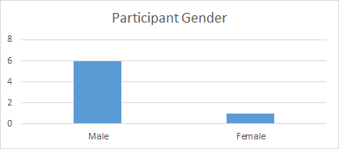](https://docs.google.com/document/d/1KzBfRg3pWlpYw4uTUH9maY_FCphE5WK0OpTnpD46gWw/edit#bookmark=id.ai1edqg7hj42)

[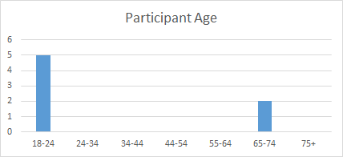](https://docs.google.com/document/d/1KzBfRg3pWlpYw4uTUH9maY_FCphE5WK0OpTnpD46gWw/edit#bookmark=id.ai1edqg7hj42)

[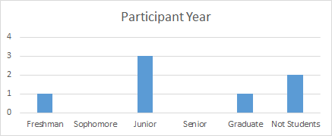](https://docs.google.com/document/d/1KzBfRg3pWlpYw4uTUH9maY_FCphE5WK0OpTnpD46gWw/edit#bookmark=id.ai1edqg7hj42)

[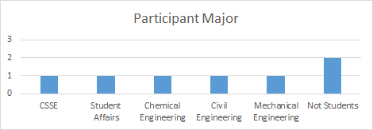](https://docs.google.com/document/d/1KzBfRg3pWlpYw4uTUH9maY_FCphE5WK0OpTnpD46gWw/edit#bookmark=id.ai1edqg7hj42)

[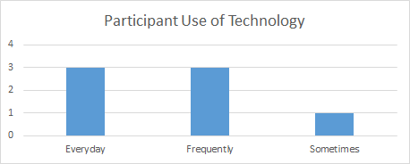](https://docs.google.com/document/d/1KzBfRg3pWlpYw4uTUH9maY_FCphE5WK0OpTnpD46gWw/edit#bookmark=id.ai1edqg7hj42)

[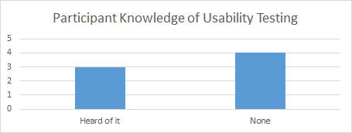](https://docs.google.com/document/d/1KzBfRg3pWlpYw4uTUH9maY_FCphE5WK0OpTnpD46gWw/edit#bookmark=id.ai1edqg7hj42)

# [Ovo Report ScreenShots](https://docs.google.com/document/d/1KzBfRg3pWlpYw4uTUH9maY_FCphE5WK0OpTnpD46gWw/edit#bookmark=id.ai1edqg7hj42)

|  |  |
| --- | --- |
| [Task Name](https://docs.google.com/document/d/1KzBfRg3pWlpYw4uTUH9maY_FCphE5WK0OpTnpD46gWw/edit#bookmark=id.ai1edqg7hj42) | [Task Number (in Ovo Studio)](https://docs.google.com/document/d/1KzBfRg3pWlpYw4uTUH9maY_FCphE5WK0OpTnpD46gWw/edit#bookmark=id.ai1edqg7hj42) |
| [Revise a Protocol for an Assay -- Primary](https://docs.google.com/document/d/1KzBfRg3pWlpYw4uTUH9maY_FCphE5WK0OpTnpD46gWw/edit#bookmark=id.ai1edqg7hj42) | [Task 01](https://docs.google.com/document/d/1KzBfRg3pWlpYw4uTUH9maY_FCphE5WK0OpTnpD46gWw/edit#bookmark=id.ai1edqg7hj42) |
| [Revise a Protocol for an Assay -- Alternate](https://docs.google.com/document/d/1KzBfRg3pWlpYw4uTUH9maY_FCphE5WK0OpTnpD46gWw/edit#bookmark=id.ai1edqg7hj42) | [Task 02](https://docs.google.com/document/d/1KzBfRg3pWlpYw4uTUH9maY_FCphE5WK0OpTnpD46gWw/edit#bookmark=id.ai1edqg7hj42) |
| [View Assays by Status -- Primary](https://docs.google.com/document/d/1KzBfRg3pWlpYw4uTUH9maY_FCphE5WK0OpTnpD46gWw/edit#bookmark=id.ai1edqg7hj42) | [Task 03](https://docs.google.com/document/d/1KzBfRg3pWlpYw4uTUH9maY_FCphE5WK0OpTnpD46gWw/edit#bookmark=id.ai1edqg7hj42) |
| [View Assays by Status -- Alternate](https://docs.google.com/document/d/1KzBfRg3pWlpYw4uTUH9maY_FCphE5WK0OpTnpD46gWw/edit#bookmark=id.ai1edqg7hj42) | [Task 04](https://docs.google.com/document/d/1KzBfRg3pWlpYw4uTUH9maY_FCphE5WK0OpTnpD46gWw/edit#bookmark=id.ai1edqg7hj42) |
| [Add a New Assay Idea -- Primary](https://docs.google.com/document/d/1KzBfRg3pWlpYw4uTUH9maY_FCphE5WK0OpTnpD46gWw/edit#bookmark=id.ai1edqg7hj42) | [Task 05](https://docs.google.com/document/d/1KzBfRg3pWlpYw4uTUH9maY_FCphE5WK0OpTnpD46gWw/edit#bookmark=id.ai1edqg7hj42) |
| [Add a New Assay Idea -- Alternate](https://docs.google.com/document/d/1KzBfRg3pWlpYw4uTUH9maY_FCphE5WK0OpTnpD46gWw/edit#bookmark=id.ai1edqg7hj42) | [Task 06](https://docs.google.com/document/d/1KzBfRg3pWlpYw4uTUH9maY_FCphE5WK0OpTnpD46gWw/edit#bookmark=id.ai1edqg7hj42) |

## 

[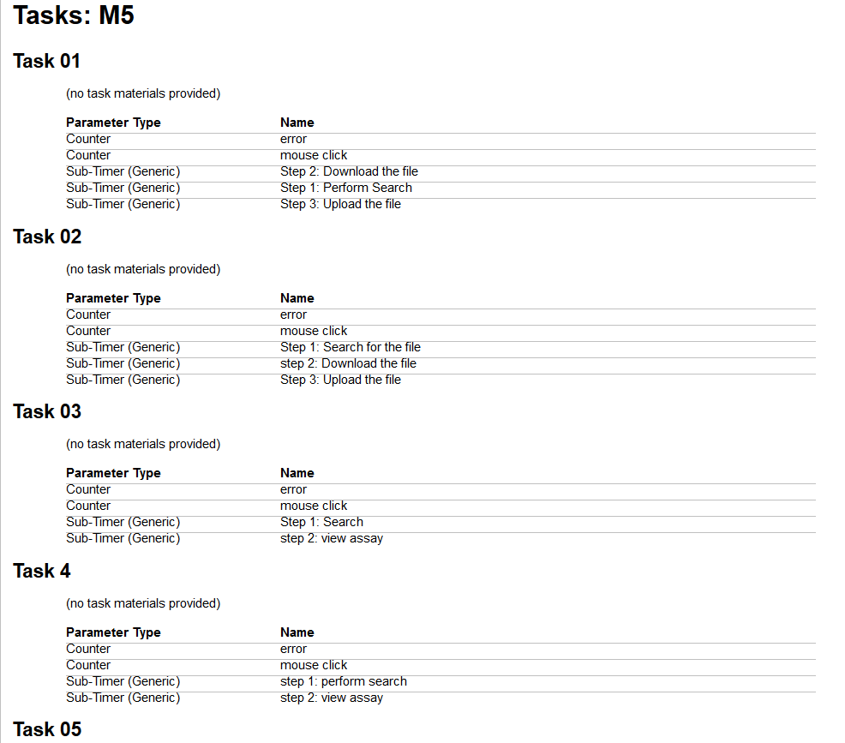](https://docs.google.com/document/d/1KzBfRg3pWlpYw4uTUH9maY_FCphE5WK0OpTnpD46gWw/edit#bookmark=id.ai1edqg7hj42)

[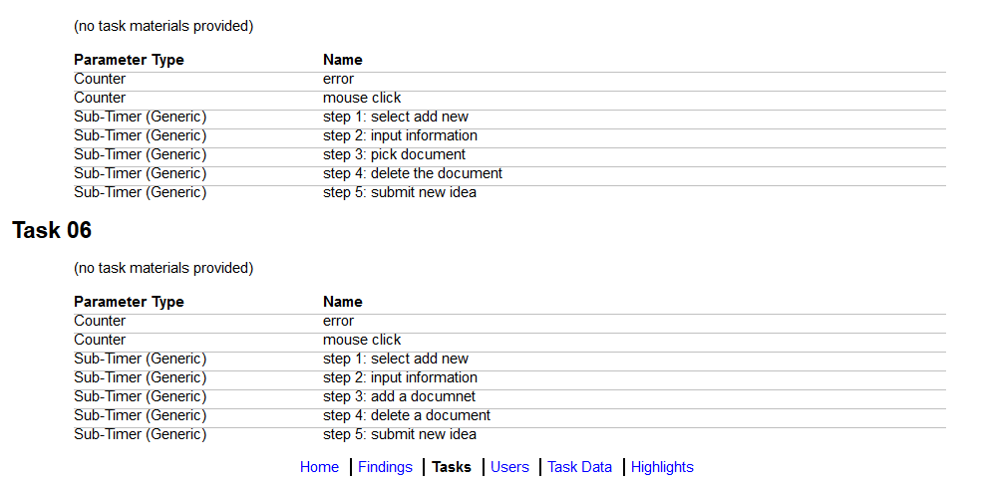](https://docs.google.com/document/d/1KzBfRg3pWlpYw4uTUH9maY_FCphE5WK0OpTnpD46gWw/edit#bookmark=id.ai1edqg7hj42)

[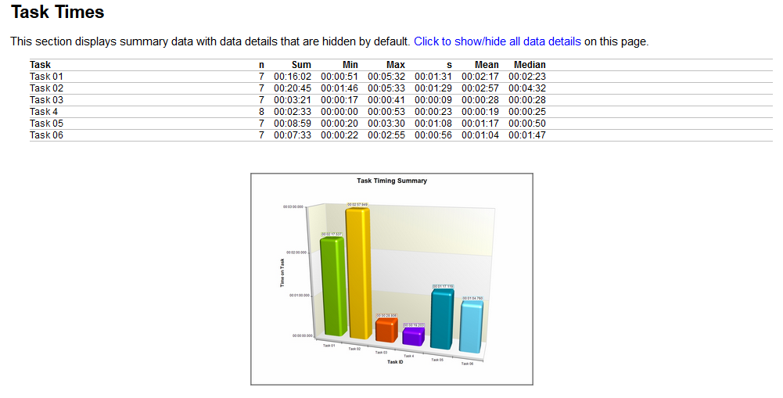](https://docs.google.com/document/d/1KzBfRg3pWlpYw4uTUH9maY_FCphE5WK0OpTnpD46gWw/edit#bookmark=id.ai1edqg7hj42)

[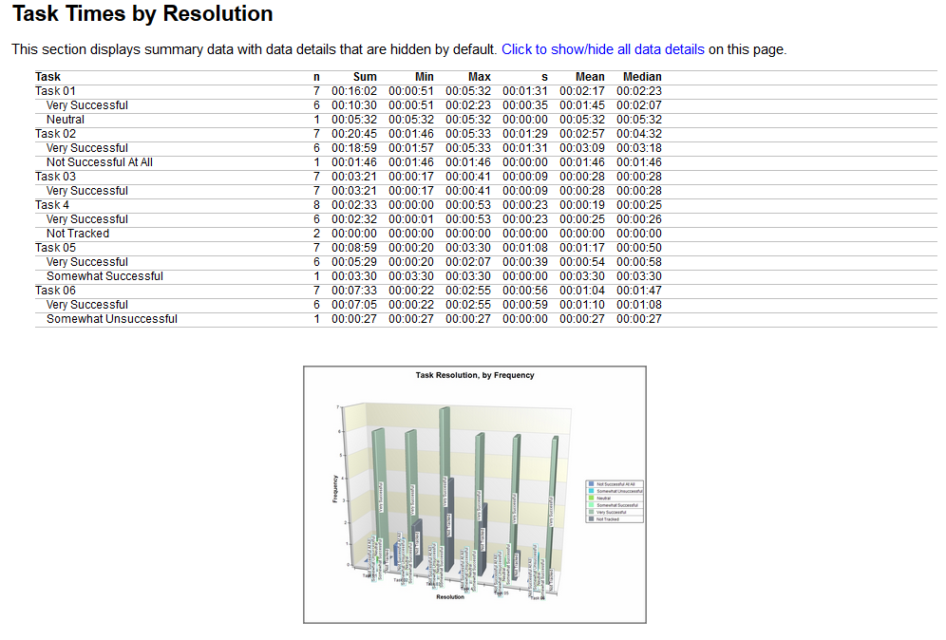](https://docs.google.com/document/d/1KzBfRg3pWlpYw4uTUH9maY_FCphE5WK0OpTnpD46gWw/edit#bookmark=id.ai1edqg7hj42)

[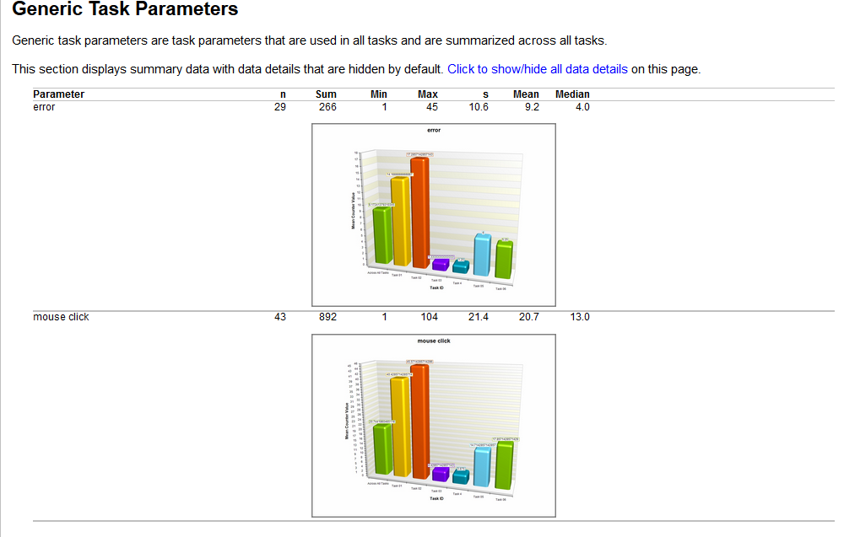](https://docs.google.com/document/d/1KzBfRg3pWlpYw4uTUH9maY_FCphE5WK0OpTnpD46gWw/edit#bookmark=id.ai1edqg7hj42)

[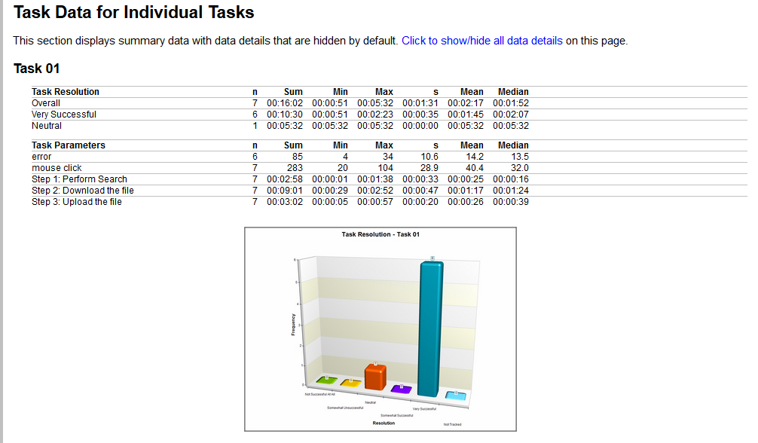](https://docs.google.com/document/d/1KzBfRg3pWlpYw4uTUH9maY_FCphE5WK0OpTnpD46gWw/edit#bookmark=id.ai1edqg7hj42)

[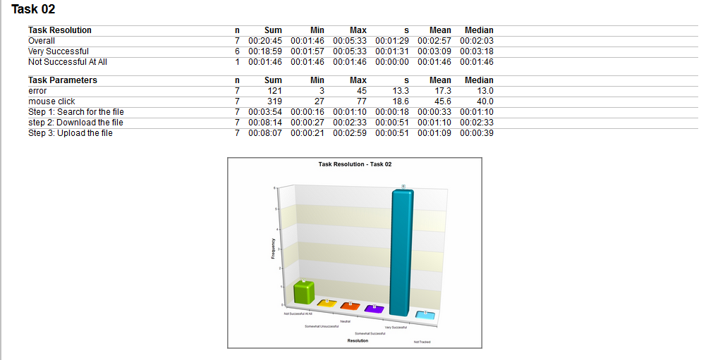](https://docs.google.com/document/d/1KzBfRg3pWlpYw4uTUH9maY_FCphE5WK0OpTnpD46gWw/edit#bookmark=id.ai1edqg7hj42)

[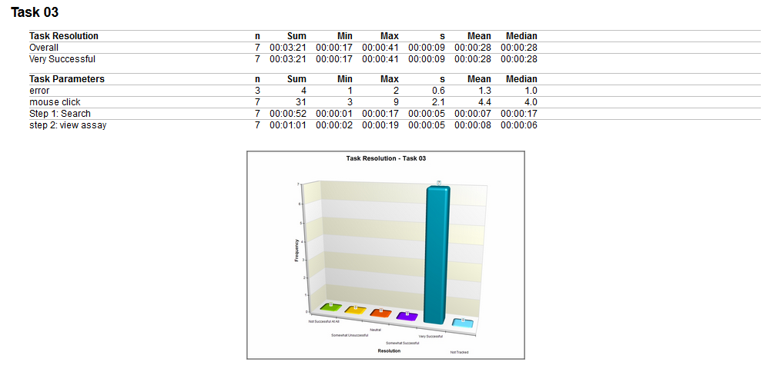](https://docs.google.com/document/d/1KzBfRg3pWlpYw4uTUH9maY_FCphE5WK0OpTnpD46gWw/edit#bookmark=id.ai1edqg7hj42)

[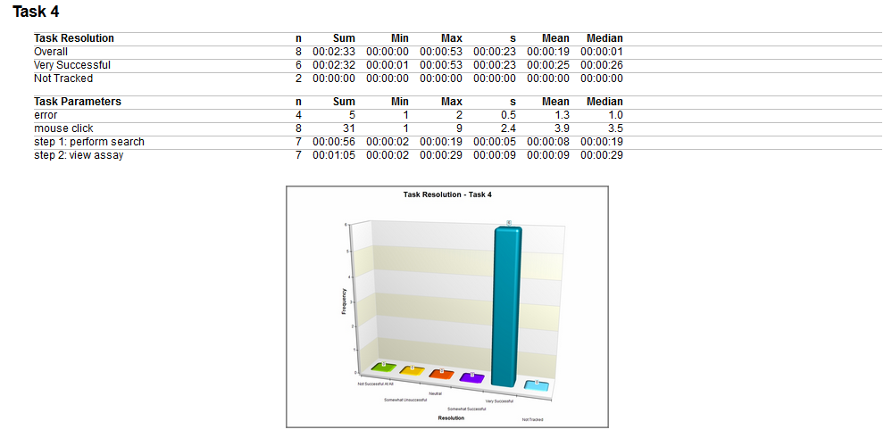](https://docs.google.com/document/d/1KzBfRg3pWlpYw4uTUH9maY_FCphE5WK0OpTnpD46gWw/edit#bookmark=id.ai1edqg7hj42)

[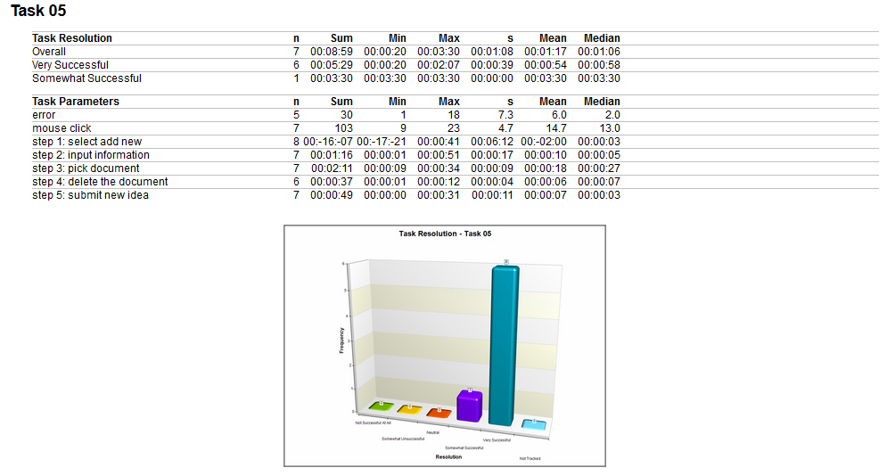](https://docs.google.com/document/d/1KzBfRg3pWlpYw4uTUH9maY_FCphE5WK0OpTnpD46gWw/edit#bookmark=id.ai1edqg7hj42)

[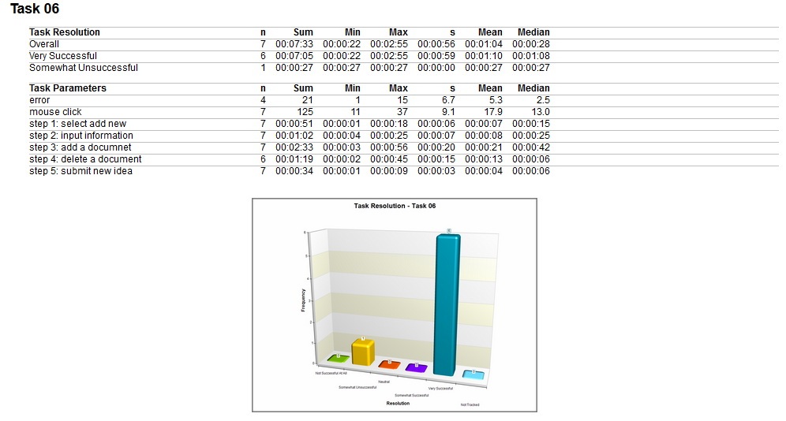](https://docs.google.com/document/d/1KzBfRg3pWlpYw4uTUH9maY_FCphE5WK0OpTnpD46gWw/edit#bookmark=id.ai1edqg7hj42)

# 

# 

# [Post Test Questionnaire Analysis](https://docs.google.com/document/d/1KzBfRg3pWlpYw4uTUH9maY_FCphE5WK0OpTnpD46gWw/edit#bookmark=id.ai1edqg7hj42)

# [Quantitative Analysis](https://docs.google.com/document/d/1KzBfRg3pWlpYw4uTUH9maY_FCphE5WK0OpTnpD46gWw/edit#bookmark=id.ai1edqg7hj42)

## [Assay Development - Revise a Protocol for an Assay](https://docs.google.com/document/d/1KzBfRg3pWlpYw4uTUH9maY_FCphE5WK0OpTnpD46gWw/edit#bookmark=id.ai1edqg7hj42)

### [Prototype](https://docs.google.com/document/d/1KzBfRg3pWlpYw4uTUH9maY_FCphE5WK0OpTnpD46gWw/edit#bookmark=id.ai1edqg7hj42)

|  |  |  |  |  |
| --- | --- | --- | --- | --- |
|  | [Mode](https://docs.google.com/document/d/1KzBfRg3pWlpYw4uTUH9maY_FCphE5WK0OpTnpD46gWw/edit#bookmark=id.ai1edqg7hj42) | [Average](https://docs.google.com/document/d/1KzBfRg3pWlpYw4uTUH9maY_FCphE5WK0OpTnpD46gWw/edit#bookmark=id.ai1edqg7hj42) | [Min](https://docs.google.com/document/d/1KzBfRg3pWlpYw4uTUH9maY_FCphE5WK0OpTnpD46gWw/edit#bookmark=id.ai1edqg7hj42) | [Max](https://docs.google.com/document/d/1KzBfRg3pWlpYw4uTUH9maY_FCphE5WK0OpTnpD46gWw/edit#bookmark=id.ai1edqg7hj42) |
| [Easy to use](https://docs.google.com/document/d/1KzBfRg3pWlpYw4uTUH9maY_FCphE5WK0OpTnpD46gWw/edit#bookmark=id.ai1edqg7hj42) | [2](https://docs.google.com/document/d/1KzBfRg3pWlpYw4uTUH9maY_FCphE5WK0OpTnpD46gWw/edit#bookmark=id.ai1edqg7hj42) | [2.285714286](https://docs.google.com/document/d/1KzBfRg3pWlpYw4uTUH9maY_FCphE5WK0OpTnpD46gWw/edit#bookmark=id.ai1edqg7hj42) | [2](https://docs.google.com/document/d/1KzBfRg3pWlpYw4uTUH9maY_FCphE5WK0OpTnpD46gWw/edit#bookmark=id.ai1edqg7hj42) | [3](https://docs.google.com/document/d/1KzBfRg3pWlpYw4uTUH9maY_FCphE5WK0OpTnpD46gWw/edit#bookmark=id.ai1edqg7hj42) |
| [Easy to understand](https://docs.google.com/document/d/1KzBfRg3pWlpYw4uTUH9maY_FCphE5WK0OpTnpD46gWw/edit#bookmark=id.ai1edqg7hj42) | [3](https://docs.google.com/document/d/1KzBfRg3pWlpYw4uTUH9maY_FCphE5WK0OpTnpD46gWw/edit#bookmark=id.ai1edqg7hj42) | [3.142857143](https://docs.google.com/document/d/1KzBfRg3pWlpYw4uTUH9maY_FCphE5WK0OpTnpD46gWw/edit#bookmark=id.ai1edqg7hj42) | [2](https://docs.google.com/document/d/1KzBfRg3pWlpYw4uTUH9maY_FCphE5WK0OpTnpD46gWw/edit#bookmark=id.ai1edqg7hj42) | [4](https://docs.google.com/document/d/1KzBfRg3pWlpYw4uTUH9maY_FCphE5WK0OpTnpD46gWw/edit#bookmark=id.ai1edqg7hj42) |
| [Felt confused/ hesitant](https://docs.google.com/document/d/1KzBfRg3pWlpYw4uTUH9maY_FCphE5WK0OpTnpD46gWw/edit#bookmark=id.ai1edqg7hj42) | [2](https://docs.google.com/document/d/1KzBfRg3pWlpYw4uTUH9maY_FCphE5WK0OpTnpD46gWw/edit#bookmark=id.ai1edqg7hj42) | [2.285714286](https://docs.google.com/document/d/1KzBfRg3pWlpYw4uTUH9maY_FCphE5WK0OpTnpD46gWw/edit#bookmark=id.ai1edqg7hj42) | [1](https://docs.google.com/document/d/1KzBfRg3pWlpYw4uTUH9maY_FCphE5WK0OpTnpD46gWw/edit#bookmark=id.ai1edqg7hj42) | [4](https://docs.google.com/document/d/1KzBfRg3pWlpYw4uTUH9maY_FCphE5WK0OpTnpD46gWw/edit#bookmark=id.ai1edqg7hj42) |
| [Task took reasonable time](https://docs.google.com/document/d/1KzBfRg3pWlpYw4uTUH9maY_FCphE5WK0OpTnpD46gWw/edit#bookmark=id.ai1edqg7hj42) | [2](https://docs.google.com/document/d/1KzBfRg3pWlpYw4uTUH9maY_FCphE5WK0OpTnpD46gWw/edit#bookmark=id.ai1edqg7hj42) | [2.714285714](https://docs.google.com/document/d/1KzBfRg3pWlpYw4uTUH9maY_FCphE5WK0OpTnpD46gWw/edit#bookmark=id.ai1edqg7hj42) | [2](https://docs.google.com/document/d/1KzBfRg3pWlpYw4uTUH9maY_FCphE5WK0OpTnpD46gWw/edit#bookmark=id.ai1edqg7hj42) | [4](https://docs.google.com/document/d/1KzBfRg3pWlpYw4uTUH9maY_FCphE5WK0OpTnpD46gWw/edit#bookmark=id.ai1edqg7hj42) |

[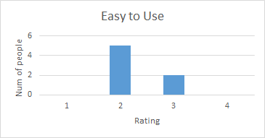](https://docs.google.com/document/d/1KzBfRg3pWlpYw4uTUH9maY_FCphE5WK0OpTnpD46gWw/edit#bookmark=id.ai1edqg7hj42)

[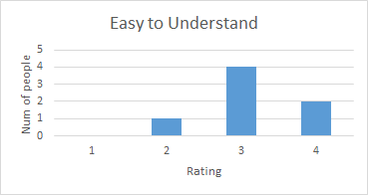](https://docs.google.com/document/d/1KzBfRg3pWlpYw4uTUH9maY_FCphE5WK0OpTnpD46gWw/edit#bookmark=id.ai1edqg7hj42)

[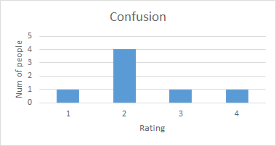](https://docs.google.com/document/d/1KzBfRg3pWlpYw4uTUH9maY_FCphE5WK0OpTnpD46gWw/edit#bookmark=id.ai1edqg7hj42)

[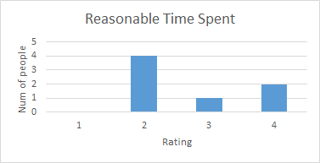](https://docs.google.com/document/d/1KzBfRg3pWlpYw4uTUH9maY_FCphE5WK0OpTnpD46gWw/edit#bookmark=id.ai1edqg7hj42)

### [Alternative](https://docs.google.com/document/d/1KzBfRg3pWlpYw4uTUH9maY_FCphE5WK0OpTnpD46gWw/edit#bookmark=id.ai1edqg7hj42)

|  |  |  |  |  |
| --- | --- | --- | --- | --- |
|  | [Mode](https://docs.google.com/document/d/1KzBfRg3pWlpYw4uTUH9maY_FCphE5WK0OpTnpD46gWw/edit#bookmark=id.ai1edqg7hj42) | [Average](https://docs.google.com/document/d/1KzBfRg3pWlpYw4uTUH9maY_FCphE5WK0OpTnpD46gWw/edit#bookmark=id.ai1edqg7hj42) | [Min](https://docs.google.com/document/d/1KzBfRg3pWlpYw4uTUH9maY_FCphE5WK0OpTnpD46gWw/edit#bookmark=id.ai1edqg7hj42) | [Max](https://docs.google.com/document/d/1KzBfRg3pWlpYw4uTUH9maY_FCphE5WK0OpTnpD46gWw/edit#bookmark=id.ai1edqg7hj42) |
| [Easy to use](https://docs.google.com/document/d/1KzBfRg3pWlpYw4uTUH9maY_FCphE5WK0OpTnpD46gWw/edit#bookmark=id.ai1edqg7hj42) | [2](https://docs.google.com/document/d/1KzBfRg3pWlpYw4uTUH9maY_FCphE5WK0OpTnpD46gWw/edit#bookmark=id.ai1edqg7hj42) | [2.714285714](https://docs.google.com/document/d/1KzBfRg3pWlpYw4uTUH9maY_FCphE5WK0OpTnpD46gWw/edit#bookmark=id.ai1edqg7hj42) | [2](https://docs.google.com/document/d/1KzBfRg3pWlpYw4uTUH9maY_FCphE5WK0OpTnpD46gWw/edit#bookmark=id.ai1edqg7hj42) | [4](https://docs.google.com/document/d/1KzBfRg3pWlpYw4uTUH9maY_FCphE5WK0OpTnpD46gWw/edit#bookmark=id.ai1edqg7hj42) |
| [Easy to understand](https://docs.google.com/document/d/1KzBfRg3pWlpYw4uTUH9maY_FCphE5WK0OpTnpD46gWw/edit#bookmark=id.ai1edqg7hj42) | [4](https://docs.google.com/document/d/1KzBfRg3pWlpYw4uTUH9maY_FCphE5WK0OpTnpD46gWw/edit#bookmark=id.ai1edqg7hj42) | [3.142857143](https://docs.google.com/document/d/1KzBfRg3pWlpYw4uTUH9maY_FCphE5WK0OpTnpD46gWw/edit#bookmark=id.ai1edqg7hj42) | [2](https://docs.google.com/document/d/1KzBfRg3pWlpYw4uTUH9maY_FCphE5WK0OpTnpD46gWw/edit#bookmark=id.ai1edqg7hj42) | [4](https://docs.google.com/document/d/1KzBfRg3pWlpYw4uTUH9maY_FCphE5WK0OpTnpD46gWw/edit#bookmark=id.ai1edqg7hj42) |
| [Felt confused/ hesitant](https://docs.google.com/document/d/1KzBfRg3pWlpYw4uTUH9maY_FCphE5WK0OpTnpD46gWw/edit#bookmark=id.ai1edqg7hj42) | [2](https://docs.google.com/document/d/1KzBfRg3pWlpYw4uTUH9maY_FCphE5WK0OpTnpD46gWw/edit#bookmark=id.ai1edqg7hj42) | [2.285714286](https://docs.google.com/document/d/1KzBfRg3pWlpYw4uTUH9maY_FCphE5WK0OpTnpD46gWw/edit#bookmark=id.ai1edqg7hj42) | [1](https://docs.google.com/document/d/1KzBfRg3pWlpYw4uTUH9maY_FCphE5WK0OpTnpD46gWw/edit#bookmark=id.ai1edqg7hj42) | [3](https://docs.google.com/document/d/1KzBfRg3pWlpYw4uTUH9maY_FCphE5WK0OpTnpD46gWw/edit#bookmark=id.ai1edqg7hj42) |
| [Task took reasonable time](https://docs.google.com/document/d/1KzBfRg3pWlpYw4uTUH9maY_FCphE5WK0OpTnpD46gWw/edit#bookmark=id.ai1edqg7hj42) | [4](https://docs.google.com/document/d/1KzBfRg3pWlpYw4uTUH9maY_FCphE5WK0OpTnpD46gWw/edit#bookmark=id.ai1edqg7hj42) | [3.142857143](https://docs.google.com/document/d/1KzBfRg3pWlpYw4uTUH9maY_FCphE5WK0OpTnpD46gWw/edit#bookmark=id.ai1edqg7hj42) | [2](https://docs.google.com/document/d/1KzBfRg3pWlpYw4uTUH9maY_FCphE5WK0OpTnpD46gWw/edit#bookmark=id.ai1edqg7hj42) | [4](https://docs.google.com/document/d/1KzBfRg3pWlpYw4uTUH9maY_FCphE5WK0OpTnpD46gWw/edit#bookmark=id.ai1edqg7hj42) |

[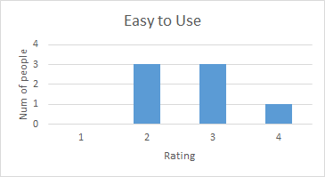](https://docs.google.com/document/d/1KzBfRg3pWlpYw4uTUH9maY_FCphE5WK0OpTnpD46gWw/edit#bookmark=id.ai1edqg7hj42)

[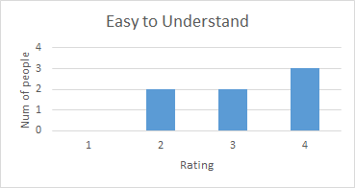](https://docs.google.com/document/d/1KzBfRg3pWlpYw4uTUH9maY_FCphE5WK0OpTnpD46gWw/edit#bookmark=id.ai1edqg7hj42)

[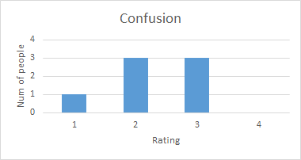](https://docs.google.com/document/d/1KzBfRg3pWlpYw4uTUH9maY_FCphE5WK0OpTnpD46gWw/edit#bookmark=id.ai1edqg7hj42)

[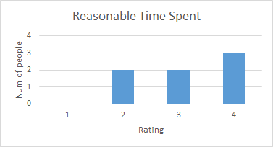](https://docs.google.com/document/d/1KzBfRg3pWlpYw4uTUH9maY_FCphE5WK0OpTnpD46gWw/edit#bookmark=id.ai1edqg7hj42)

## [Assay Development - View Assays by Status](https://docs.google.com/document/d/1KzBfRg3pWlpYw4uTUH9maY_FCphE5WK0OpTnpD46gWw/edit#bookmark=id.ai1edqg7hj42)

### [Prototype](https://docs.google.com/document/d/1KzBfRg3pWlpYw4uTUH9maY_FCphE5WK0OpTnpD46gWw/edit#bookmark=id.ai1edqg7hj42)

|  |  |  |  |  |
| --- | --- | --- | --- | --- |
|  | [Mode](https://docs.google.com/document/d/1KzBfRg3pWlpYw4uTUH9maY_FCphE5WK0OpTnpD46gWw/edit#bookmark=id.ai1edqg7hj42) | [Average](https://docs.google.com/document/d/1KzBfRg3pWlpYw4uTUH9maY_FCphE5WK0OpTnpD46gWw/edit#bookmark=id.ai1edqg7hj42) | [Min](https://docs.google.com/document/d/1KzBfRg3pWlpYw4uTUH9maY_FCphE5WK0OpTnpD46gWw/edit#bookmark=id.ai1edqg7hj42) | [Max](https://docs.google.com/document/d/1KzBfRg3pWlpYw4uTUH9maY_FCphE5WK0OpTnpD46gWw/edit#bookmark=id.ai1edqg7hj42) |
| [Easy to use](https://docs.google.com/document/d/1KzBfRg3pWlpYw4uTUH9maY_FCphE5WK0OpTnpD46gWw/edit#bookmark=id.ai1edqg7hj42) | [4](https://docs.google.com/document/d/1KzBfRg3pWlpYw4uTUH9maY_FCphE5WK0OpTnpD46gWw/edit#bookmark=id.ai1edqg7hj42) | [3.428571429](https://docs.google.com/document/d/1KzBfRg3pWlpYw4uTUH9maY_FCphE5WK0OpTnpD46gWw/edit#bookmark=id.ai1edqg7hj42) | [1](https://docs.google.com/document/d/1KzBfRg3pWlpYw4uTUH9maY_FCphE5WK0OpTnpD46gWw/edit#bookmark=id.ai1edqg7hj42) | [4](https://docs.google.com/document/d/1KzBfRg3pWlpYw4uTUH9maY_FCphE5WK0OpTnpD46gWw/edit#bookmark=id.ai1edqg7hj42) |
| [Easy to understand](https://docs.google.com/document/d/1KzBfRg3pWlpYw4uTUH9maY_FCphE5WK0OpTnpD46gWw/edit#bookmark=id.ai1edqg7hj42) | [4](https://docs.google.com/document/d/1KzBfRg3pWlpYw4uTUH9maY_FCphE5WK0OpTnpD46gWw/edit#bookmark=id.ai1edqg7hj42) | [3.428571429](https://docs.google.com/document/d/1KzBfRg3pWlpYw4uTUH9maY_FCphE5WK0OpTnpD46gWw/edit#bookmark=id.ai1edqg7hj42) | [1](https://docs.google.com/document/d/1KzBfRg3pWlpYw4uTUH9maY_FCphE5WK0OpTnpD46gWw/edit#bookmark=id.ai1edqg7hj42) | [4](https://docs.google.com/document/d/1KzBfRg3pWlpYw4uTUH9maY_FCphE5WK0OpTnpD46gWw/edit#bookmark=id.ai1edqg7hj42) |
| [Felt confused/ hesitant](https://docs.google.com/document/d/1KzBfRg3pWlpYw4uTUH9maY_FCphE5WK0OpTnpD46gWw/edit#bookmark=id.ai1edqg7hj42) | [1](https://docs.google.com/document/d/1KzBfRg3pWlpYw4uTUH9maY_FCphE5WK0OpTnpD46gWw/edit#bookmark=id.ai1edqg7hj42) | [1.857142857](https://docs.google.com/document/d/1KzBfRg3pWlpYw4uTUH9maY_FCphE5WK0OpTnpD46gWw/edit#bookmark=id.ai1edqg7hj42) | [1](https://docs.google.com/document/d/1KzBfRg3pWlpYw4uTUH9maY_FCphE5WK0OpTnpD46gWw/edit#bookmark=id.ai1edqg7hj42) | [4](https://docs.google.com/document/d/1KzBfRg3pWlpYw4uTUH9maY_FCphE5WK0OpTnpD46gWw/edit#bookmark=id.ai1edqg7hj42) |
| [Task took reasonable time](https://docs.google.com/document/d/1KzBfRg3pWlpYw4uTUH9maY_FCphE5WK0OpTnpD46gWw/edit#bookmark=id.ai1edqg7hj42) | [4](https://docs.google.com/document/d/1KzBfRg3pWlpYw4uTUH9maY_FCphE5WK0OpTnpD46gWw/edit#bookmark=id.ai1edqg7hj42) | [3.428571429](https://docs.google.com/document/d/1KzBfRg3pWlpYw4uTUH9maY_FCphE5WK0OpTnpD46gWw/edit#bookmark=id.ai1edqg7hj42) | [1](https://docs.google.com/document/d/1KzBfRg3pWlpYw4uTUH9maY_FCphE5WK0OpTnpD46gWw/edit#bookmark=id.ai1edqg7hj42) | [4](https://docs.google.com/document/d/1KzBfRg3pWlpYw4uTUH9maY_FCphE5WK0OpTnpD46gWw/edit#bookmark=id.ai1edqg7hj42) |

[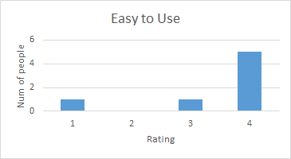](https://docs.google.com/document/d/1KzBfRg3pWlpYw4uTUH9maY_FCphE5WK0OpTnpD46gWw/edit#bookmark=id.ai1edqg7hj42)

[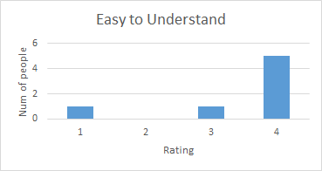](https://docs.google.com/document/d/1KzBfRg3pWlpYw4uTUH9maY_FCphE5WK0OpTnpD46gWw/edit#bookmark=id.ai1edqg7hj42)

[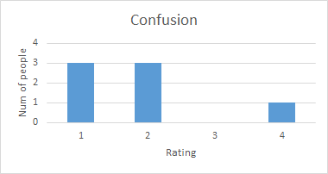](https://docs.google.com/document/d/1KzBfRg3pWlpYw4uTUH9maY_FCphE5WK0OpTnpD46gWw/edit#bookmark=id.ai1edqg7hj42)

[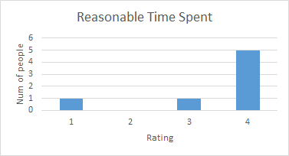](https://docs.google.com/document/d/1KzBfRg3pWlpYw4uTUH9maY_FCphE5WK0OpTnpD46gWw/edit#bookmark=id.ai1edqg7hj42)

### [Alternative](https://docs.google.com/document/d/1KzBfRg3pWlpYw4uTUH9maY_FCphE5WK0OpTnpD46gWw/edit#bookmark=id.ai1edqg7hj42)

|  |  |  |  |  |
| --- | --- | --- | --- | --- |
|  | [Mode](https://docs.google.com/document/d/1KzBfRg3pWlpYw4uTUH9maY_FCphE5WK0OpTnpD46gWw/edit#bookmark=id.ai1edqg7hj42) | [Average](https://docs.google.com/document/d/1KzBfRg3pWlpYw4uTUH9maY_FCphE5WK0OpTnpD46gWw/edit#bookmark=id.ai1edqg7hj42) | [Min](https://docs.google.com/document/d/1KzBfRg3pWlpYw4uTUH9maY_FCphE5WK0OpTnpD46gWw/edit#bookmark=id.ai1edqg7hj42) | [Max](https://docs.google.com/document/d/1KzBfRg3pWlpYw4uTUH9maY_FCphE5WK0OpTnpD46gWw/edit#bookmark=id.ai1edqg7hj42) |
| [Easy to use](https://docs.google.com/document/d/1KzBfRg3pWlpYw4uTUH9maY_FCphE5WK0OpTnpD46gWw/edit#bookmark=id.ai1edqg7hj42) | [4](https://docs.google.com/document/d/1KzBfRg3pWlpYw4uTUH9maY_FCphE5WK0OpTnpD46gWw/edit#bookmark=id.ai1edqg7hj42) | [3.428571429](https://docs.google.com/document/d/1KzBfRg3pWlpYw4uTUH9maY_FCphE5WK0OpTnpD46gWw/edit#bookmark=id.ai1edqg7hj42) | [2](https://docs.google.com/document/d/1KzBfRg3pWlpYw4uTUH9maY_FCphE5WK0OpTnpD46gWw/edit#bookmark=id.ai1edqg7hj42) | [4](https://docs.google.com/document/d/1KzBfRg3pWlpYw4uTUH9maY_FCphE5WK0OpTnpD46gWw/edit#bookmark=id.ai1edqg7hj42) |
| [Easy to understand](https://docs.google.com/document/d/1KzBfRg3pWlpYw4uTUH9maY_FCphE5WK0OpTnpD46gWw/edit#bookmark=id.ai1edqg7hj42) | [4](https://docs.google.com/document/d/1KzBfRg3pWlpYw4uTUH9maY_FCphE5WK0OpTnpD46gWw/edit#bookmark=id.ai1edqg7hj42) | [3.571428571](https://docs.google.com/document/d/1KzBfRg3pWlpYw4uTUH9maY_FCphE5WK0OpTnpD46gWw/edit#bookmark=id.ai1edqg7hj42) | [2](https://docs.google.com/document/d/1KzBfRg3pWlpYw4uTUH9maY_FCphE5WK0OpTnpD46gWw/edit#bookmark=id.ai1edqg7hj42) | [4](https://docs.google.com/document/d/1KzBfRg3pWlpYw4uTUH9maY_FCphE5WK0OpTnpD46gWw/edit#bookmark=id.ai1edqg7hj42) |
| [Felt confused/ hesitant](https://docs.google.com/document/d/1KzBfRg3pWlpYw4uTUH9maY_FCphE5WK0OpTnpD46gWw/edit#bookmark=id.ai1edqg7hj42) | [1](https://docs.google.com/document/d/1KzBfRg3pWlpYw4uTUH9maY_FCphE5WK0OpTnpD46gWw/edit#bookmark=id.ai1edqg7hj42) | [1.857142857](https://docs.google.com/document/d/1KzBfRg3pWlpYw4uTUH9maY_FCphE5WK0OpTnpD46gWw/edit#bookmark=id.ai1edqg7hj42) | [1](https://docs.google.com/document/d/1KzBfRg3pWlpYw4uTUH9maY_FCphE5WK0OpTnpD46gWw/edit#bookmark=id.ai1edqg7hj42) | [4](https://docs.google.com/document/d/1KzBfRg3pWlpYw4uTUH9maY_FCphE5WK0OpTnpD46gWw/edit#bookmark=id.ai1edqg7hj42) |
| [Task took reasonable time](https://docs.google.com/document/d/1KzBfRg3pWlpYw4uTUH9maY_FCphE5WK0OpTnpD46gWw/edit#bookmark=id.ai1edqg7hj42) | [4](https://docs.google.com/document/d/1KzBfRg3pWlpYw4uTUH9maY_FCphE5WK0OpTnpD46gWw/edit#bookmark=id.ai1edqg7hj42) | [3.285714286](https://docs.google.com/document/d/1KzBfRg3pWlpYw4uTUH9maY_FCphE5WK0OpTnpD46gWw/edit#bookmark=id.ai1edqg7hj42) | [1](https://docs.google.com/document/d/1KzBfRg3pWlpYw4uTUH9maY_FCphE5WK0OpTnpD46gWw/edit#bookmark=id.ai1edqg7hj42) | [4](https://docs.google.com/document/d/1KzBfRg3pWlpYw4uTUH9maY_FCphE5WK0OpTnpD46gWw/edit#bookmark=id.ai1edqg7hj42) |

[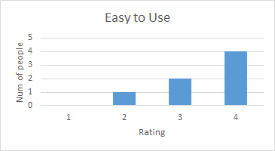](https://docs.google.com/document/d/1KzBfRg3pWlpYw4uTUH9maY_FCphE5WK0OpTnpD46gWw/edit#bookmark=id.ai1edqg7hj42)

[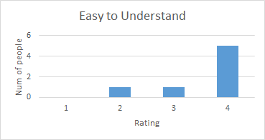](https://docs.google.com/document/d/1KzBfRg3pWlpYw4uTUH9maY_FCphE5WK0OpTnpD46gWw/edit#bookmark=id.ai1edqg7hj42)

[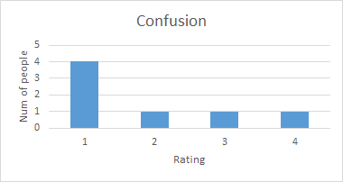](https://docs.google.com/document/d/1KzBfRg3pWlpYw4uTUH9maY_FCphE5WK0OpTnpD46gWw/edit#bookmark=id.ai1edqg7hj42)

[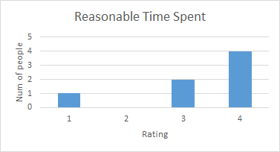](https://docs.google.com/document/d/1KzBfRg3pWlpYw4uTUH9maY_FCphE5WK0OpTnpD46gWw/edit#bookmark=id.ai1edqg7hj42)

## [Assay Development - Add a New Assay Idea](https://docs.google.com/document/d/1KzBfRg3pWlpYw4uTUH9maY_FCphE5WK0OpTnpD46gWw/edit#bookmark=id.ai1edqg7hj42)

### [Prototype](https://docs.google.com/document/d/1KzBfRg3pWlpYw4uTUH9maY_FCphE5WK0OpTnpD46gWw/edit#bookmark=id.ai1edqg7hj42)

|  |  |  |  |  |
| --- | --- | --- | --- | --- |
|  | [Mode](https://docs.google.com/document/d/1KzBfRg3pWlpYw4uTUH9maY_FCphE5WK0OpTnpD46gWw/edit#bookmark=id.ai1edqg7hj42) | [Average](https://docs.google.com/document/d/1KzBfRg3pWlpYw4uTUH9maY_FCphE5WK0OpTnpD46gWw/edit#bookmark=id.ai1edqg7hj42) | [Min](https://docs.google.com/document/d/1KzBfRg3pWlpYw4uTUH9maY_FCphE5WK0OpTnpD46gWw/edit#bookmark=id.ai1edqg7hj42) | [Max](https://docs.google.com/document/d/1KzBfRg3pWlpYw4uTUH9maY_FCphE5WK0OpTnpD46gWw/edit#bookmark=id.ai1edqg7hj42) |
| [Easy to use](https://docs.google.com/document/d/1KzBfRg3pWlpYw4uTUH9maY_FCphE5WK0OpTnpD46gWw/edit#bookmark=id.ai1edqg7hj42) | [4](https://docs.google.com/document/d/1KzBfRg3pWlpYw4uTUH9maY_FCphE5WK0OpTnpD46gWw/edit#bookmark=id.ai1edqg7hj42) | [3.428571429](https://docs.google.com/document/d/1KzBfRg3pWlpYw4uTUH9maY_FCphE5WK0OpTnpD46gWw/edit#bookmark=id.ai1edqg7hj42) | [2](https://docs.google.com/document/d/1KzBfRg3pWlpYw4uTUH9maY_FCphE5WK0OpTnpD46gWw/edit#bookmark=id.ai1edqg7hj42) | [4](https://docs.google.com/document/d/1KzBfRg3pWlpYw4uTUH9maY_FCphE5WK0OpTnpD46gWw/edit#bookmark=id.ai1edqg7hj42) |
| [Easy to understand](https://docs.google.com/document/d/1KzBfRg3pWlpYw4uTUH9maY_FCphE5WK0OpTnpD46gWw/edit#bookmark=id.ai1edqg7hj42) | [4](https://docs.google.com/document/d/1KzBfRg3pWlpYw4uTUH9maY_FCphE5WK0OpTnpD46gWw/edit#bookmark=id.ai1edqg7hj42) | [3.142857143](https://docs.google.com/document/d/1KzBfRg3pWlpYw4uTUH9maY_FCphE5WK0OpTnpD46gWw/edit#bookmark=id.ai1edqg7hj42) | [2](https://docs.google.com/document/d/1KzBfRg3pWlpYw4uTUH9maY_FCphE5WK0OpTnpD46gWw/edit#bookmark=id.ai1edqg7hj42) | [4](https://docs.google.com/document/d/1KzBfRg3pWlpYw4uTUH9maY_FCphE5WK0OpTnpD46gWw/edit#bookmark=id.ai1edqg7hj42) |
| [Felt confused/ hesitant](https://docs.google.com/document/d/1KzBfRg3pWlpYw4uTUH9maY_FCphE5WK0OpTnpD46gWw/edit#bookmark=id.ai1edqg7hj42) | [1](https://docs.google.com/document/d/1KzBfRg3pWlpYw4uTUH9maY_FCphE5WK0OpTnpD46gWw/edit#bookmark=id.ai1edqg7hj42) | [1.857142857](https://docs.google.com/document/d/1KzBfRg3pWlpYw4uTUH9maY_FCphE5WK0OpTnpD46gWw/edit#bookmark=id.ai1edqg7hj42) | [1](https://docs.google.com/document/d/1KzBfRg3pWlpYw4uTUH9maY_FCphE5WK0OpTnpD46gWw/edit#bookmark=id.ai1edqg7hj42) | [4](https://docs.google.com/document/d/1KzBfRg3pWlpYw4uTUH9maY_FCphE5WK0OpTnpD46gWw/edit#bookmark=id.ai1edqg7hj42) |
| [Task took reasonable time](https://docs.google.com/document/d/1KzBfRg3pWlpYw4uTUH9maY_FCphE5WK0OpTnpD46gWw/edit#bookmark=id.ai1edqg7hj42) | [4](https://docs.google.com/document/d/1KzBfRg3pWlpYw4uTUH9maY_FCphE5WK0OpTnpD46gWw/edit#bookmark=id.ai1edqg7hj42) | [3.285714286](https://docs.google.com/document/d/1KzBfRg3pWlpYw4uTUH9maY_FCphE5WK0OpTnpD46gWw/edit#bookmark=id.ai1edqg7hj42) | [2](https://docs.google.com/document/d/1KzBfRg3pWlpYw4uTUH9maY_FCphE5WK0OpTnpD46gWw/edit#bookmark=id.ai1edqg7hj42) | [4](https://docs.google.com/document/d/1KzBfRg3pWlpYw4uTUH9maY_FCphE5WK0OpTnpD46gWw/edit#bookmark=id.ai1edqg7hj42) |

[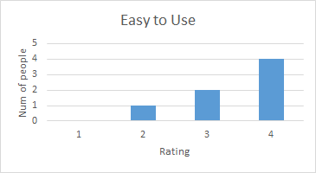](https://docs.google.com/document/d/1KzBfRg3pWlpYw4uTUH9maY_FCphE5WK0OpTnpD46gWw/edit#bookmark=id.ai1edqg7hj42)

[](https://docs.google.com/document/d/1KzBfRg3pWlpYw4uTUH9maY_FCphE5WK0OpTnpD46gWw/edit#bookmark=id.ai1edqg7hj42)

[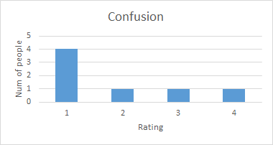](https://docs.google.com/document/d/1KzBfRg3pWlpYw4uTUH9maY_FCphE5WK0OpTnpD46gWw/edit#bookmark=id.ai1edqg7hj42)

[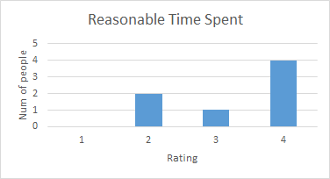](https://docs.google.com/document/d/1KzBfRg3pWlpYw4uTUH9maY_FCphE5WK0OpTnpD46gWw/edit#bookmark=id.ai1edqg7hj42)

### [Alternative](https://docs.google.com/document/d/1KzBfRg3pWlpYw4uTUH9maY_FCphE5WK0OpTnpD46gWw/edit#bookmark=id.ai1edqg7hj42)

|  |  |  |  |  |
| --- | --- | --- | --- | --- |
|  | [Mode](https://docs.google.com/document/d/1KzBfRg3pWlpYw4uTUH9maY_FCphE5WK0OpTnpD46gWw/edit#bookmark=id.ai1edqg7hj42) | [Average](https://docs.google.com/document/d/1KzBfRg3pWlpYw4uTUH9maY_FCphE5WK0OpTnpD46gWw/edit#bookmark=id.ai1edqg7hj42) | [Min](https://docs.google.com/document/d/1KzBfRg3pWlpYw4uTUH9maY_FCphE5WK0OpTnpD46gWw/edit#bookmark=id.ai1edqg7hj42) | [Max](https://docs.google.com/document/d/1KzBfRg3pWlpYw4uTUH9maY_FCphE5WK0OpTnpD46gWw/edit#bookmark=id.ai1edqg7hj42) |
| [Easy to use](https://docs.google.com/document/d/1KzBfRg3pWlpYw4uTUH9maY_FCphE5WK0OpTnpD46gWw/edit#bookmark=id.ai1edqg7hj42) | [4](https://docs.google.com/document/d/1KzBfRg3pWlpYw4uTUH9maY_FCphE5WK0OpTnpD46gWw/edit#bookmark=id.ai1edqg7hj42) | [3.285714286](https://docs.google.com/document/d/1KzBfRg3pWlpYw4uTUH9maY_FCphE5WK0OpTnpD46gWw/edit#bookmark=id.ai1edqg7hj42) | [2](https://docs.google.com/document/d/1KzBfRg3pWlpYw4uTUH9maY_FCphE5WK0OpTnpD46gWw/edit#bookmark=id.ai1edqg7hj42) | [4](https://docs.google.com/document/d/1KzBfRg3pWlpYw4uTUH9maY_FCphE5WK0OpTnpD46gWw/edit#bookmark=id.ai1edqg7hj42) |
| [Easy to understand](https://docs.google.com/document/d/1KzBfRg3pWlpYw4uTUH9maY_FCphE5WK0OpTnpD46gWw/edit#bookmark=id.ai1edqg7hj42) | [4](https://docs.google.com/document/d/1KzBfRg3pWlpYw4uTUH9maY_FCphE5WK0OpTnpD46gWw/edit#bookmark=id.ai1edqg7hj42) | [3.142857143](https://docs.google.com/document/d/1KzBfRg3pWlpYw4uTUH9maY_FCphE5WK0OpTnpD46gWw/edit#bookmark=id.ai1edqg7hj42) | [2](https://docs.google.com/document/d/1KzBfRg3pWlpYw4uTUH9maY_FCphE5WK0OpTnpD46gWw/edit#bookmark=id.ai1edqg7hj42) | [4](https://docs.google.com/document/d/1KzBfRg3pWlpYw4uTUH9maY_FCphE5WK0OpTnpD46gWw/edit#bookmark=id.ai1edqg7hj42) |
| [Felt confused/ hesitant](https://docs.google.com/document/d/1KzBfRg3pWlpYw4uTUH9maY_FCphE5WK0OpTnpD46gWw/edit#bookmark=id.ai1edqg7hj42) | [1](https://docs.google.com/document/d/1KzBfRg3pWlpYw4uTUH9maY_FCphE5WK0OpTnpD46gWw/edit#bookmark=id.ai1edqg7hj42) | [1.571428571](https://docs.google.com/document/d/1KzBfRg3pWlpYw4uTUH9maY_FCphE5WK0OpTnpD46gWw/edit#bookmark=id.ai1edqg7hj42) | [1](https://docs.google.com/document/d/1KzBfRg3pWlpYw4uTUH9maY_FCphE5WK0OpTnpD46gWw/edit#bookmark=id.ai1edqg7hj42) | [3](https://docs.google.com/document/d/1KzBfRg3pWlpYw4uTUH9maY_FCphE5WK0OpTnpD46gWw/edit#bookmark=id.ai1edqg7hj42) |
| [Task took reasonable time](https://docs.google.com/document/d/1KzBfRg3pWlpYw4uTUH9maY_FCphE5WK0OpTnpD46gWw/edit#bookmark=id.ai1edqg7hj42) | [4](https://docs.google.com/document/d/1KzBfRg3pWlpYw4uTUH9maY_FCphE5WK0OpTnpD46gWw/edit#bookmark=id.ai1edqg7hj42) | [3.285714286](https://docs.google.com/document/d/1KzBfRg3pWlpYw4uTUH9maY_FCphE5WK0OpTnpD46gWw/edit#bookmark=id.ai1edqg7hj42) | [2](https://docs.google.com/document/d/1KzBfRg3pWlpYw4uTUH9maY_FCphE5WK0OpTnpD46gWw/edit#bookmark=id.ai1edqg7hj42) | [4](https://docs.google.com/document/d/1KzBfRg3pWlpYw4uTUH9maY_FCphE5WK0OpTnpD46gWw/edit#bookmark=id.ai1edqg7hj42) |

[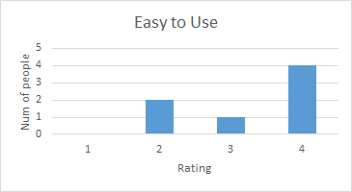](https://docs.google.com/document/d/1KzBfRg3pWlpYw4uTUH9maY_FCphE5WK0OpTnpD46gWw/edit#bookmark=id.ai1edqg7hj42)

[](https://docs.google.com/document/d/1KzBfRg3pWlpYw4uTUH9maY_FCphE5WK0OpTnpD46gWw/edit#bookmark=id.ai1edqg7hj42)

[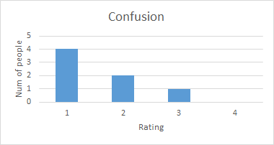](https://docs.google.com/document/d/1KzBfRg3pWlpYw4uTUH9maY_FCphE5WK0OpTnpD46gWw/edit#bookmark=id.ai1edqg7hj42)

[](https://docs.google.com/document/d/1KzBfRg3pWlpYw4uTUH9maY_FCphE5WK0OpTnpD46gWw/edit#bookmark=id.ai1edqg7hj42)

# [Qualitative Analysis](https://docs.google.com/document/d/1KzBfRg3pWlpYw4uTUH9maY_FCphE5WK0OpTnpD46gWw/edit#bookmark=id.ai1edqg7hj42)

## [Categories](https://docs.google.com/document/d/1KzBfRg3pWlpYw4uTUH9maY_FCphE5WK0OpTnpD46gWw/edit#bookmark=id.ai1edqg7hj42)

1. [Difficulty in navigating the interface.](https://docs.google.com/document/d/1KzBfRg3pWlpYw4uTUH9maY_FCphE5WK0OpTnpD46gWw/edit#bookmark=id.ai1edqg7hj42)
2. [Length of time for task is not as expected.](https://docs.google.com/document/d/1KzBfRg3pWlpYw4uTUH9maY_FCphE5WK0OpTnpD46gWw/edit#bookmark=id.ai1edqg7hj42)
3. [The design is intuitive or non-intuitive.](https://docs.google.com/document/d/1KzBfRg3pWlpYw4uTUH9maY_FCphE5WK0OpTnpD46gWw/edit#bookmark=id.ai1edqg7hj42)
4. [Difficulty in locating relevant information to the tasks.](https://docs.google.com/document/d/1KzBfRg3pWlpYw4uTUH9maY_FCphE5WK0OpTnpD46gWw/edit#bookmark=id.ai1edqg7hj42)

## [Analysis](https://docs.google.com/document/d/1KzBfRg3pWlpYw4uTUH9maY_FCphE5WK0OpTnpD46gWw/edit#bookmark=id.ai1edqg7hj42)

### [Assay Development - Revise a protocol for an assay](https://docs.google.com/document/d/1KzBfRg3pWlpYw4uTUH9maY_FCphE5WK0OpTnpD46gWw/edit#bookmark=id.ai1edqg7hj42)

* [Difficulty in navigating the interface](https://docs.google.com/document/d/1KzBfRg3pWlpYw4uTUH9maY_FCphE5WK0OpTnpD46gWw/edit#bookmark=id.ai1edqg7hj42)
  + [One user feels the prototype has less difficulty in navigating the interface than alternate design does.](https://docs.google.com/document/d/1KzBfRg3pWlpYw4uTUH9maY_FCphE5WK0OpTnpD46gWw/edit#bookmark=id.ai1edqg7hj42)
  + [One user feels the the design needs an easier step back option instead of starting over](https://docs.google.com/document/d/1KzBfRg3pWlpYw4uTUH9maY_FCphE5WK0OpTnpD46gWw/edit#bookmark=id.ai1edqg7hj42)
* [Length of time for task is not as expected](https://docs.google.com/document/d/1KzBfRg3pWlpYw4uTUH9maY_FCphE5WK0OpTnpD46gWw/edit#bookmark=id.ai1edqg7hj42)
  + [One user complains about the steps to complete a task is too much](https://docs.google.com/document/d/1KzBfRg3pWlpYw4uTUH9maY_FCphE5WK0OpTnpD46gWw/edit#bookmark=id.ai1edqg7hj42)
* [The design is intuitive or non-intuitive](https://docs.google.com/document/d/1KzBfRg3pWlpYw4uTUH9maY_FCphE5WK0OpTnpD46gWw/edit#bookmark=id.ai1edqg7hj42)
  + [Two users feel the prototype is more intuitive than alternate design](https://docs.google.com/document/d/1KzBfRg3pWlpYw4uTUH9maY_FCphE5WK0OpTnpD46gWw/edit#bookmark=id.ai1edqg7hj42)
  + [One user thinks we should have the information about file path autocomplete to the text bar for him to filling in](https://docs.google.com/document/d/1KzBfRg3pWlpYw4uTUH9maY_FCphE5WK0OpTnpD46gWw/edit#bookmark=id.ai1edqg7hj42)
* [Difficulty in locating relevant information to the tasks](https://docs.google.com/document/d/1KzBfRg3pWlpYw4uTUH9maY_FCphE5WK0OpTnpD46gWw/edit#bookmark=id.ai1edqg7hj42)
  + [One user feels the page contains too many things to find relevant information quickly](https://docs.google.com/document/d/1KzBfRg3pWlpYw4uTUH9maY_FCphE5WK0OpTnpD46gWw/edit#bookmark=id.ai1edqg7hj42)
  + [One user feels the error message is not correctly shown](https://docs.google.com/document/d/1KzBfRg3pWlpYw4uTUH9maY_FCphE5WK0OpTnpD46gWw/edit#bookmark=id.ai1edqg7hj42)

[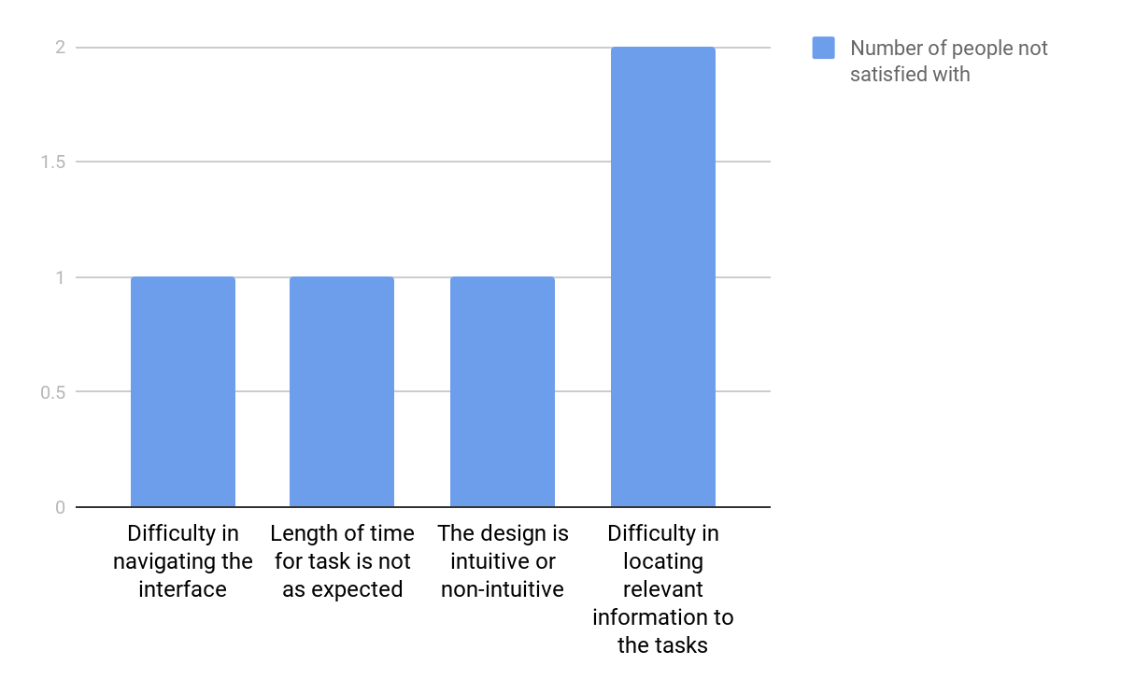](https://docs.google.com/document/d/1KzBfRg3pWlpYw4uTUH9maY_FCphE5WK0OpTnpD46gWw/edit#bookmark=id.ai1edqg7hj42)

[From the post-test questionnaires’ result, users like the prototype better. Half of them like prototype better, and two of them directly point out that the format of the interface in prototype is easier for them to read and flow. Overall, for this task, the difficulty in locating relevant information to the tasks is the most serious problem we have. This is mainly caused by the redundancy of information on the page.](https://docs.google.com/document/d/1KzBfRg3pWlpYw4uTUH9maY_FCphE5WK0OpTnpD46gWw/edit#bookmark=id.ai1edqg7hj42)

### [Assay Development - View the assay by status](https://docs.google.com/document/d/1KzBfRg3pWlpYw4uTUH9maY_FCphE5WK0OpTnpD46gWw/edit#bookmark=id.ai1edqg7hj42)

* [Difficulty in navigating the interface](https://docs.google.com/document/d/1KzBfRg3pWlpYw4uTUH9maY_FCphE5WK0OpTnpD46gWw/edit#bookmark=id.ai1edqg7hj42)
  + [One user feels both design are clean and clear of unnecessary information](https://docs.google.com/document/d/1KzBfRg3pWlpYw4uTUH9maY_FCphE5WK0OpTnpD46gWw/edit#bookmark=id.ai1edqg7hj42)
  + [One user feels the alternate design cannot lead him back to the home screen](https://docs.google.com/document/d/1KzBfRg3pWlpYw4uTUH9maY_FCphE5WK0OpTnpD46gWw/edit#bookmark=id.ai1edqg7hj42)
  + [One user thinks the arrow that shows where he can click is not pointing to correct place, this is an ovo studio problem, not what we can solve or improve.](https://docs.google.com/document/d/1KzBfRg3pWlpYw4uTUH9maY_FCphE5WK0OpTnpD46gWw/edit#bookmark=id.ai1edqg7hj42)
* [Length of time for task is not as expected](https://docs.google.com/document/d/1KzBfRg3pWlpYw4uTUH9maY_FCphE5WK0OpTnpD46gWw/edit#bookmark=id.ai1edqg7hj42)
  + [Two user prefer the alternate design because it takes less time to finish the task](https://docs.google.com/document/d/1KzBfRg3pWlpYw4uTUH9maY_FCphE5WK0OpTnpD46gWw/edit#bookmark=id.ai1edqg7hj42)
* [The design is intuitive or non-intuitive](https://docs.google.com/document/d/1KzBfRg3pWlpYw4uTUH9maY_FCphE5WK0OpTnpD46gWw/edit#bookmark=id.ai1edqg7hj42)
  + [Two users feel the returning to home screen should be applied by a ‘home-button’ or ‘return button’ instead of cleaning the search bar](https://docs.google.com/document/d/1KzBfRg3pWlpYw4uTUH9maY_FCphE5WK0OpTnpD46gWw/edit#bookmark=id.ai1edqg7hj42)
* [Difficulty in locating relevant information to the tasks](https://docs.google.com/document/d/1KzBfRg3pWlpYw4uTUH9maY_FCphE5WK0OpTnpD46gWw/edit#bookmark=id.ai1edqg7hj42)
  + [One user suggests to add a drop off for search bar to let him choose from options](https://docs.google.com/document/d/1KzBfRg3pWlpYw4uTUH9maY_FCphE5WK0OpTnpD46gWw/edit#bookmark=id.ai1edqg7hj42)

[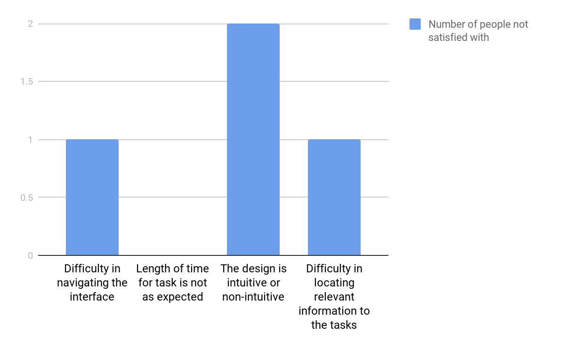](https://docs.google.com/document/d/1KzBfRg3pWlpYw4uTUH9maY_FCphE5WK0OpTnpD46gWw/edit#bookmark=id.ai1edqg7hj42)

[From the post-test questionnaires’ result, users prefer the alternate design because it takes less steps and time to finish the task. Some user feels uncomfortable about how to return to home screen, and they recommend a return button. Overall, in this task the most serious problem is that design is not intuitive enough. This is caused by the lack of a clear way to lead users back to home screen.](https://docs.google.com/document/d/1KzBfRg3pWlpYw4uTUH9maY_FCphE5WK0OpTnpD46gWw/edit#bookmark=id.ai1edqg7hj42)

### [Assay Development - View the assay by status](https://docs.google.com/document/d/1KzBfRg3pWlpYw4uTUH9maY_FCphE5WK0OpTnpD46gWw/edit#bookmark=id.ai1edqg7hj42)

* [Difficulty in navigating the interface](https://docs.google.com/document/d/1KzBfRg3pWlpYw4uTUH9maY_FCphE5WK0OpTnpD46gWw/edit#bookmark=id.ai1edqg7hj42)
  + [None](https://docs.google.com/document/d/1KzBfRg3pWlpYw4uTUH9maY_FCphE5WK0OpTnpD46gWw/edit#bookmark=id.ai1edqg7hj42)
* [Length of time for task is not as expected](https://docs.google.com/document/d/1KzBfRg3pWlpYw4uTUH9maY_FCphE5WK0OpTnpD46gWw/edit#bookmark=id.ai1edqg7hj42)
  + [None](https://docs.google.com/document/d/1KzBfRg3pWlpYw4uTUH9maY_FCphE5WK0OpTnpD46gWw/edit#bookmark=id.ai1edqg7hj42)
* [The design is intuitive or non-intuitive](https://docs.google.com/document/d/1KzBfRg3pWlpYw4uTUH9maY_FCphE5WK0OpTnpD46gWw/edit#bookmark=id.ai1edqg7hj42)
  + [One user thinks the design is very non-intuitive about what he should input. The software should be clear what will be autocomplete](https://docs.google.com/document/d/1KzBfRg3pWlpYw4uTUH9maY_FCphE5WK0OpTnpD46gWw/edit#bookmark=id.ai1edqg7hj42)
  + [One user complains the prototype has ‘next’ instead of ‘submit’ when the action is actually submit](https://docs.google.com/document/d/1KzBfRg3pWlpYw4uTUH9maY_FCphE5WK0OpTnpD46gWw/edit#bookmark=id.ai1edqg7hj42)
* [Difficulty in locating relevant information to the tasks](https://docs.google.com/document/d/1KzBfRg3pWlpYw4uTUH9maY_FCphE5WK0OpTnpD46gWw/edit#bookmark=id.ai1edqg7hj42)
  + [One user likes the prototype because the description and documents are separate to be easier to read](https://docs.google.com/document/d/1KzBfRg3pWlpYw4uTUH9maY_FCphE5WK0OpTnpD46gWw/edit#bookmark=id.ai1edqg7hj42)
  + [One user complains about the alternate design has too much information at one step](https://docs.google.com/document/d/1KzBfRg3pWlpYw4uTUH9maY_FCphE5WK0OpTnpD46gWw/edit#bookmark=id.ai1edqg7hj42)

[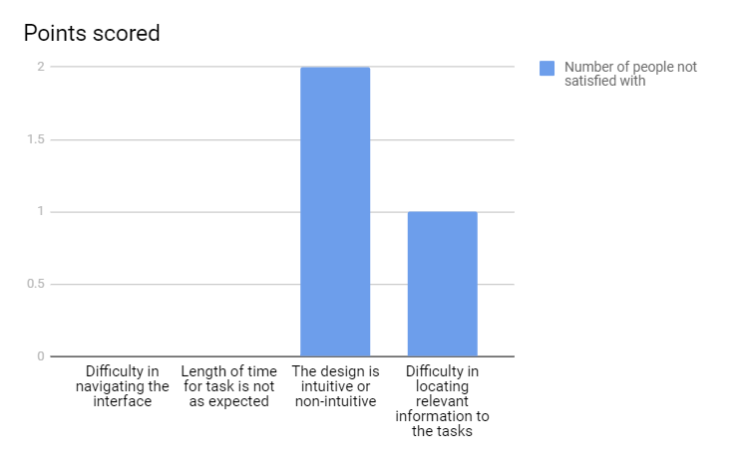](https://docs.google.com/document/d/1KzBfRg3pWlpYw4uTUH9maY_FCphE5WK0OpTnpD46gWw/edit#bookmark=id.ai1edqg7hj42)

[From the post-test questionnaires’ result, users prefer the prototype other than the alternate design because it is easier to get relevant information. The alternate design has too much information at a same page, which distracts users from the important information. Overall, the most serious problem of our design for this task is the design is not intuitive enough. The design should be more clear about which parts of text field should be filled by users, and which parts will be auto filled. In addition, we also need to set our button's’ label to be more clearly showing the consequence or the purpose of clicking it.](https://docs.google.com/document/d/1KzBfRg3pWlpYw4uTUH9maY_FCphE5WK0OpTnpD46gWw/edit#bookmark=id.ai1edqg7hj42)

# 

# 

# [Summary and Conclusions](https://docs.google.com/document/d/1KzBfRg3pWlpYw4uTUH9maY_FCphE5WK0OpTnpD46gWw/edit#bookmark=id.ai1edqg7hj42)

[For all the tasks, we rotated whether the participant saw the prototype first or the alternative first so the results are not skewed in favor of one or the other based on familiarity with the system (whichever design the saw second they understood more so they rate it better since they were already exposed to a similar design/doing the task).](https://docs.google.com/document/d/1KzBfRg3pWlpYw4uTUH9maY_FCphE5WK0OpTnpD46gWw/edit#bookmark=id.ai1edqg7hj42)

## [Revise a Protocol for an Assay](https://docs.google.com/document/d/1KzBfRg3pWlpYw4uTUH9maY_FCphE5WK0OpTnpD46gWw/edit#bookmark=id.ai1edqg7hj42)

[The results of the questionnaire for this task were inconclusive in pointing out the better design.](https://docs.google.com/document/d/1KzBfRg3pWlpYw4uTUH9maY_FCphE5WK0OpTnpD46gWw/edit#bookmark=id.ai1edqg7hj42)

[The overall ratings of both designs are very low and unexpected. The interfaces rank in the middle on understanding and time taken to perform the task, but users show high level of confusion and hesitation when performing the task. This shows that the users were able to complete the task but were unhappy with how the user interface was set up in terms of perception. The designs for this task are not user friendly and also not distinguishable.](https://docs.google.com/document/d/1KzBfRg3pWlpYw4uTUH9maY_FCphE5WK0OpTnpD46gWw/edit#bookmark=id.ai1edqg7hj42)

## [View Assays by Status](https://docs.google.com/document/d/1KzBfRg3pWlpYw4uTUH9maY_FCphE5WK0OpTnpD46gWw/edit#bookmark=id.ai1edqg7hj42)

[The results of the questionnaire for this task were inconclusive in pointing out the better design.](https://docs.google.com/document/d/1KzBfRg3pWlpYw4uTUH9maY_FCphE5WK0OpTnpD46gWw/edit#bookmark=id.ai1edqg7hj42)

[The ratings for the designs were practically the same and most people did not have any feedback on which one was actually better. While the ratings were high for understandability, easiness to use, and time taken to complete the task and low for confusion experienced during the task, the prototype and design have almost identical ratings. The ratings for each were within .5 of each with the design who was rated more favorably changing for each feature rated. The designs for this task were well received by the users but indistinguishable.](https://docs.google.com/document/d/1KzBfRg3pWlpYw4uTUH9maY_FCphE5WK0OpTnpD46gWw/edit#bookmark=id.ai1edqg7hj42)

## [Add a New Assay Idea](https://docs.google.com/document/d/1KzBfRg3pWlpYw4uTUH9maY_FCphE5WK0OpTnpD46gWw/edit#bookmark=id.ai1edqg7hj42)

[The results of the questionnaire for this task point towards the prototype design of this task to be slightly better.](https://docs.google.com/document/d/1KzBfRg3pWlpYw4uTUH9maY_FCphE5WK0OpTnpD46gWw/edit#bookmark=id.ai1edqg7hj42)

[The ratings for the prototype and alternative were very similar for all categories. People preferred one over the other here, but it varied from person to person which format they liked better. Overall, the designs were both rated favorably in all categories. The prototype was rated about .3 higher in multiple cases and then tied in the other categories. This points to the prototype being slightly more user friendly, but overall the experience on each was positive for the user.](https://docs.google.com/document/d/1KzBfRg3pWlpYw4uTUH9maY_FCphE5WK0OpTnpD46gWw/edit#bookmark=id.ai1edqg7hj42)

# [Recommendations for Change to Software](https://docs.google.com/document/d/1KzBfRg3pWlpYw4uTUH9maY_FCphE5WK0OpTnpD46gWw/edit#bookmark=id.ai1edqg7hj42)

|  |  |  |
| --- | --- | --- |
| [Finding](https://docs.google.com/document/d/1KzBfRg3pWlpYw4uTUH9maY_FCphE5WK0OpTnpD46gWw/edit#bookmark=id.ai1edqg7hj42) | [Description](https://docs.google.com/document/d/1KzBfRg3pWlpYw4uTUH9maY_FCphE5WK0OpTnpD46gWw/edit#bookmark=id.ai1edqg7hj42) | [Video Link](https://docs.google.com/document/d/1KzBfRg3pWlpYw4uTUH9maY_FCphE5WK0OpTnpD46gWw/edit#bookmark=id.ai1edqg7hj42) |
| [Looping in Task 2](https://docs.google.com/document/d/1KzBfRg3pWlpYw4uTUH9maY_FCphE5WK0OpTnpD46gWw/edit#bookmark=id.ai1edqg7hj42) | [In task 02, users are often looping between selecting version number and downloading, then uploading. They would then accidently select the version number again which would prevent them from uploading.](https://docs.google.com/document/d/1KzBfRg3pWlpYw4uTUH9maY_FCphE5WK0OpTnpD46gWw/edit#bookmark=id.ai1edqg7hj42) | [[video](https://docs.google.com/document/d/1KzBfRg3pWlpYw4uTUH9maY_FCphE5WK0OpTnpD46gWw/edit#bookmark=id.ai1edqg7hj42)](https://drive.google.com/open?id=1oNoLCiLUN8wauX0e1IlJLRaxtUdrTdC-) |
| [Lack of Feedback](https://docs.google.com/document/d/1KzBfRg3pWlpYw4uTUH9maY_FCphE5WK0OpTnpD46gWw/edit#bookmark=id.ai1edqg7hj42) | [In all tasks except for adding a new, when users perform a wrong action, the system doesn’t give any error message back. When users finish their tasks, the system also doesn’t give any message to inform the users.](https://docs.google.com/document/d/1KzBfRg3pWlpYw4uTUH9maY_FCphE5WK0OpTnpD46gWw/edit#bookmark=id.ai1edqg7hj42) | [[Video1](https://docs.google.com/document/d/1KzBfRg3pWlpYw4uTUH9maY_FCphE5WK0OpTnpD46gWw/edit#bookmark=id.ai1edqg7hj42)](https://drive.google.com/open?id=1zf2w1TqW_a5Q0WfPJo7WozxyN_xmjzdI)[,](https://docs.google.com/document/d/1KzBfRg3pWlpYw4uTUH9maY_FCphE5WK0OpTnpD46gWw/edit#bookmark=id.ai1edqg7hj42) [[video2](https://docs.google.com/document/d/1KzBfRg3pWlpYw4uTUH9maY_FCphE5WK0OpTnpD46gWw/edit#bookmark=id.ai1edqg7hj42)](https://drive.google.com/open?id=1juZv4yZa1W0F_twdmETbyuRN93TQhZ3K)[,](https://docs.google.com/document/d/1KzBfRg3pWlpYw4uTUH9maY_FCphE5WK0OpTnpD46gWw/edit#bookmark=id.ai1edqg7hj42) [[video3](https://docs.google.com/document/d/1KzBfRg3pWlpYw4uTUH9maY_FCphE5WK0OpTnpD46gWw/edit#bookmark=id.ai1edqg7hj42)](https://drive.google.com/open?id=1EKSKxEZz77wgp75EE1II2gtOLMwgpvsH) |
| [Lack of Constraint](https://docs.google.com/document/d/1KzBfRg3pWlpYw4uTUH9maY_FCphE5WK0OpTnpD46gWw/edit#bookmark=id.ai1edqg7hj42) | [In task 02 Users can see both Download button and Upload button on the selecting version page and the protocol information page, but only one of the button is functional on both pages. Users don’t know about that, so they kept clicking the wrong button.](https://docs.google.com/document/d/1KzBfRg3pWlpYw4uTUH9maY_FCphE5WK0OpTnpD46gWw/edit#bookmark=id.ai1edqg7hj42) | [[Video1](https://docs.google.com/document/d/1KzBfRg3pWlpYw4uTUH9maY_FCphE5WK0OpTnpD46gWw/edit#bookmark=id.ai1edqg7hj42)](https://drive.google.com/open?id=12c54nu628S-KWUV2wiYD3bTydXYwrG7k)[,](https://docs.google.com/document/d/1KzBfRg3pWlpYw4uTUH9maY_FCphE5WK0OpTnpD46gWw/edit#bookmark=id.ai1edqg7hj42) [[video2](https://docs.google.com/document/d/1KzBfRg3pWlpYw4uTUH9maY_FCphE5WK0OpTnpD46gWw/edit#bookmark=id.ai1edqg7hj42)](https://drive.google.com/open?id=1NI2DQRBKJIIss0-YLb8UlU-GMoLBnsXs)[,](https://docs.google.com/document/d/1KzBfRg3pWlpYw4uTUH9maY_FCphE5WK0OpTnpD46gWw/edit#bookmark=id.ai1edqg7hj42) [[video3](https://docs.google.com/document/d/1KzBfRg3pWlpYw4uTUH9maY_FCphE5WK0OpTnpD46gWw/edit#bookmark=id.ai1edqg7hj42)](https://drive.google.com/open?id=10ZwfVwdEKQHLsG_5RaYNA55_i3lW4_In) |
| [Try to add before choose](https://docs.google.com/document/d/1KzBfRg3pWlpYw4uTUH9maY_FCphE5WK0OpTnpD46gWw/edit#bookmark=id.ai1edqg7hj42) | [In task 05, 06 Users would try to add the document before they choose the document to add. Users can see the Add button and the Choose button before they click the Choose button. When users tried to add a file, they always clicked the Add button which is actually used for adding the file after you choosing it.](https://docs.google.com/document/d/1KzBfRg3pWlpYw4uTUH9maY_FCphE5WK0OpTnpD46gWw/edit#bookmark=id.ai1edqg7hj42) | [[video](https://docs.google.com/document/d/1KzBfRg3pWlpYw4uTUH9maY_FCphE5WK0OpTnpD46gWw/edit#bookmark=id.ai1edqg7hj42)](https://drive.google.com/open?id=1N78fb8w6qWSto1JkO8jLPiMxz9b1oBZT) |

## [Recommendations](https://docs.google.com/document/d/1KzBfRg3pWlpYw4uTUH9maY_FCphE5WK0OpTnpD46gWw/edit#bookmark=id.ai1edqg7hj42)

### [Looping in Task 2](https://docs.google.com/document/d/1KzBfRg3pWlpYw4uTUH9maY_FCphE5WK0OpTnpD46gWw/edit#bookmark=id.ai1edqg7hj42)

[We can solve this by having the users be trained in how to upload, but additionally we should have our actual software allow the user to upload regardless of the current version number. The prototype only allows them to upload if the selected version is the current highest version.](https://docs.google.com/document/d/1KzBfRg3pWlpYw4uTUH9maY_FCphE5WK0OpTnpD46gWw/edit#bookmark=id.ai1edqg7hj42)

### [Lack of Feedback](https://docs.google.com/document/d/1KzBfRg3pWlpYw4uTUH9maY_FCphE5WK0OpTnpD46gWw/edit#bookmark=id.ai1edqg7hj42)

[We can fix this by adding more windows that are like our “Add a New Assay Idea” with success screens on them so that the user can see what they have attempted to do has been completed. For instance we need to add an “Upload Complete” screen for uploading, not only to make it consistent with our download complete screen, so that the user understands that they have finished their task.](https://docs.google.com/document/d/1KzBfRg3pWlpYw4uTUH9maY_FCphE5WK0OpTnpD46gWw/edit#bookmark=id.ai1edqg7hj42)

### [Lack of Constraints](https://docs.google.com/document/d/1KzBfRg3pWlpYw4uTUH9maY_FCphE5WK0OpTnpD46gWw/edit#bookmark=id.ai1edqg7hj42)

[We simply need to move the upload button away from the download button on the page that it is non-functional on.](https://docs.google.com/document/d/1KzBfRg3pWlpYw4uTUH9maY_FCphE5WK0OpTnpD46gWw/edit#bookmark=id.ai1edqg7hj42)

### [Try to add before choose](https://docs.google.com/document/d/1KzBfRg3pWlpYw4uTUH9maY_FCphE5WK0OpTnpD46gWw/edit#bookmark=id.ai1edqg7hj42)

[There were some small changes for upgrades that we noticed during the experiment. One small thing that we could change would be only displaying the add button when a document was chosen to be added on the add new assay task. Overall, people were able to do the task and thought the task to be reasonable to complete, but this was the one trip up that people had on this task. It would make the design better for the user but we do not expect that it would exponentially enhance the user experience doing this task on the designed interface.](https://docs.google.com/document/d/1KzBfRg3pWlpYw4uTUH9maY_FCphE5WK0OpTnpD46gWw/edit#bookmark=id.ai1edqg7hj42)